Supplementary Table 1. PICO elements

PICO elements | Description
Population | Kidney transplant recipients
Intervention | CYP3A4*22 (rs35599367) C>T variant allele carriers
Comparator | CYP3A4*22 (rs35599367) C>T variant allele non-carriers
Outcomes | Tacrolimus trough concentration, dose requirement

Supplementary Table 2. Search strategy

No | Search term | Pubmed | Web of science | Embase
#1 | Transplantation | 1,000,043 | 640,905 | 1,542,295
#2 | (Polymorphi*) OR (SNP*) OR (mutation*) OR (variant*) OR (genotyp*) OR (allele*) | 1,890,238 | 2,063,291 | 2,536,899
#3 | #1 AND #2 | 50,890 | 33,349 | 103,219
#4 | (Tacrolimus) OR (FK506) | 30,094 | 32,181 | 103,599
#5 | #3 AND #4 | 1,290 | 1,593 | 6,124
#6 | CYP3A4* | 11,949 | 12,766 | 16,719
#7 | #5 AND #6 | 234 | 265 | 451

Supplementary Table 3. Sensitivity analysis on post-transplantation periods.

Excluded period | Heterogeneity I² (%) | Statistical model | Mean difference  [95% CI]
Dose-adjusted trough concentration (C₀/dose, ng/mL/mg)
None | 76 | Random | 0.57 [0.28, 0.86]
1 Week | 30 | Fixed | 0.68 [0.47, 0.89]
2 Weeks | 77 | Random | 0.60 [0.26, 0.93]
4-6 Weeks | 80 | Random | 0.54 [0.21, 0.87]
3 Months | 80 | Random | 0.52 [0.20, 0.84]
6 Months | 78 | Random | 0.54 [0.19, 0.89]
1 Year | 79 | Random | 0.54 [0.22, 0.86]
Daily dose requirement (mg/day)
None | 75 | Random | -2.02 [-2.55, -1.50]
1 Week | 80 | Random | -2.06 [-2.67, -1.45]
2 Weeks | 78 | Random | -2.01 [-2.58, -1.44]
4 Weeks | 78 | Random | -2.06 [-2.66, -1.47]
3 Months | 76 | Random | -1.85 [-2.46, -1.25]
6 Months | 78 | Random | -2.19 [-2.87, -1.51]
1 Year | 15 | Fixed | -1.86 [-2.13, -1.58]
CI: confidence interval

Supplementary Table 4. Sensitivity analysis on quality score of included studies.

Excluded study | Heterogeneity I² (%) | Statistical model | Mean difference  [95% CI]
None | 76 | Random | 0.57 [0.28, 0.86]
Lunde et al. 2014 and Madsen et al. 2017 | 79 | Random | 0.60 [0.29, 0.90]
CI: confidence interval

Supplementary Figure 1. Forest plot showing the association between CYP3A5*3 polymorphism and (a) C₀/D (b) daily dose.

(a)
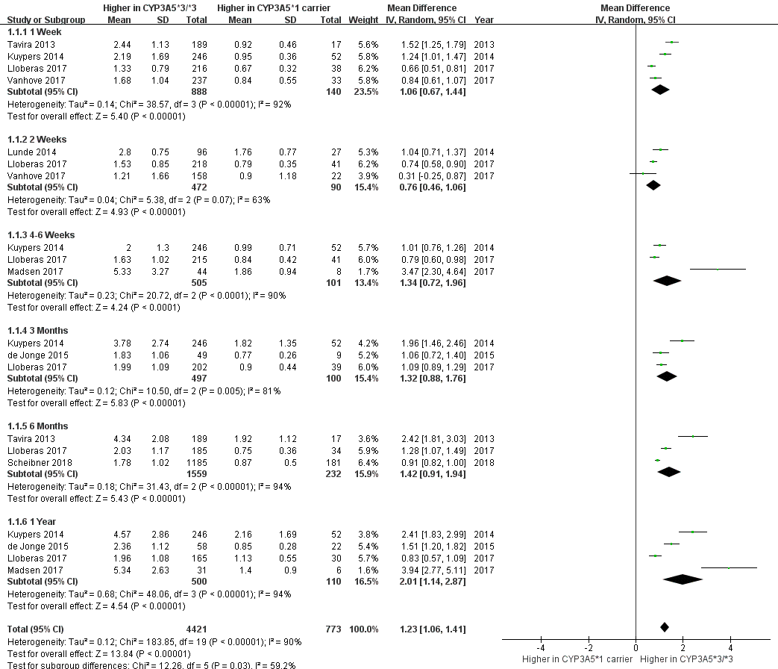

(b)
