Supplementary Material

Article Title
Elephants in the farm – changing temporal and seasonal patterns of human-elephant interactions in a forest-agriculture matrix in the Western Ghats, India.
Anoop NR, Siddhartha Krishnan, T. Ganesh
* Correspondence: Corresponding Author: anoop.nr@atree.org

Supplementary Figures 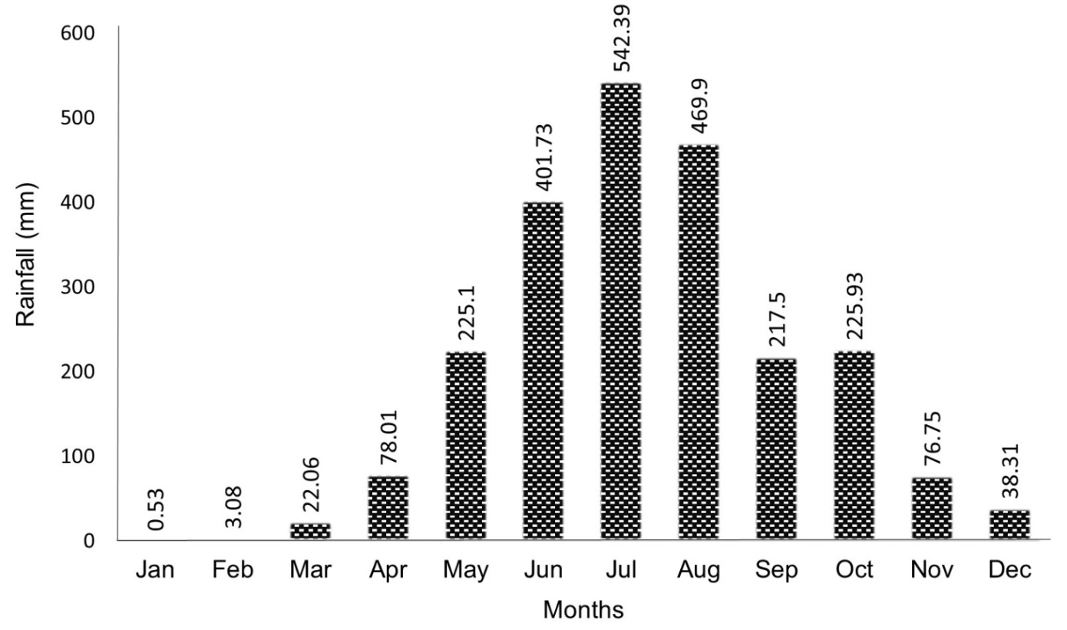
Supplementary Figure 1. Mean monthly rainfall during the study period in Wayanad.

 | Jan | Feb | Mar | Apr | May | Jun | Jul | Aug | Sep | Oct | Nov | Dec
Paddy
Plantain
Jackfruit
Mango
Coconut
Areca nut
Coffee

Emergence
Medium stage
Ripen
All stages across the seasons

Supplementary Figure 1I. The cropping calendar (major commercial and non-commercial crops attract elephants) of the main crop types in the study areas.
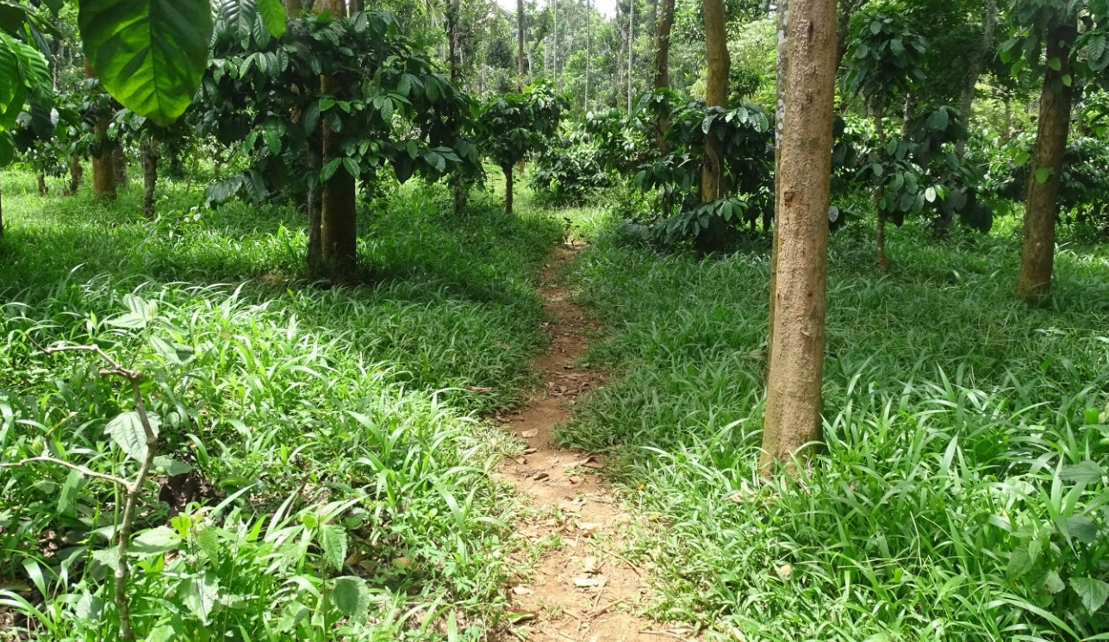
Supplementary Figure III. Permanent paths formed in the coffee plantations due to continuous use by bull elephants during jackfruit season.
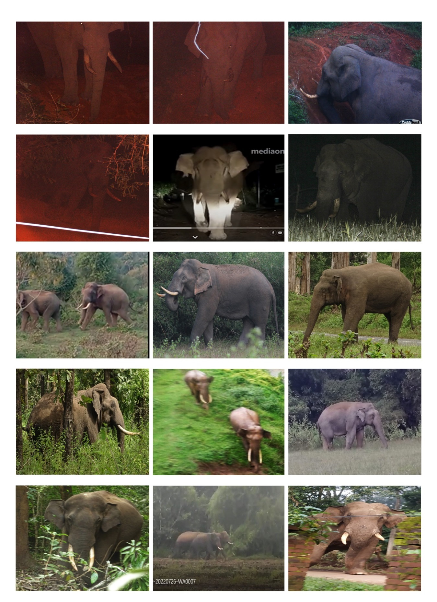
Supplementary Figure IV. Different crop-raiding elephants identified from Tholpetty and Chethalayam forest ranges during 2019 and 2020.

