Field ponding water exacerbates the dissemination of manure-derived antibiotic resistance genes from paddy soil to surrounding waterbodies

Ming-Sha Zhang ^{a,#}, Si-Zhou Liang ^{b,c,#}, Wei-Guo Zhang ^{a,c,d,e,⁎}, Ya-Jun Chang ^{b,⁎}, Zhongfang Lei ^{d}, Wen Li ^{f}, Guo-Liang Zhang ^{g}, Yan Gao ^{h}

ª School of Resources and Environmental Sciences, Nanjing Agricultural University, Nanjing 210095, China
^{b} Jiangsu Key Laboratory for the Research and Utilization of Plant Resources, Institute of Botany, Jiangsu Province and Chinese Academy of Sciences (Nanjing Botanical Garden Memorial Sun Yat-Sen), Nanjing 210014, China
^{c} School of the Environment and Safety Engineering, Jiangsu University, Zhenjiang 212013, China
^{d} School of Life and Environmental Sciences, University of Tsukuba, Tsukuba 305-8577, Japan
^{e} Jiangsu Key Laboratory for Food Quality and Safety-State Key Laboratory Cultivation Base , Ministry of Science and Technology, Nanjing 210014, China
^{f} School of Life Sciences, Nanjing University, Nanjing 210093, China
^{g} Huaiyin Institute of Technology, Huaian 223001, China
^{h} Institute of Agricultural Resources and Environment, Jiangsu Academy of Agricultural Sciences, Nanjing 210014, China

# These authors contributed equally to this article
⁎ Corresponding author, Wei-Guo Zhang, Institute of Agricultural Resources and Environment, Jiangsu Academy of Agricultural Sciences, Nanjing 210014, China. weiguozhang@jaas.ac.cn; Ya-Jun Chang, Jiangsu Key Laboratory for the Research and Utilization of Plant Resources, Institute of Botany, Jiangsu Province and Chinese Academy of Sciences (Nanjing Botanical Garden Memorial Sun Yat-Sen), Nanjing 210014, China. changyj@cnbg.net.

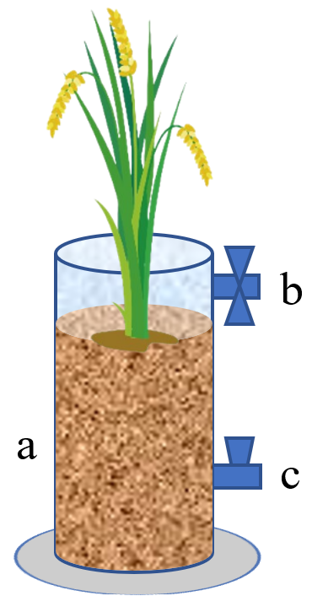

Fig. S1. The experimental equipment used to conduct pot experiments. The bottom area and depth of this equipment were 483 cm² and 30 cm, respectively. a, plastic tube made from methyl methacrylate; b, the tap used to collect field ponding water; c, the tap used to collect paddy soil. When sampling the field ponding water, the tap b was opened. When sampling the paddy soil, the tap c was opened and a spoon with a long handle was used to stick into and grab the paddy soil.

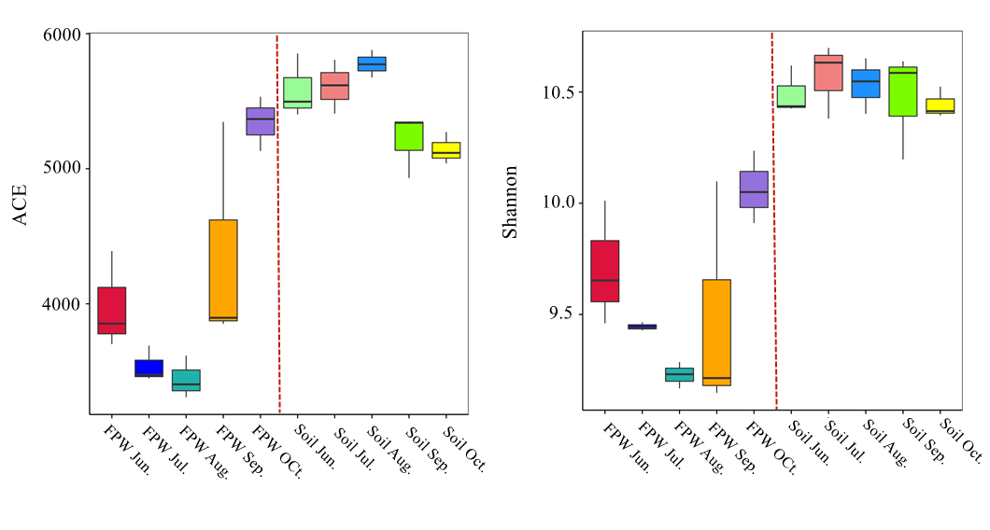 Fig. S2. Alpha diversity (ACE and Shannon) of microbial community in paddy soil and field ponding water. FPW, field ponding water.

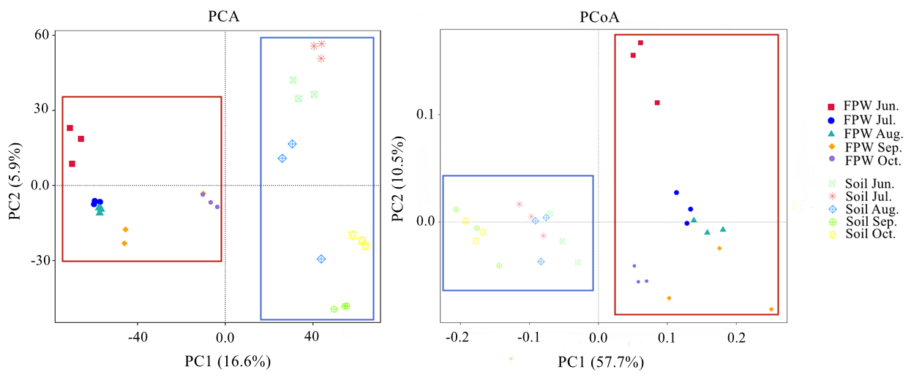
Fig. S3. The cluster analysis of microbial community (PCA and PCoA) basing on beta diversity indexes in paddy soil and field ponding water. FPW, field ponding water.

Table S1. Information of the ARGs detected in the commercial chicken manure and the corresponding primers. The primers of 16S rRNA was included in this table.
Number | Gene Name | Forward Primer | Reverse Primer | Classification
1 | 16S rRNA | GGGTTGCGCTCGTTGC | ATGGYTGTCGTCAGCTCGTG
2 | aac | CCCTGCGTTGTGGCTATGT | TTGGCCACGCCAATCC | Aminoglycoside
3 | aadA1 | AGCTAAGCGCGAACTGCAAT | TGGCTCGAAGATACCTGCAA | Aminoglycoside
4 | aadE | TACCTTATTGCCCTTGGAAGAGTTA | GGAACTATGTCCCTTTTAATTCTACAATCT | Aminoglycoside
5 | bla1 | GCAAGTTGAAGCGAAAGAAAAGA | TACCAGTATCAATCGCATATACACCTAA | Beta-Lactamase
6 | blaCMY | CCGCGGCGAAATTAAGC | GCCACTGTTTGCCTGTCAGTT | Beta-Lactamase
7 | catA1 | GGGTGAGTTTCACCAGTTTTGATT | CACCTTGTCGCCTTGCGTATA | Chloramphenicol
8 | catB3 | GCACTCGATGCCTTCCAAAA | AGAGCCGATCCAAACGTCAT | Chloramphenicol
9 | cmlA1-01 | TAGGAAGCATCGGAACGTTGAT | CAGACCGAGCACGACTGTTG | Chloramphenicol
10 | cmx(A) | GCGATCGCCATCCTCTGT | TCGACACGGAGCCTTGGT | Chloramphenicol
11 | ermB | TAAAGGGCATTTAACGACGAAACT | TTTATACCTCTGTTTGTTAGGGAATTGAA | MLSB
12 | ermC | TTTGAAATCGGCTCAGGAAAA | ATGGTCTATTTCAATGGCAGTTACG | MLSB
13 | ermF | CAGCTTTGGTTGAACATTTACGAA | AAATTCCTAAAATCACAACCGACAA | MLSB
14 | mepA | ATCGGTCGCTCTTCGTTCAC | ATAAATAGGATCGAGCTGCTGGAT | Multidrug
15 | mexF | CCGCGAGAAGGCCAAGA | TTGAGTTCGGCGGTGATGA | Multidrug
16 | tetPB-01 | ACACCTGGACACGCTGATTTT | ACCGTCTAGAACGCGGAATG | Tetracycline
17 | tetT | CCATATAGAGGTTCCACCAAATCC | TGACCCTATTGGTAGTGGTTCTATTG | Tetracycline
18 | tnpA-01 | CATCATCGGACGGACAGAATT | GTCGGAGATGTGGGTGTAGAAAGT | Transposase
19 | tnpA-02 | GGGCGGGTCGATTGAAA | GTGGGCGGGATCTGCTT | Transposase

