Determination of Phytochemicals by UPLC-Q/TOF-MS/MS
Peak 4 with the formula C₁₃H₁₆O₈ was identified as salicylic acid 2-O-β-D-glucoside due to the molecular ions at m/z 299 [M-H]-, accompanied by a characteristic fragment at m/z 137 [M-H-162]- from the loss of a glucose reside as previously reported [1]. Compared to peak 5 (1-O-caffeoyl-β-D-glucoside) that absorbed at 330 nm, peak 6 and peak 7 had similar absorbance spectra with λ_{max} at 314 nm. Based on the MS/MS analysis in negative mode, compound 6 and compound 7 exhibited same molecular ion at m/z 325 and produced fragment ions at m/z 163 (loss of a hexose), 145, 117, and 59, which is characteristic for 1-O-(4-Coumaroyl)-β-D-Glucose and its isomer. The identification of the molecule was also found to be consistent with published data [2].
Flavonoids, especially flavone C-glycosides, are the major active constituents of D. officinale. Flavone C-glycoside, which was different from flavone O-glycoside, usually produces neutral loss of characteristic fragments of 90 Da, 120 Da and 150 Da [2]. Fifteen flavone C-glycosides were identified in this study (compounds 9, 10, 11, 12, 14, 15, 17, 18, 19, 20, 21, 22, 26, 29, and 30). As shown in Table 1, though compounds 10 and 20 exhibited similar molecular ions at m/z 593 [M-H]-, compound 10 produced extra fragment ions at m/z 473 [(M-H)-120]- and 353 [(M-H)-120]-, indicating losses of glucose residues at the 6-position and 8-position [2]. Thus compounds 10 was apigenin-6,8-di-C-glucoside, also known as vicenin-2, which was further confirmed with authentic standards. Compound 20 was characterised as glucosyl-vitexin, owing to the direct loss of 162 Da and an aglycone radical ion at m/z 431. Fragment ions at m/z 311([M-H-162-120]-) suggested a hexose residue was substituted in compound 20, which was in accordance with reported data [3]. The peaks 14, 17, 19, and 21 exhibited the similar molecular ions at m/z 563 [M-H]−. Compounds 14, 17, 19, and 21 generated the similar fragment ions at m/z 383 and 353, which were characteristic of apigenin-6, 8-di-C-glucosides. For the fragment ion m/z 503 [(M-H)-60]−,m/z 473 [(M-H)-90]− and m/z 443 [(M-H)-120]−, suggesting a glucose and pentose residue at the 6-position and 8-position optionally. By comparing to the fragmentation of the reference standards and the published data [2; 4], the compound corresponding to peaks 14, 17, 19, and 21 were proposed as apigenin-6-C-β-D-xyloside-8-C-β-D-glucoside (also known as vicenin-1), apigenin 6-C-β-D-glucoside-8-C-α-L-arabinoside (also known as schaftoside), apigenin-6-C-β-D-glucoside-8-C-β-D-xyloside (also known as vicenin-3) and apigenin 6-C-β-D-glucoside-8-C-β-L-arabinoside (also known as neoschaftoside), respectively. A typical MS spectrogram fragmentation mechanism for flavonoid disaccharide C-glycoside such as schaftoside was shown as fig 6. Compound 22 produced the molecular ion at m/z 533 [M-H-]−, the fragment ion at m/z 443 [(M-H)-90]− and m/z 383 [(M-H)-90-90]− suggested a 6,8-di-C-pentose substitution pattern. Based on literature data [5]and comparison to reference, compound 22 was confirmed to be apigenin-6-C-β-D-xyloside-8-C-α-L-arabinoside. Applying a similar method, compound 26 was tentatively assigned to be apigenin-6-C-α-L-arabinoside-8-C-β-D-xyloside by comparing with authentic standard and examining the known flavonoids in different parts of D. officinale. Both compounds 29 and 30 exhibited same molecular ion at m/z [M+H]+ 565, and possessed same characteristic fragment ion at m/z 385 [(M+H)-180]+, which implied the loss of a glucose reside. Thus, peaks 29 and 30 were deduced as apigenin-6-C-α-L-arabinosyl-(1→2)-O-β-D-glucoside and apigenin-8-C-glucosyl-(1→2)-α-L-arabinoside, respectively [5]. Compounds 9, 11, 12, 15, and 18 were all preliminarily identified as luteolin C-glycosides. MS spectrum of 18 showed [M-H]- ion at m/z 447, and MS/MS fragment ions appeared at m/z 357 and 327, corresponding to [M-H-90]- and [M-H-120]- ions. By comparing with MS of a reference standard and previously reported data, compound 18 was identified as luteolin-6-C-β-D-glucoside [6; 7]. Compared with reference standards, compounds 9, 11, and 15 were assigned to be luteolin-6-C-β-D-glucoside-8-C-β-D-galactoside, luteolin-6-C-β-D-xyloside-8-C-β-D- glucoside and luteolin-6-C-β-D-glucoside-8-C-β-D-xyloside. Compound 12 has same [M-H]- ion at m/z 579 and similar MS/MS fragment ions with compounds 11 and 15. Consequently, compound 12 can just be tentatively deduced as isomer of luteolin-6-C-xyloside-8-C-glucoside in the absence of a standard.
Flavone O-glycoside was also a prominent flavonoid in DOF extract. Compounds 8, 16, 23, 24, 25, 27, and 33 were assigned to be quercetin glycosides by their product ions at m/z 300 and m/z 301 in negative MS2 spectra. The kinds of sugars conjugated with flavonoid aglycone are easily assigned by their fragment ion information in MS² spectrum, which result from the losses of 162 Da for a hexose (a glucose or a galactose), 146 Da for a rhamnose, and 132 Da for a pentose (an apiose, an arabinose, or a xylose) or 324 Da for a sophoroside residue. Compared with the standards, compounds 16, 23, and 24 were determined to be quercetin-3-O-sophoroside, quercetin-3-O-rutinoside (rutin) and quercetin 3-O-β-D-glucoside (isoquercetrin), respectively. Compound 8 gave a molecular ion [M-H]- (m/z = 771), and fragments of 609, 463, and 301was attributed to the loss of [M-H-162], [M-H-308] and [M-H-162-308]- units, fitting the loss of glucose, rutinose, and both, respectively. MS spectrum of compound 23 showed the [M-H]- ion at m/z 609, which was less 162 Da than that of compound 8. Compound 23 possessed the similar MS/MS fragments at m/z 463 and 301. As a result, compound 8 and 23 was tentatively assigned to be quercetin 3-O-glucosyl-rutinoside and quercetin-7-O-rutinoside. Compound 27 produced [M-H-]− at m/z 549 and fragment ions at m/z 505, 463, 301, 300, 271, and 255 which was consistent with previous literature [8].Thus, compound 27 was tentatively proposed as quercetin-3-O-(6''-malonyl-glucoside). The ion at 505 indicated loss of CO₂. Ion at 463 was the result of loss of a neutral fragment malondiacyl group with 86 Da. Molecular ion 549 lost the neutral malonyl-glucose fragment of 248 Da to form quercetin ion fragment m/z 301. Fragment ion 255 was produced by the loss of H₂O and CO from 301 fragment ion. Similar to compound 27, compound 33 displayed the [M-H]- ion at m/z 506, which was less 44 Da than that of compound 27. Compound 33 was then tentatively deduced as quercetin 3-O-(6''-acetyl-glucoside). Compounds 28 and 31 was identified as kaempferol-3-O-rutinoside and kaempferol-3-O-glucoside (also known as astragalin). Thus, compound 34 may be malonyl-glucoside of kaempferol, which presented similar fragmentation pathway to that of compound 27. So, compound 34 was tentatively identified as kaempferol 3-O-(6′′-malonyl-glucoside). Compared with the standard, compound 32 deprotonated molecule [M-H]- at m/z 477 and was identified as isorhamnetin-3-O-glucoside. Similarly, compound 13 lost C₁₂H₂₀O₉ to yield the ion of aglycone at m/z 315. Additionally, the product ion at m/z 357 was generated by the cleavage of glycosyl [9]. Compounds 13 was tentatively assigned to be isorhamnetin-3-O-neohesperidoside.
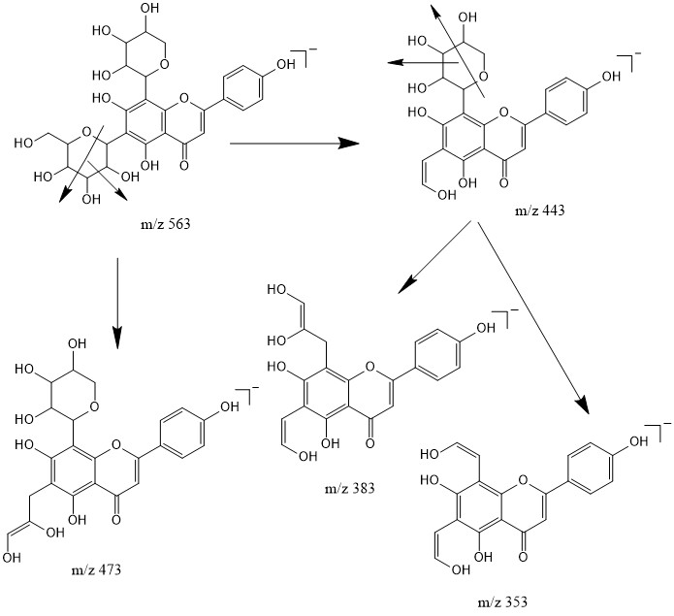
Supplementary Figure 1. MS fragmentation mechanism proposed for apigenin 8-C-α-L-arabinoside 6-C-β-D-glucoside (schaftoside).

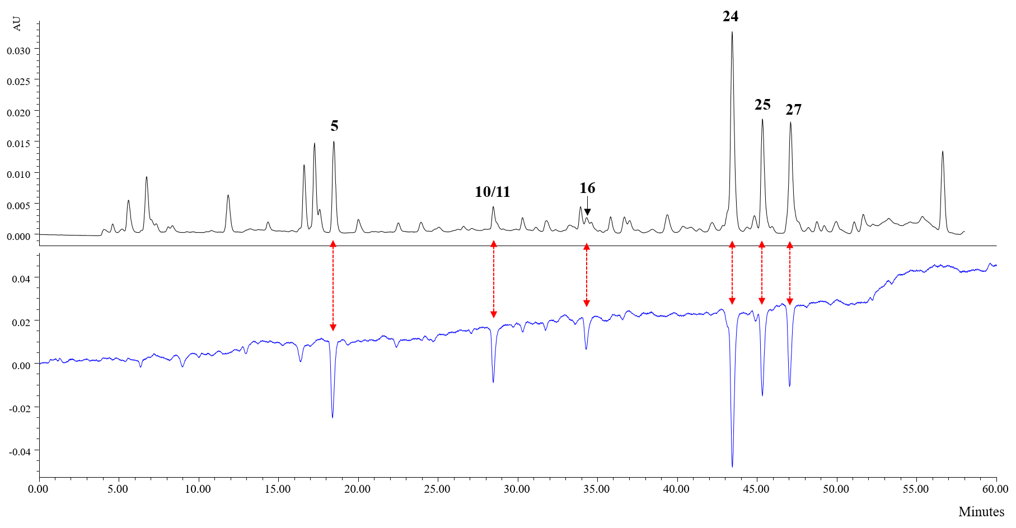
Supplementary Figure 2. UPLC-PDA-Qda traces at 254 nm and online antioxidant detection at 734 nm basic component of DOF aqueous extract. Compounds 5, 10, 11, 16, 24, 25, and 27 was 1-O-caffeoyl-β-D-glucoside, vicenin-2, luteolin-6-C-β-D-xyloside-8-C-β-D-glucoside, quercetin-3-O-sophoroside, rutin, isoquercitrin, and quercetin 3-O-(6’’-O-malonyl)-β-D-glucoside, respectively.

REFERENCES
[1] R. Shakya, and D.A. Navarre, Rapid screening of ascorbic acid, glycoalkaloids, and phenolics in potato using high-performance liquid chromatography. Journal of agricultural and food chemistry 54 (2006) 5253-60.
[2] X. Zhang, S. Zhang, B. Gao, Z. Qian, J. Liu, S. Wu, and J. Si, Identification and quantitative analysis of phenolic glycosides with antioxidant activity in methanolic extract of Dendrobium catenatum flowers and selection of quality control herb-markers. Food research international (Ottawa, Ont.) 123 (2019) 732-745.
[3] Z. Ren, X. Ji, Z. Jiao, Y. Luo, G.Q. Zhang, S. Tao, Z. Lei, J. Zhang, Y. Wang, Z.J. Liu, and G. Wei, Functional analysis of a novel C-glycosyltransferase in the orchid Dendrobium catenatum. 7 (2020) 111.
[4] Z.Y. Liang, J.Y. Zhang, and Y.C. Huang, Identification of flavonoids in Dendrobium huoshanense and comparison with those in allied species of Dendrobium by TLC, HPLC and HPLC coupled with electrospray ionization multi-stage tandem MS analyses. 42 (2019) 1088-1104.
[5] Z. Ye, J.R. Dai, C.G. Zhang, Y. Lu, L.L. Wu, A.G.W. Gong, and H. Xu, Chemical Differentiation of Dendrobium officinale and Dendrobium devonianum by Using HPLC Fingerprints, HPLC-ESI-MS, and HPTLC Analyses. 2017 (2017) 8647212.
[6] D. Chen, Y. Meng, Y. Zhu, G. Wu, J. Yuan, M. Qin, and G. Xie, Qualitative and Quantitative Analysis of C-glycosyl-flavones of Iris lactea Leaves by Liquid Chromatography/Tandem Mass Spectrometry. Molecules 23 (2018).
[7] G.Y. Xie, Y. Zhu, P. Shu, X.Y. Qin, G. Wu, Q. Wang, and M.J. Qin, Phenolic metabolite profiles and antioxidants assay of three Iridaceae medicinal plants for traditional Chinese medicine "She-gan" by on-line HPLC-DAD coupled with chemiluminescence (CL) and ESI-Q-TOF-MS/MS. Journal of pharmaceutical and biomedical analysis 98 (2014) 40-51.
[8] C. Makita, L. Chimuka, P. Steenkamp, E. Cukrowska, and E. Madala, Comparative analyses of flavonoid content in Moringa oleifera and Moringa ovalifolia with the aid of UHPLC-qTOF-MS fingerprinting. South African Journal of Botany 105 (2016) 116-122.
[9] L.Y. Du, M. Zhao, J.H. Tao, D.W. Qian, S. Jiang, E.X. Shang, J.M. Guo, P. Liu, S.L. Su, and J.A. Duan, The Metabolic Profiling of Isorhamnetin-3-O-Neohesperidoside Produced by Human Intestinal Flora Employing UPLC-Q-TOF/MS. Journal of chromatographic science 55 (2017) 243-250.

