Supplementary Material

Supplementary Figures and Tables
Table S1. Contributors of seabird survey data (n = number of transect segments) in lower Cook Inlet, Alaska.
Principal Investigator or Other Contributor | Years | n
Kathy Kuletz, Dan Cushing, Liz Labunski, Martin Renner | 2004-2018 | 2190
John F. Piatt, Suzann Speckman, Gary Drew, Greg Snedgen | 1989-2003 | 1998
Mayumi Arimitsu, John Piatt, Sarah Schoen, Caitlin Marsteller, Sam Stark | 2016-2021 | 997
Beverly Agler | 1993-1994 | 563
David Frazer | 1976 | 96
Heather Coletti | 2006-2019 | 70
Arthur Sowls | 1976 | 59
Patrick Gould | 1976-1983 | 54
Craig Harrison | 1976 | 45
Denny Zwiefelhofer | 1989 | 40
Ken Morgan, Kathleen Moore | 1996 | 35
George L. Hunt | 1979 | 20
John Wiens | 1976 | 19
Doug Forsell | 1976-1982 | 9
Anthony DeGange | 1976 | 8
Karen Henderson, Collen Handel | 1975 | 7
Patricia Baird | 1976 | 7
Robert Day | 1986-1986 | 7
James Bartonek | 1976 | 4
Scott Hatch | 1975 | 3
David Nysewander | 1978 | 2
Mark Rauzon | 1976 | 2
Juan Guzman | 1978 | 1
Total | 1975 - 2021 | 6236
For more information on Supplementary Material and for details on the different file types accepted, please see here. Figures, tables, and images will be published under a Creative Commons CC-BY licence and permission must be obtained for use of copyrighted material from other sources (including re-published/adapted/modified/partial figures and images from the internet). It is the responsibility of the authors to acquire the licenses, to follow any citation instructions requested by third-party rights holders, and cover any supplementary charges.

Supplementary Figures

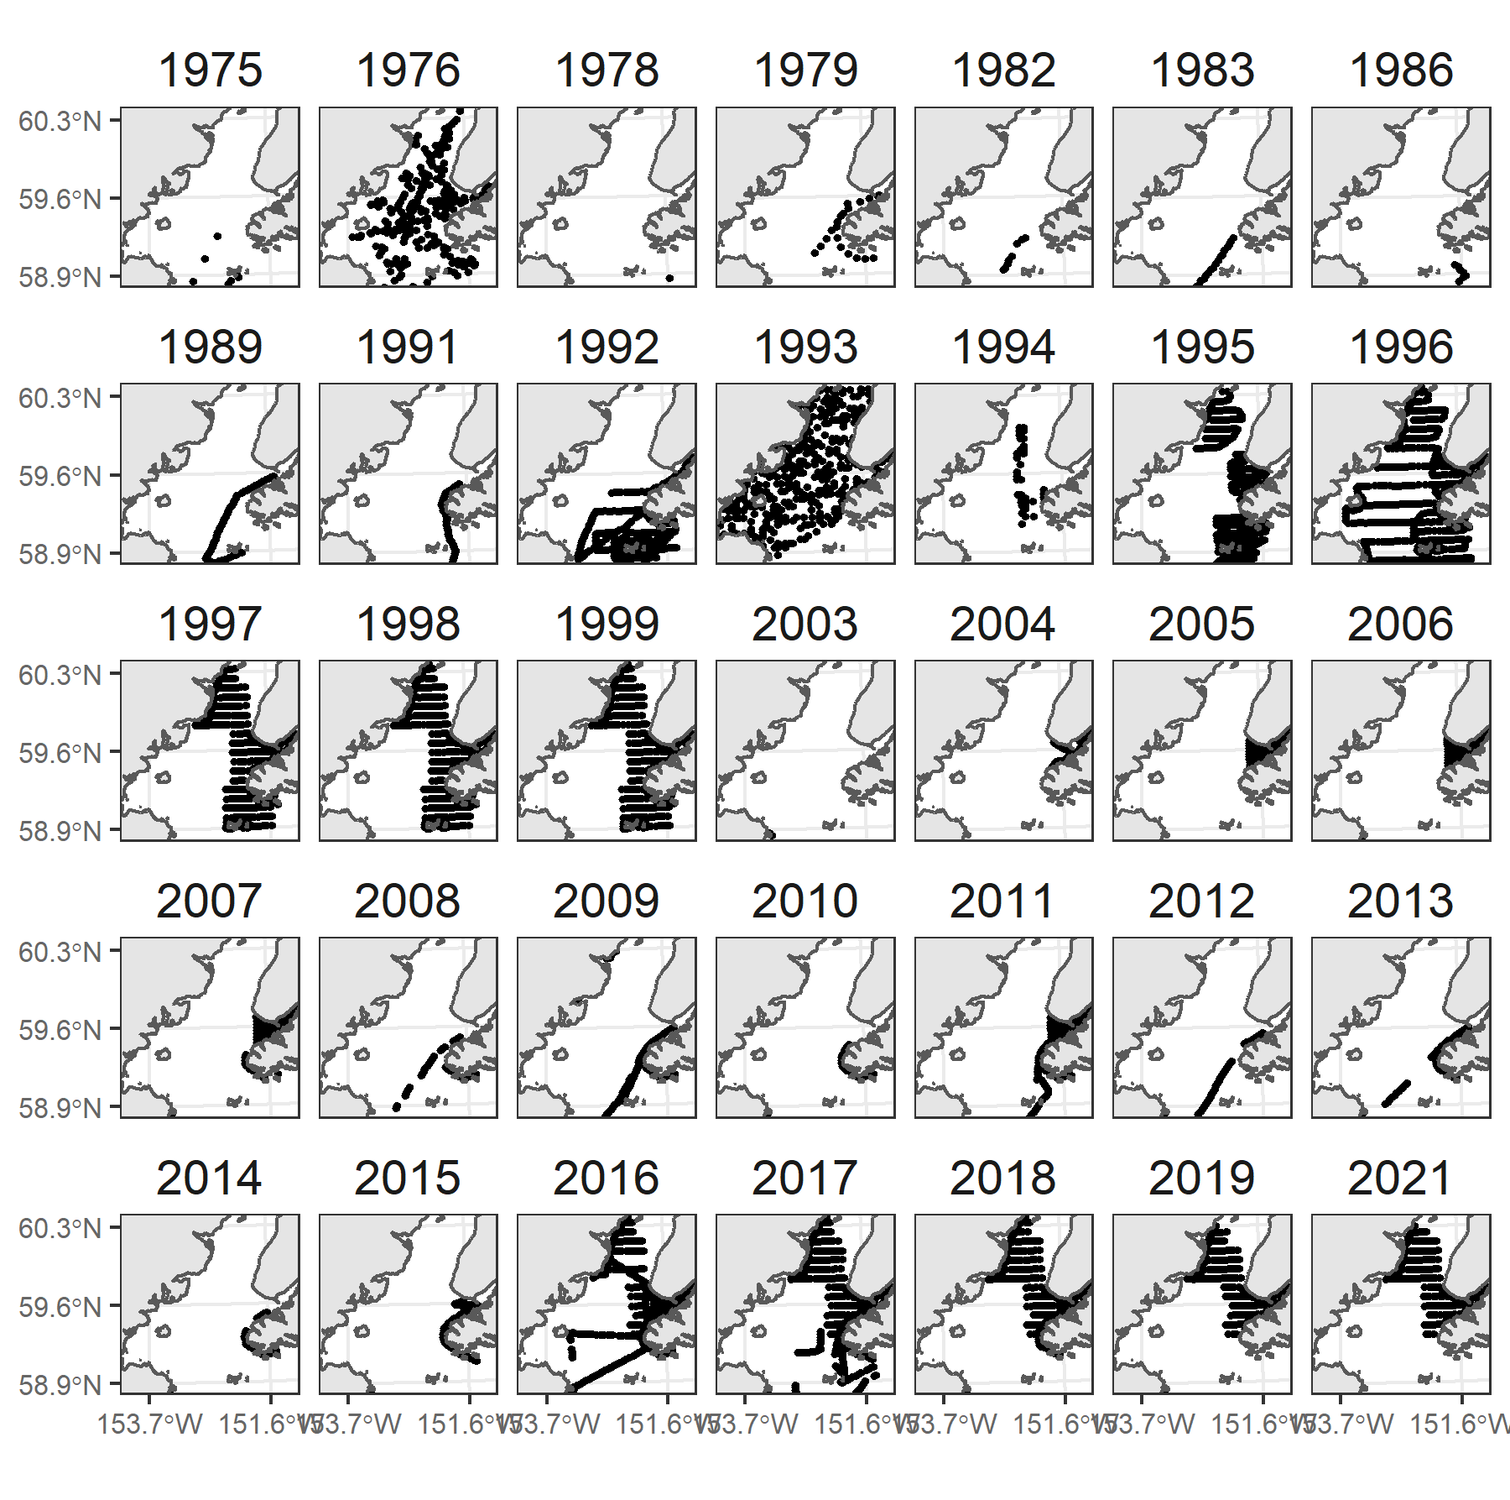
Supplementary Figure 1. Distribution of sampling effort by year in lower Cook Inlet, Alaska.

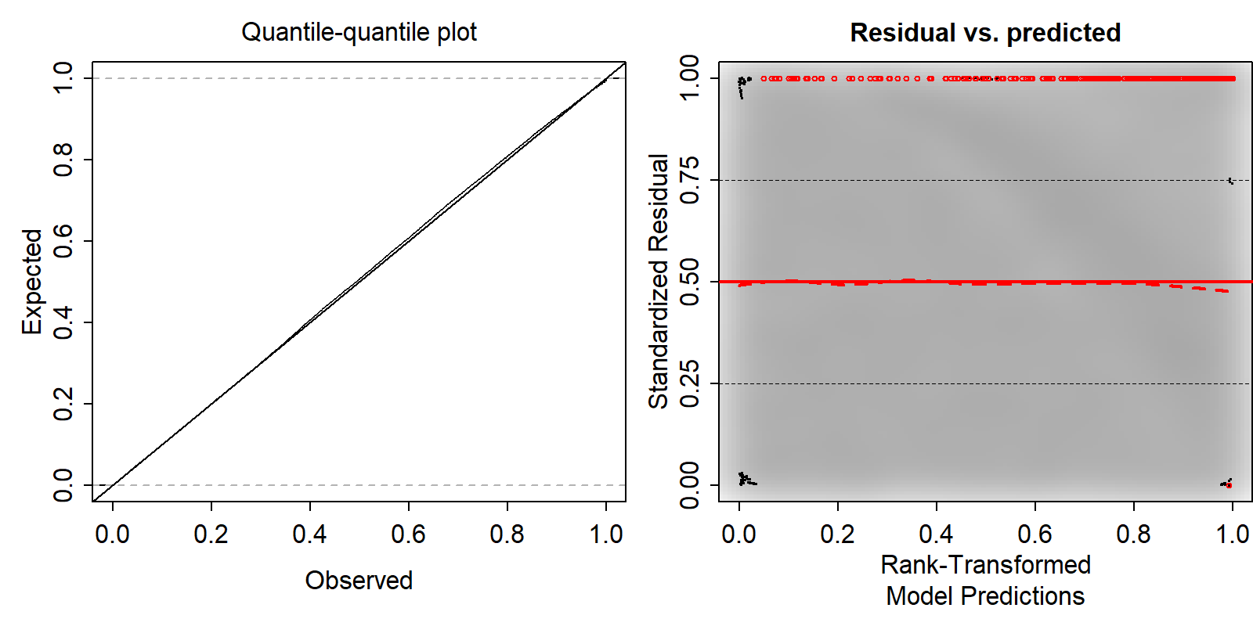
Supplementary Figure 2. Quantile residual model diagnostics of multispecies joint dynamic species distribution model of seabirds in Cook Inlet, Alaska.

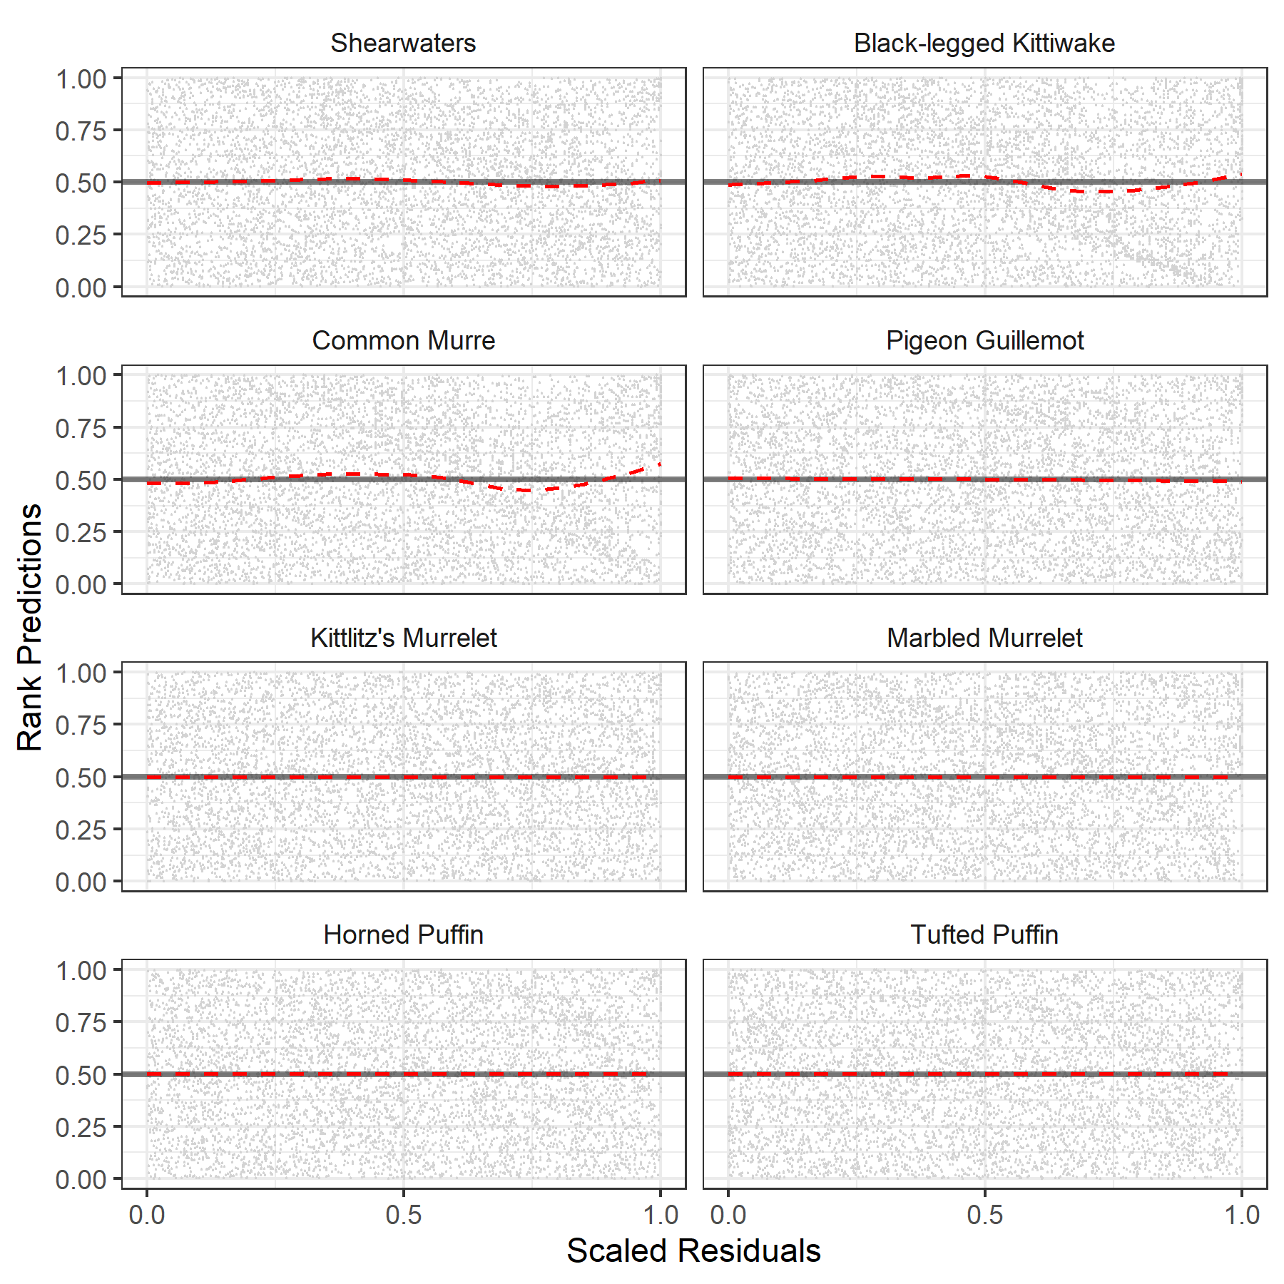
Supplementary Figure 3. Simulated DHARMa residuals of rank predictions for a joint dynamic species distribution model of seabirds in Cook Inlet, Alaska. Red dashed lines represent a GAM fit of rank predictions by scaled residuals scaled for each species.
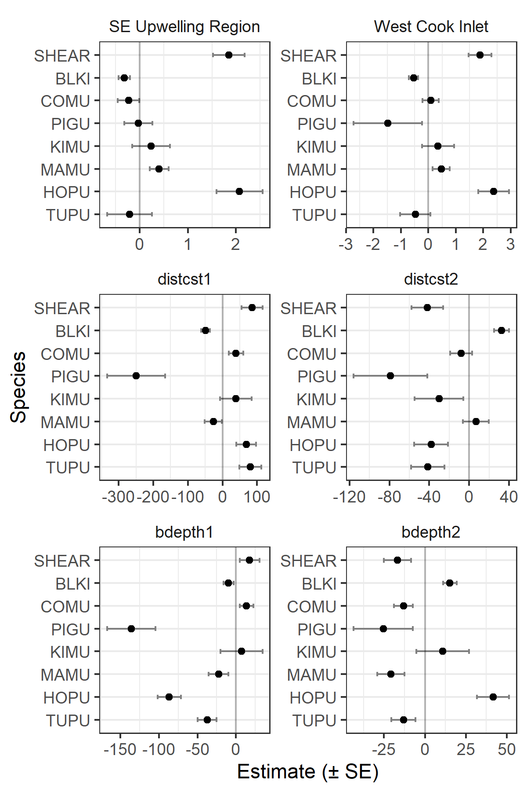
Supplementary Figure 4. Parameter estimates for habitat covariates. Abbreviations: SHEAR, dark shearwaters; BLKI, black-legged kittiwake; COMU, common murre; PIGU, pigeon guillemot; KIMU, Kittlitz’s murrelet; MAMU, marbled murrelet; HOPU, horned puffin; TUPU, tufted puffin; distcst, distance to coast; bdepth, bottom depth.
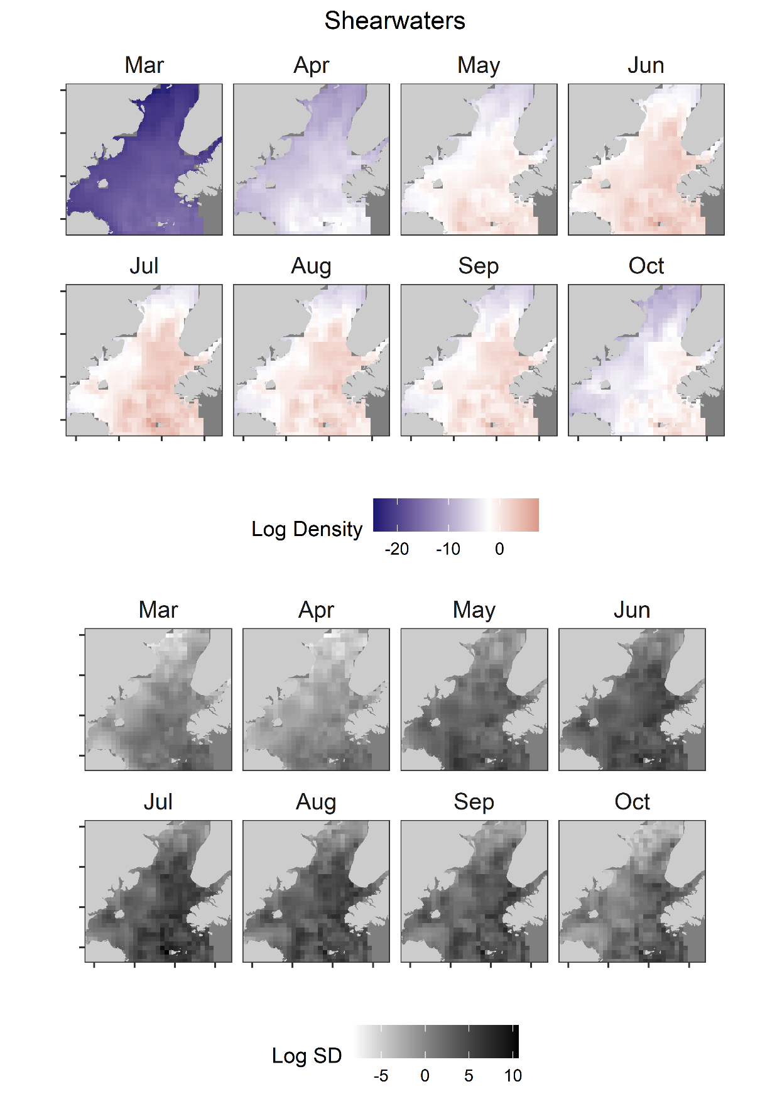
Supplementary Figure 5. Monthly predicted log density (color, median = white) and log SD (greyscale) of shearwaters in Cook Inlet, Alaska.
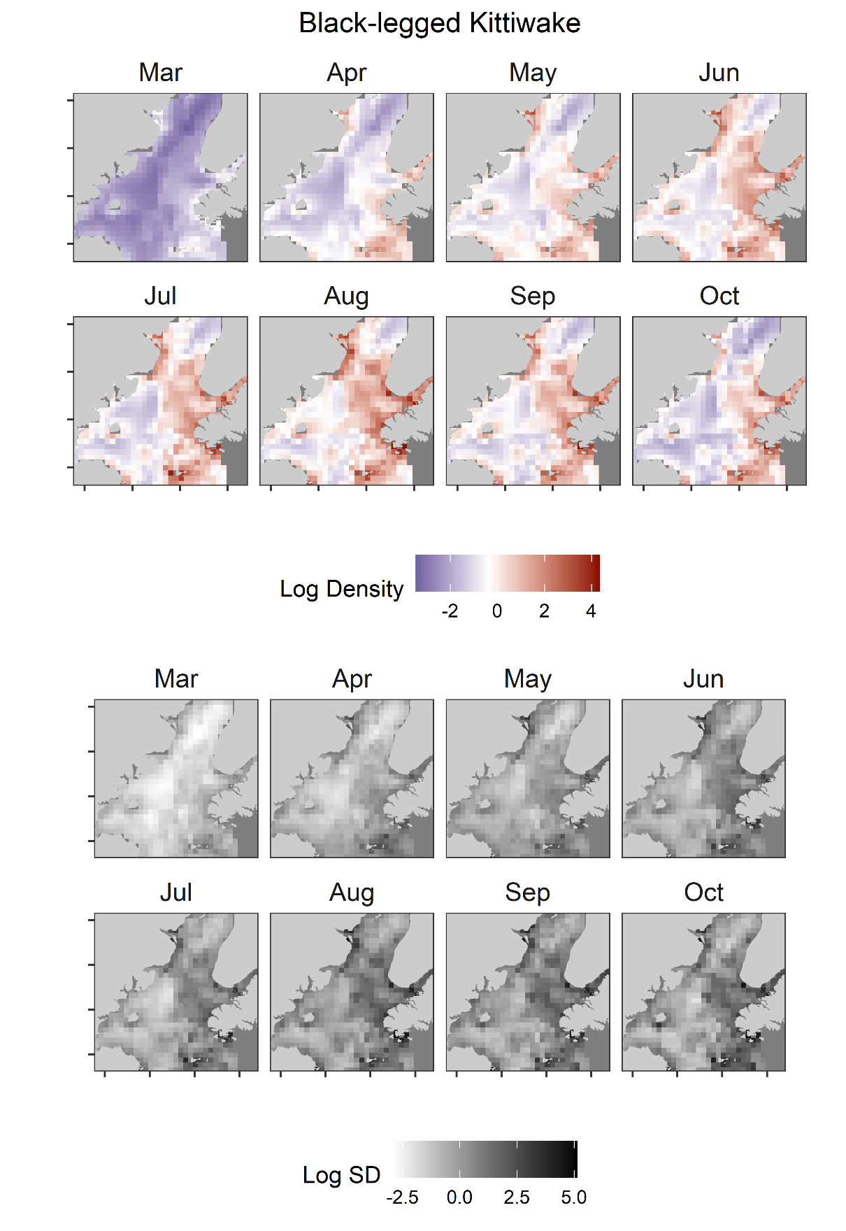
Supplementary Figure 6. Monthly predicted log density (color, median = white) and log SD (grey scale) of black-legged kittiwake in Cook Inlet, Alaska.
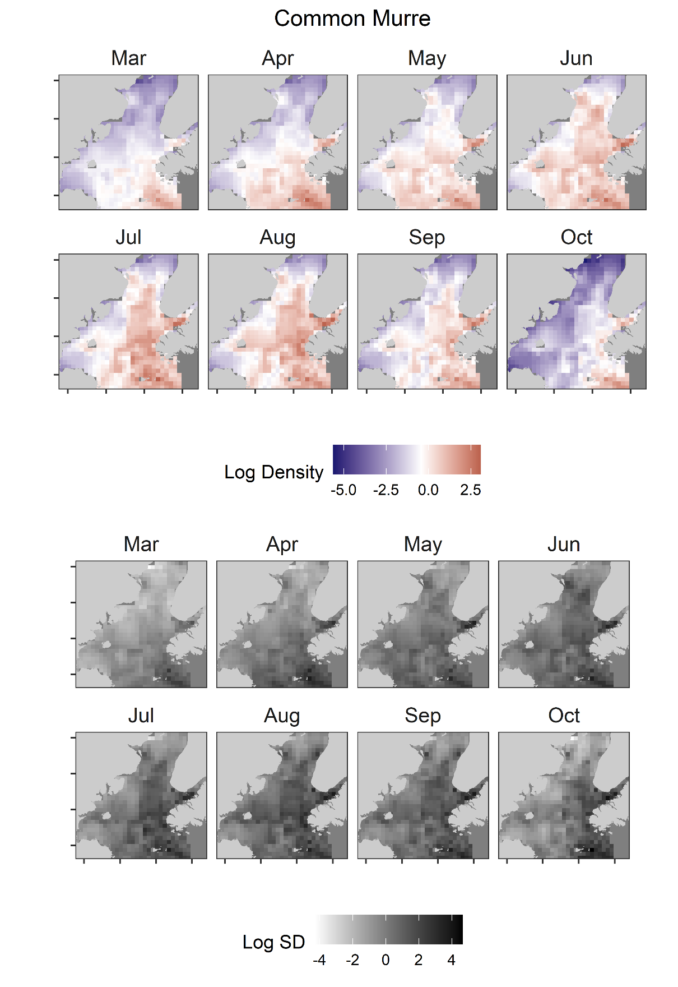
Supplementary Figure 7. Monthly predicted log density (color, median = white) and log SD (grey scale) of common murre in Cook Inlet, Alaska.
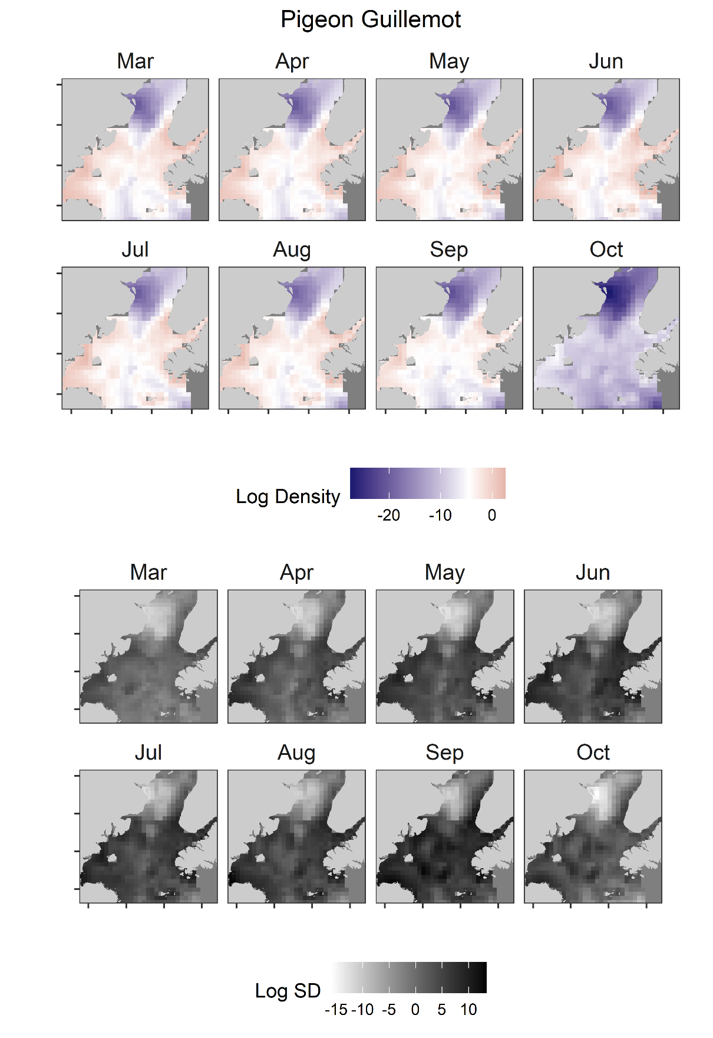
Supplementary Figure 8. Monthly predicted log density (color, median = white) and log SD (grey scale) of pigeon guillemot in Cook Inlet, Alaska.
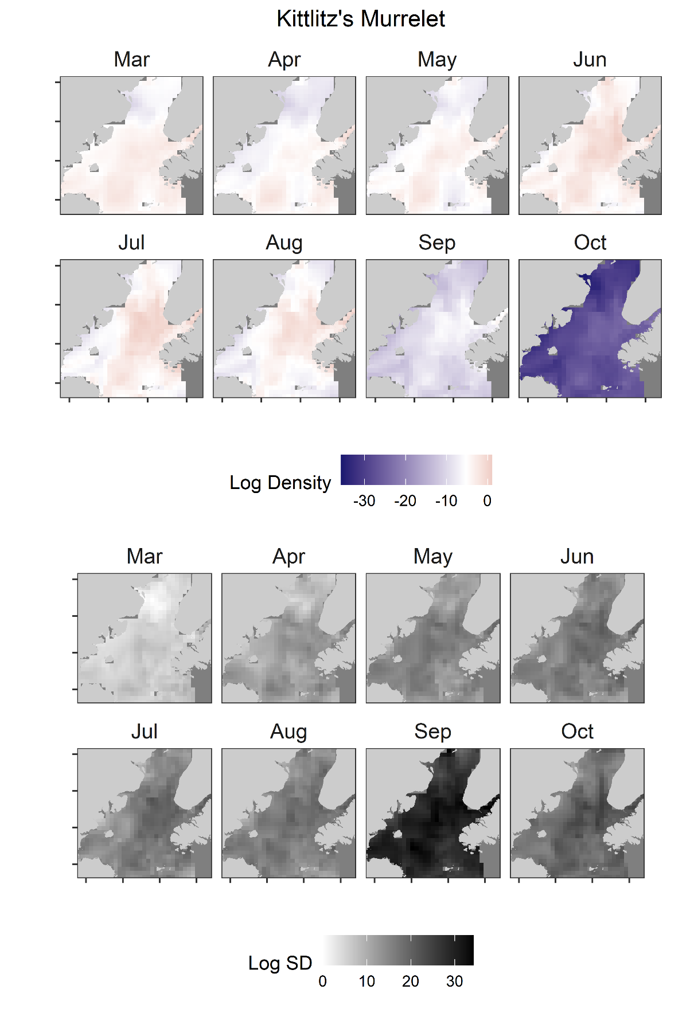
Supplementary Figure 9. Monthly predicted log density (color, median = white) and log SD (grey scale) of Kittlitz’s murrelet in Cook Inlet, Alaska.
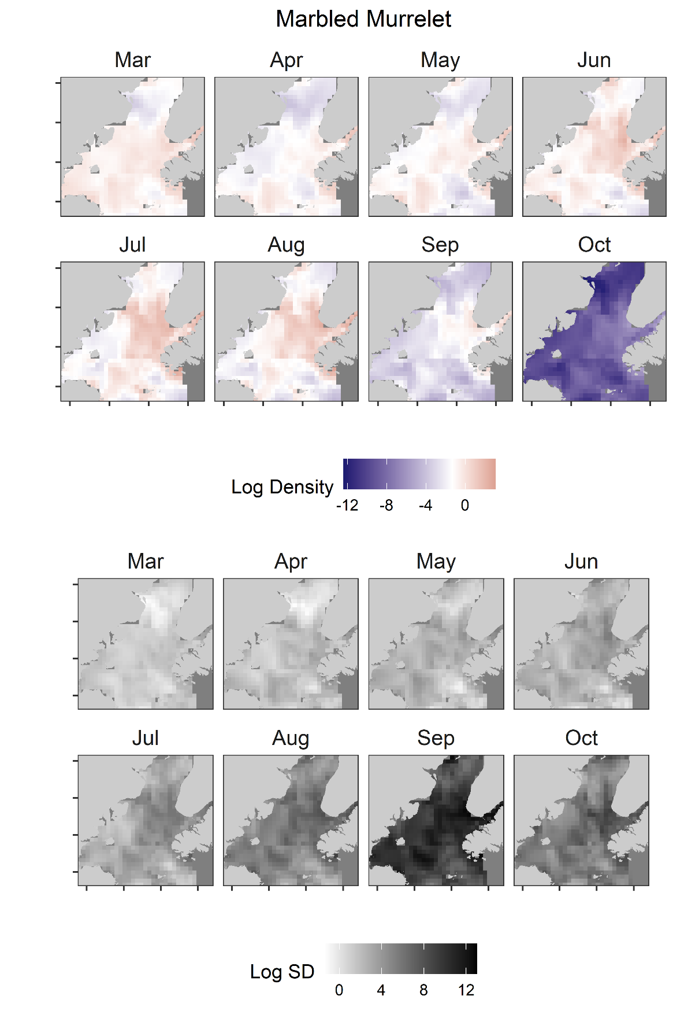
Supplementary Figure 10. Monthly predicted log density (color, median = white) and log SD (grey scale) of marbled murrelet in Cook Inlet, Alaska.
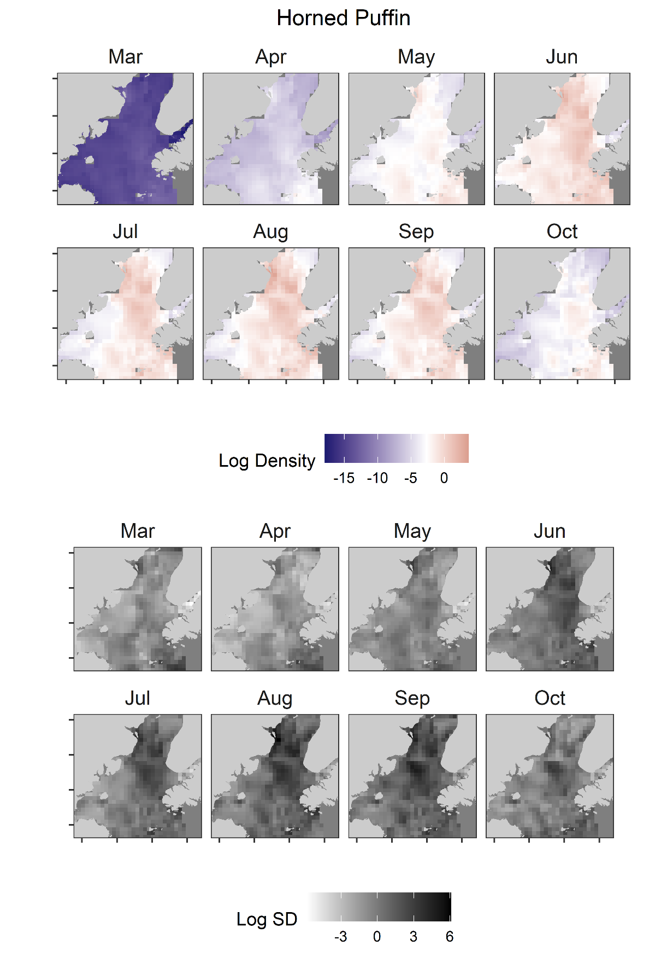
Supplementary Figure 11. Monthly predicted log density (color, median = white) and log SD (grey scale) of horned puffin in Cook Inlet, Alaska.
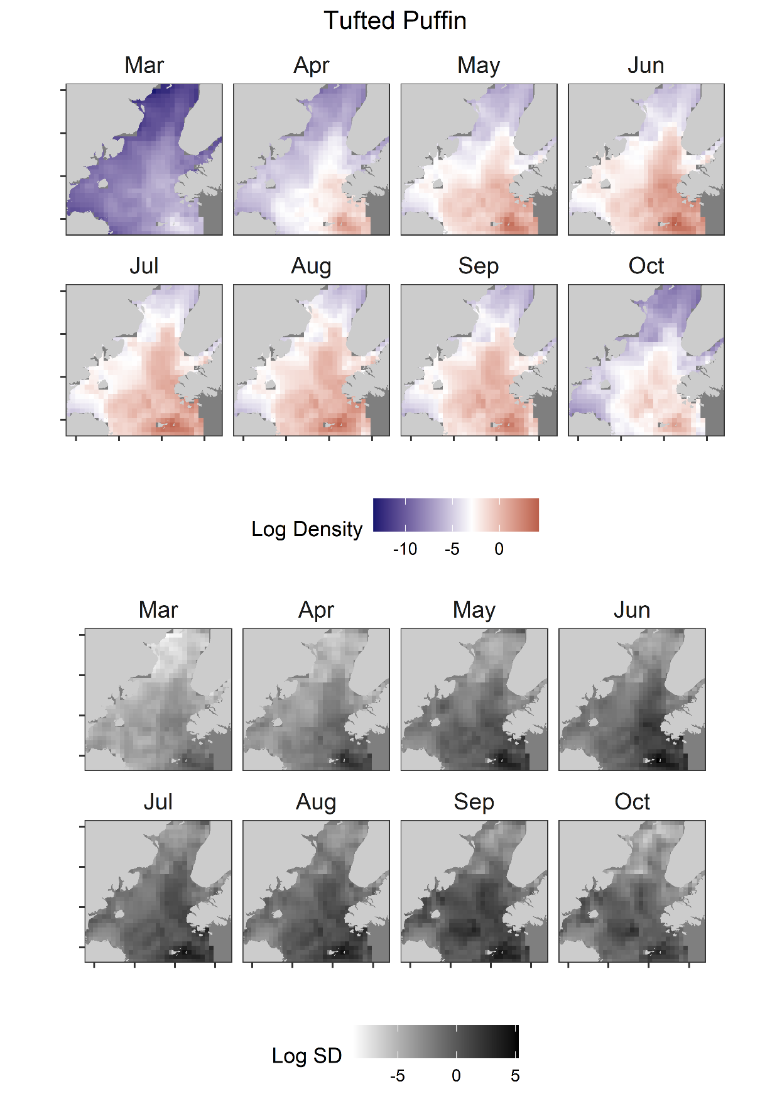
Supplementary Figure 12. Monthly predicted log density (color, median = white) and log SD (grey scale) of tufted puffin in Cook Inlet, Alaska.

