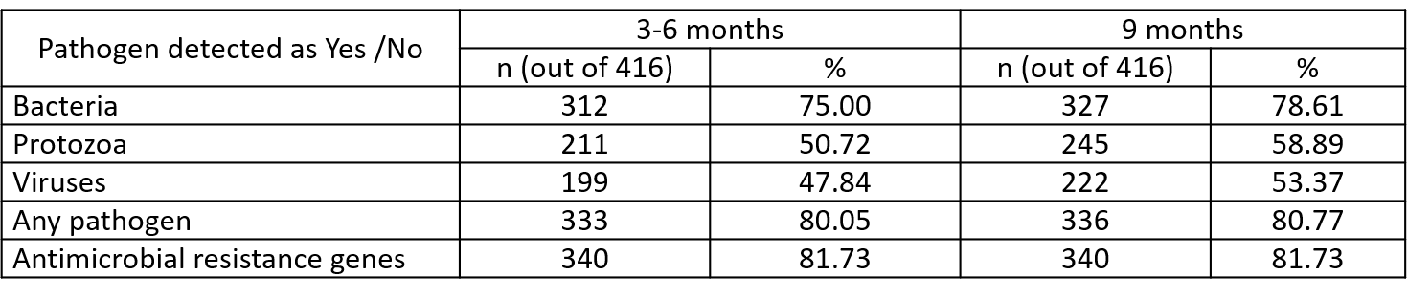

**Supplementary Table1:** Presence of enteropathogen and antimicrobial genes detected via TAC card based on Ct value cut-off.