Supplementary Material
Data source for bioinformatics
Genome sequences and annotation information were downloaded from the NCBI genome server (ftp://ftp.ncbi.nlm.nih.gov/genomes/) as follows: Burkholderia glumae BGR1, GCF_000022645.2 (Lim et al., 2009); Ralstonia solanacearum GMI1000, GCF_000009125.1 (Salanoubat et al., 2002); Xanthomonas oryzae pv. oryzae (Xoo) KACC10331, GCF_000007385.1 (Lee et al., 2005). For comparative in planta transcriptome analyses, two expression profiling datasets were downloaded from the GEO database (http://www.ncbi.nlm.nih.gov/geo/): RNA-seq library of B. glumae BGR1, GSM832378 (Kim et al., 2014); and microarray library of R. solanacearum GMI1000, GSE33657 (Jacobs et al., 2012). The B. glumae RNA-seq dataset included three independent replicates of in planta and in vitro libraries (Kim et al., 2014). From the R. solanacearum dataset, eight libraries of rich-medium and in planta conditions (full-blown disease in tomato) at 28°C were used (Jacobs et al., 2012).
RNA-seq of Xoo KACC10331
Xoo KACC10331 was incubated in peptone sucrose (PS) medium at 30°C for two days. The final concentration of the subculture was adjusted to an optical density (OD) of 0.5 at 600 nm. Cultured cells were washed twice with sterile water and resuspended in distilled water. Vegetative-stage leaves of rice (cv. Dongjin) were inoculated with the Xoo KACC10331 suspension using the leaf-clipping method. The inoculated plants were grown in a greenhouse (30°C during the day and 25°C during the night) for 10 days. The infected rice leaves were segmented in a cold room (4°C) into strips of approximately 3 cm in length and then centrifuged at 2000 × g and 4°C for 5 min in 15 ml of conical tubes (SPL Lifesciences, Pocheon, Korea) to collect in planta bacterial pellets. The pellets contained cells at a concentration of 1.0 × 10⁹ to 1.5 × 10⁹ CFU/ml and were primarily composed of Xoo KACC10331 cells. For in vitro growth, Xoo KACC10331 cultures in the PS medium were adjusted to an OD₆₀₀ of 1.0–1.5, corresponding to a concentration of 1.0 × 10⁹ to 1.5 × 10⁹ CFU/ml. The pellets were resuspended in RNAprotect™ bacteria reagent (Qiagen, Valencia, CA, USA). The experiment was conducted using three independent replicates.
Next, total RNA was extracted from in planta and in vitro pellets using an RNeasy midi kit (Qiagen), according to the manufacturer’s protocols. Residual genomic DNA was removed using an RNase-free DNase set (Qiagen). The MICROBExpress™ bacterial mRNA enrichment kit (Ambion, Austin, TX, USA) was used to remove bacterial ribosomal RNA from the total RNA samples. Libraries for RNA-seq were prepared using the Illumina TruSeq™ RNA sample prep kit (Illumina, San Diego, CA, USA) with a standard low-throughput protocol. RNA-seq was performed using the Illumina HiSeq2000 instrument at the National Instrumentation Center for Environmental Management (NICEM, Seoul, Korea).
Kyoto encyclopedia of genes and genomes (KEGG) pathway enrichment analysis
KEGG is a useful database for evaluating high-throughput sequencing results in terms of activated/inactivated biological pathways (http://www.genome.jp/kegg/). Pathway information was used to identify the biological systems induced in the non-orthologous groups of pathogens. Incomplete pathways forming a partial network (≤5 genes) were excluded to remove false positives. Each non-overlapping KEGG pathway was matched to in planta-dependent differentially expressed genes (DEGs) in the unique genome using an in-house developed python script. A hypergeometric distribution, obtained with the phyper function, was used to perform enrichment analysis for comparison with the reference gene background (Qureshi and Sacan, 2013). The formula applied for this analysis is shown below.
$$P=1-\sum_{i=0}^{m-1}{\frac{\left({m \atop i}\right)\left({N-M \atop n-i}\right) }{\left({N \atop n}\right)}}$$
where N represents the number of KEGG-annotated genes in the whole genome, and n represents the number of target genes in N. M represents the number of single pathway-annotated genes, and m represents the number of target genes in M. KEGG pathways with P ≤ 0.05 were considered to be significantly enriched.
Bacterial strains, plasmids, and growth conditions
The bacterial strains and plasmid constructs used in this study are listed in Table S7. B. glumae and Escherichia coli strains were cultivated in Luria-Bertani (LB) broth at 37°C. The R. solanacearum and Xoo strains were cultivated at 28°C in casamino acid peptone glucose and PS medium, respectively. Yeast extract dextrose CaCO₃ (YDC) medium was used for triparental mating between R. solanacearum and E. coli HB101. All liquid cultures were incubated in a shaker-incubator at 200 rpm. When required, the media were supplemented with antibiotics as follows: ampicillin (Amp), 100 μg/ml; apramycin (Apm), 100 μg/ml; cephalexin (Cp), 20 μg/ml; kanamycin (Km), 50 or 100 μg/ml; rifampin (Rif), 50 or 100 μg/ml; and tetracycline (Tc), 15 μg/ml.
Construction of mutant strains
Standard techniques were used for DNA manipulation, cloning, restriction digestion, and agarose gel electrophoresis (Sambrook and Russell, 2001). Details on the primers used for the mutagenesis experiments are provided in Table S8.
The internal regions of co-upregulated DEGs were amplified from B. glumae BGR1 and inserted into the pGEM-T Easy vector (Promega, Fitchburg, WI, USA). After sequencing to confirm the correctness of ligation, the amplified fragments were digested with EcoRI and KpnI (New England Biolabs, Ipswich, MA, USA) and inserted into the pVIK112 suicide vector (Kalogeraki and Winans, 1997). E. coli DH5α λpir competent cells were transformed with the recombinant pVIK112 plasmids and then cultured in a Km-supplemented (50 μg/ml) LB medium. The amplified plasmids were introduced into E. coli S17-1 λpir before transferring to B. glumae BGR1 using the biparental mating method. Finally, the identity of B. glumae mutants that were able to grow on a medium supplemented with two antibiotics (Km, 100 μg/ml and Rif, 100 μg/ml) was confirmed by PCR annealing to an internal sequence (Lacfuse) of the pVIK112 backbone and sequences upstream of the genes.
In R. solanacearum, the mutagenesis of protocatechuate 3,4-dioxygenase (PCD) was carried out according to previously described methods (Lee et al., 2001). Briefly, two fragments of the RS_RS07255 gene spanning upstream and downstream were separately amplified from R. solanacearum GMI1000. The nucleotide sequences between the upstream and the downstream fragments were complementary to the DNA sequences of the Km resistance gene cassette. One such cassette was amplified from the pMKm2 plasmid. The three amplified DNA fragments were mixed at an equimolar ratio and overlap extension PCR (OE-PCR) was performed to fuse the three PCR products. The fused product was cloned into pGEM-T Easy vector and subsequently subcloned into the broad-host-range pRK415 vector (Keen et al., 1988) to generate pRIRS07255. The latter was introduced into the wild-type strain by triparental mating in YDC medium, with pRK2013 acting as a helper vector. Mutants sensitive to Tc (15 μg/ml) but resistant to Km (50 μg/ml) were selected.
To construct a PCD mutant in Xoo according to Cai et al. (2017), the upstream and downstream regions of XOO_RS02315 were amplified and fused by OE-PCR. The correct PCR products were ligated into the suicide vector pK18mobsacB (Schäfer et al., 1994) using EcoRI and HindIII (New England Biolabs) digestion. Using the biparental mating method, the recombinant pXDRS02315 plasmid was introduced into the wild-type strain to generate single-crossover mutants on Km- and Cp-supplemented medium (50 μg/ml and 20 μg/ml, respectively). Next, the single-crossover mutants were incubated in a PS medium for two days before growing on a medium containing Cp (20 μg/ml) and 10% sucrose (w/v) to select double-crossover mutants. The correctness of the PCD-disrupted mutants was confirmed by PCR.
Complementation of PCD mutant strains in B. glumae and Xoo
The DNA fragments containing the BGLU_RS23755 gene (705 bp) of B. glumae and the XOO_RS02315 gene (729 bp) of Xoo were PCR amplified from the genomic DNA, using the primer sets BCRS23755_H/BCRS23755_B and XCRS02315_E/XCRS02315_B, respectively (Table S8). After sequence verification, these PCR products were excised and ligated into pRK415 and pBBR1MCS2 vectors (Keen et al., 1988; Luo and Farrand, 1999), resulting in the cloned genes being oriented in the same direction as the lac promoter of two vectors (Table S7). The complementation plasmids, pBCRS23755 and pXCRS02315, were introduced into the mutant WBI23755 and WXD02315, respectively, via the conjugation of E. coli S17-1. The appropriate transformation of the complementation plasmid was confirmed by a colony PCR technique.
Swarming motility assay
The swarming motility assay was performed on LB agar (0.5% agar, w/v). The wild-type B. glumae BGR1, FlhA mutant WBI00925, and quorum sensing (QS)-deficient mutant BGS2 were incubated at 37°C overnight in 3 ml of LB liquid medium. Thereafter, 1 ml of stationary phase culture was centrifuged at 1000 × g for 2 min and washed twice with fresh LB broth. The bacterial pellets were resuspended in 100 μl of LB broth. Each cell suspension (5 μl) was spotted on swarming assay plates. After 24 h of incubation at 37°C, the bacterial movement was assessed.
TLC assay
The level of toxoflavin production by B. glumae strains under protocatechuic acid (PCA) supplementation was determined by a TLC assay. Cultured cells (1 ml) were centrifuged at 12,000 × g for 1 min; the supernatant (500 μl) was transferred into a new tube containing 500 μl of chloroform. After vortexing on a Vortex-Genie 2 (VWR, Chicago, IL, USA), the mixture was again centrifuged at 12,000 × g for 10 min. Next, 500 μl of the infranatant was transferred to a new tube and dried in a centrifugal vaporizer (Tokyo Rikakikai, Tokyo, Japan). The solutes were dissolved in 10 μl of 80% methanol, and an aliquot of each solution was repetitively applied onto a TLC plate (Merck Millipore, Darmstadt, Germany). The TLC plates were placed in a chamber (solvent, 95:5 chloroform: methanol) for 20 min. 3UV™ multi-wavelength lamps (UVP, Upland, CA, USA) were used to examine the band patterns. To compare fluorescence intensity of band patterns, image analysis of TLC plates was conducted using the quantitative TLC (qTLC) tool following the detailed tutorial presented in Mac Fhionnlaoich et al. (2018). Assuming that the toxoflavin concentration of the wild-type strain in LB broth was 100%, the relative concentration of the band in each sample was quantified.
Quantitative real-time PCR (qPCR) analysis
PCA (1 mg/ml) was added to 1:100 dilutions of overnight cultures of B. glumae strains; the mixtures were then incubated at 37°C for 2 h. Total RNA was extracted using the RNeasy midi kit (Qiagen) and treated with RNase-free DNase (Qiagen). DNase-treated total RNA (2–2.5 μg) was used as starting material to generate cDNA with the SuperScript™ III first-strand kit (Invitrogen, Carlsbad, CA, USA). The generated cDNA was diluted to a concentration of 15–20 ng/μl in DEPC-treated water. The sequences of primers used for qPCR are listed in Table S8. Each reaction mixture was prepared as follows: TOPreal™ qPCR 2X premix (Enzynomics, Seoul, Korea), 10 μl; cDNA, 1 μl; primers, 2 μl each; and distilled water, 7 μl. qPCR analysis was performed using a Rotor-gene Q instrument (Qiagen) with the following protocol: 10 min at 95°C, followed by 50 cycles of PCR (95°C for 10 s, 60°C for 15 s, and 72°C for 20 s). The relative transcription levels were determined using the 2^{-ΔΔCt} method with the 16S rRNA gene for normalization.
SUPPLEMENTARY FIGURES
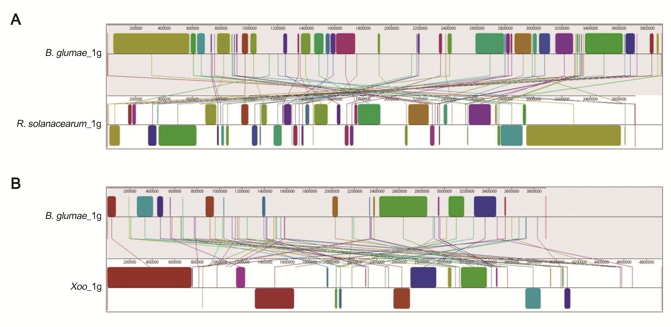
Figure S1. Genome rearrangements among chromosome 1 replicons of the three pathogens
The chromosome 1 replicon of B. glumae BGR1 was used as a reference. A Mauve was used to align the reference sequence to the chromosome replicons of (A) R. solanacearum GMI1000 and (B) Xoo KACC10331. Colored blocks represent similarity profiles within the genome sequence, denoted as locally collinear blocks (LCBs). The highly homologous LCBs between pathogens are labeled with identical colors. LCBs below the central line of each pathogen indicate regions in the reverse complement orientation.
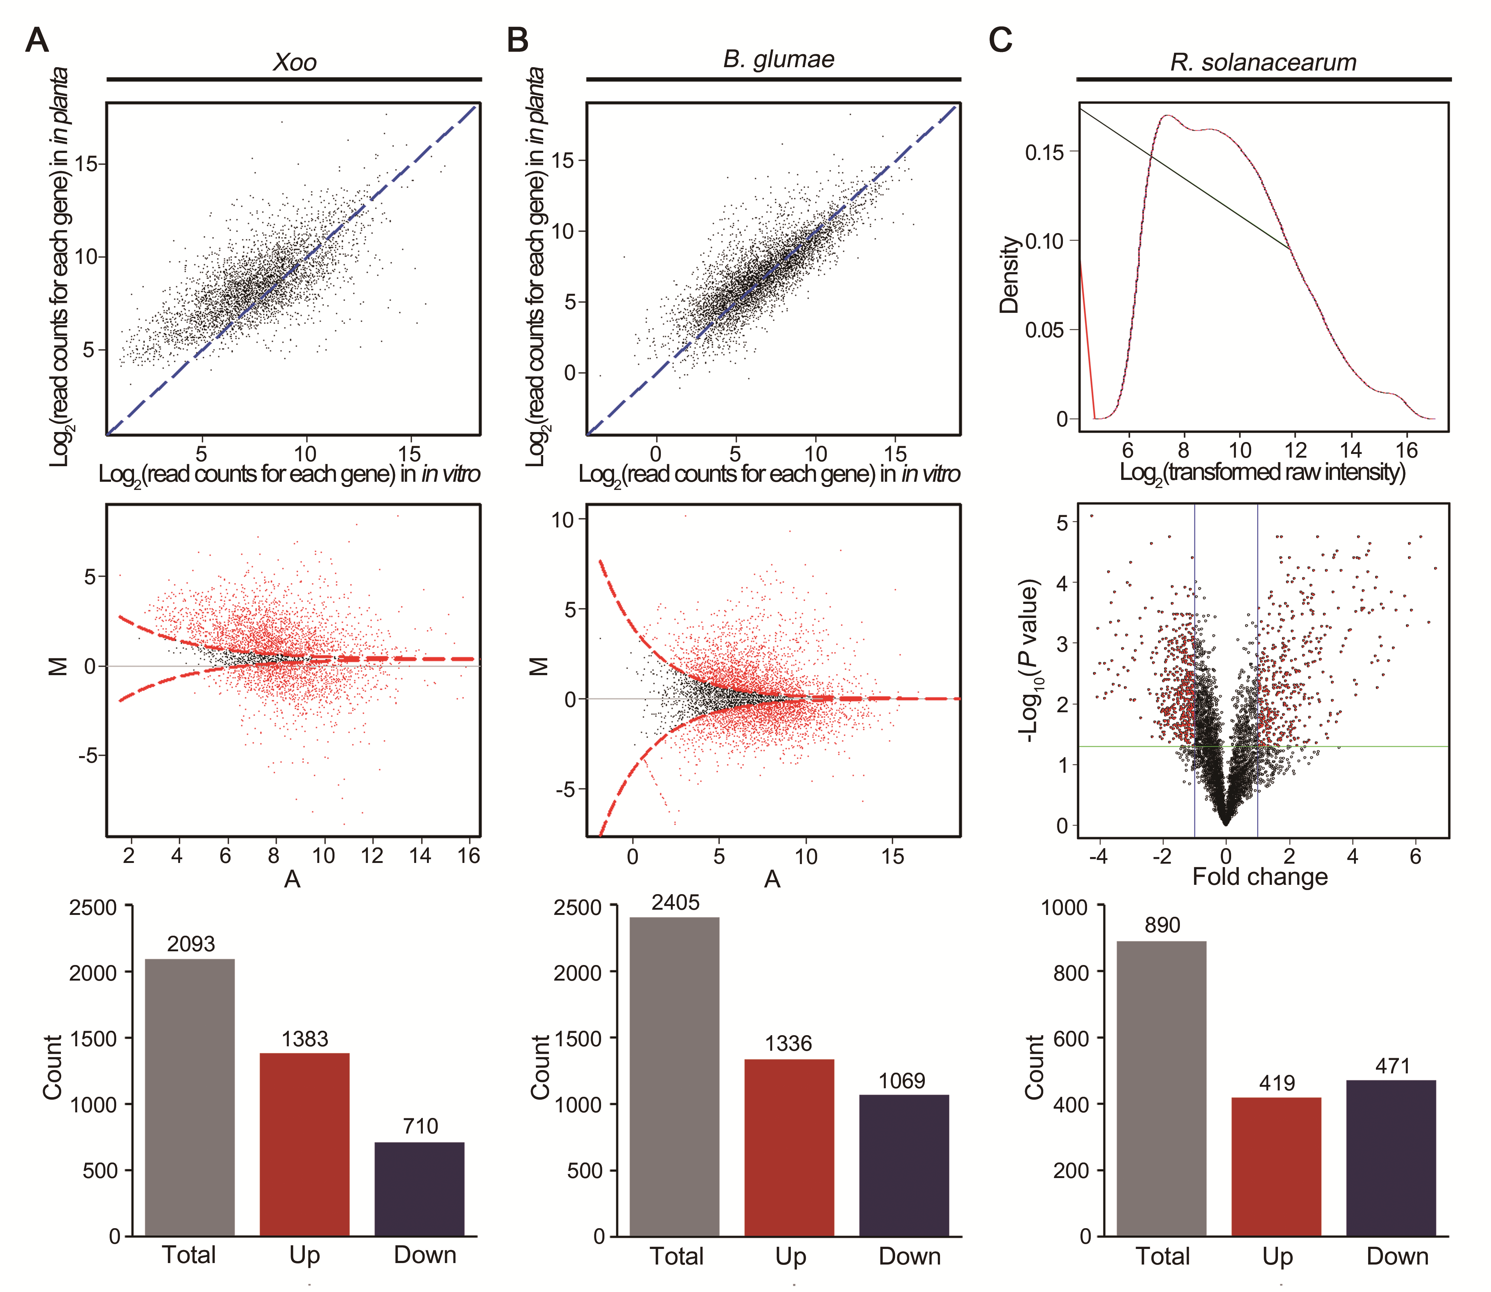
Figure S2. Overview of DEGs of in planta transcriptomes
The distribution of expressed genes in (A) Xoo and (B) B. glumae is represented in a scatterplot and MA-plot. The scatterplot depicts the comparison of gene expression levels, expressed as normalized read counts, between in vitro (x-axis) and in planta (y-axis) conditions. Red points in the MA-plot reflect significant differences between conditions with a false discovery rate (FDR) < 0.05 as determined by the MARS method. (C) In R. solanacearum, a density plot illustrates the distribution of gene expression levels in the color channels of each array. The expression intensity of genes is plotted on the x-axis and the density values on the y-axis. The log₂(in planta/in vitro) and their corresponding –log(P-value) of all genes were taken for the construction of a volcano plot. Black dots denote genes that have not changed significantly. The horizontal green line and vertical blue line depict the cut-off values for the fold changes and P-value, respectively. In all three pathogens, the same criteria of an FDR < 0.05 and log₂(in planta/in vitro) ≥ 1 were used for DEG identification. Bar charts at the bottom row illustrate the distribution of DEGs. Red and blue bars denote the number of upregulated and downregulated genes, respectively.
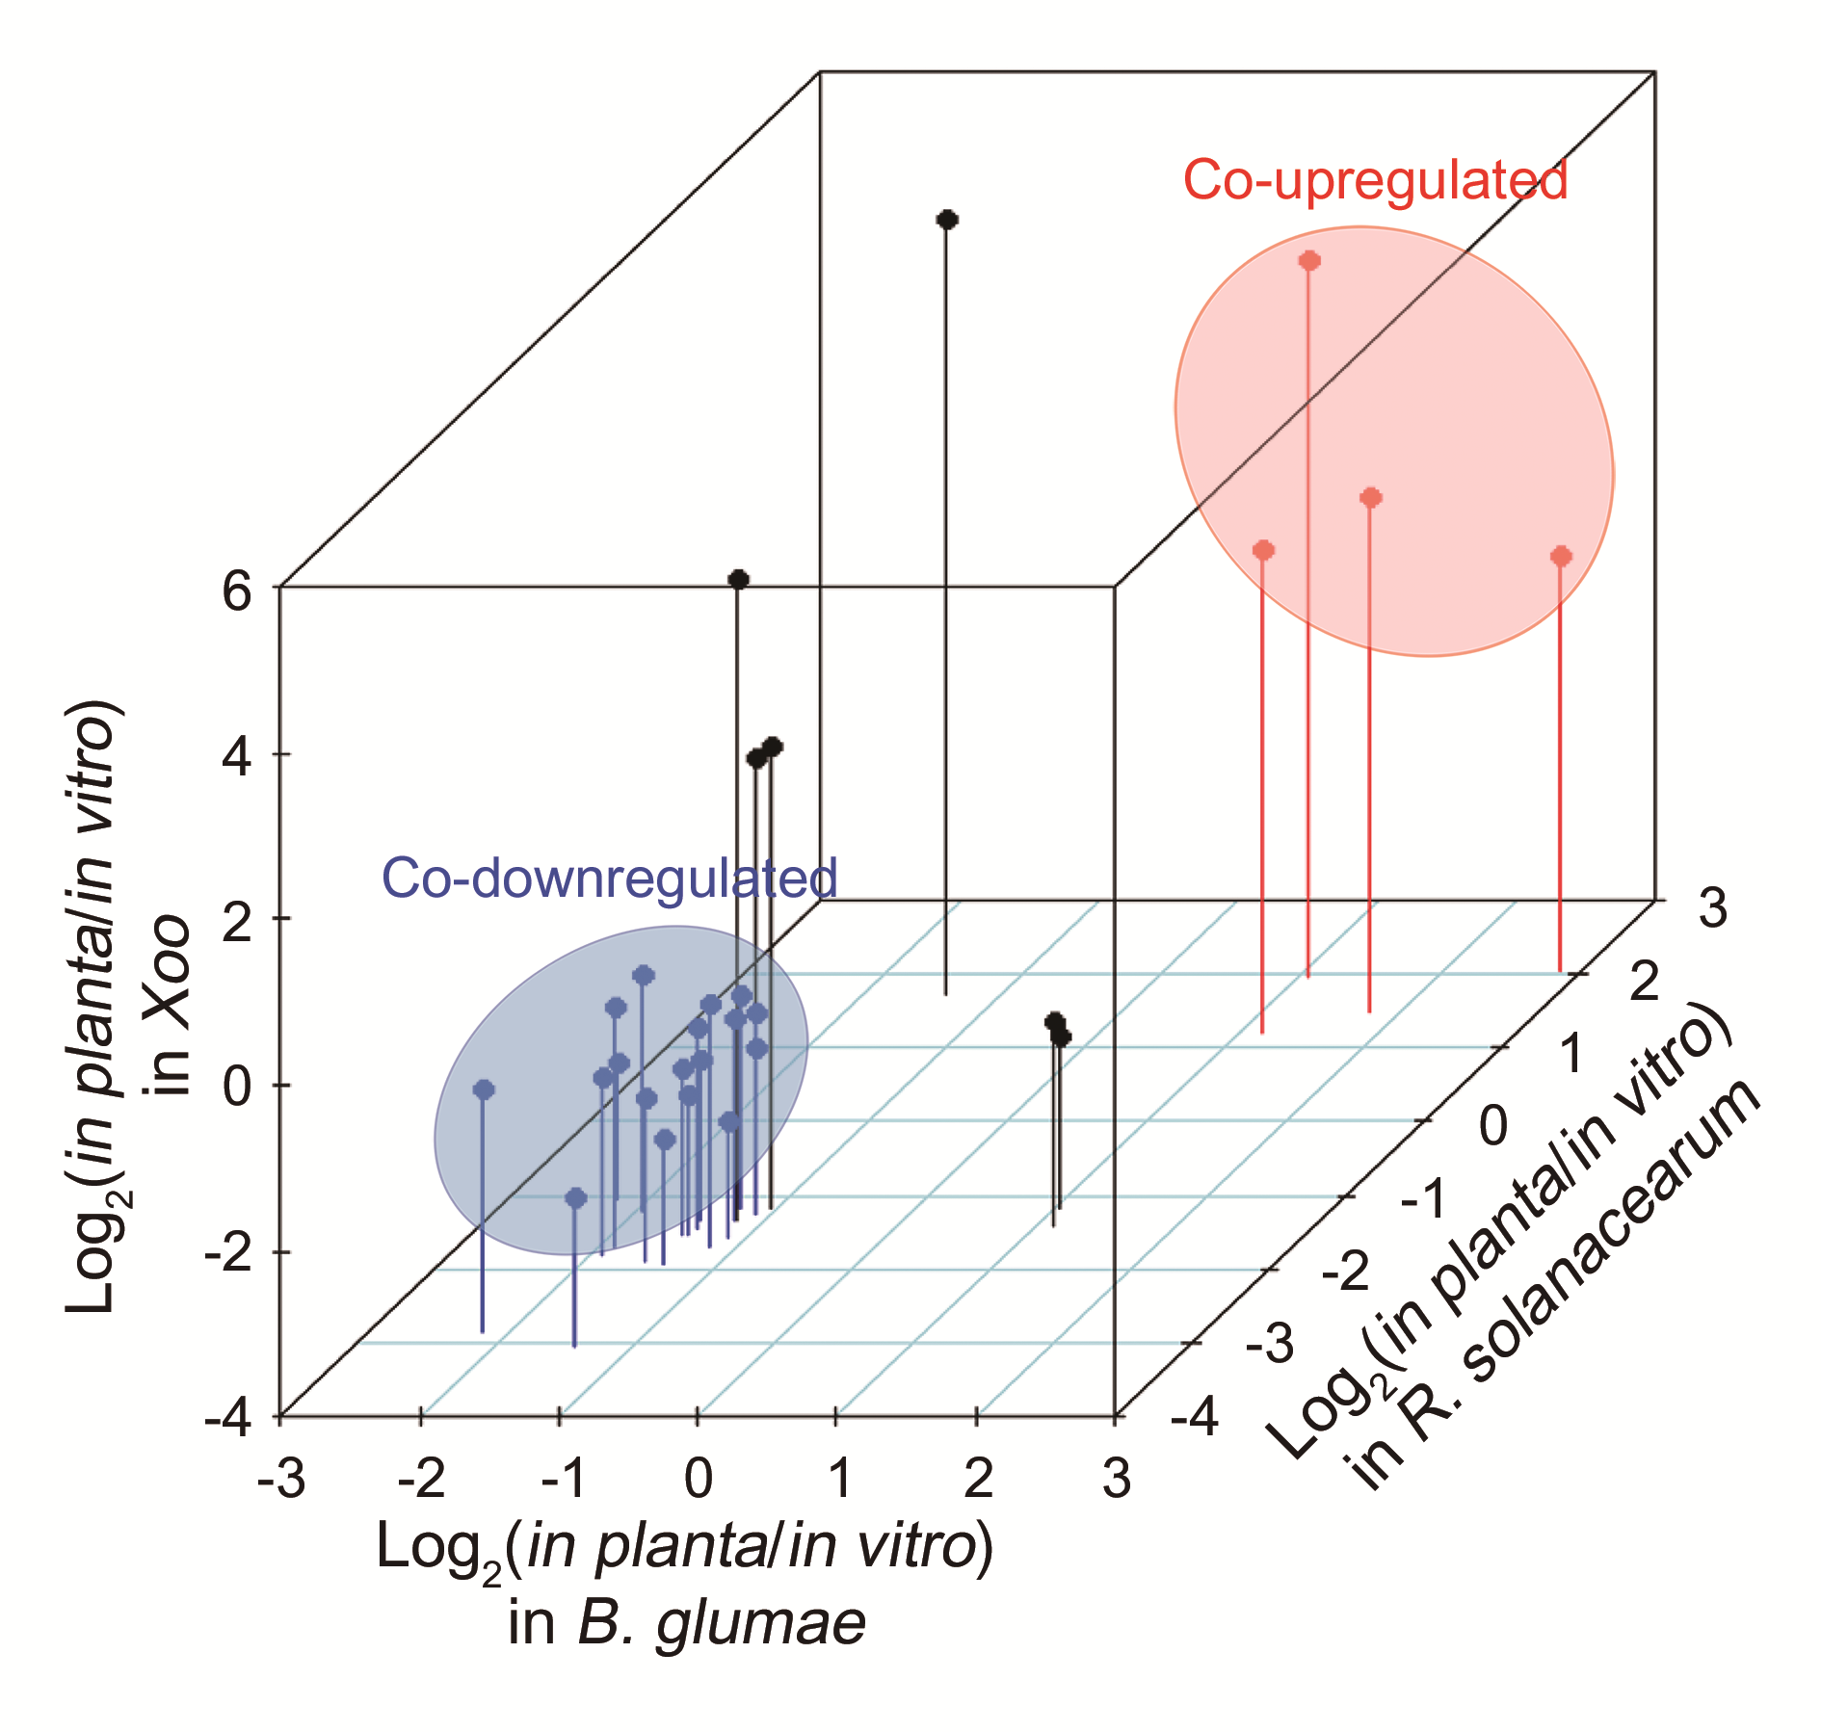
Figure S3. Co-expression patterns of the core genome across the three pathogens
Each node represents a common DEG determined by in planta transcriptome analysis of all three pathogens. The x-, y-, and z-axes define the relative expression, presented as log₂(in planta/in vitro). DEGs that followed identical expression tendencies were grouped into colored circles. Red and blue nodes indicate co-upregulated and co-downregulated DEGs in planta, respectively.

Figure S4. Growth curve of the B. glumae BGR1 and mutant strains
The growth of the wild-type B. glumae BGR1 and four mutants (WBI00925, WBI16715, WBI23755, and WBI28435) was monitored in pure LB broth. OD₆₀₀ values were measured at 2 h intervals over a period of 14 h. Error bars represent the standard errors from three independent experiments.

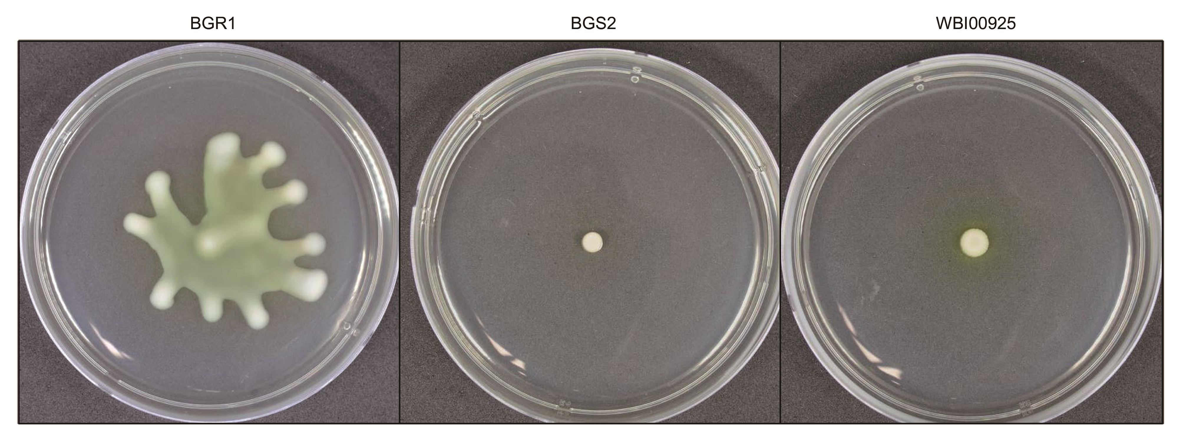
Figure S5. Swarming motility of the flagellar biosynthesis protein FlhA-disrupted mutant
A swarming motility assay was performed to inspect the bacterial motility of the WBI00925 mutant. Cultured bacterial cells were seeded onto 0.5% agar plates, and swarming motility was measured after 24 h of incubation at 37°C. The uncovered plates were photographed by irradiating a standardized light source D65 (Daylight 6500K) in a light box (Super Light-VI, BoTeck, Korea). B. glumae BGR1 and QS-deficient mutant BGS2 were used as the positive and negative control, respectively.

Figure S6. TLC image-based quantification of toxoflavin
Toxoflavin quantification assay was performed using the qTLC tool. The x-axis represents the relative toxoflavin concentration of samples compared to that of BGR1-LB sample as control TLC band (100%). The y-axis represents the pixel area of each TLC band, with higher numbers indicating abundant production of toxoflavin. The relative concentration values are indicated at spots.

Figure S7. Relative transcription level of genes related to toxoflavin biosynthesis in LB medium.
Under the normal condition without PCA, the expression of toxoflavin biosynthesis genes (tofI, tofR, toxJ, toxA, and toxR) in B. glumae BGR1, WBI23755, and MBC23755 strains was determined by qPCR. The relative transcription levels were calculated using the 2^{−ΔΔCt} method. Error bars represent the standard errors from three replicates. There were no statistical significances between treatments at P <0.05 according to ANOVA.

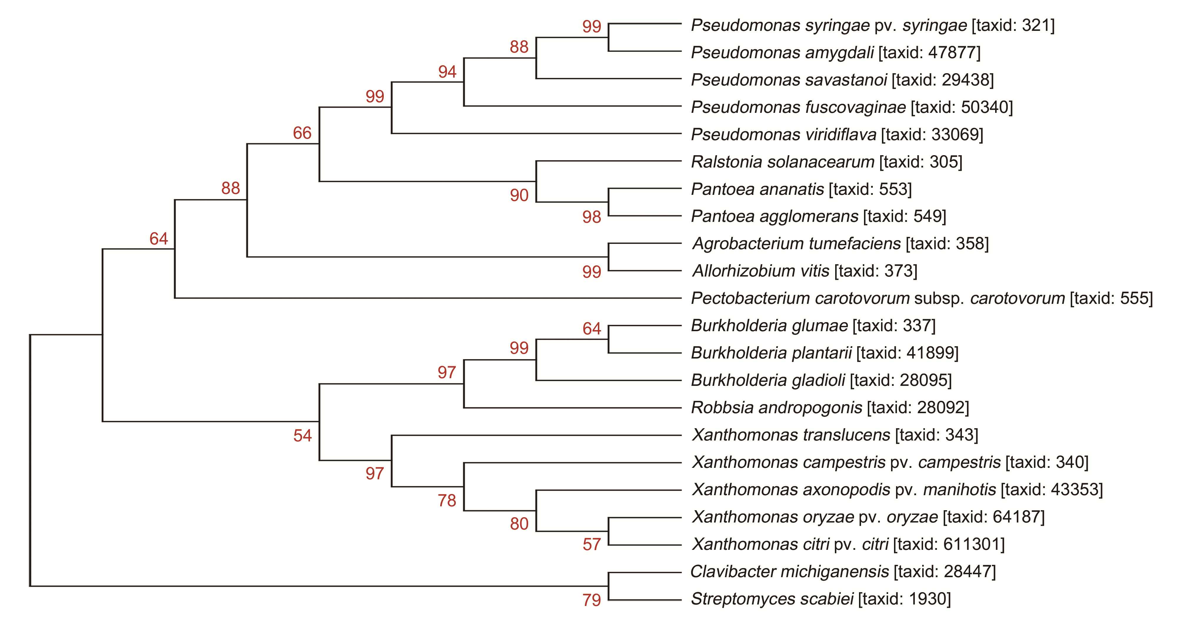
Figure S8. Phylogenetic tree based on PCD amino acid sequences
The amino acid sequences of PCD genes from 22 plant pathogens were used for phylogenetic analysis as follows: Agrobacterium, 1 pathogen; Allorhizobium, 1 pathogen; Burkholderia, 3 pathogens; Clavibacter, 1 pathogen; Pantoea, 2 pathogens; Pectobacterium, 1 pathogen; Pseudomonas, 5 pathogens; Ralstonia, 1 pathogen; Robbsia, 1 pathogen; Streptomyces, 1 pathogen; and Xanthomonas, 5 pathogens. The percentage of iterations clustered together in the bootstrap test based on 1000 replications are shown next to the corresponding branch and values greater than 50% are denoted. The NCBI taxonomy ID of each pathogen is shown in parentheses.
SUPPLEMENTARY TABLES
Table S1. Summary of genome statistics of the three plant pathogens
Organism | Replicon | Size (Mb) | GC (%) | Gene | rRNA | Protein | RefSeqª
B. glumae  BGR1 | Chromosome 1 | 3.91 | 68.1 | 3568 | 9 | 3429 | NC_012724.2
 | Chromosome 2 | 2.83 | 68.8 | 2198 | 6 | 2131 | NC_012721.2
 | Plasmid 1 | 0.13 | 60.6 | 129 | 0 | 117 | NC_012723.1
 | Plasmid 2 | 0.14 | 63.2 | 112 | 0 | 106 | NC_012718.1
 | Plasmid 3 | 0.14 | 62.7 | 114 | 0 | 104 | NC_012720.2
 | Plasmid 4 | 0.13 | 62.7 | 113 | 0 | 108 | NC_012725.2
R. solanacearum  GMI1000 | Chromosome 1 | 3.72 | 67.0 | 3429 | 9 | 3316 | NC_003295.1
 | Plasmid 1 | 2.09 | 66.9 | 1583 | 3 | 1533 | NC_003296.1
Xoo  KACC10331 | Chromosome 1 | 4.94 | 63.7 | 4568 | 6 | 4055 | NC_006834.1
ªReference sequence ID in the GenBank database.
Table S2. The top five COG categories in the orthologous and non-orthologous groups
COG  category | Description | Average percentage (%)ª
 |  | Orthologous group | Non-orthologous group
J | Translation, ribosomal structure and biogenesis | 11.38 | 2.15
C | Energy production and conversion | 8.66 | 4.26
H | Coenzyme transport and metabolism | 6.19 | 3.40
F | Nucleotide transport and metabolism | 3.73 | 1.04
L | Replication, recombination and repair | 4.49 | 2.61
M | Cell wall/membrane/envelope biogenesis | 4.41 | 6.32
K | Transcription | 5.02 | 8.29
R | General function prediction only | 5.91 | 9.41
S | Function unknown | 1.84 | 5.93
X | Mobilome: prophages, transposons | 2.03 | 9.86
ªAverage percentage in the particular functional category of groups relative to all genes of 25 COG categories.
Table S3. Detailed information on RNA-seq libraries of Xoo KACC10331
Sample | Orientationª | Length | Quality^{b} | Raw reads | Filtered reads^{c} | Mapped reads in genes
In vitro 1 | R1 | 126 | 36 | 29,295,580 | 24,998,325 | 32,017,127
 | R2 | 126 | 36 | 29,295,580 | 24,998,325
In vitro 2 | R1 | 126 | 36 | 22,671,210 | 20,918,453 | 25,268,913
 | R2 | 126 | 36 | 22,671,210 | 20,918,453
In vitro 3 | R1 | 126 | 36 | 19,208,178 | 18,488,368 | 22,281,081
 | R2 | 126 | 36 | 19,208,178 | 18,488,368
In planta 1 | R1 | 126 | 36 | 24,937,253 | 22,977,498 | 14,757,938
 | R2 | 126 | 36 | 24,937,253 | 22,977,498
In planta 2 | R1 | 126 | 36 | 21,466,176 | 19,785,231 | 12,215,998
 | R2 | 126 | 36 | 21,466,176 | 19,785,231
In planta 3 | R1 | 126 | 36 | 17,833,318 | 16,295,579 | 10,534,935
 | R2 | 126 | 36 | 17,833,318 | 16,295,579
ªR1, forward strand reads; R2, reverse strand reads.
^{b}An average Phred score.
^{c}Reads filtered to a minimum Phred score of 28 in >50% lengths.
Table S4. List of common DEGs with identical expression patterns
Orthologous  group | Gene set 1 |  | Gene set 2 |  | Expression  tendency^{b}
 | Gene locus ID | Log₂(in planta/in vitro)ª | Gene locus ID | Log₂(in planta /in vitro)
BR group | BGLU_RS00280 | 1.67 | RS_RS16745 | 1.70 | Up
 | BGLU_RS00285 | 1.53 | RS_RS16740 | 1.13 | Up
 | BGLU_RS00355 | -2.20 | RS_RS16620 | -1.06 | Down
 | BGLU_RS00385 | -2.24 | RS_RS16540 | -1.91 | Down
 | BGLU_RS00390 | -3.00 | RS_RS16535 | -1.09 | Down
 | BGLU_RS00435 | 5.79 | RS_RS15715 | 1.38 | Up
 | BGLU_RS00470 | -2.19 | RS_RS16510 | -2.85 | Down
 | BGLU_RS00475 | -1.75 | RS_RS16505 | -1.76 | Down
 | BGLU_RS00480 | -1.44 | RS_RS16500 | -3.02 | Down
 | BGLU_RS00850 | 3.12 | RS_RS23935 | 1.33 | Up
 | BGLU_RS00925 | 2.85 | RS_RS23845 | 2.05 | Up
 | BGLU_RS01925 | -1.18 | RS_RS20650 | -1.82 | Down
 | BGLU_RS01930 | -1.17 | RS_RS20655 | -1.65 | Down
 | BGLU_RS01940 | -2.11 | RS_RS20665 | -2.02 | Down
 | BGLU_RS01945 | -1.73 | RS_RS20670 | -1.36 | Down
 | BGLU_RS01950 | -1.66 | RS_RS20675 | -1.32 | Down
 | BGLU_RS01960 | -1.55 | RS_RS20685 | -2.07 | Down
 | BGLU_RS01965 | -1.88 | RS_RS20690 | -1.69 | Down
 | BGLU_RS01975 | -1.13 | RS_RS20700 | -1.58 | Down
 | BGLU_RS01980 | -1.97 | RS_RS20750 | -2.01 | Down
 | BGLU_RS01985 | -1.20 | RS_RS20760 | -1.70 | Down
 | BGLU_RS01990 | -1.44 | RS_RS20765 | -1.63 | Down
 | BGLU_RS02000 | -1.14 | RS_RS20785 | -1.20 | Down
 | BGLU_RS02045 | 1.39 | RS_RS17670 | 1.49 | Up
 | BGLU_RS02520 | -1.05 | RS_RS13960 | -1.53 | Down
 | BGLU_RS02535 | -1.02 | RS_RS13945 | -1.26 | Down
 | BGLU_RS02540 | -1.50 | RS_RS13940 | -1.52 | Down
 | BGLU_RS02545 | -2.28 | RS_RS13935 | -1.76 | Down
 | BGLU_RS02655 | -1.46 | RS_RS13845 | -1.19 | Down
 | BGLU_RS02685 | -1.20 | RS_RS13760 | -1.35 | Down
 | BGLU_RS02700 | 2.16 | RS_RS16410 | 1.41 | Up
 | BGLU_RS02810 | -1.20 | RS_RS02390 | -1.37 | Down
 | BGLU_RS03025 | -1.17 | RS_RS13585 | -2.04 | Down
 | BGLU_RS03165 | -1.46 | RS_RS13200 | -1.09 | Down
 | BGLU_RS03350 | -1.65 | RS_RS03705 | -1.28 | Down
 | BGLU_RS03430 | -1.37 | RS_RS03795 | -1.06 | Down
 | BGLU_RS03820 | -2.48 | RS_RS03500 | -2.00 | Down
 | BGLU_RS03825 | -1.64 | RS_RS03505 | -1.51 | Down
 | BGLU_RS04000 | -1.55 | RS_RS24615 | -2.03 | Down
 | BGLU_RS04195 | -1.47 | RS_RS10665 | -1.33 | Down
 | BGLU_RS04230 | -1.23 | RS_RS10525 | -1.17 | Down
 | BGLU_RS05405 | 2.27 | RS_RS24095 | 2.16 | Up
 | BGLU_RS06215 | 4.26 | RS_RS06810 | 2.46 | Up
 | BGLU_RS06220 | 1.89 | RS_RS04735 | 1.62 | Up
 | BGLU_RS06500 | -1.40 | RS_RS24615 | -2.03 | Down
 | BGLU_RS06690 | 6.52 | RS_RS23935 | 1.33 | Up
 | BGLU_RS06785 | -1.27 | RS_RS08685 | -1.11 | Down
 | BGLU_RS06835 | -2.29 | RS_RS08815 | -1.11 | Down
 | BGLU_RS06955 | 1.46 | RS_RS16450 | 2.37 | Up
 | BGLU_RS06960 | 1.27 | RS_RS16445 | 3.52 | Up
 | BGLU_RS07080 | -1.12 | RS_RS06655 | -1.16 | Down
 | BGLU_RS08460 | 3.46 | RS_RS06545 | 1.13 | Up
 | BGLU_RS08850 | 1.12 | RS_RS24095 | 2.16 | Up
 | BGLU_RS09310 | -1.15 | RS_RS20060 | -1.02 | Down
 | BGLU_RS09385 | 1.43 | RS_RS06750 | 1.65 | Up
 | BGLU_RS09940 | 1.04 | RS_RS13990 | 2.07 | Up
 | BGLU_RS09955 | -1.41 | RS_RS06370 | -1.91 | Down
 | BGLU_RS09960 | -1.44 | RS_RS06365 | -1.52 | Down
 | BGLU_RS09965 | -1.55 | RS_RS06360 | -1.90 | Down
 | BGLU_RS11190 | 3.18 | RS_RS06215 | 1.53 | Up
 | BGLU_RS11195 | 2.25 | RS_RS06210 | 1.48 | Up
 | BGLU_RS11200 | 1.99 | RS_RS06205 | 2.41 | Up
 | BGLU_RS11205 | 1.53 | RS_RS06200 | 1.95 | Up
 | BGLU_RS12840 | -1.10 | RS_RS05735 | -1.26 | Down
 | BGLU_RS12875 | -1.07 | RS_RS05695 | -1.64 | Down
 | BGLU_RS12930 | -1.22 | RS_RS05620 | -1.06 | Down
 | BGLU_RS13365 | -1.66 | RS_RS20130 | -1.63 | Down
 | BGLU_RS13400 | -1.42 | RS_RS09830 | -1.46 | Down
 | BGLU_RS13560 | -1.36 | RS_RS10100 | -1.09 | Down
 | BGLU_RS14135 | -1.91 | RS_RS04900 | -1.81 | Down
 | BGLU_RS14185 | -1.75 | RS_RS04840 | -1.16 | Down
 | BGLU_RS14695 | -1.04 | RS_RS11840 | -1.50 | Down
 | BGLU_RS14880 | -1.02 | RS_RS12120 | -1.14 | Down
 | BGLU_RS15510 | -1.61 | RS_RS17530 | -1.38 | Down
 | BGLU_RS15590 | -1.25 | RS_RS02880 | -1.19 | Down
 | BGLU_RS15720 | 1.19 | RS_RS02740 | 2.07 | Up
 | BGLU_RS15835 | 3.26 | RS_RS07425 | 1.72 | Up
 | BGLU_RS15915 | -1.05 | RS_RS15295 | -2.37 | Down
 | BGLU_RS15930 | -1.62 | RS_RS15300 | -2.90 | Down
 | BGLU_RS15935 | -1.17 | RS_RS15335 | -1.76 | Down
 | BGLU_RS16140 | -1.06 | RS_RS02270 | -1.17 | Down
 | BGLU_RS16715 | 1.09 | RS_RS01625 | 1.95 | Up
 | BGLU_RS16865 | -1.96 | RS_RS01480 | -1.20 | Down
 | BGLU_RS17170 | -1.21 | RS_RS12800 | -1.13 | Down
 | BGLU_RS17510 | 2.34 | RS_RS19040 | 1.34 | Up
 | BGLU_RS18040 | 2.52 | RS_RS05360 | 4.08 | Up
 | BGLU_RS18045 | 3.05 | RS_RS21070 | 5.15 | Up
 | BGLU_RS18655 | -1.20 | RS_RS20675 | -1.32 | Down
 | BGLU_RS18795 | 3.25 | RS_RS24890 | 1.03 | Up
 | BGLU_RS18900 | -2.02 | RS_RS03125 | -2.17 | Down
 | BGLU_RS19485 | 1.43 | RS_RS07365 | 1.33 | Up
 | BGLU_RS19720 | 1.30 | RS_RS21080 | 2.03 | Up
 | BGLU_RS19725 | 1.72 | RS_RS21075 | 1.64 | Up
 | BGLU_RS19735 | 4.59 | RS_RS21070 | 5.15 | Up
 | BGLU_RS20280 | 1.55 | RS_RS03840 | 2.46 | Up
 | BGLU_RS20335 | 1.72 | RS_RS20360 | 1.94 | Up
 | BGLU_RS20775 | 2.89 | RS_RS17455 | 1.41 | Up
 | BGLU_RS20955 | 2.08 | RS_RS01005 | 5.87 | Up
 | BGLU_RS21575 | 1.57 | RS_RS00960 | 2.34 | Up
 | BGLU_RS23160 | -1.90 | RS_RS20130 | -1.63 | Down
 | BGLU_RS23755 | 1.78 | RS_RS07255 | 1.50 | Up
 | BGLU_RS23845 | 2.63 | RS_RS21190 | 1.83 | Up
 | BGLU_RS23955 | 1.58 | RS_RS00950 | 2.51 | Up
 | BGLU_RS24295 | 1.17 | RS_RS22230 | 2.70 | Up
 | BGLU_RS24895 | 1.84 | RS_RS18220 | 1.60 | Up
 | BGLU_RS25385 | 2.71 | RS_RS18305 | 2.18 | Up
 | BGLU_RS26860 | 1.70 | RS_RS24860 | 1.14 | Up
 | BGLU_RS27745 | 4.86 | RS_RS00950 | 2.51 | Up
 | BGLU_RS27820 | 1.41 | RS_RS07565 | 2.67 | Up
 | BGLU_RS28180 | 4.34 | RS_RS19975 | 1.17 | Up
 | BGLU_RS28435 | 1.17 | RS_RS17740 | 1.21 | Up
 | BGLU_RS31170 | -1.12 | RS_RS16115 | -1.25 | Down
 | BGLU_RS31185 | -2.27 | RS_RS16115 | -1.25 | Down
BX group | BGLU_RS00040 | -1.10 | XOO_RS02120 | -1.98 | Down
 | BGLU_RS00330 | -2.04 | XOO_RS03525 | -1.08 | Down
 | BGLU_RS00345 | -1.48 | XOO_RS03540 | -2.16 | Down
 | BGLU_RS00350 | -1.41 | XOO_RS03545 | -1.87 | Down
 | BGLU_RS00355 | -2.20 | XOO_RS03550 | -2.35 | Down
 | BGLU_RS00470 | -2.19 | XOO_RS17560 | -1.07 | Down
 | BGLU_RS00480 | -1.44 | XOO_RS08810 | -2.22 | Down
 | BGLU_RS00810 | 1.02 | XOO_RS20415 | 1.03 | Up
 | BGLU_RS00875 | 2.45 | XOO_RS14045 | 2.26 | Up
 | BGLU_RS00925 | 2.85 | XOO_RS12870 | 1.00 | Up
 | BGLU_RS01475 | 1.16 | XOO_RS11770 | 2.34 | Up
 | BGLU_RS01965 | -1.88 | XOO_RS17170 | -1.09 | Down
 | BGLU_RS01975 | -1.13 | XOO_RS17160 | -2.60 | Down
 | BGLU_RS01985 | -1.20 | XOO_RS17385 | -1.06 | Down
 | BGLU_RS02350 | -1.34 | XOO_RS18895 | -1.09 | Down
 | BGLU_RS02540 | -1.50 | XOO_RS02685 | -2.00 | Down
 | BGLU_RS02685 | -1.20 | XOO_RS05685 | -1.57 | Down
 | BGLU_RS02690 | -2.46 | XOO_RS05820 | -1.67 | Down
 | BGLU_RS02740 | -1.11 | XOO_RS16440 | -1.24 | Down
 | BGLU_RS03240 | -1.73 | XOO_RS03860 | -4.13 | Down
 | BGLU_RS03565 | -4.30 | XOO_RS21210 | -2.20 | Down
 | BGLU_RS03570 | -4.31 | XOO_RS21205 | -2.28 | Down
 | BGLU_RS03970 | -1.57 | XOO_RS19075 | -1.40 | Down
 | BGLU_RS03975 | -1.33 | XOO_RS05960 | -1.24 | Down
 | BGLU_RS04095 | 1.01 | XOO_RS13725 | 1.51 | Up
 | BGLU_RS04195 | -1.47 | XOO_RS00080 | -2.05 | Down
 | BGLU_RS04410 | -1.07 | XOO_RS10085 | -2.17 | Down
 | BGLU_RS04465 | -1.04 | XOO_RS03835 | -1.54 | Down
 | BGLU_RS04890 | -1.93 | XOO_RS03710 | -1.27 | Down
 | BGLU_RS04975 | 1.98 | XOO_RS14715 | 1.80 | Up
 | BGLU_RS05265 | 5.52 | XOO_RS09835 | 2.01 | Up
 | BGLU_RS06715 | 2.37 | XOO_RS02070 | 3.84 | Up
 | BGLU_RS07030 | -1.24 | XOO_RS14425 | -2.24 | Down
 | BGLU_RS07195 | -2.79 | XOO_RS05160 | -1.90 | Down
 | BGLU_RS08735 | 2.38 | XOO_RS08315 | 3.62 | Up
 | BGLU_RS09955 | -1.41 | XOO_RS09955 | -2.50 | Down
 | BGLU_RS09960 | -1.44 | XOO_RS09960 | -2.30 | Down
 | BGLU_RS09965 | -1.55 | XOO_RS09965 | -2.02 | Down
 | BGLU_RS11100 | 1.69 | XOO_RS14045 | 2.26 | Up
 | BGLU_RS11120 | -1.27 | XOO_RS04015 | -1.39 | Down
 | BGLU_RS11395 | 3.40 | XOO_RS14045 | 2.26 | Up
 | BGLU_RS11420 | 1.95 | XOO_RS14035 | 1.46 | Up
 | BGLU_RS11475 | 1.81 | XOO_RS11255 | 3.89 | Up
 | BGLU_RS12035 | 1.77 | XOO_RS21430 | 1.87 | Up
 | BGLU_RS12840 | -1.10 | XOO_RS08010 | -1.57 | Down
 | BGLU_RS12930 | -1.22 | XOO_RS14640 | -2.15 | Down
 | BGLU_RS12985 | -1.13 | XOO_RS14175 | -2.16 | Down
 | BGLU_RS13275 | 1.05 | XOO_RS11815 | 2.88 | Up
 | BGLU_RS13400 | -1.42 | XOO_RS11505 | -1.56 | Down
 | BGLU_RS13485 | -1.19 | XOO_RS18700 | -1.81 | Down
 | BGLU_RS13635 | -1.64 | XOO_RS15950 | -1.50 | Down
 | BGLU_RS13640 | -1.17 | XOO_RS15955 | -1.61 | Down
 | BGLU_RS13645 | -1.42 | XOO_RS15960 | -1.77 | Down
 | BGLU_RS13655 | -1.62 | XOO_RS15970 | -1.71 | Down
 | BGLU_RS13660 | -1.05 | XOO_RS15975 | -1.36 | Down
 | BGLU_RS14135 | -1.91 | XOO_RS12340 | -1.86 | Down
 | BGLU_RS14660 | -2.00 | XOO_RS04580 | -1.70 | Down
 | BGLU_RS14730 | -1.16 | XOO_RS16215 | -1.23 | Down
 | BGLU_RS15505 | -1.85 | XOO_RS19135 | -1.77 | Down
 | BGLU_RS15590 | -1.25 | XOO_RS15885 | -1.42 | Down
 | BGLU_RS15695 | -1.04 | XOO_RS07720 | -2.46 | Down
 | BGLU_RS16635 | -1.26 | XOO_RS07120 | -3.06 | Down
 | BGLU_RS16715 | 1.09 | XOO_RS05400 | 4.67 | Up
 | BGLU_RS16865 | -1.96 | XOO_RS03740 | -1.14 | Down
 | BGLU_RS17095 | -1.73 | XOO_RS10120 | -1.51 | Down
 | BGLU_RS17870 | 1.46 | XOO_RS13405 | 1.28 | Up
 | BGLU_RS17995 | -2.10 | XOO_RS18280 | -1.46 | Down
 | BGLU_RS18000 | -2.08 | XOO_RS18250 | -1.64 | Down
 | BGLU_RS18480 | 1.97 | XOO_RS14045 | 2.26 | Up
 | BGLU_RS18510 | 1.59 | XOO_RS14045 | 2.26 | Up
 | BGLU_RS18605 | -3.34 | XOO_RS00110 | -1.14 | Down
 | BGLU_RS18935 | 1.92 | XOO_RS14045 | 2.26 | Up
 | BGLU_RS19030 | 1.78 | XOO_RS00380 | 4.72 | Up
 | BGLU_RS19050 | 1.20 | XOO_RS00400 | 5.80 | Up
 | BGLU_RS20095 | 4.26 | XOO_RS14035 | 1.46 | Up
 | BGLU_RS21895 | -1.04 | XOO_RS04650 | -1.25 | Down
 | BGLU_RS21930 | -2.27 | XOO_RS05590 | -2.47 | Down
 | BGLU_RS22035 | -1.46 | XOO_RS18210 | -1.53 | Down
 | BGLU_RS22280 | 2.60 | XOO_RS14035 | 1.46 | Up
 | BGLU_RS22435 | 2.18 | XOO_RS13790 | 2.59 | Up
 | BGLU_RS22565 | 4.34 | XOO_RS14045 | 2.26 | Up
 | BGLU_RS22855 | -1.96 | XOO_RS07555 | -1.38 | Down
 | BGLU_RS23085 | 1.26 | XOO_RS16335 | 1.48 | Up
 | BGLU_RS23425 | 1.49 | XOO_RS18645 | 3.56 | Up
 | BGLU_RS23575 | -2.72 | XOO_RS22360 | -1.69 | Down
 | BGLU_RS23635 | 2.46 | XOO_RS14055 | 2.11 | Up
 | BGLU_RS23680 | 6.89 | XOO_RS14045 | 2.26 | Up
 | BGLU_RS23755 | 1.78 | XOO_RS02315 | 2.21 | Up
 | BGLU_RS24045 | 1.52 | XOO_RS03105 | 1.73 | Up
 | BGLU_RS24910 | 1.52 | XOO_RS08880 | 2.69 | Up
 | BGLU_RS25335 | -1.08 | XOO_RS22400 | -4.83 | Down
 | BGLU_RS25365 | 4.93 | XOO_RS14045 | 2.26 | Up
 | BGLU_RS26035 | 1.26 | XOO_RS12475 | 2.26 | Up
 | BGLU_RS26235 | 2.39 | XOO_RS14045 | 2.26 | Up
 | BGLU_RS26680 | 1.15 | XOO_RS14045 | 2.26 | Up
 | BGLU_RS26900 | -1.03 | XOO_RS20145 | -1.66 | Down
 | BGLU_RS26980 | -1.10 | XOO_RS10955 | -1.03 | Down
 | BGLU_RS27030 | 1.11 | XOO_RS04240 | 3.54 | Up
 | BGLU_RS27285 | -3.68 | XOO_RS21205 | -2.28 | Down
 | BGLU_RS27290 | -4.33 | XOO_RS21210 | -2.20 | Down
 | BGLU_RS27430 | -1.28 | XOO_RS00130 | -3.17 | Down
 | BGLU_RS28060 | 1.77 | XOO_RS14035 | 1.46 | Up
 | BGLU_RS28110 | 1.27 | XOO_RS20815 | 1.72 | Up
 | BGLU_RS28170 | 4.50 | XOO_RS14045 | 2.26 | Up
 | BGLU_RS28435 | 1.17 | XOO_RS04315 | 1.84 | Up
 | BGLU_RS28720 | 2.89 | XOO_RS07025 | 1.30 | Up
 | BGLU_RS28725 | 1.62 | XOO_RS07030 | 1.96 | Up
 | BGLU_RS29260 | 4.00 | XOO_RS14045 | 2.26 | Up
 | BGLU_RS29350 | 2.60 | XOO_RS14035 | 1.46 | Up
 | BGLU_RS29715 | 3.92 | XOO_RS14045 | 2.26 | Up
ªRelative expression presented as log₂(in planta/in vitro).
^{b}Expression tendency of common DEGs in in planta condition.
Table S5. List of co-upregulated DEGs associated with MCPs and transcriptional regulators
Gene locus IDª | Description | Degree of in planta gene expression^{b}
 |  | B. glumae | R. solanacearum | Xoo
BGLU_RS00875 | Methyl-accepting chemotaxis protein | ++ | ++ | ++
BGLU_RS02045 | Transcriptional regulator, TetR family | ++ | ++ | −
BGLU_RS11100 | Methyl-accepting chemotaxis sensory transducer | ++ | + | ++
BGLU_RS11395 | Methyl-accepting chemotaxis protein | ++ | − | ++
BGLU_RS11420 | Methyl-accepting chemotaxis sensory transducer | ++ | − | ++
BGLU_RS18480 | Methyl-accepting chemotaxis sensory transducer | ++ | ++ | ++
BGLU_RS18510 | Methyl-accepting chemotaxis sensory transducer | ++ | + | ++
BGLU_RS18795 | LuxR family transcriptional regulator | ++ | ++ | −
BGLU_RS18935 | Methyl-accepting chemotaxis sensory transducer | ++ | + | ++
BGLU_RS20095 | Methyl-accepting chemotaxis sensory transducer | ++ | ++ | ++
BGLU_RS20775 | Transcriptional regulator, AraC family | ++ | ++ | −−
BGLU_RS22280 | Methyl-accepting chemotaxis sensory transducer | ++ | − | ++
BGLU_RS22565 | Methyl-accepting chemotaxis sensory transducer | ++ | + | ++
BGLU_RS23635 | Methyl-accepting chemotaxis protein | ++ | + | ++
BGLU_RS23680 | Methyl-accepting chemotaxis sensory transducer | ++ | + | ++
BGLU_RS23845 | RNA polymerase sigma factor FecI | ++ | ++ | +
BGLU_RS23955 | Two component LuxR family transcriptional regulator | ++ | ++ | −
BGLU_RS25365 | Methyl-accepting chemotaxis sensory transducer | ++ | + | ++
BGLU_RS26235 | Methyl-accepting chemotaxis sensory transducer | ++ | ++ | ++
BGLU_RS26680 | Methyl-accepting chemotaxis sensory transducer | ++ | − | ++
BGLU_RS27745 | Two component transcriptional regulator, LuxR family | ++ | ++ | −
BGLU_RS28060 | Methyl-accepting chemotaxis protein | ++ | + | ++
BGLU_RS28170 | Methyl-accepting chemotaxis sensory transducer | ++ | − | ++
BGLU_RS29260 | Methyl-accepting chemotaxis sensory transducer | ++ | + | ++
BGLU_RS29350 | Methyl-accepting chemotaxis sensory transducer | ++ | − | ++
BGLU_RS29715 | Methyl-accepting chemotaxis sensory transducer | ++ | + | ++
ªGene locus ID in the reference B. glumae genome.
^{b}++, upregulated DEG; +, upregulated gene; −−, downregulated DEG; −, downregulated gene.
Table S6. List of co-downregulated DEGs in the core genome
Description | Gene locus ID (Relative expressionª)
 | B. glumae | R. solanacearum | Xoo
Flagellar motor protein MotB | BGLU_RS01985  (-1.20) | RS_RS20760  (-1.70) | XOO_RS17385  (-1.06)
Glycine dehydrogenase | BGLU_RS00470  (-2.19) | RS_RS16510  (-2.85) | XOO_RS17560  (-1.07)
Type VI secretion protein | BGLU_RS01965  (-1.88) | RS_RS20690  (-1.69) | XOO_RS17170  (-1.09)
Fumarylacetoacetate hydrolase | BGLU_RS16865  (-1.96) | RS_RS01480  (-1.20) | XOO_RS03740  (-1.14)
N5-carboxyamino imidazole ribonucleotide mutase | BGLU_RS15590  (-1.25) | RS_RS02880  (-1.19) | XOO_RS15885  (-1.42)
Fumarate hydratase | BGLU_RS13400  (-1.42) | RS_RS09830  (-1.46) | XOO_RS11505  (-1.56)
Transketolase | BGLU_RS02685  (-1.20) | RS_RS13760  (-1.35) | XOO_RS05685  (-1.57)
DNA mismatch repair protein MutS | BGLU_RS12840  (-1.10) | RS_RS05735  (-1.26) | XOO_RS08010  (-1.57)
Heat-shock protein Hsp90 | BGLU_RS14135  (-1.91) | RS_RS04900  (-1.81) | XOO_RS12340  (-1.86)
Acetyl-CoA carboxylase Biotin carboxylase subunit | BGLU_RS02540  (-1.50) | RS_RS13940  (-1.52) | XOO_RS02685  (-2.00)
2-oxoglutarate dehydrogenase E1 | BGLU_RS09965  (-1.55) | RS_RS06360  (-1.90) | XOO_RS09965  (-2.02)
Fructose 1,6-bisphosphatase | BGLU_RS04195  (-1.47) | RS_RS10665  (-1.33) | XOO_RS00080  (-2.05)
Enolase | BGLU_RS12930  (-1.22) | RS_RS05620  (-1.06) | XOO_RS14640  (-2.15)
Glycine cleavage system protein T | BGLU_RS00480  (-1.44) | RS_RS16500  (-3.02) | XOO_RS08810  (-2.22)
Dihydrolipoamide succinyltransferase | BGLU_RS09960  (-1.44) | RS_RS06365  (-1.52) | XOO_RS09960  (-2.30)
F0F1 ATP synthase subunit beta | BGLU_RS00355  (-2.20) | RS_RS16620  (-1.06) | XOO_RS03550  (-2.35)
Dihydrolipoamide dehydrogenase | BGLU_RS09955  (-1.41) | RS_RS06370  (-1.91) | XOO_RS09955  (-2.50)
ATPase | BGLU_RS01975  (-1.13) | RS_RS20700  (-1.58) | XOO_RS17160  (-2.60)
ªRelative expression level presented as log₂(in planta/in vitro).

Table S7. Bacterial strains and plasmids used in this study
Strain or plasmid | Descriptionª | References
B. glumae
BGR1 | A wild type strain isolated from diseased rice in Korea, Rif^{r} | (Jeong et al., 2003)
BGS2 | BGR1 tofI::Ω | (Kim et al., 2004)
WBI00925 | A derivative of BGR1, BGLU_RS00925::pBIRS00925 | This study
WBI16715 | A derivative of BGR1, BGLU_RS16715::pBIRS16715 | This study
WBI23755 | A derivative of BGR1, BGLU_RS23755::pBIRS23755 | This study
WBI28435 | A derivative of BGR1, BGLU_RS28435::pBIRS28435 | This study
MBC23755 | A complement strain of WBI23755 | This study
R. solanacearum
GMI1000 | A wild type strain isolated from diseased tomato in French Guiana, Race 1, phylotype I | (Boucher et al., 1985)
WRI07255 | A derivative of GMI1000, RS_RS07255::Km^{r} gene cassette | This study
Xoo
KACC10331 | A wild type strain isolated from diseased rice in Korea, Cp^{r} | (Lee et al., 2005)
WXD02315 | A derivative of KACC10331, markerless deletion in XOO_RS02315 | This study
MXC02315 | A complement strain of WXD02315 | This study
E. coli
DH5α | E. coli used for cloning and propagation of plasmids | Promega
DH5α λpir | A derivative of DH5α, λpir enables oriR6K vectors replication | (Choi et al., 2006)
S17-1 λpir | A derivative of S17-1, RK2 tra regulon, λpir enables oriR6K vectors replication | (Choi et al., 2006)
HB101 | E. coli used for triparental mating with R. solanacearum | Promega
Plasmids
pGEM-T Easy | A TA cloning vector, Amp^{r} | Promega
pVIK112 | A R6K suicide vector, lacZY for transcriptional fusions, Km^{r} | (Kalogeraki and Winans, 1997)
pBIRS00925 | A pVIK112 vector containing internal region of BGLU_RS00925 | This study
pBIRS16715 | A pVIK112 vector containing internal region of BGLU_RS16715 | This study
pBIRS23755 | A pVIK112 vector containing internal region of BGLU_RS23755 | This study
pBIRS28435 | A pVIK112 vector containing internal region of BGLU_RS28435 | This study
pRK415 | A RK-2 derived cloning vector, Tc^{r} | (Keen et al., 1988)
pMKm2 | A vector carrying a Km^{r} gene cassette, Amp^{r}, Km^{r} | (Um et al., 2011)
pRIRS07255 | A pRK415 vector containing 2.0-kb PCR fragment with RS_RS07255::Km^{r} | This study
pRK2013 | A mobilization helper vector for triparental mating, Km^{r} | (Figurski and Helinski, 1979)
pK18mobsacB | A pBR322 suicide vector, sacB, Km^{r} | (Schäfer et al., 1994)
pXDRS02315 | A pK18mobsacB vector containing 532 bp up/downstream PCR fragment of XOO_RS02315 | This study
pBBR1MCS2 | A broad-host-range vector, Km^{r} | (Kovach et al., 1995)
pBCRS23755 | A pRK415 containing PCR fragment of BGLU_RS23755 | This study
pXCRS02315 | A pBBR1MCS2 containing PCR fragment of XOO_RS02315 | This study
ªRif^{r}, rifampin resistance; Km^{r}, kanamycin resistance; Cp^{r}, cephalexin resistance; Amp^{r}, ampicillin resistance; Tc^{r}, tetracyclin resistance.

Table S8. PCR primers used in this study
Primer name | Sequence (5’→3’)ª | Purpose
BIRS00925_E | (EcoRI) GAATTCGATCTGCTGTTCACGTTCAAC | To amplify internal region of BGLU_RS00925
BIRS00925_K | (KpnI) GGTACCGATCACCGTGAAGTTGATGATC
BIRS16715_E | (EcoRI) GAATTCCGATCAGCATCTCTTCCTTGAT | To amplify internal region of BGLU_RS16715
BIRS16715_K | (KpnI) GGTACCATCGTCCACATCATCACCAAG
BIRS23755_E | (EcoRI) GAATTCCAACGCGATGAAGAACGG | To amplify internal region of BGLU_RS23755
BIRS23755_K | (KpnI) GGTACCAGAAATGAATATGGTTCGGGC
BIRS28435_E | (EcoRI) GAATTCCTTGATGCGATCGACCATCT | To amplify internal region of BGLU_RS28435
BIRS28435_K | (KpnI)  GGTACCCCATGGAAGACGTGCTGAT
BIRS00925_UpF | GGCGCACGTAACGAAGGAGAT | Sequencing for mutant WBI00925
BIRS16715_UpF | ATGTAGATGTTGGTGCCGTCCA | Sequencing for mutant WBI16715
BIRS23755_UpF | GTTCATCCCGACTACCGCTCG | Sequencing for mutant WBI23755
BIRS28435_UpF | TAGTCGTCGAGCGTCTTCATGG | Sequencing for mutant WBI28435
Lacfuse | GGGGATGTGCTGCAAGGCG | Sequencing for cloning pVIK112 vector and B. glumae mutants
RIRS07255_UpF | CCGACCACCAGATCCAGTT | To amplify upstream region of RS_RS07255
RIRS07255_UpR | CAGAGATTTTGAGACACACTGAAGCCACTGTATAGCGG
RIRS07255_DownF | CTAATCAGAATTGGTTAAAATCCCTGGAACGCACCC | To amplify downstream region of RS_RS07255
RIRS07255_DownR | CTCGTCGCTGAAGTACACG
Km^{r}_F | TGTGTCTCAAAATCTCTG | To amplify kanamycin resistance gene cassette
Km^{r}_R | TTAACCAATTCTGATTAG
XDRS02315_UpE | (EcoRI) GAATTCACGATGCCGCACACGTCAATG | To amplify upstream region of XOO_RS02315
XDRS02315_UpB | (BamHI) GGATCCCATCTTGAATCTCCGTCGGCA
XDRS02315_DownB | (BamHI) GGATCCTGACACGATGAGCCTGCATG | To amplify downstream region of XOO_RS02315
XDRS02315_DownH | (HindIII) AAGCTTGGCCACAACCATCGAAGCTG
XDRS02315_UpF | AATGCCTCCGGTCTCAACGAT | Sequencing for mutant WXD02315
XDRS02315_DownR | CAACAGGCCACGCATGAAGA
pK18_DownR | GTGAAGCTAGCTTATCGCCAT | Sequencing for first-crossover recombinant
BCRS23755_H | (HindIII)  AAAAAAAGCTTAATGGACGATTCCATCCTCAGC | To amplify BGLU_RS23755 for complementation
BCRS23755_B | (BamHI)  AAAGGATCCTCAGCGCTCCATCGGGGT
XCRS02315_E | (EcoRI)  AAAAAGAATTCAATGCGTGATCCCACCTCTGA | To amplify XOO_RS02315 for complementation
XCRS02315_B | (BamHI)  AAAGGATCCTCACTGCCAGACCGTTTGCT
ToxA_qPCR_F | CAAGGTGGTCGGCGTGGATATC | To measure the expression change of BGLU_RS21055 by qPCR
ToxA_qPCR_R | CACCACCTTGAACATCTTGCG
ToxJ_qPCR_F | GATCCGTGAACGTAGAGTC | To measure the expression change of BGLU_RS21020 by qPCR
ToxJ_qPCR_R | TGTTCATGTGGATCAGCTG
ToxR_qPCR_F | CATCTGCGCGACATCTTCAAC | To measure the expression change of BGLU_RS21050 by qPCR
ToxR_qPCR_R | CGGACATCGACACGCGAAACAC
TofI_qPCR_F | CTGGGTTCGTACCGTTATCG | To measure the expression change of BGLU_RS24865 by qPCR
TofI_qPCR_R | GAACACTTCCTGCAACAGGTAG
TofR_qPCR_F | CTTCGAGTACTGCTGCTATG | To measure the expression change of BGLU_RS24855 by qPCR
TofR_qPCR_R | CAGATGATCATGTTCGGGCTC
Control_qPCR_F | TGCGAATGGGGAGATATGCG | Control gene for normalization of qPCR
Control_qPCR_R | AACGTGACCCCGATCAACTG
ªRestriction enzymes are indicated in the parentheses.
Table S9. Distribution of PCD gene in plant pathogens
Species | NCBI  Taxonomy ID | Phylum | Accession | Identityª  (%) | Coverage^{b}  (%)
Acidovorax citrulli | 80869 | Proteobacteria | - | - | -
Agrobacterium tumefaciens | 358 | Proteobacteria | KIQ04082.1 | 63.87 | 96
Allorhizobium vitis | 373 | Proteobacteria | MBB4955205.1 | 65.55 | 96
Bacillus pumilus | 1408 | Firmicutes | - | - | -
Burkholderia gladioli | 28095 | Proteobacteria | WP_013690224.1 | 94.02 | 100
Burkholderia glumae | 337 | Proteobacteria | WP_012733977.1 | 100 | 100
Burkholderia plantarii | 41899 | Proteobacteria | WP_042627860.1 | 95.3 | 100
Candidatus liberibacter asiaticus | 34021 | Proteobacteria | - | - | -
Clavibacter michiganensis | 28447 | Actinomycetota | WP_104280413.1 | 54.5 | 93
Dickeya dadantii | 204038 | Proteobacteria | - | - | -
Erwinia amylovora | 552 | Proteobacteria | - | - | -
Erwinia pyrifoliae | 79967 | Proteobacteria | - | - | -
Pantoea agglomerans | 549 | Proteobacteria | WP_069027011.1 | 73.73 | 95
Pantoea ananatis | 553 | Proteobacteria | WP_024471045.1 | 74.15 | 95
Pectobacterium carotovorum  subsp. carotovorum | 555 | Proteobacteria | WP_039507206.1 | 30.82 | 57
Pectobacterium wasabiae | 55208 | Proteobacteria | - | - | -
Pseudomonas amygdali | 47877 | Proteobacteria | WP_003373348.1 | 62.34 | 93
Pseudomonas fuscovaginae | 50340 | Proteobacteria | WP_010448477.1 | 60.68 | 95
Pseudomonas savastanoi | 29438 | Proteobacteria | WP_122395308.1 | 60.85 | 95
Pseudomonas syringae pv. syringae | 321 | Proteobacteria | WP_024673659.1 | 61.47 | 93
Pseudomonas viridiflava | 33069 | Proteobacteria | WP_043192756.1 | 62.23 | 94
Ralstonia solanacearum | 305 | Proteobacteria | WP_011001390.1 | 100 | 100
Robbsia andropogonis | 28092 | Proteobacteria | WP_024904575.1 | 74.68 | 99
Streptomyces scabiei | 1930 | Actinomycetota | WP_059082833.1 | 56.22 | 90
Xanthomonas axonopodis pv. manihotis | 43353 | Proteobacteria | WP_017158879.1 | 91.02 | 100
Xanthomonas campestris pv. campestris | 340 | Proteobacteria | WP_080639980.1 | 84.91 | 94
Xanthomonas citri pv. citri | 611301 | Proteobacteria | WP_011050271.1 | 92.24 | 100
Xanthomonas oryzae pv. oryzae | 64187 | Proteobacteria | WP_011257410.1 | 100 | 100
Xanthomonas translucens | 343 | Proteobacteria | MBB4128399.1 | 84.78 | 93
Xylella fastidiosa | 2371 | Proteobacteria | - | - | -
ªBLASTp identity against PCD genes.
^{b}BLASTp coverage against PCD genes.
REFERENCES
Boucher, C., Barberis, P., Trigalet, A., and Demery, D. (1985). Transposon mutagenesis of Pseudomonas solanacearum: Isolation of Tn5-induced avirulent mutants. Microbiology 131: 2449–2457.
Cai, Z., Yuan, Z.H., Zhang, H., Pan, Y., Wu, Y., Tian, X.Q., Wang, F.F., Wang, L., and Qian, W. (2017). Fatty acid DSF binds and allosterically activates histidine kinase RpfC of phytopathogenic bacterium Xanthomonas campestris pv. campestris to regulate quorum-sensing and virulence. PLoS Pathog. 13: e1006304.
Choi, K.H., DeShazer, D., and Schweizer, H.P. (2006). mini-Tn7 insertion in bacteria with multiple glmS-linked attTn7 sites: example Burkholderia mallei ATCC 23344. Nat. Protoc. 1: 162–169.
Figurski, D., and Helinski, D. (1979). Replication of an origin-containing derivative of plasmid RK2 dependent on a plasmid function provided in trans. Proc. Natl. Acad. Sci. U. S. A. 76: 1648–1652.
Jacobs, J.M., Babujee, L., Meng, F., Milling, A., and Allen, C. (2012). The in planta transcriptome of Ralstonia solanacearum: conserved physiological and virulence strategies during bacterial wilt of tomato. MBio 3: e00114-12.
Jeong, Y., Kim, J., Kim, S., Kang, Y., Nagamatsu, T., and Hwang, I. (2003). Toxoflavin produced by Burkholderia glumae causing rice grain rot is responsible for inducing bacterial wilt in many field crops. Plant Dis. 87: 890–895.
Kalogeraki, V.S., and Winans, S.C. (1997). Suicide plasmids containing promoterless reporter genes can simultaneously disrupt and create fusions to target genes of diverse bacteria. Gene 188: 69–75.
Keen, N., Tamaki, S., Kobayashi, D., and Trollinger, D. (1988). Improved broad-host-range plasmids for DNA cloning in gram-negative bacteria. Gene 70: 191–197.
Kim, J., Kim, J.G., Kang, Y., Jang, J.Y., Jog, G.J., Lim, J.Y., Kim, S., Suga, H., Nagamatsu, T., and Hwang, I. (2004). Quorum sensing and the LysR-type transcriptional activator ToxR regulate toxoflavin biosynthesis and transport in Burkholderia glumae. Mol. Microbiol. 54: 921–934.
Kim, S., Park, J., Lee, J., Shin, D., Park, D.S., Lim, J.S., Choi, I.Y., and Seo, Y.S. (2014). Understanding pathogenic Burkholderia glumae metabolic and signaling pathways within rice tissues through in vivo transcriptome analyses. Gene 547: 77–85.
Kovach, M.E., Elzer, P.H., Steven Hill, D., Robertson, G.T., Farris, M.A., Roop, R.M., and Peterson, K.M. (1995). Four new derivatives of the broad-host-range cloning vector pBBR1MCS, carrying different antibiotic-resistance cassettes. Gene 166: 175–176.
Lee, B.M., Park, Y.J., Park, D.S., Kang, H.W., Kim, J.G., Song, E.S., Park, I.C., Yoon, U.H., Hahn, J.H., Koo, B.S., Lee, G.B., Kim, H., Park, H.S., Yoon, K.O., Kim, J.H., Jung, C. hee, Koh, N.H., Seo, J.S., and Go, S.J. (2005). The genome sequence of Xanthomonas oryzae pathovar oryzae KACC10331, the bacterial blight pathogen of rice. Nucleic Acids Res. 33: 577–586.
Lee, S.W., Glickmann, E., and Cooksey, D.A. (2001). Chromosomal locus for cadmium resistance in Pseudomonas putida consisting of a cadmium-transporting ATPase and a MerR family response regulator. Appl. Environ. Microbiol. 67: 1437–1444.
Lim, J., Lee, T., Nahm, B., Choi, Y., Kim, M., and Hwang, I. (2009). Complete genome sequence of Burkholderia glumae BGR1. J. Bacteriol. 191: 3758–3759.
Luo, Z.Q., and Farrand, S.K. (1999). Signal-dependent DNA binding and functional domains of the quorum-sensing activator TraR as identified by repressor activity. Proc. Natl. Acad. Sci. U. S. A. 96: 9009–9014.
Mac Fhionnlaoich, N., Ibsen, S., Serrano, L.A., Taylor, A., Qi, R., and Guldin, S. (2018). A toolkit to quantify target compounds in thin-layer-chromatography experiments. J. Chem. Educ. 95: 2191–2196.
Qureshi, R., and Sacan, A. (2013). Weighted set enrichment of gene expression data. BMC Syst. Biol. 7: S10.
Salanoubat, M., Genin, S., Artiguenave, F., Gouzy, J., Mangenot, S., Arlat, M., Billault, A., Brottier, P., Camus, J.C., Cattolico, L., Chandler, M., Choisne, N., Claudel-Renard, C., Cunnac, S., Demange, N., Gaspin, C., Lavie, M., Moisan, A., Robert, C., Saurin, W., Schiex, T., Siguier, P., Thébault, P., Whalen, M., Wincker, P., Levy, M., Weissenbach, J., and Boucher, C.A. (2002). Genome sequence of the plant pathogen Ralstonia solanacearum. Nature 415: 497–502.
Sambrook, J., and Russell, D.W. (2001). Molecular cloning: A laboratory manual. 3rd ed. Cold Spring Harbor Lab Press, New York, USA.
Schäfer, A., Tauch, A., Jäger, W., Kalinowski, J., Thierbach, G., and Pühler, A. (1994). Small mobilizable multi-purpose cloning vectors derived from the Escherichia coli plasmids pK18 and pK19: selection of defined deletions in the chromosome of Corynebacterium glutamicum. Gene 145: 69–73.
Um, H.Y., Chung, E., Lee, J.H., and Lee, S.W. (2011). Improved antibiotic resistance gene cassette for marker exchange mutagenesis in Ralstonia solanacearum and Burkholderia species. J. Microbiol. 49: 305–308.

