Supplementary Figure 1. Uncropped dot blots appearing in Figures 1-5. (A) Uncropped dot blot of Figure 1C, (B) of Figure 2A, (C) of Figure 2B, (D) of Figure 4E, (E) of Figure 5B. Samples not mentioned in the manuscript due to irrelevance and which have been used only to test conditions are labeled with x.
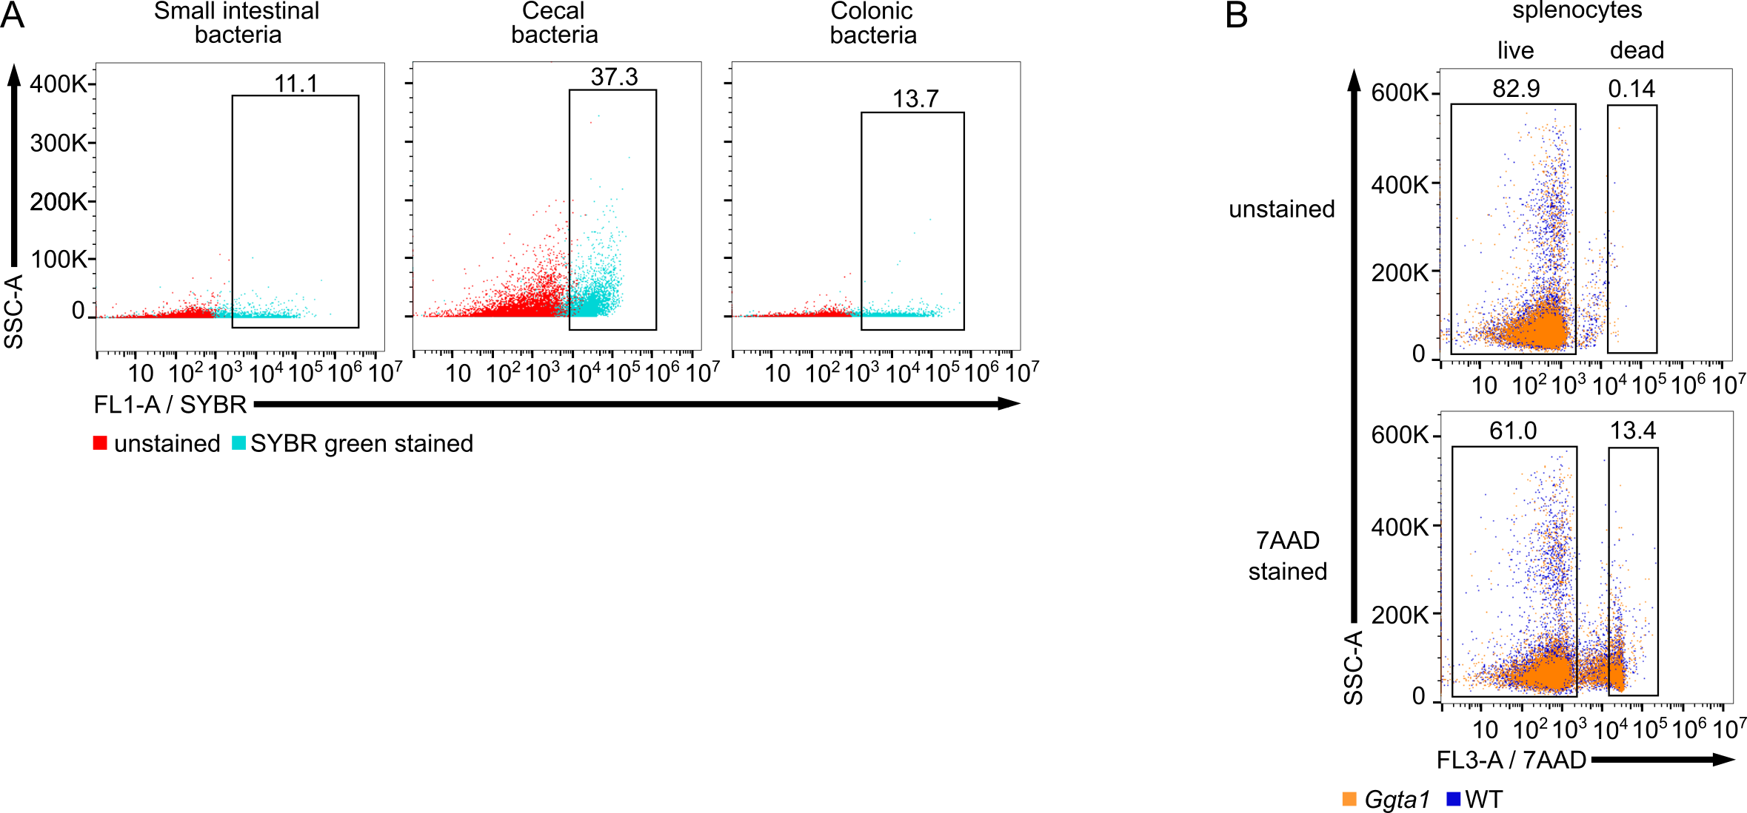
Supplementary Figure 2. Representative flow cytometry plots displaying pre-gating for bacterial and live cell identification for plots shown in Figure 5 C-D. (A) Identification of bacteria via SYBR green positive staining of intestinal contents of small intestine, cecum and colon (B) Identification of live murine splenocytes via staining with 7AAD.

