Contents
Appendix 1: Consolidated Health Economic Evaluation Reporting Standards statement…….….2
Appendix 2: Supplementary figures………………………………………………………………5
Figure S1 Kaplan-Meier curves of the overall survival………………………………...5
Figure S2 Kaplan-Meier curves of the grafts’ survival…………………………………6
Figure S3 Direct medical costs in IPD setting……………………………………….7
Reference………………………………………………………………………………………….8

Appendix 1: Consolidated Health Economic Evaluation Reporting Standards statement

CHEERS 2022 Checklist¹
Topic | No. | Item | Location where item is reported
Title
 | 1 | Identify the study as an economic evaluation and specify the interventions being compared. | page 1, lines 1-2
Abstract
 | 2 | Provide a structured summary that highlights context, key methods, results, and alternative analyses. | page 1, lines 24-40
Introduction
Background and objectives | 3 | Give the context for the study, the study question, and its practical relevance for decision making in policy or practice. | page 3, lines 79-76
Methods
Health economic analysis plan | 4 | Indicate whether a health economic analysis plan was developed and where available. | Not available
Study population | 5 | Describe characteristics of the study population (such as age range, demographics, socioeconomic, or clinical characteristics). | page 3, lines 79-82
Setting and location | 6 | Provide relevant contextual information that may influence findings. | page 4, lines 88-97
Comparators | 7 | Describe the interventions or strategies being compared and why chosen. | page 4, lines 98-109
Perspective | 8 | State the perspective(s) adopted by the study and why chosen. | page 5, lines 163-166
Time horizon | 9 | State the time horizon for the study and why appropriate. | page 4, lines 100-102
Discount rate | 10 | Report the discount rate(s) and reason chosen. | page 4, lines 124-126
Selection of outcomes | 11 | Describe what outcomes were used as the measure(s) of benefit(s) and harm(s). | page 5, lines 149-161
Measurement of outcomes | 12 | Describe how outcomes used to capture benefit(s) and harm(s) were measured. | page 5, lines 149-161
Valuation of outcomes | 13 | Describe the population and methods used to measure and value outcomes. | page 5, lines 172-178
Measurement and valuation of resources and costs | 14 | Describe how costs were valued. | page 5, lines 163-178
Currency, price date, and conversion | 15 | Report the dates of the estimated resource quantities and unit costs, plus the currency and year of conversion. | page 6, lines 179-183
Rationale and description of model | 16 | If modelling is used, describe in detail and why used. Report if the model is publicly available and where it can be accessed. | Not available
Analytics and assumptions | 17 | Describe any methods for analysing or statistically transforming data, any extrapolation methods, and approaches for validating any model used. | page 4, lines 98-120
Characterising heterogeneity | 18 | Describe any methods used for estimating how the results of the study vary for subgroups. | Not available
Characterising distributional effects | 19 | Describe how impacts are distributed across different individuals or adjustments made to reflect priority populations. | Not available
Characterising uncertainty | 20 | Describe methods to characterise any sources of uncertainty in the analysis. | page 4, lines 127-134
Approach to engagement with patients and others affected by the study | 21 | Describe any approaches to engage patients or service recipients, the general public, communities, or stakeholders (such as clinicians or payers) in the design of the study. | Not available
Results
Study parameters | 22 | Report all analytic inputs (such as values, ranges, references) including uncertainty or distributional assumptions. | page 4, lines 138-147, table 1
Summary of main results | 23 | Report the mean values for the main categories of costs and outcomes of interest and summarise them in the most appropriate overall measure. | page 6, lines 209-225  table 3,4,5
Effect of uncertainty | 24 | Describe how uncertainty about analytic judgments, inputs, or projections affect findings. Report the effect of choice of discount rate and time horizon, if applicable. | page 7, lines 226-239  Figure 2
Effect of engagement with patients and others affected by the study | 25 | Report on any difference patient/service recipient, general public, community, or stakeholder involvement made to the approach or findings of the study | Not available
Discussion
Study findings, limitations, generalisability, and current knowledge | 26 | Report key findings, limitations, ethical or equity considerations not captured, and how these could affect patients, policy, or practice. | page 9, lines 319-359
Other relevant information
Source of funding | 27 | Describe how the study was funded and any role of the funder in the identification, design, conduct, and reporting of the analysis | Not available
Conflicts of interest | 28 | Report authors conflicts of interest according to journal or International Committee of Medical Journal Editors requirements. | page 10, lines 372-373

Appendix 2: Supplementary figures

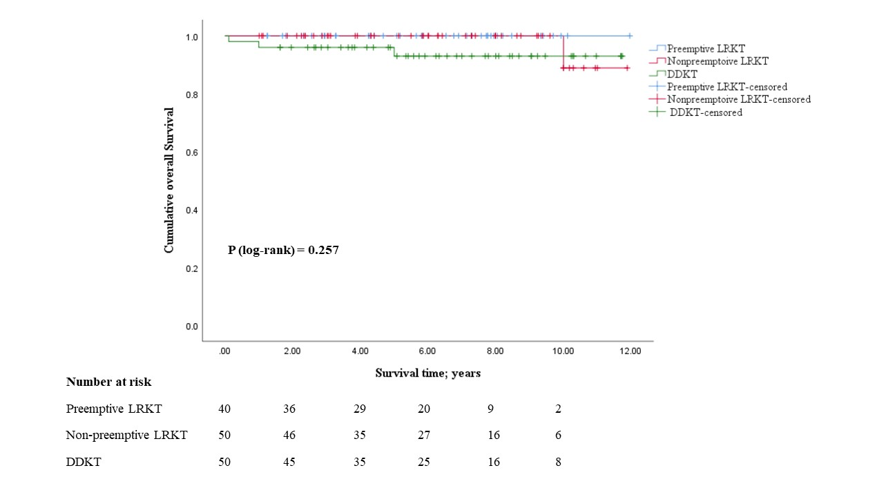
Figure S1 Kaplan-Meier curves of the overall survival
DDKT, deceased-donor kidney transplantation; LRKT, living-related kidney transplantation

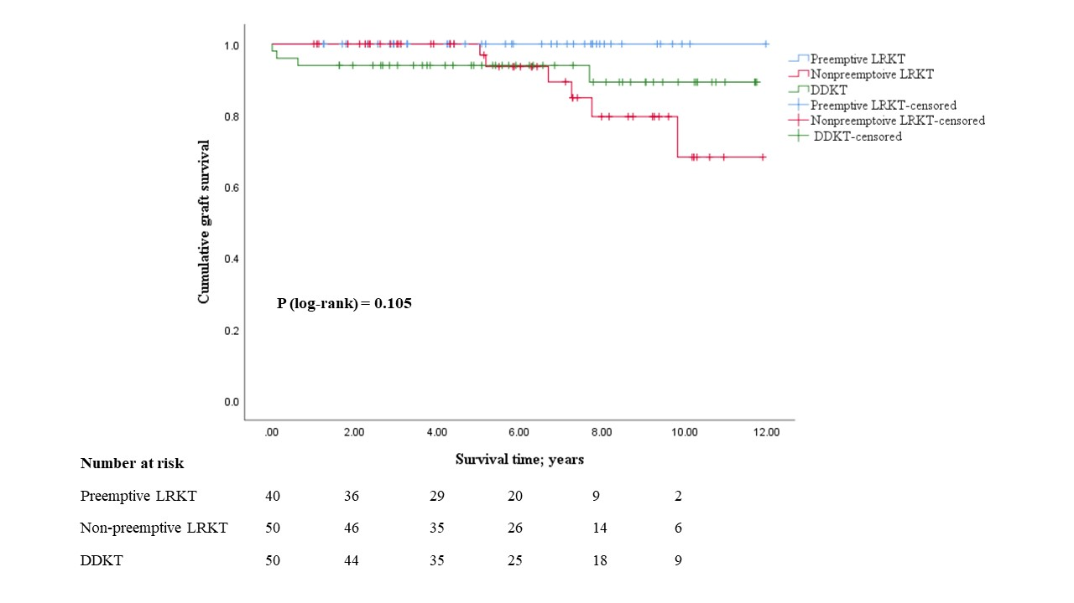
Figure S2 Kaplan-Meier curves of the grafts’ survival
DDKT, deceased-donor kidney transplantation; LRKT, living-related kidney transplantation

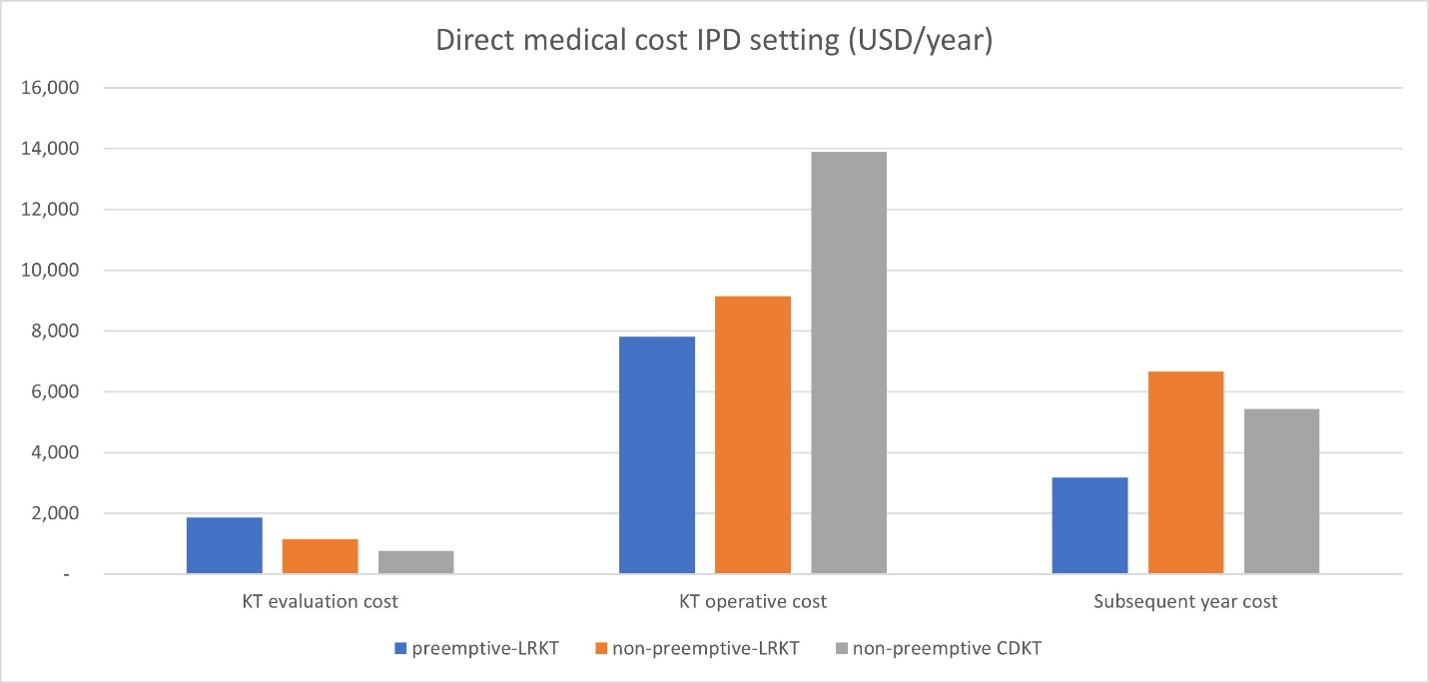
Figure S3 Direct medical costs in IPD setting
DDKT, deceased-donor kidney transplantation; IPD, inpatient department; LRKT, living-related kidney transplantation

Reference
1. Husereau D, Drummond M, Augustovski F, et al. Consolidated Health Economic Evaluation Reporting Standards 2022 (CHEERS 2022) Explanation and Elaboration: A Report of the ISPOR CHEERS II Good Practices Task Force. Value Health 2022;25. doi:10.1016/j.jval.2021.10.008

