Supplementary Materials to Age-Related Differences in Amygdala Activation Associated with Face Trustworthiness but No Evidence of Oxytocin Modulation by Lin, Pehlivanoglu, Ziaei, Liu, Woods, Feifel, Fischer, & Ebner

Behavioral Results: Effects of Treatment Group (Oxytocin vs. Placebo) on Face Trustworthiness Ratings. The interaction between treatment group and face trustworthiness level on face trustworthiness ratings was not significant [F(3.01, 280.25) = 2.22, p = 0.086, η_{p}² = 0.023].
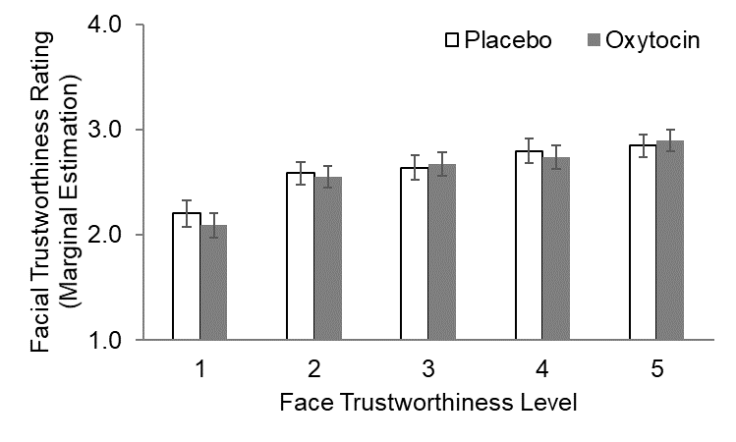
Figure S1. Face trustworthiness ratings (with higher scores indicating higher trustworthiness ratings) as a function of face trustworthiness level in the placebo and oxytocin groups. Error bars indicate 95% confidence intervals.

Table S1. Marginal Estimates [Mean (Standard Error)] of Face Trustworthiness Ratings by Face Trustworthiness Level for Young and Older Participants in the Placebo and Oxytocin Groups.
 | Young |  | Older
Face Trustworthiness Level | Placebo | Oxytocin | Placebo | Oxytocin
 | Mean (SE) | Mean (SE) | Mean (SE) | Mean (SE)
1 | 2.10 (0.09) | 2.09 (0.08) | 2.31 (0.09) | 2.09 (0.08)
2 | 2.46 (0.08) | 2.49 (0.07) | 2.72 (0.08) | 2.61 (0.07)
3 | 2.62 (0.08) | 2.61 (0.08) | 2.65 (0.08) | 2.73 (0.08)
4 | 2.77 (0.08) | 2.75 (0.08) | 2.82 (0.08) | 2.73 (0.08)
5 | 2.87 (0.08) | 2.91 (0.07) | 2.83 (0.08) | 2.88 (0.07)
Note. SE = Standard Error.

Neuroimaging Results: Effects of Treatment Group (Oxytocin vs. Placebo) on Left Amygdala Activity Associated with Face Trustworthiness. The interaction between treatment group and the linear effect of face trustworthiness on left amygdala activity was not significant (B = 0.10, z = 1.65, p = 0.098). Please see Table S2 for all effects from the multilevel modeling analyses on left and right amygdala activity.
Table S2. Results of the Multilevel Linear Regression for Age Group, Treatment Group, and the Linear/Quadratic Trends of Face Trustworthiness on Left and Right Amygdala Activity
 | Left Amygdala |  |  | Right Amygdala
Fixed Effect | B (SE) | [95% CI] | B (SE) |  | [95% CI]
Age Group | -0.25 (0.42) | [-1.08, 0.57] | -0.71 (0.32) |  | [-1.33, -0.09]
Treatment Group | 0.28 (0.44) | [-0.59, 1.15] | -0.0003 (0.32) |  | [-0.63, 0.63]
Age Group × Treatment Group | 0.06 (0.65) | [-1.21, 1.32] | 0.27 (0.46) |  | [-0.63, 1.17]
Face Trustworthiness (Linear) | -0.13 (0.04) | [-0.21, -0.06] | -0.1 (0.03) |  | [-0.16, -0.04]
Age Group × Face Trustworthiness (Linear) | 0.03 (0.06) | [-0.07, 0.14] | 0.09 (0.04) |  | [0.01, 0.18]
Treatment Group × Face Trustworthiness (Linear) | 0.1 (0.06) | [-0.02, 0.21] | 0.06 (0.05) |  | [-0.03, 0.16]
Age Group × Treatment Group × Face Trustworthiness (Linear) | -0.14 (0.09) | [-0.31, 0.04] | -0.08 (0.07) |  | [-0.21, 0.06]
Face Trustworthiness (Quadratic) | 0.03 (0.04) | [-0.06, 0.11] | 0.05 (0.03) |  | [0.001, 0.10]
Age Group × Face Trustworthiness (Quadratic) | 0.02 (0.06) | [-0.1, 0.14] | 0.04 (0.03) |  | [-0.03, 0.11]
Treatment Group × Face Trustworthiness (Quadratic) | -0.04 (0.05) | [-0.15, 0.07] | -0.03 (0.03) |  | [-0.09, 0.04]
Age Group × Treatment Group × Face Trustworthiness (Quadratic) | -0.02 (0.09) | [-0.2, 0.16] | -0.04 (0.05) |  | [-0.14, 0.06]
Sex | 0.05 (0.27) | [-0.48, 0.57] | 0.11 (0.18) |  | [-0.24, 0.45]
Intercept | 1.25 (0.32) | [0.61, 1.89] | 1.08 (0.24) |  | [0.61, 1.55]
Random Effect | σ² (SE) | [95% CI] | σ² (SE) |  | [95% CI]
Intercept | 1.58 (0.28) | [1.11, 2.23] | 0.68 (0.10) |  | [0.51, 0.90]
Note. Bold print indicates significant effects at p < 0.05.

