Supplementary Material
Synthesis and evaluation of 5-fluoro-2-oxindole derivatives as α-glucosidase inhibitors
Jing Lin†, Qi-Ming Liang†, Yuan-Na Ye, Di Xiao, Li Lu, Meng-Yue Li, Jian-Ping Li, Yu-Fei Zhang, Zhuang Xiong*, Na Feng*, Chen Li*
School of Biotechnology and Health Sciences, Wuyi University, Jiangmen 529000, P. R. China

†Jing Lin and Qi-Ming Liang contributed equally to this work.
*Corresponding authors: Zhuang Xiong, Na Feng, Chen Li. Email: wyuchemxz@126.com; wyuchemfn@126.com; wyuchemlc@126.com. Tel./fax.: +86 750 3299397

- IC₅₀ of 3d, 3f, 3i and acarbose against α-glucosidase ………………………………………..2-3
- Lineweaver-Burk plots of acarbose………………………………….………….......................4
- Inhibitory mechanism analysis of 3d and 3i………………………………………………..…5-6
- ¹H NMR of compounds 3a ~ 3v………………………………………………………………7-17

Fig. S1 IC₅₀ of compound 3d against α-glucosidase
Fig. S2 IC₅₀ of compound 3f against α-glucosidase

Fig. S3 IC₅₀ of compound 3i against α-glucosidase

Fig. S4 IC₅₀ of acarbose against α-glucosidase
Fig.S5 Lineweaver-Burk plots of acarbose against α-glucosidase

Fig.S6 Inhibition mechanism determination of compound 3d on α-glucosidase
Fig.S7 Inhibition mechanism determination of compound 3i on α-glucosidase.

Fig.8 Lineweaver-Burk plots of compounds 3d and 3i on α-glucosidase. Plot of slope vs the concentration of compounds 3d and 3i for the calculation of the inhibition constant K_{I}. Plot of intercept vs the concentration of compounds 3d and 3i for the determination of the inhibition constant K_{IS}.

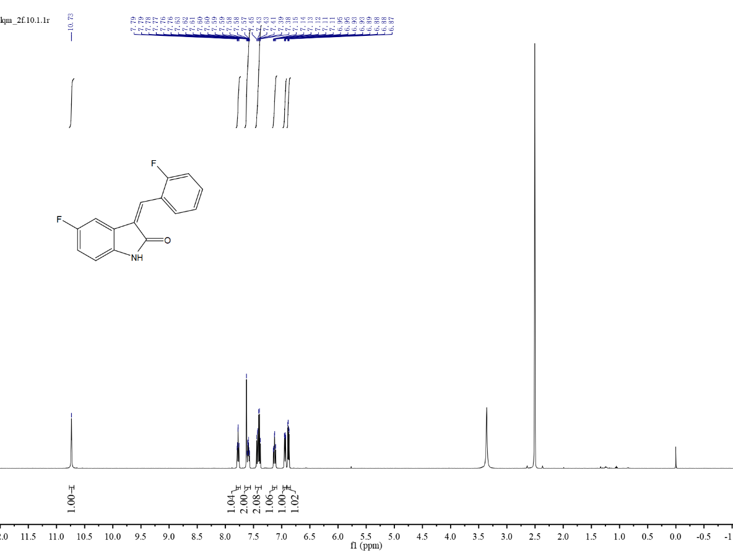
Fig.S9 ¹H NMR of compound 3a
Fig.S10 ¹H NMR of compound 3b
Fig.S11 ¹H NMR of compound 3c
Fig.S12 ¹H NMR of compound 3d
Fig.S13 ¹H NMR of compound 3e
Fig.S14 ¹H NMR of compound 3f
Fig.S15 ¹H NMR of compound 3g
Fig.S16 ¹H NMR of compound 3h
Fig.S17 ¹H NMR of compound 3i
Fig.S18 ¹H NMR of compound 3j
Fig.S19 ¹H NMR of compound 3k
Fig.S20 ¹H NMR of compound 3l
Fig.S21 ¹H NMR of compound 3m
Fig.S22 ¹H NMR of compound 3n
Fig.S23 ¹H NMR of compound 3o
Fig.S24 ¹H NMR of compound 3p
Fig.S25 ¹H NMR of compound 3q
Fig.S26 ¹H NMR of compound 3r
Fig.S27 ¹H NMR of compound 3s
Fig.S28 ¹H NMR of compound 3t
Fig.S29 ¹H NMR of compound 3u
Fig.S30 ¹H NMR of compound 3v

