Supplementary Material

Copper-nanocoated ultra-small cells in grain boundaries inside an extinct vent chimney

Hinako Takamiya¹, Mariko Kouduka¹, Hitoshi Furutani¹, Hiroki Mukai², Kaoru Nakagawa³, Takushi Yamamoto³, Shingo Kato⁴, Yu Kodama⁵, Naotaka Tomioka⁶, Motoo Ito⁶, and Yohey Suzuki¹

¹Department of Earth and Planetary Science, The University of Tokyo, 7-3-1 Hongo, Bunkyo-ku, Tokyo 113-0033, Japan

²Faculty of Life and Environmental Sciences, University of Tsukuba, Tennodai 1-1-1, Tsukuba, Ibaraki 305-8572, Japan
³ Solutions COE, Analytical & Measuring Instruments Division, Shimadzu Corporation, 1, Nishinokyo Kuwabara-cho, Nakagyo-ku, Kyoto 604-8511, Japan

⁴Japan Collection of Microorganisms (JCM), RIKEN BioResource Research Center, 3-1-1 Koyadai, Tsukuba, Ibaraki 305-0074, Japan ⁵TOYO Corporation,⁵TOYO Corporation, 1-6, Yaesu 1-chome, Chuo-ku, Tokyo 103-8284, Japan ⁶Kochi Institute for Core Sample Research, Japan Agency for Marine-Earth Science and Technology (JAMSTEC), Monobe B200, Nankoku, Kochi 783-8502, Japan

*Yohey Suzuki

Email: yohey-suzuki@eps.s.u-tokyo.ac.jp

This file includes:

Figures S1 to S9

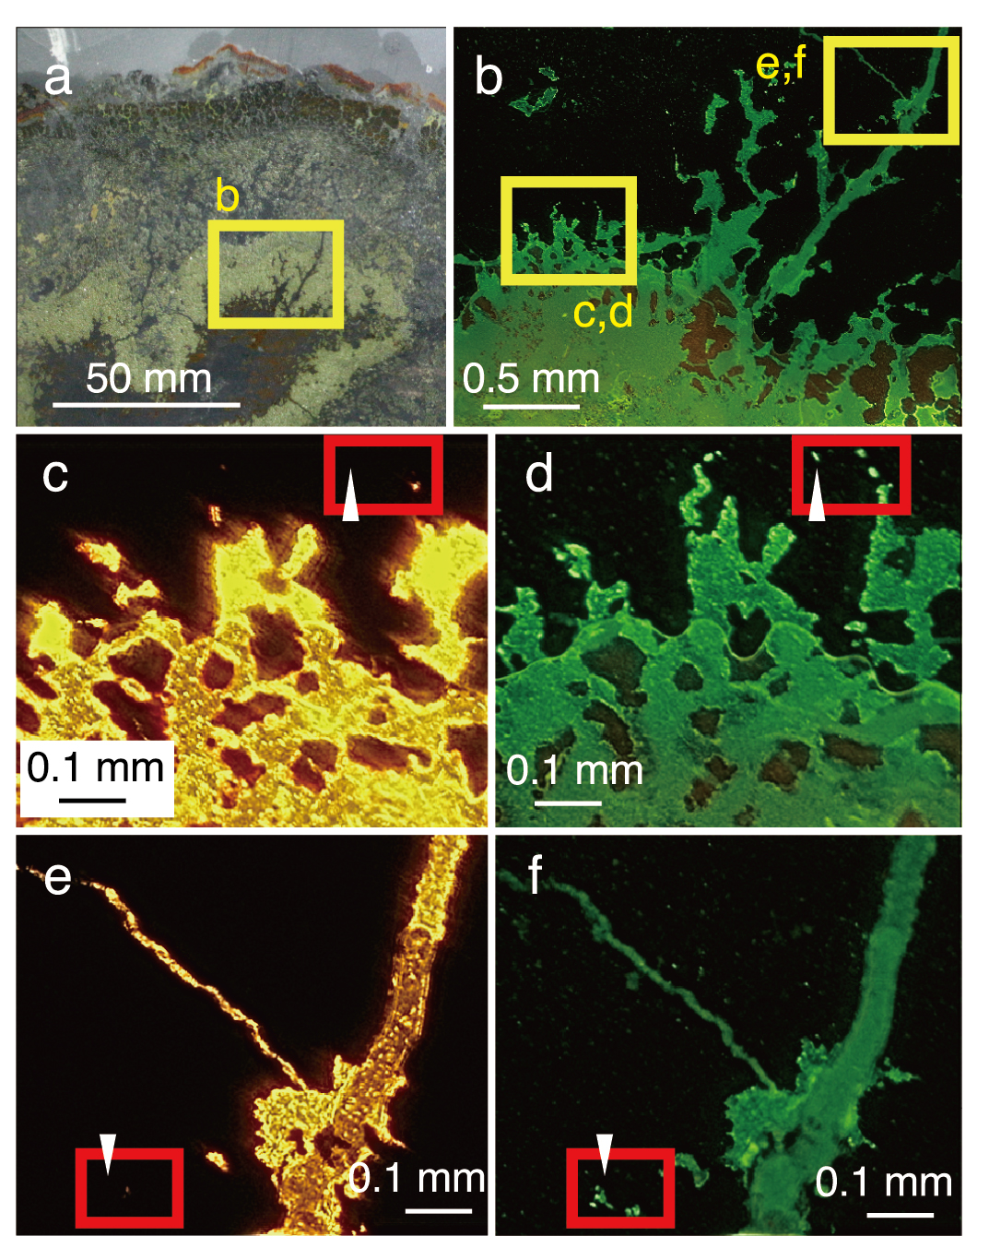

Supplementary Figure 1. Light and fluorescence microscopy images of a SYBR Green I-stained thin section from the extinct chimney. a, Optical microscope image. b, Low-magnification fluorescence image. c, Middle-magnification transmitted-light image. d, Middle-magnification fluorescence image. e, Middle-magnification transmitted-light image. f, Middle-magnification fluorescence image. Yellow rectangles highlight areas observed at higher magnifications in separate images. Red rectangles and arrows highlight SYBR-Green stained grain boundaries without light transmission.

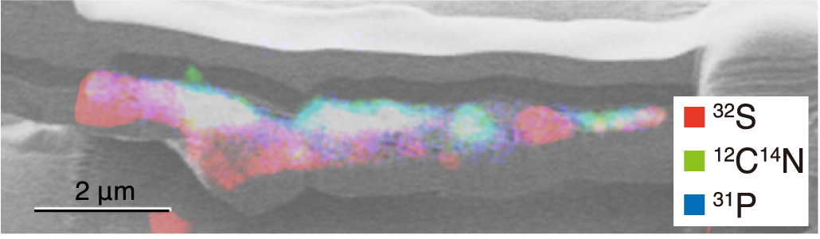

Supplementary Figure 2. Elemental distribution in a silicate-bearing layer with sub-micron voids. Overlay image of a Ga ion image in black and white and the Nanoscale secondary ion mass spectrometry (NanoSIMS) images of ³²S in red, ¹²C¹⁴N in green, and ³¹P in blue.

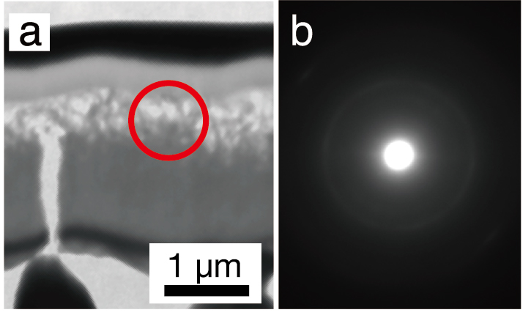

Supplementary Figure 3. Mineralogical characterizations of a fibrous silica-bearing layer in a 300-nm thick FIB section. a, Transmission electron microscope (TEM) image. b, A selected area electron diffraction (SAED) pattern. Extended Fig. 3b was taken from a red circle in Extended Fig. 3a.

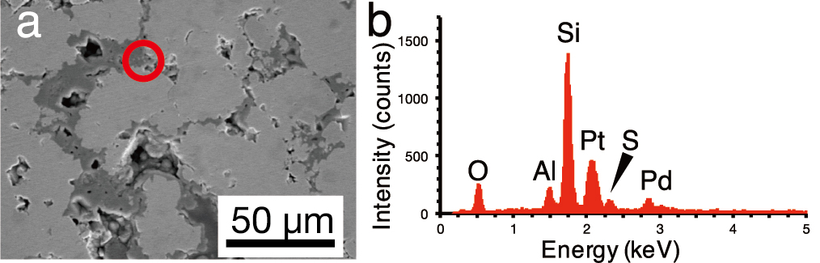

Supplementary Figure 4. Mineralogical characterizations of a region fabricated for a 150-nm thick FIB section. a, Scanning electron microscope (SEM) image. b, Energy-dispersive X-ray spectroscopy (EDS) spectrum of a red circle in Extended Fig. 4.

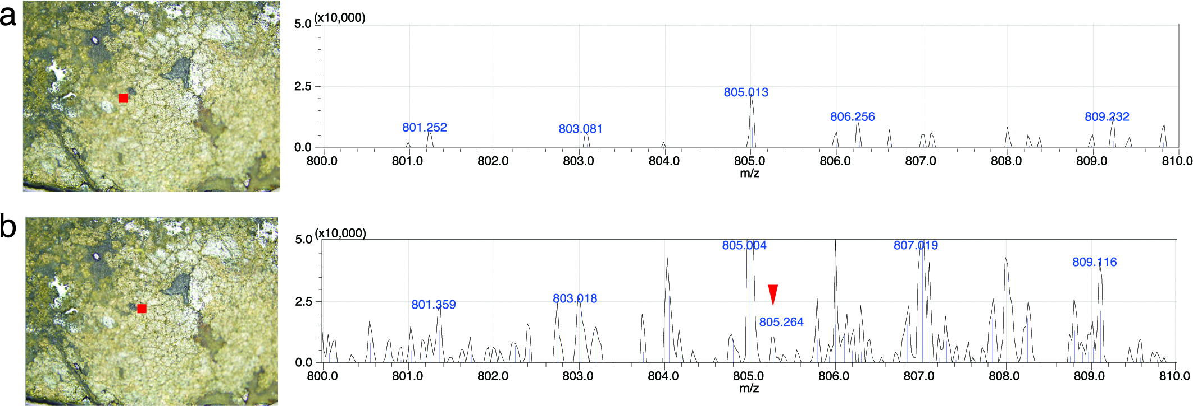

Supplementary Figure 5. Imaging mass spectrometry analysis of grain boundaries of the inner chalcopyrite wall. Spot analysis was conducted at each filled square in the left images. a-b, Chalcopyrite grain boundary.

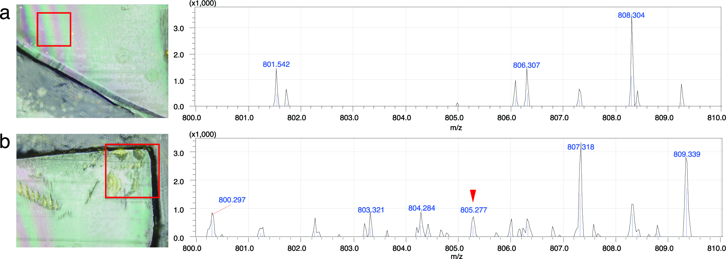

Supplementary Figure 6. Imaging mass spectrometry analysis of a 12.5-μm thick section of cultured cells of Thermococcus kodakarensis. Scan analysis was conducted in each red square. a, resin. b, cell aggregates.

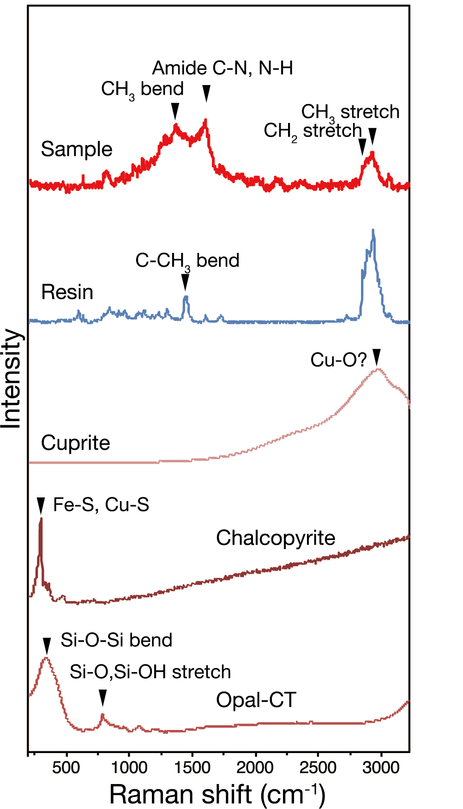

Supplementary Figure 7. Comparison of Raman spectra from a grain boundary in the inner chalcopyrite wall and references. A spectrum marked with “sample” is also shown in Fig. 4b. A spectrum marked with “resin” was obtained from LR White resin. Cuprite, chalcopyrite and opal-CT were shown as spectra obtained from RRUFF (http://rruff.info)(Lafuente et al. 2015). Peak positions in opal-CT are almost the same as those in amorphous silica (Sodo et al. 2016).

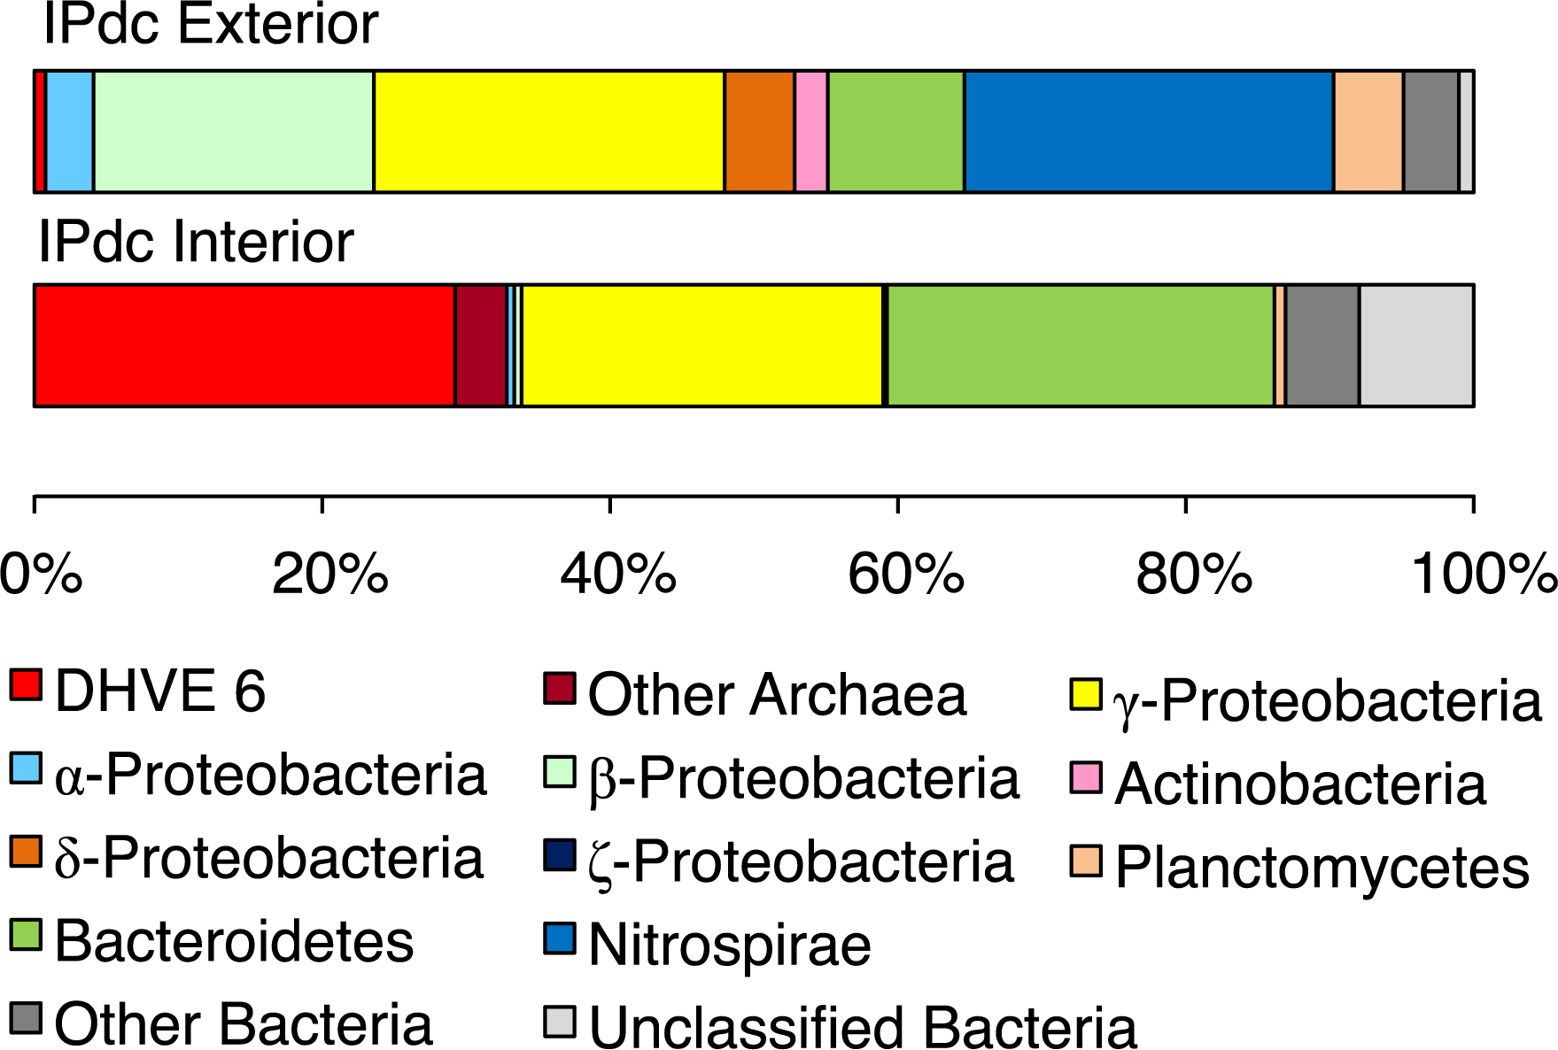
Supplementary Figure 8. Microbial community structures based on prokaryotic 16S rRNA gene sequences from the chimney interior and exterior. The relative abundances of sequences classified by phylum or class are shown.

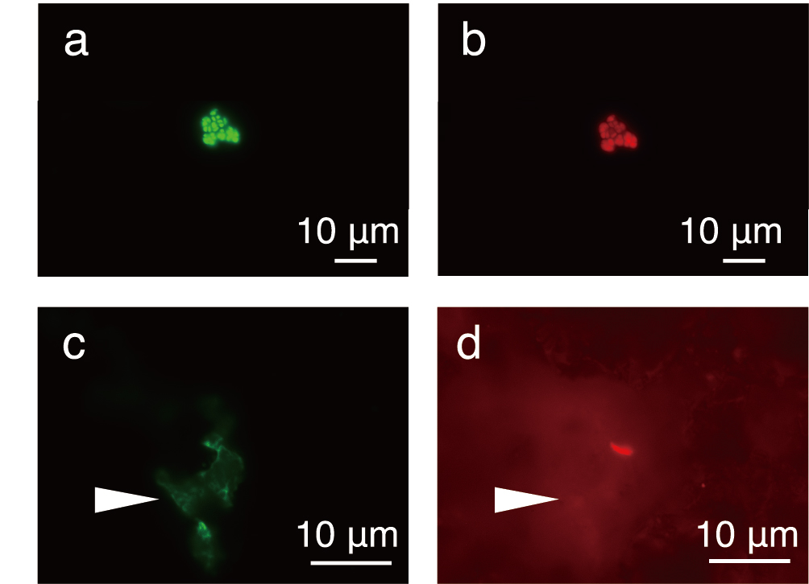
Supplementary Figure 9. Application of FISH to resin-embedded microbial cells in thin sections. a-b, Cultured cells of Methanocaldococcus sp. Mc-365-70 stained with SYBR-Green I (left) and a Cy5-labelled Archaea-universal probe called Arch915 (right). c-d, Grain boundary of the inner chalcopyrite wall stained with SYBR-Green I (left) and a Cy5-labelled Pacearchaeota-targeted probe called Pace915 (right). A white arrow indicates a grain boundary region, in which greenish spots stained by SYBR-Green I (left) are not associated with Cy5-derived signals (right).

References
Lafuente, B., Downs, R., Yang, H., & Stone, N. (2015) The power of databases: the RRUFF project. In “Highlights in mineralogical crystallography”, Armbruster, T. & Danisi, RM, eds. W. De Gruyter, Berlin, Germany 1:30.
Sodo, A., Casanova Municchia, A., Barucca, S., Bellatreccia, F., Della Ventura, G., Butini, F., & Ricci, M. A. (2016) Raman, FT‐IR and XRD investigation of natural opals. J Raman Spectrosc 47:444-1451. doi.org/10.1002/jrs.4972

