Supplementary Material

Supplementary Figures (Figures S1-S6)

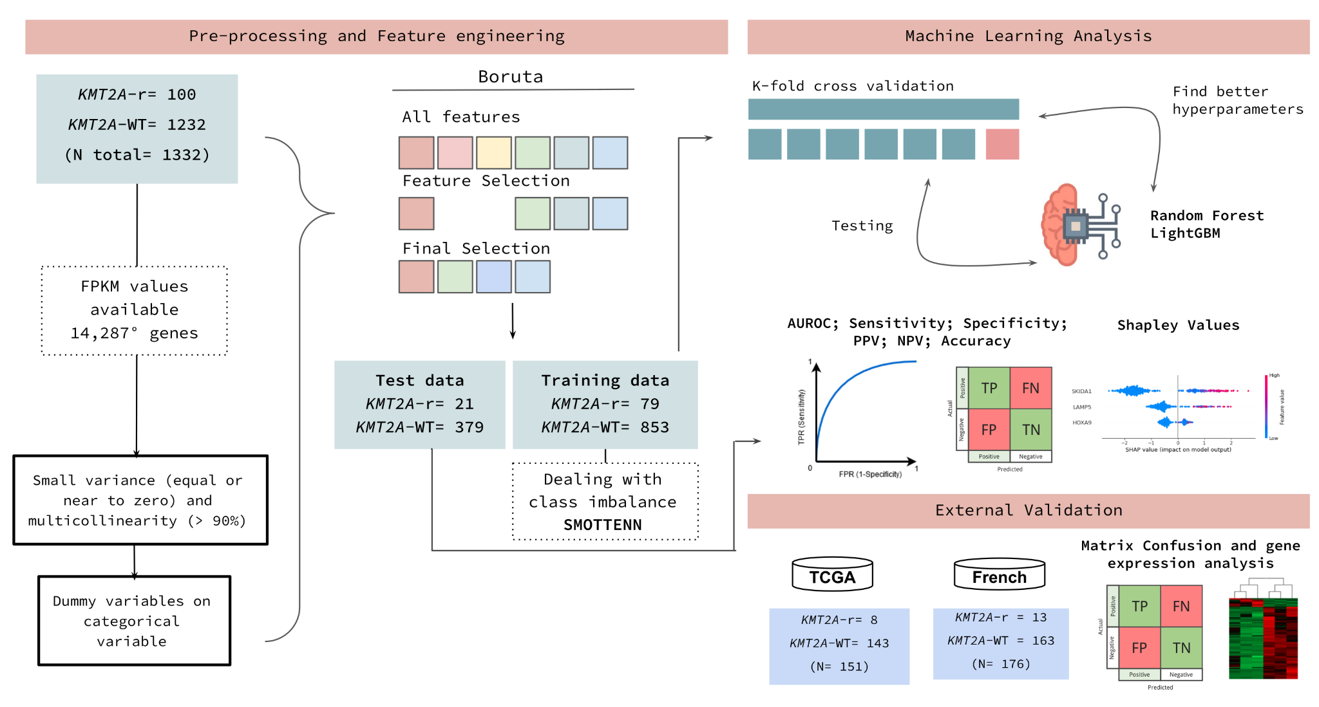Figure S1. Workflow of machine learning analysis.

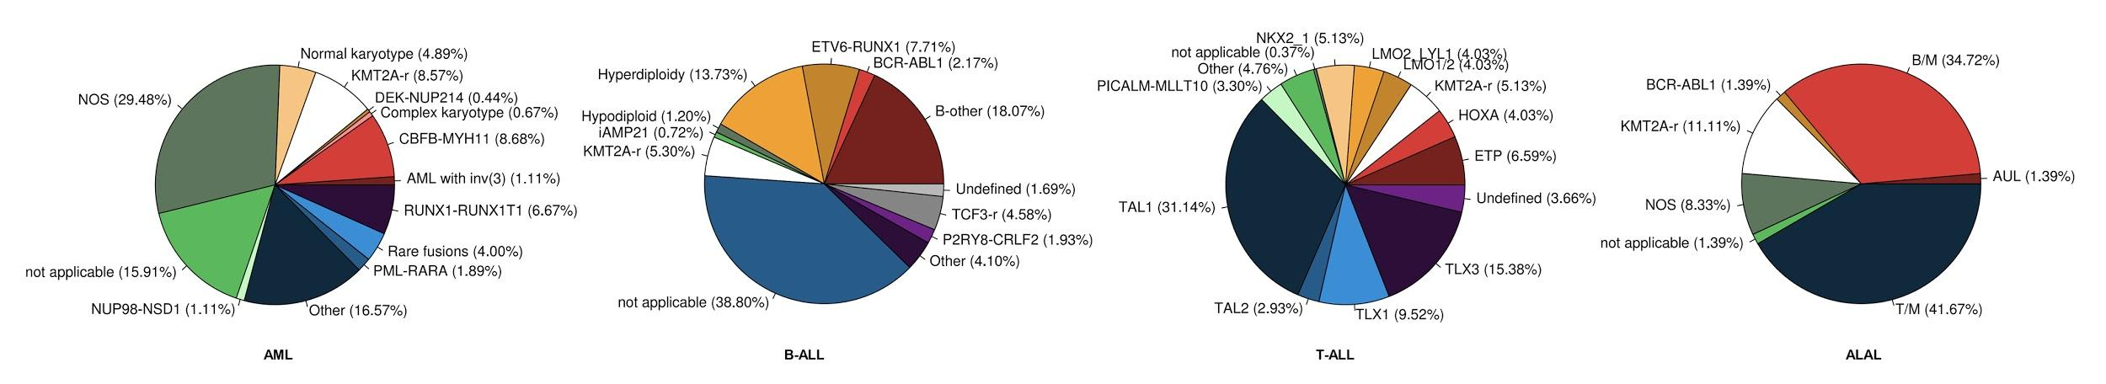
Figure S2. Cytogenetic and molecular characterization of acute leukemia included in this work. The pie charts illustrate the frequencies of the different cytogenetic/molecular subgroups in our entire cohort according to acute leukemia subtypes: AML, B-ALL, T-ALL, and ALAL. The KMT2A-r subgroup is highlighted in white boxes.

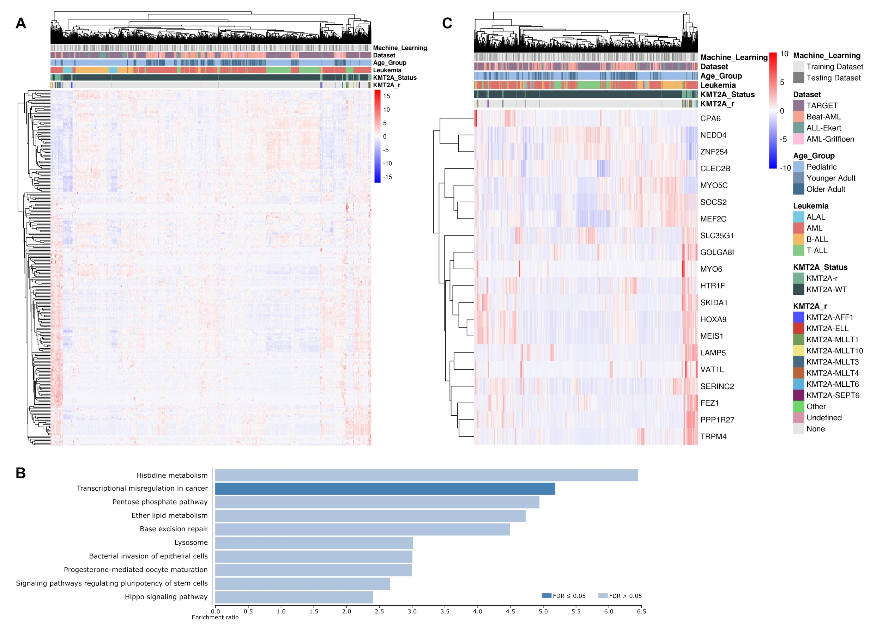
Figure S3. Gene expression of KMT2A-r predictors. (A) Heatmap showing the expression of 247 genes selected by our machine learning model, and (B) its pathway enrichment analysis. Dark blue bars represent significant pathways (FDR ≤ 0.05). (C) Heatmap illustrating the expression of top 20 genes with the greatest contribution for the prediction of KMT2A-r in the LightGBM algorithm model.
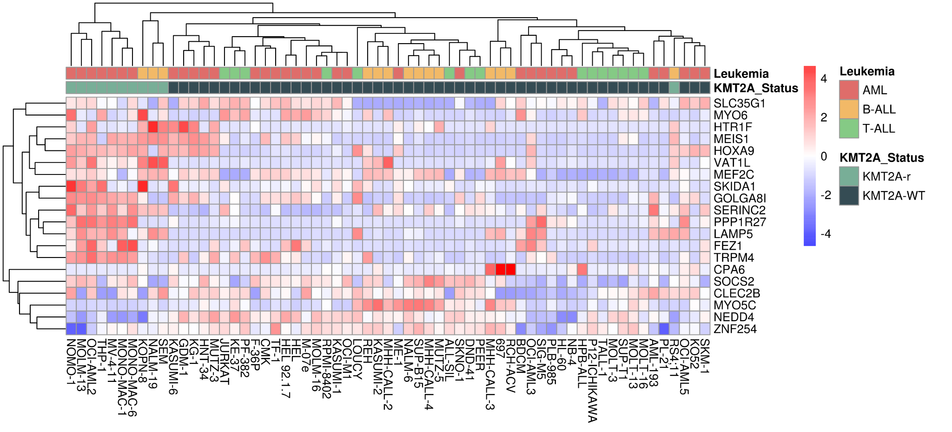
Figure S4. Validation of KMT2A-r predictors in acute leukemia cell lines. Heatmap showing the expression of top 20 genes selected by our final machine learning model in acute leukemia cell lines samples.

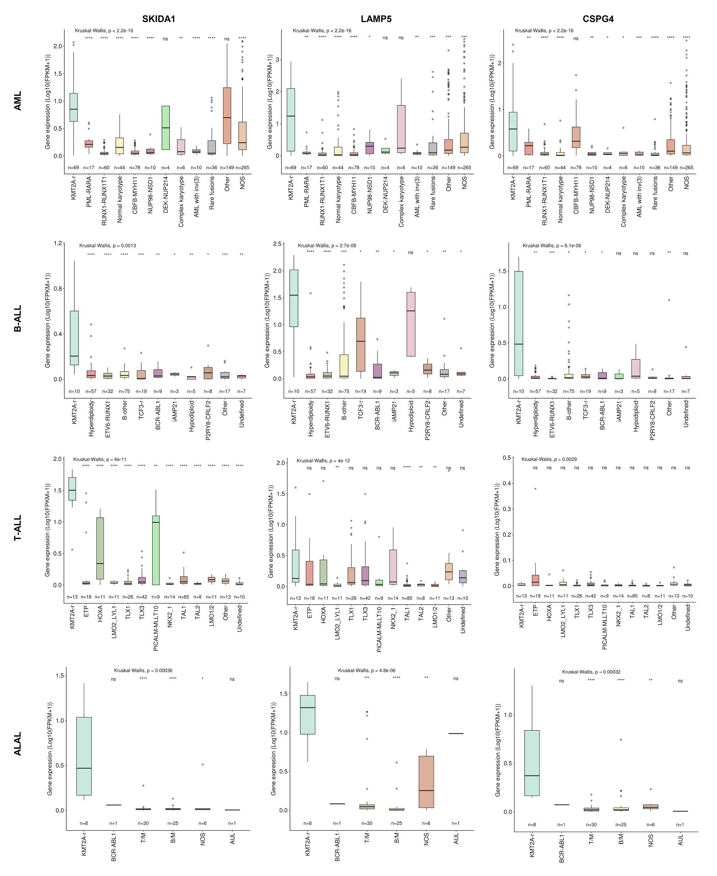
Figure S5. Relationship between SKIDA1, LAMP5, and CSPG4 expression and acute leukemia subgroups. Transcript expression among cytogenetic/molecular subgroups in their respective acute leukemia subtypes. KMT2A-r was used as the reference group for statistical analyses. ns: P > 0.05; *: P ≤ 0.05; **: P ≤ 0.01; ***: P ≤ 0.001; ****: P ≤ 0.0001.
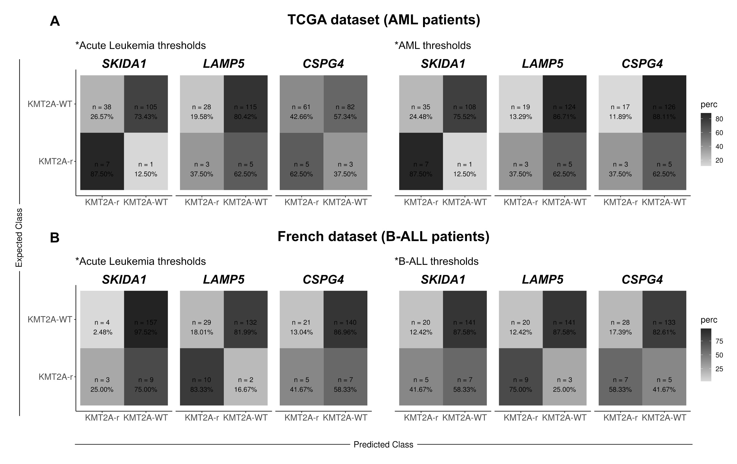
Figure S6. Validation of potential biomarkers for KMT2A-r. Confusion matrices demonstrating the predictive power of SKIDA1, LAMP5 and CSPG4 for KMT2A-r in the validation cohorts of (A) AML (TCGA dataset) and (B) ALL (French dataset) using their respective thresholds.

- Supplementary Tables (Tables S1-S9)

Table S1. Description of datasets.
Cohorts |  |  |  | Data (number of samples) |  |  | KMT2A status (number of samples) |  | RNA-Seq
Datasets | Acute Leukemia Subtypes | Age group¹ | Data Availability | With KMT2A status | Gene expression (RNA-Seq) | Both  (N final) | KMT2A-WT | KMT2A-r | Library construction | Platform
Train/test datasets |  |  |  |  |  | N total = 1332 | N total = 1232 | N total = 100
TARGET² | B-ALL | Pediatric | dbGaP accession phs000464 | 143 | 187 | 143 | 139 | 4 | Paired-end | Illumina HiSeq2000
 | T-ALL |  | dbGaP accession phs000464 | 244 | 264 | 244 | 232 | 12 | Paired-end | Illumina HiSeq2000
 | AML |  | dbGaP accession phs000465 | 957 | 256 | 248 | 199 | 49 | Paired-end | Illumina HiSeq2500
 | ALAL |  | dbGaP accession phs000464 | 71 | 87 | 71 | 63 | 8 | Paired-end | Illumina HiSeq2500
Beat AML | AML | Pediatric and adult | dbGaP accession phs001657.v1.p1 | 609 | 451 | 403 | 390 | 13 | Paired-end | Illumina HiSeq2500
ALL-Ekert³ | B-ALL | Pediatric | EGA accession EGAS00001004212 | 99 | 99 | 99 | 93 | 6 | Paired-end | Illumina HiSeq4000
 | T-ALL |  |  | 27 | 27 | 27 | 26 | 1
AML-Griffioen³ | AML | Adult | EGA accession EGAS00001003096 | 100 | 98 | 97 | 90 | 7 | Paired-end | Illumina HiSeq2500
External validation datasets |  |  |  |  |  | N total = 327 | N total = 306 | N total = 21
TCGA | AML | Pediatric and adult | dbGaP accession phs000178 | 200 | 151 | 151 | 143 | 8 | Paired-end | Illumina HiSeq2000
French | B-ALL | Pediatric | Upon request | 173 | 173 | 173 | 161 | 12 | Paired-end | Illumina NovaSeq
 | T-ALL |  |  | 2 | 2 | 2 | 1 | 1
 | ALAL |  |  | 1 | 1 | 1 | 1 | 0
TOTAL | - |  | - | - | - | 1659 | 1538 | 121 | - | -
¹ Pediatric (<22y); Adult - younger adults (≥22y and <60y) and older adults (≥60y).
² Data was retrieved from TARGET ALL Phase II discovery cohort (B-ALL), TARGET ALL Phase II validation cohort (T-ALL), TARGET AML discovery cohort (AML) and TARGET ALL Phase III subproject (ALAL).
³ Fictitious dataset name: leukemia subtype-corresponding author's surname.

Table S2. Cohort characterization according to training and testing datasets.
Variables |  | Training Dataset |  |  |  |  |  |  | Testing Dataset |  |  |  |  |  |  | P-value*
 |  | Overall |  | KMT2A-r |  | KMT2A-WT |  |  | Overall |  | KMT2A-r |  | KMT2A-WT
Age group¹ |  |  |  |  |  |  |  |  |  |  |  |  |  |  |  | 0.643
Pediatric |  | 596 | (63.9) | 63 | (79.7) | 533 | (62.5) |  | 247 | (61.8) | 16 | (76.2) | 231 | (60.9)
Younger adult |  | 167 | (17.9) | 15 | (19.0) | 152 | (17.8) |  | 72 | (18.0) | 4 | (19.0) | 68 | (17.9)
Older adult |  | 169 | (18.1) | 1 | (1.3) | 168 | (19.7) |  | 81 | (20.3) | 1 | (4.8) | 80 | (21.1)
Sex |  |  |  |  |  |  |  |  |  |  |  |  |  |  |  | 0.900
Female |  | 384 | (41.2) | 42 | (53.2) | 342 | (40.1) |  | 167 | (41.8) | 10 | (47.6) | 157 | (41.4)
Male |  | 548 | (58.8) | 37 | (46.8) | 511 | (59.9) |  | 233 | (58.3) | 11 | (52.4) | 222 | (58.6)
Sample type |  |  |  |  |  |  |  |  |  |  |  |  |  |  |  | 0.532
Diagnosis |  | 836 | (89.7) | 77 | (97.5) | 759 | (89.0) |  | 357 | (89.3) | 21 | (100.0) | 336 | (88.7)
Refractory |  | 65 | (7.0) | 1 | (1.3) | 64 | (7.5) |  | 28 | (7.0) | 0 | (0.0) | 28 | (7.4)
Relapse |  | 14 | (1.5) | 1 | (1.3) | 13 | (1.5) |  | 9 | (2.3) | 0 | (0.0) | 9 | (2.4)
Remission |  | 12 | (1.3) | 0 | (0.0) | 12 | (1.4) |  | 6 | (1.5) | 0 | (0.0) | 6 | (1.6)
Unknown |  | 5 | (0.5) | 0 | (0.0) | 5 | (0.6) |  | 0 | (0.0) | 0 | (0.0) | 0 | (0.0)
Leukemia Subtype |  |  |  |  |  |  |  |  |  |  |  |  |  |  |  | 0.163
B-ALL |  | 157 | (16.8) | 8 | (10.1) | 149 | (17.5) |  | 85 | (21.3) | 2 | (9.5) | 83 | (21.9)
T-ALL |  | 192 | (20.6) | 11 | (13.9) | 181 | (21.2) |  | 79 | (19.8) | 2 | (9.5) | 77 | (20.3)
AML |  | 528 | (56.7) | 53 | (67.1) | 475 | (55.7) |  | 220 | (55.0) | 16 | (76.2) | 204 | (53.8)
ALAL |  | 55 | (5.9) | 7 | (8.9) | 48 | (5.6) |  | 16 | (4.0) | 1 | (4.8) | 15 | (4.0)
KMT2A status |  |  |  |  |  |  |  |  |  |  |  |  |  |  |  | 0.053
KMT2A-r |  | 79 | (8.5) | - |  | - |  |  | 21 | (5.3) | - |  | -
KMT2A-WT |  | 853 | (91.5) | - |  | - |  |  | 379 | (94.8) | - |  | -
TOTAL |  | 932 | (100.0) | 79 | (100.0) | 853 | (100.0) |  | 400 | (100.0) | 21 | (100.0) | 379 | (100.0) |  | -

* Pearson's Chi-squared test.
¹ Pediatric (<22y); Adult - younger adults (≥22y and <60y) and older adults (≥60y).

Table S3. Cytogenetic/molecular alterations according to training and testing datasets.
Subgroups |  | Training Dataset |  |  | Testing Dataset
AML
AML with inv(3) |  | 6 | (1.1) |  | 4 | (1.8)
PML-RARA |  | 14 | (2.7) |  | 3 | (1.4)
CBFB-MYH11 |  | 61 | (11.6) |  | 17 | (7.7)
RUNX1-RUNX1T1 |  | 43 | (8.1) |  | 17 | (7.7)
KMT2A-r |  | 53 | (10.0) |  | 16 | (7.3)
Normal karyotype |  | 30 | (5.7) |  | 14 | (6.4)
Rare fusions |  | 23 | (4.4) |  | 13 | (5.9)
DEK-NUP214 |  | 3 | (0.6) |  | 1 | (0.5)
NUP98-NSD1 |  | 8 | (1.5) |  | 2 | (0.9)
Complex karyotype |  | 5 | (0.9) |  | 1 | (0.5)
Other |  | 100 | (18.9) |  | 49 | (22.3)
NOS |  | 182 | (34.5) |  | 83 | (37.7)
B-ALL
B-other |  | 49 | (31.2) |  | 26 | (30.6)
Hyperdiploidy |  | 37 | (23.6) |  | 20 | (23.5)
TCF3-r |  | 13 | (8.3) |  | 6 | (7.1)
ETV6-RUNX1 |  | 19 | (12.1) |  | 13 | (15.3)
KMT2A-r |  | 8 | (5.1) |  | 2 | (2.4)
BCR-ABL1 |  | 3 | (1.9) |  | 6 | (7.1)
iAMP21 |  | 2 | (1.3) |  | 1 | (1.2)
P2RY8-CRLF2 |  | 7 | (4.5) |  | 1 | (1.2)
Hypodiploidy |  | 3 | (1.9) |  | 2 | (2.4)
Other |  | 11 | (7.0) |  | 6 | (7.1)
Undefined |  | 5 | (3.2) |  | 2 | (2.4)
T-ALL
TAL1 |  | 56 | (29.2) |  | 29 | (36.7)
TLX3 |  | 33 | (17.2) |  | 9 | (11.4)
TLX1 |  | 20 | (10.4) |  | 6 | (7.6)
ETP |  | 10 | (5.2) |  | 8 | (10.1)
NKX2_1 |  | 10 | (5.2) |  | 4 | (5.1)
LMO2_LYL1 |  | 9 | (4.7) |  | 2 | (2.5)
KMT2A-r |  | 11 | (5.7) |  | 2 | (2.5)
LMO1/2 |  | 7 | (3.6) |  | 4 | (5.1)
TAL2 |  | 4 | (2.1) |  | 4 | (5.1)
PICALM-MLLT10 |  | 5 | (2.6) |  | 4 | (5.1)
HOXA |  | 8 | (4.2) |  | 3 | (3.8)
Other |  | 9 | (4.7) |  | 4 | (5.1)
Undefined |  | 10 | (5.2) |  | 0 | (0.0)
ALAL
T/M |  | 25 | (45.5) |  | 5 | (31.3)
B/M |  | 17 | (30.9) |  | 8 | (50.0)
KMT2A-r |  | 7 | (12.7) |  | 1 | (6.3)
NOS |  | 5 | (9.1) |  | 1 | (6.3)
BCR-ABL1 |  | 0 | (0.0) |  | 1 | (6.3)
AUL |  | 1 | (1.8) |  | 0 | (0.0)
TOTAL |  | 932 | (100.0) |  | 400 | (100.0)

Table S4a. Performance measures of machine learning models.
Performance measures* |  | Random Forest |  |  |  |  | LightGBM
 |  | 247 genes without clinical variables | 247 genes with clinical variables | 247 genes with Age group variable | 247 genes with Leukemia variable |  | 247 genes without clinical variables | 247 genes with clinical variables | 247 genes with Age group variable | 247 genes with Leukemia variable
AUC |  | 0.984 | 0.985 | 0.987 | 0.984 |  | 0.988 | 0.989 | 0.988 | 0.988
Accuracy |  | 0.970 | 0.975 | 0.973 | 0.970 |  | 0.973 | 0.970 | 0.970 | 0.970
Sensitivity |  | 0.810 | 0.857 | 0.810 | 0.810 |  | 0.905 | 0.905 | 0.905 | 0.857
Specificity |  | 0.979 | 0.982 | 0.982 | 0.979 |  | 0.976 | 0.974 | 0.974 | 0.976
PPV |  | 0.680 | 0.720 | 0.708 | 0.680 |  | 0.679 | 0.655 | 0.655 | 0.667
NPV |  | 0.989 | 0.992 | 0.989 | 0.989 |  | 0.995 | 0.995 | 0.995 | 0.992
* KMT2A-r as “positive” class

Table S4b. Performance measures of machine learning models on Top 20 genes.
Performance measures* |  | LightGBM
 |  | 20 genes without clinical variables | 20 genes with clinical variables | 20 genes with Age group variable | 20 genes with Leukemia variable**
AUC |  | 0.979 | 0.985 | 0.978 | 0.984
Accuracy |  | 0.965 | 0.970 | 0.973 | 0.970
Sensitivity |  | 0.905 | 0.905 | 0.905 | 0.905
Specificity |  | 0.968 | 0.974 | 0.976 | 0.974
PPV |  | 0.613 | 0.655 | 0.679 | 0.655
NPV |  | 0.995 | 0.995 | 0.995 | 0.995
* KMT2A-r as “positive” class
** Performed better when validated using data obtained from the TCGA (AUC: 0.868)"

Table S5. Information about the false negative/positive groups.
Patient ID | Type error | KMT2A Status | KMT2A-r | Leukemia Subtype | Molecular Subgroup | Machine Learning Dataset | Study | Age (in years) | Sex
TARGET-20-PASWAT | False negative | KMT2A-r | KMT2A-SEPT6 | AML | KMT2A-r | Test | TARGET | 14.1 | Female
TARGET-10-PASZJW | False negative | KMT2A-r | KMT2A-CT45A4 | T-ALL | KMT2A-r | Test | TARGET | 30.0 | Male
TCGA-AB-2834 | False negative | KMT2A-r | KMT2A-ELL | AML | KMT2A-r | Validation | TCGA | 33.0 | Male
TCGA-AB-2844 | False negative | KMT2A-r | KMT2A-ELL | AML | KMT2A-r | Validation | TCGA | 63.0 | Male
21597 | False negative* | KMT2A-r | KMT2A-USP2 | B-ALL | KMT2A-r | Validation | French | 0.7 | Female
26181 | False negative* | KMT2A-r | KMT2A-7q22.3 | B-ALL | KMT2A-r | Validation | French | 6.6 | Male
29468 | False negative* | KMT2A-r | KMT2A-MGMT | B-ALL | KMT2A-r | Validation | French | 9.3 | Male
TARGET-20-PANGJY | False positive | KMT2A-WT | None | AML | Other | Test | TARGET | 1.6 | Female
TARGET-20-PASBPK | False positive | KMT2A-WT | None | AML | Other | Test | TARGET | 0.4 | Male
TARGET-10-PANYEJ | False positive | KMT2A-WT | None | B-ALL | Hyperdiploidy | Test | TARGET | 1.9 | Male
TARGET-10-PATKYI | False positive | KMT2A-WT | None | T-ALL | ETP | Test | TARGET | 20.9 | Male
13-00255 | False positive | KMT2A-WT | None | AML | NOS | Test | Beat-AML | 72.0 | Male
14-00012 | False positive | KMT2A-WT | None | AML | Other | Test | Beat-AML | 72.0 | Male
14-00231 | False positive | KMT2A-WT | None | AML | NOS | Test | Beat-AML | 57.0 | Female
15-00563 | False positive | KMT2A-WT | None | AML | NOS | Test | Beat-AML | 2.0 | Female
16-00951 | False positive | KMT2A-WT | None | AML | NOS | Test | Beat-AML | 42.0 | Male
3-032 | False positive | KMT2A-WT | None | AML | Other | Test | EGA-AML | 58.0 | Female
TCGA-AB-2925 | False positive | KMT2A-WT | None | AML | Not applicable | Validation | TCGA | 57.0 | Male
TCGA-AB-2861 | False positive | KMT2A-WT | None | AML | Not applicable | Validation | TCGA | 76.0 | Male
27635 | False positive* | KMT2A-WT | None | B-ALL | Not applicable | Validation | French | 0.3 | Male
23591 | False positive* | KMT2A-WT | None | B-ALL | Not applicable | Validation | French | 0.4 | Female
27473 | False positive* | KMT2A-WT | None | B-ALL | Not applicable | Validation | French | 0.5 | Male
27181 | False positive* | KMT2A-WT | None | B-ALL | Not applicable | Validation | French | 0.7 | Male
27865 | False positive* | KMT2A-WT | None | B-ALL | Not applicable | Validation | French | 0.7 | Male
24088 | False positive* | KMT2A-WT | None | B-ALL | Not applicable | Validation | French | 0.8 | Female
27769 | False positive* | KMT2A-WT | None | B-ALL | Not applicable | Validation | French | 1.7 | Female
28011 | False positive* | KMT2A-WT | None | B-ALL | Not applicable | Validation | French | 3.1 | Female
26302 | False positive* | KMT2A-WT | None | B-ALL | Not applicable | Validation | French | 10.8 | Male
27150 | False positive* | KMT2A-WT | None | B-ALL | Not applicable | Validation | French | 11.0 | Female
*Type error considered based on hierarchical clustering (Figure 2D)
Table S6. Performance measures by single genes in TCGA and French datasets.
Performance measures* |  | AML patients (TCGA) |  |  |  | B-ALL patients (French)
 |  | SKIDA1 | LAMP5 | CSPG4 |  | SKIDA1 | LAMP5 | CSPG4
The overall acute leukemia threshold
Accuracy |  | 0.742 | 0.781 | 0.576 |  | 0.925 | 0.821 | 0.838
Sensitivity |  | 0.875 | 0.375 | 0.625 |  | 0.250 | 0.833 | 0.417
Specificity |  | 0.734 | 0.802 | 0.573 |  | 0.975 | 0.820 | 0.870
PPV |  | 0.155 | 0.097 | 0.076 |  | 0.429 | 0.256 | 0.192
NPV |  | 0.990 | 0.958 | 0.965 |  | 0.946 | 0.985 | 0.952
The respective acute leukemia subtype threshold (AML or B-ALL)
Accuracy |  | 0.762 | 0.841 | 0.854 |  | 0.844 | 0.867 | 0.810
Sensitivity |  | 0.875 | 0.375 | 0.375 |  | 0.417 | 0.750 | 0.583
Specificity |  | 0.755 | 0.867 | 0.881 |  | 0.876 | 0.876 | 0.826
PPV |  | 0.167 | 0.136 | 0.150 |  | 0.200 | 0.310 | 0.200
NPV |  | 0.991 | 0.961 | 0.962 |  | 0.953 | 0.980 | 0.964
* KMT2A-r as “positive” class

Table S7. KMT2A fusions according to acute leukemia subtypes in machine learning datasets.
Acute leukemia | KMT2A status | KMT2A fusions
AML | KMT2A-r (n = 69) | KMT2A-MLLT3 (n = 35)
 | KMT2A-WT (n = 679) | KMT2A-MLLT10 (n = 13)
 |  | KMT2A-MLLT4 (n = 7)
 |  | KMT2A-ELL (n = 4)
 |  | KMT2A-MLLT1 (n = 2)
 |  | KMT2A-SEPT6 (n = 2)
 |  | KMT2A-AFF1 (n = 1)
 |  | KMT2A-CEP170B (n = 1)
 |  | KMT2A-MLLT6 (n = 1)
 |  | other KMT2A (n = 3)
B-ALL | KMT2A-r (n = 10) | KMT2A-AFF1 (n = 3)
 | KMT2A-WT (n = 232) | KMT2A-SARNP (n = 1)
 |  | KMT2A-USP2 (n = 1)
 |  | Undefined (n = 5)
T-ALL | KMT2A-r (n = 13) | KMT2A-MLLT1 (n = 8)
 | KMT2A-WT (n = 258) | KMT2A-CT45A4 (n = 1)
 |  | KMT2A-ELL (n = 1)
 |  | KMT2A-MLLT4 (n = 1)
 |  | KMT2A-MLLT6 (n = 1)
 |  | KMT2A-MLLT10 (n = 1)
ALAL | KMT2A-r (n = 8) | KMT2A-AFF1 (n = 5)
 | KMT2A-WT (n = 63) | KMT2A-TET1 (n = 1)
 |  | other KMT2A (n = 2)

Table S8. Acute leukemia cell lines included in this study from GDSC database.
KMT2A status | Acute leukemia | Cell line name (KMT2A fusion)
KMT2A-r (n = 6) | B-ALL (n = 1) | RS4;11 (KMT2A-AFF1)
 | AML (n = 5) | MOLM-13 (KMT2A-MLLT3)
 |  | MONO-MAC-6 (KMT2A-MLLT3)
 |  | NOMO-1 (KMT2A-MLLT3)
 |  | OCI-AML2 (KMT2A-MLLT4)
 |  | THP-1 (KMT2A-MLLT3)
KMT2A-WT (n = 27) | B-ALL (n = 1) | SUP-B15
 | T-ALL (n = 11) | ALL-SIL | P12-ICHIKAWA
 |  | DND-41 | PF-382
 |  | Jurkat | RPMI-8402
 |  | KE-37 | SUP-T1
 |  | MOLT-13 | TALL-1
 |  | MOLT-16
 | AML (n = 15) | CMK | NB4
 |  | GDM-1 | OCI-AML3
 |  | HEL | OCI-AML5
 |  | HL-60 | OCI-M1
 |  | KASUMI-1 | P31-FUJ
 |  | KG-1 | PL-21
 |  | ME-1 | SIG-M5
 |  | MOLM-16

Table S9. Drug-gene interactions according to DGIdb database.
Drug | Genes
Fluorouracil | SELE | PERP | GSTP1 | CDC25C
 | VEGFA | EXO1 | CYP19A1 | ERBB2
 | PTEN | DPYS | MUC2 | RGS5
 | CYP2C19 | BIRC5 | CHN2 | TPT1
 | ABCB1 | ENOSF1 | TP53AIP1 | RBX1
 | PTPRC | DPYD | MEGF11 | ITGAL
 | KRAS | IRS1 | ERCC1 | IGFBP3
 | XRCC1 | HLA-G | HSPA5 | CBR3
 | ALDH3A1 | SHMT1 | FOXO1 | PON1
 | FPGS | ABCG1 | CYP3A4 | DKK1
 | KLC1 | REV3L | ABCG2 | FAS
 | EGFR | CYP2A6 | MET | PARD3B
 | UMPS | DTYMK | IL2RA | AURKA
 | CYP2C8 | TOP2A | CDKN1A | ATM
 | APC | NOS1 | PIK3CA | HMMR
 | HBB | TMEM167A | CYP1B1 | NT5C1A
 | CYP2E1 | TYMP | CBLB | LGR5
 | TP53 | GNAS | BDNF | INSR
 | CCND1 | XRCC4 | MTHFR | NQO1
 | PIK3R2 | ALCAM | MIR27A | CBR1
 | XRCC3 | IL6R | FGFR4 | SMAD4
 | DLG5 | SLCO1B1 | NOS3 | BRAF
 | WNT5B | ABCC5 | ABCC4
 | IL11 | TSHB | CCNK
Foretinib | KDR | TEK | KIT | MST1R
 | FLT4 | FLT3 | FLT1 | YES1
 | PDGFRA | MET | PDGFRB | ROS1
Pevonedistat | UBA3 | NAE1 | SAE1 | UBA2

- Supplementary File (File S1)

File S1. Feature selection by the Boruta method

Keep: ['PQLC2', 'COL9A2', 'AKR7A2', 'PTPRU', 'IL12RB2', 'BMP8B', 'STMN1', 'TXNDC12', 'C1orf54', 'FCGR1A', 'MCOLN2', 'FAM213B', 'CACHD1', 'SV2A', 'WDR63', 'SLC22A15', 'SERINC2', 'LPAR3', 'RNPEP', 'CLCNKA', 'RNF220', 'SPAG6', 'NEBL', 'MLLT10', 'DNTT', 'LZTS2', 'CISD1', 'DNAJC1', 'COMMD3', 'ZEB1', 'IPMK', 'REEP3', 'ZNF503', 'SLC35G1', 'FZD8', 'SKIDA1', 'KIAA1598', 'CASC10', 'DNAJC9', 'TMEM109', 'HIPK3', 'KIAA1549L', 'DPF2', 'ZC3H12C', 'FEZ1', 'TPP1', 'VPS37C', 'PRKCDBP', 'PLA2G16', 'RAB39A', 'CADM1', 'SVIP', 'SLC6A13', 'CD4', 'BCAT1', 'NUAK1', 'CLEC2B', 'LIN7A', 'ACRBP', 'SOCS2', 'BHLHE41', 'ITGA7', 'FGD4', 'CACNA2D4', 'PLBD2', 'CRADD', 'WNT10B', 'POLE', 'SMAD9', 'DACH1', 'PRKCH', 'SLC22A17', 'HIF1A', 'RIPK3', 'PARP2', 'OXA1L', 'NDRG2', 'CDCA4', 'NEDD4', 'CTSH', 'TGM5', 'MYO5C', 'GOLGA8I', 'LIPC', 'SPINT1', 'NIPA1', 'CSPG4', 'THSD4', 'KIF22', 'SYT17', 'ITGAX', 'NUDT7', 'ADCY9', 'LDHD', 'VAT1L', 'MT1F', 'CES1', 'GPR56', 'ALDH3A1', 'SCPEP1', 'C17orf53', 'KAT7', 'SLC47A1', 'CCL23', 'CBX2', 'PPP1R27', 'LRRC37B', 'ZNF532', 'MAPRE2', 'ZNF521', 'PAFAH1B3', 'TNNT1', 'PLD3', 'GRIN2D', 'ZNF85', 'ZFP30', 'ZSCAN18', 'C3', 'IGFLR1', 'TRPM4', 'ZNF331', 'KCNC3', 'ZNF776', 'ZNF256', 'BRSK1', 'FBXO27', 'ZNF91', 'HSD11B1L', 'ZNF571', 'ZNF329', 'LILRB4', 'ZNF681', 'ZNF418', 'ZNF682', 'ZNF772', 'ZNF461', 'ZNF544', 'ZNF43', 'ZNF254', 'ZNF134', 'ZNF844', 'ZNF737', 'ADAM23', 'TANC1', 'SPR', 'TGFBRAP1', 'DTNB', 'MEIS1', 'HNMT', 'AP1S3', 'B3GNT7', 'BRE', 'DAPL1', 'NMUR1', 'WDSUB1', 'MRPL33', 'PHACTR3', 'BFSP1', 'LAMP5', 'BTBD3', 'ZNF512B', 'SLC2A10', 'ZBTB21', 'UMODL1', 'CLTCL1', 'HMGXB4', 'UPK3A', 'CDC42EP1', 'IGF2BP2', 'PLCH1', 'ATG3', 'MBNL1', 'MRAS', 'CLSTN2', 'MAGEF1', 'HTR1F', 'VGLL3', 'PROM1', 'GUCY1B3', 'GLRB', 'TMEM156', 'CPEB2', 'MMRN1', 'OCIAD2', 'STK32B', 'GUCY1A3', 'RHOH', 'SMAD1', 'UNC5C', 'HEXB', 'MEF2C', 'NPR3', 'WWC1', 'MSX2', 'NRG2', 'RHOBTB3', 'IRX1', 'S100Z', 'ANXA2R', 'PRR16', 'BVES', 'WASF1', 'GPR126', 'QKI', 'SENP6', 'RUNX2', 'IL22RA2', 'NKAIN2', 'SUPT3H', 'MYO6', 'CD2AP', 'L3MBTL3', 'PPP1R3G', 'ETV1', 'HOXA9', 'ZC3HAV1', 'HOXA3', 'HOXA5', 'HOXA6', 'ABHD11', 'HOXA7', 'DYNC1I1', 'CLCN1', 'HOXA4', 'HOXA10', 'TRPS1', 'DNAJC5B', 'CPA6', 'FAM110B', 'PENK', 'CLDN23', 'VLDLR', 'GNA14', 'CDK20', 'PPAPDC3', 'PSIP1', 'FBP1', 'PBX3', 'GAS1', 'TDRD7', 'TKTL1', 'NXT2', 'FAM127A', 'CCNB3', 'RAB39B', 'KCNE1L', 'SAGE1']

