Supplementary Material

Supplementary Table S1. Standardized prevalence of obesity and overweight of different regions
Region |  | Prevalence of obesity* | Prevalence of overweight*
Central |  | 8.17 (7.71–8.68) | 11.04 (10.50–11.63)
East |  | 8.36 (8.00–8.75) | 11.29 (10.87–11.72)
North | 10.85 (9.37–12.73) |  | 11.75 (10.10–12.80)
Northeast |  | 9.48 (8.98–10.04) | 12.27 (11.68–12.90)
Northwest |  | 8.18 (6.27–10.83) | 12.76 (10.26–15.98)
South |  | 6.16 (5.75–6.61) | 9.45 (8.92–10.02)
Southwest |  | 6.68 (6.41–7.31) | 10.79 (10.17–11.46)
Prevalence was shown as % (95% CI).
* Adjusted by sex and age according to the 2010 China census population data.

Supplementary Table S2: BMI z-score changes by sex and age

 | Preschool |  |  | School-aged
Year | Total | Female | Male | Total | Female | Male
2017-2018 | 0.06 (1.20) | 0.02 (1.19) | 0.09 (1.20) | 0.21 (1.29) | 0.29 (1.25) | 0.13 (1.31)
2019 | 0.03 (1.36) | -0.03 (1.34) | 0.08 (1.37) | 0.21 (1.33) | 0.29 (1.31) | 0.13 (1.35)
2020 | 0.06 (1.31) | 0.03 (1.30) | 0.08 (1.31) | 0.41 (1.34) | 0.48 (1.29) | 0.32 (1.40)
2021 | 0.15 (1.24) | 0.12 (1.23) | 0.18 (1.24) | 0.37 (1.22) | 0.46 (1.19) | 0.26 (1.24)
Data were mean (SD).

Supplementary Table S3: BMI z-score changes by regions

 | Preschool |  |  |  |  |  |  | School-aged
 | Central | East | North | Northeast | Northwest | South | Southwest | Central | East | North | Northeast | Northwest | South | Southwest
2017-2018 | 0.04 (1.30) | -0.01 (1.21) | 0.18 (1.16) | 0.16 (1.27) | 0.06 (1.24) | -0.11 (1.27) | -0.03 (1.13) | 0.26 (1.37) | 0.23 (1.26) | 0.28 (1.31) | 0.31 (1.36) | 0.07 (1.27) | 0.05 (1.31) | 0.24 (1.2)
2019 | 0.04 (1.30) | 0.10 (1.34) | 0.13 (1.32) | 0.09 (1.39) | -0.02 (1.19) | -0.13 (1.39) | -0.15 (1.29) | 0.21 (1.30) | 0.23 (1.26) | 0.33 (1.39) | 0.27 (1.40) | 0.21 (1.25) | 0.01 (1.30) | 0.18 (1.25)
2020 | 0.14 (1.30) | 0.12 (1.33) | 0.13 (1.26) | 0.11 (1.25) | 0.06 (1.29) | -0.09 (1.32) | 0.00 (1.23) | 0.38 (1.30) | 0.44 (1.32) | 0.55 (1.36) | 0.56 (1.41) | 0.49 (1.30) | 0.23 (1.29) | 0.38 (1.28)
2021 | 0.13 (1.14) | 0.27 (1.23) | 0.43 (1.20) | 0.16 (1.28) | 0.32 (1.24) | -0.08 (1.28) | 0.00 (1.13) | 0.37 (1.17) | 0.38 (1.17) | 0.57 (1.25) | 0.40 (1.29) | 0.47 (1.30) | 0.19 (1.22) | 0.32 (1.16)
Data were mean (SD).

Supplementary Table S4. General characteristics different data resource

 | Hospital  (n = 447481) | Mobile terminal  (n = 208915) | P#
Female | 228585 (51.1%) | 93388 (44.7%) | < 0.0001
Age (years) | 7.67 (3.20) | 6.26 (2.91) | < 0.0001
Age groups (years) |  |  | < 0.0001
3–6 | 209033 (46.7%) | 154433 (73.9%)
7–11 | 189736 (42.4%) | 40676 (19.5%)
12–14 | 42390 (9.5%) | 10938 (5.2%)
15–19 | 6322 (1.4%) | 2868 (1.3%)
Region* |  |  | < 0.0001
Central | 47121 (10.5%) | 13925 (6.7%)
East | 130928 (29.3%) | 40013 (19.2%)
North | 125233 (28.0%) | 35807 (17.1%)
Northeast | 6449 (1.4%) | 7753 (3.7%)
Northwest | 5288 (1.2%) | 1521 (0.7%)
South | 75733 (16.9%) | 64309 (30.8%)
Southwest | 56729 (12.7%) | 8922 (4.3%)
BMI z-score | 0.18 (1.24) | 0.16 (1.47) | < 0.0001
Obesity status |  |  | < 0.0001
Obesity | 33578 (7.5%) | 16956 (8.1%)
Overweight | 48025 (10.7%) | 17725 (8.5%)
Obesity/Overweight | 81603 (18.2%) | 34681 (16.6%)
Data were n (%) or mean (SD). BMI=body-mass index.
* 36665 cases from mobile terminal didn’t have exact province. # p value for difference in different sexes.

Supplementary Table S5: BMI z-score changes during COVID-19 lockdown by different data resources

 | Total |  | Hospital |  | Mobile Terminal
Year | Preschool | School-aged | Preschool | School-aged | Preschool | School-aged
2017–2018 | 0.06 (1.20) | 0.21 (1.29) | 0.06 (1.16) | 0.19 (1.23) | 0.06 (1.33) | 0.34 (1.52)
2019 | 0.03 (1.36) | 0.21 (1.33) | -0.02 (1.21) | 0.15 (1.23) | 0.06 (1.45) | 0.41 (1.64)
Jan. – Jun. 2020 | 0.12 (1.33) | 0.45 (1.32) | 0.14 (1.24) | 0.42 (1.23) | 0.12 (1.39) | 0.51 (1.54)
Jul. – Dec. 2020 | 0.01 (1.29) | 0.38 (1.36) | 0.03 (1.25) | 0.37 (1.30) | -0.06 (1.38) | 0.42 (1.60)
Jan. – Apr. 2021 | 0.15 (1.24) | 0.37 (1.22) | 0.15 (1.18) | 0.36 (1.18) | 0.16 (1.36) | 0.41 (1.46)
Data were mean (SD).

Supplementary Figure S1: BMI z-score changes from 2017 to 2021.
*** p < 0.001

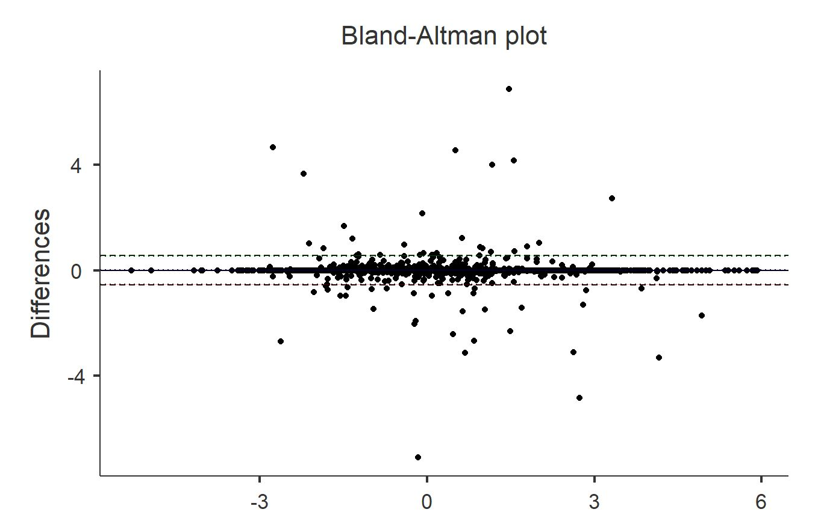

Supplementary Figure S2: Bland-Altman analysis of duplicated data

