Supplementary Material

Supplementary Figures and Tables

Supplementary Figures
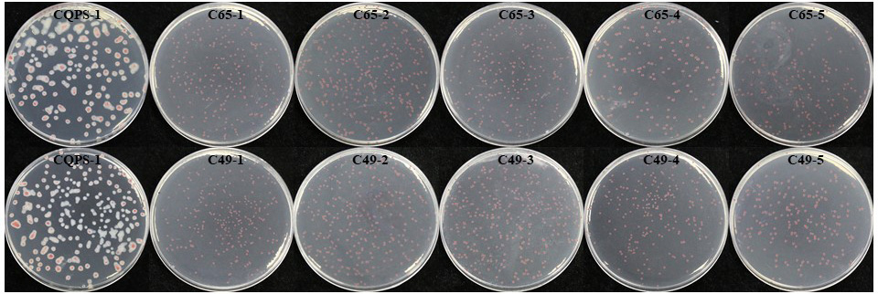
Supplementary Figure 1. Colony morphology of original and experimental Ralstonia solanacearum strains after the long-term serial passage experiment.

Supplementary Figure 2. Growth curves of the spp deletion mutant and the wild-type strain in minimal medium (MM medium) at pH 4.9. Error bars indicated the standard error of three independent biological replicates.

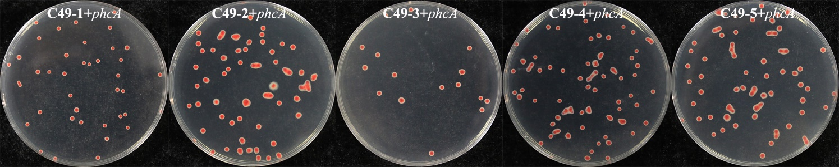
Supplementary Figure 3. Colony morphology of C49 strains complemented the phcA gene (under the control of its native promoter) by the complementary experiment.

Supplementary Tables
Supplementary Table 1. Primers used in this study.
Primers | Sequences (5’-3’)
spp-YZ-F | CGCACAATCCGCAACTCTTA
spp-YZ-R | GCACGGTACCCAAACCAGAT
phcA-YZ-F | ATGGTCAACGTCGATACCAAGC
phcA-YZ-R | AGACGGACAGCCGCGACT
pehR-YZ1-F | CATGTCCAAAGCTGCCGTC
pehR-YZ1-R | CGTTGAGCCGGTAGAACAAA
pehR-YZ2-F | TTTGTTCTACCGGCTCAACG
pehR-YZ2-R | GGCAAAGAAATCCAGCACGT
trmD-YZ-F | ATGTCATCTCGCTGTTCCCG
trmD-YZ-R | CGCTTGCGCATCGTATTCAA
phcA-A1SmaI | TCCCCCGGGTGGGCTACACGGAAGACAAG
phcA-B1C | GGAGGAGCGCGGTGCTGGCAGGGACGCTTTGGCTCAGACA
phcA-A2C | TGTCTGAGCCAAAGCGTCCCTGCCAGCACCGCGCTCCTCC
phcA-B2HindIII | CCCAAGCTTGCCGCCAAAACCCTTATGATTG
spp-EcoRI-F1 | GGAATTCCGCACAATCCGCAACTCTTA
spp-F2 | GTCCGGCCGGATCGCAACGGTAAATCCTTTTATAGATCAGTGA
spp-F3 | TCACTGATCTATAAAAGGATTTACCGTTGCGATCCGGCCGGAC
spp-HindIII-F5 | CCCAAGCTTGAACTGTCGGTCGGCGAG
phcAB2H | CTGGATCCAGACCTCAAGAACATCGGTC
phcAA1B | CTAAGCTTGCCAGCTACGACGAGATCTG

Supplementary Table 2. Genome sequencing information of each sample.
Strains | Clean Reads number | GC (%)ª | Q20 (%)^{b} | Q30 (%)^{c} | Average coverage depth | Mapped (%)^{d} | Properly_mapped (%)^{e}
C49-1 | 7506476 | 66.7 | 97.92 | 94.24 | 373 | 99.82 | 99.53
C49-2 | 8202147 | 66.73 | 98.16 | 94.8 | 396 | 99.83 | 99.59
C49-3 | 7660669 | 66.72 | 98.23 | 94.92 | 379 | 99.89 | 99.67
C49-4 | 7989473 | 66.63 | 97.78 | 93.91 | 389 | 99.84 | 99.56
C49-5 | 6512013 | 66.63 | 97.58 | 93.55 | 324 | 99.78 | 99.48
C65-1 | 7342215 | 66.86 | 97.66 | 93.65 | 368 | 99.81 | 99.51
C65-2 | 8769798 | 66.68 | 97.65 | 93.68 | 434 | 99.77 | 99.46
C65-3 | 7979882 | 66.69 | 97.96 | 94.33 | 399 | 99.81 | 99.53
C65-4 | 10182220 | 66.72 | 98 | 94.41 | 491 | 99.86 | 99.51
C65-5 | 7784499 | 66.7 | 98.19 | 94.72 | 380 | 99.87 | 99.56
Notes:
ªGC (%): Sample GC content
^{b}Q20 (%): The percentage of bases with a quality value greater than or equal to 20 to the total number of bases
^{c}Q30 (%): The percentage of bases with a quality value greater than or equal to 30 to the total number of bases
^{d}Mapped (%): The percentage of the number of clean reads located to the reference genome to the number of all clean reads
^{e}Properly_mapped (%): The paired-end sequencing reads are all located on the reference genome, and the distance is consistent with the length distribution of the sequenced fragments

Supplementary Table 3. Number of variant genes in 2000 generation acid experimental strains.
strains | Gene number of non synonymous SNP | Gene number of InDel | strains | Gene number of non synonymous SNP | Gene number of InDel
C65-1 | 1 | 127 | C49-1 | 1 | 128
C65-2 | 2 | 127 | C49-2 | 0 | 130
C65-3 | 3 | 126 | C49-3 | 1 | 129
C65-4 | 2 | 128 | C49-4 | 1 | 130
C65-5 | 2 | 127 | C49-5 | 2 | 128

