Promoting angiogenesis effect and molecular mechanism of Isopropyl Caffeate (KYZ), a novel metabolism-derived candidate drug, based on integrated network pharmacology and transgenic zebrafish models

Haotian Kong^{a,d,1}， Songsong Wang ^{a,1}， Yougang Zhangª， Qiuxia He^{b}， Rong Dongª， Xiaohui Zheng^{c,*}， Kechun Liu^{b,*}， Liwen Han^{a,*}
a. School of Pharmacy and Pharmaceutical Science, Shandong First Medical University and Shandong Academy of Medical Sciences, Jinan, China
b. Biology Institute of Shandong Academy of Sciences, Jinan, Shandong, China
c. College of Life Sciences, Northwest University, Xi’an, 710069, China
d. School of Basic Medical Sciences, Shandong University, Jinan, China

¹ These authors have contributed equally to this work and share the first authorship.
*Corresponding author at:zhengxh318@nwu.edu.cn (X.-H.Zheng),hliukch@sdas.org(K.-C.Liu),hanliwen@sdfmu.edu.cn(L.-W. Han).

Abbreviation

KYZ | Isopropyl caffeic acid
CA | caffeic acid
PTU | N-Phenylthiourea
DHI | Danhong Injection
PTK787 | Vatalanib dihydrochloride
FBS | Fetal Bovine Serum
hpf | hour post fertilization
ISV | intersegmental vascular
SIV | subintestinal vessel
CCK-8 | Cell Counting Kit-8

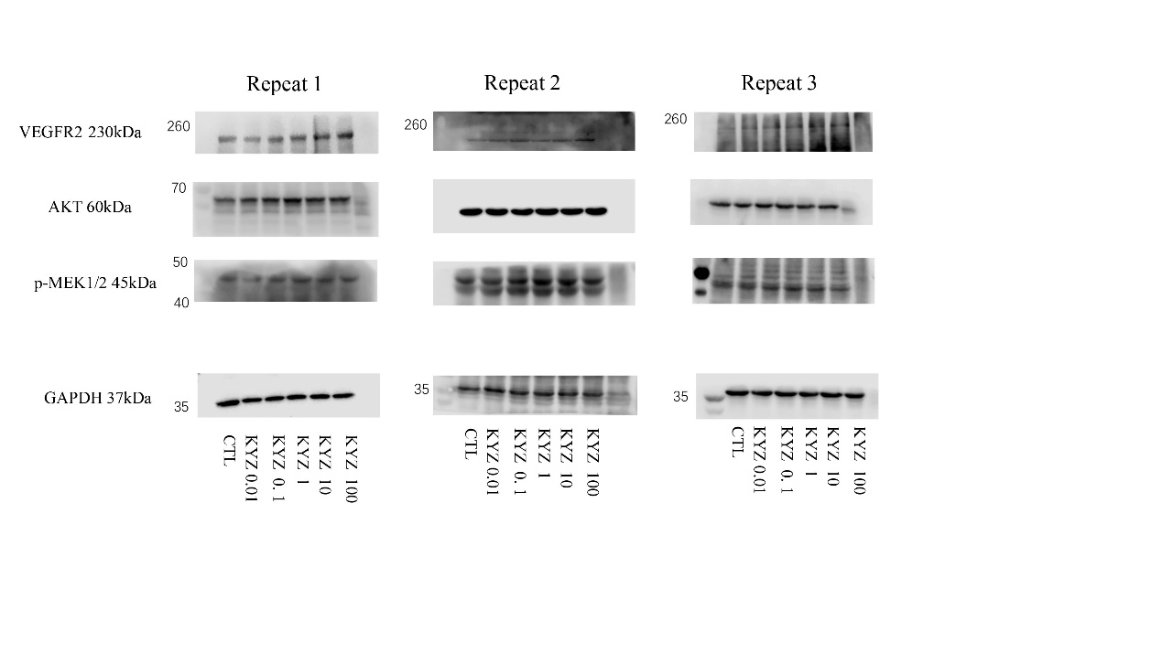

Fig.S1 The VEGFR2 and GAPDH represent western blot analysis shown in Fig.8
The AKT and p-MEK1/2 represent western blot analysis shown in Fig.9

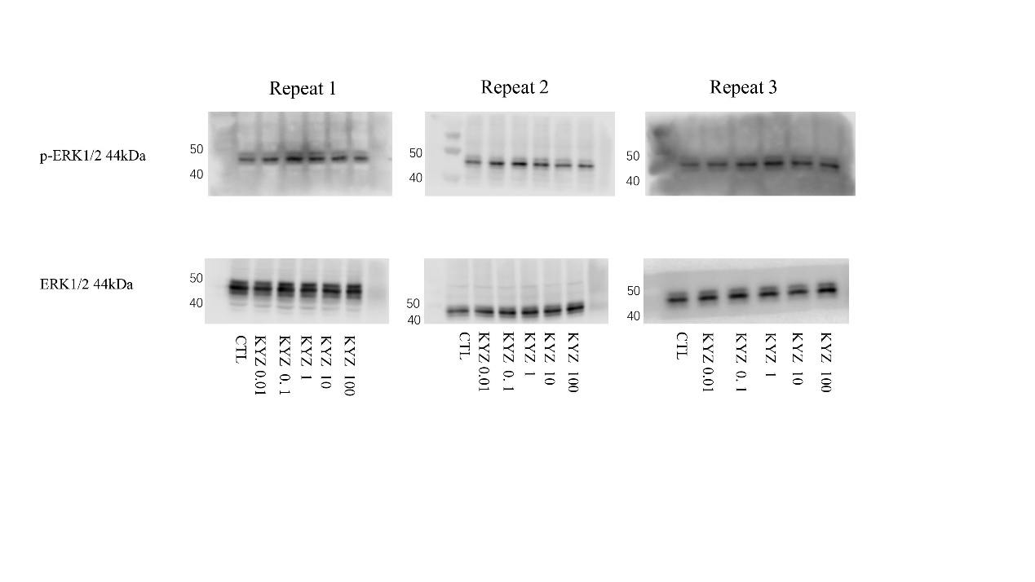

Fig.S2 The ERK1/2and p-ERK1/2 represent western blot analysis shown in Fig.9

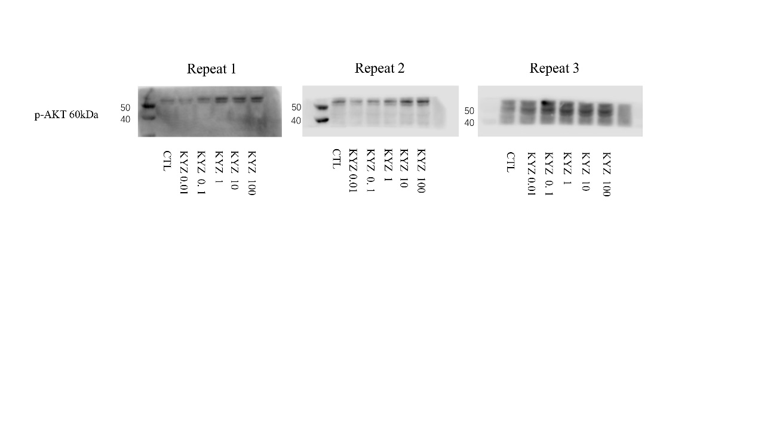
Fig.S3 The p-AKT represents western blot analysis shown in Fig.9

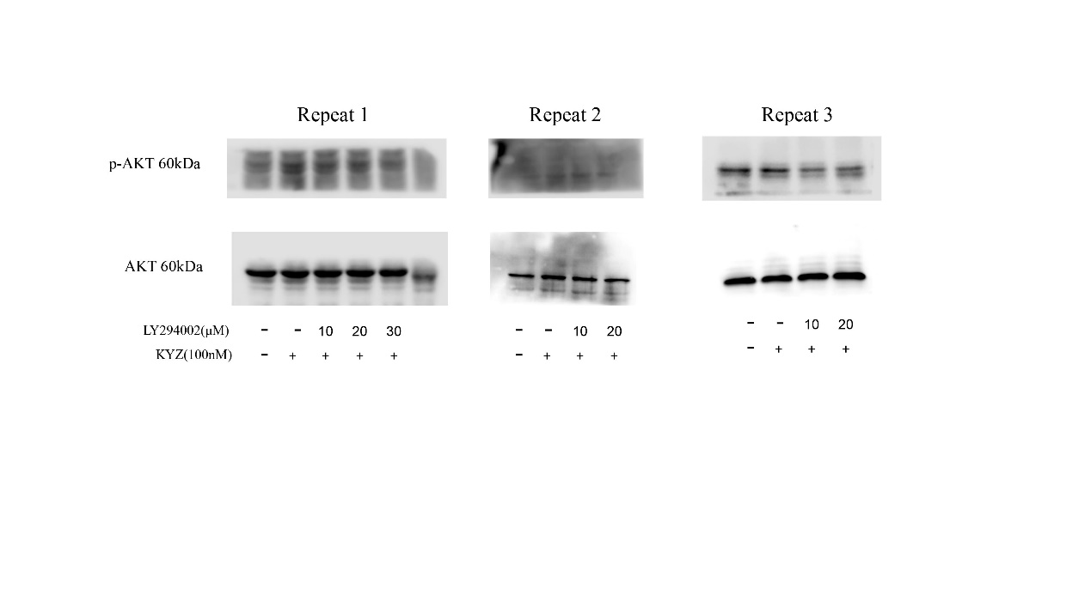

Fig.S4 The p-AKT and AKT represent western blot analysis shown in Fig.10

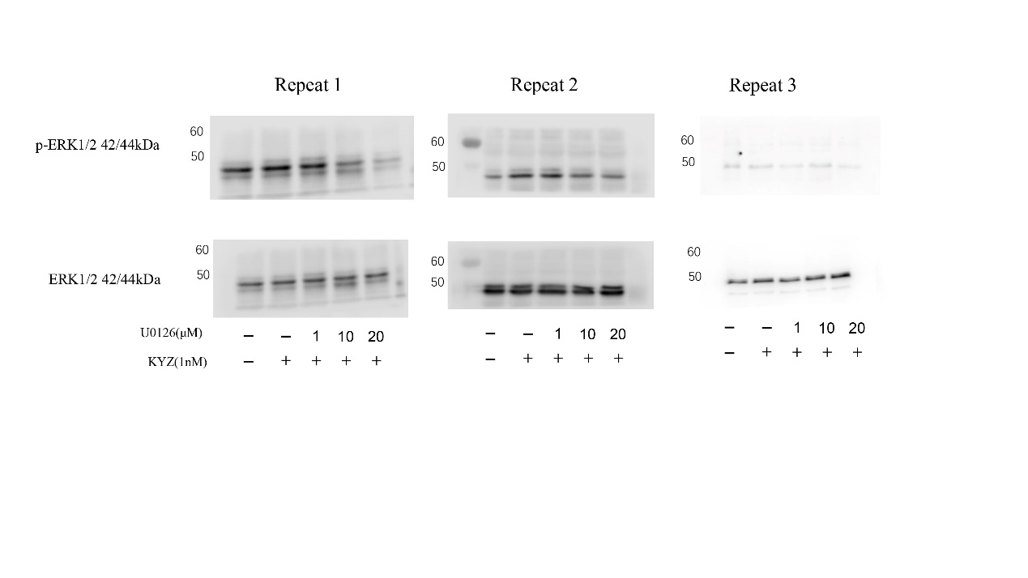

Fig.S5 The p-ERK1/2 and ERK1/2 represent western blot analysis shown in Fig.10

