Supplementary Material

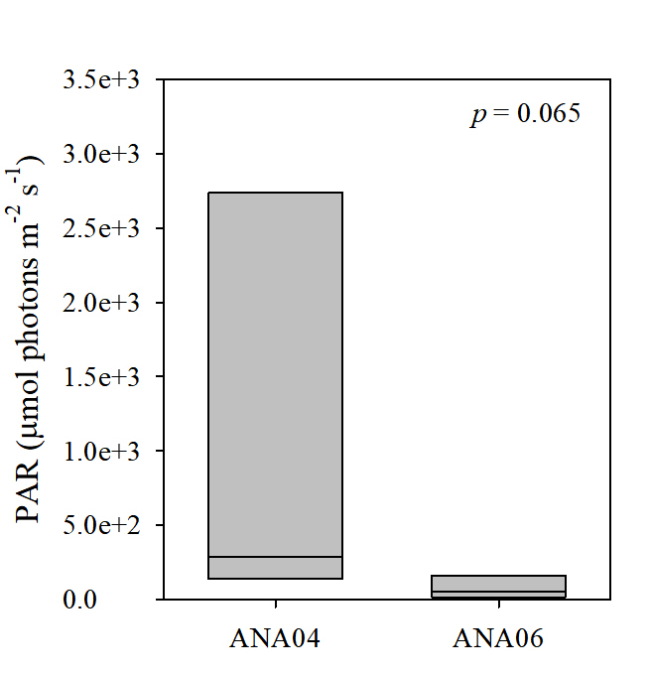

Supplementary Figure 1. Surface photosynthetically active radiation (PAR) intensity measured during conductivity-temperature-depth (CTD) cast in ANA04 and ANA06 in the ASP.

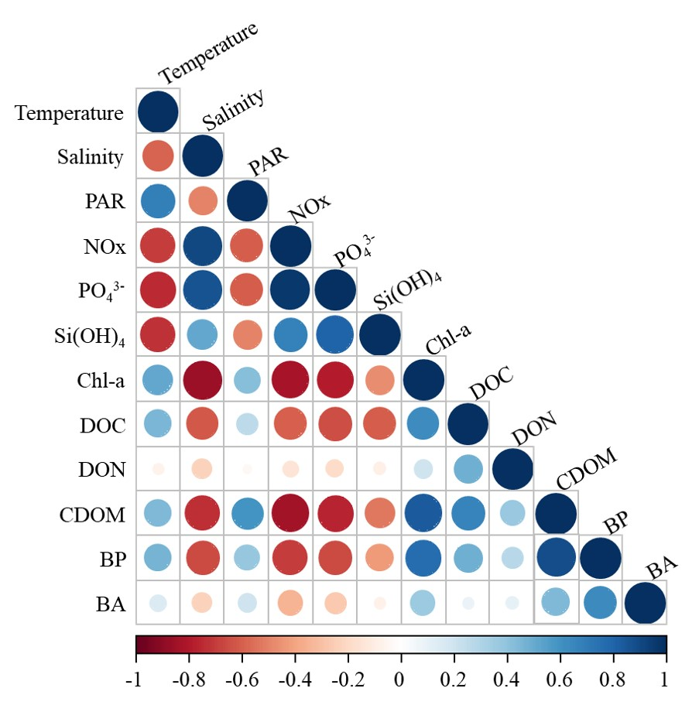

Supplementary Figure 2. Spearman’s rank correlation matrix between bacterial parameters and environmental parameters during the ANA04 and ANA06 periods. The colors of the scale bar denote the nature of the correlation (Spearman’s rho) with 1 indicating a perfect positive correlation (dark blue) and -1 indicating a perfect negative correlation (dark red) between parameters. Statistical significance is indicated by circle size, with a larger size indicating a stronger correlation. PAR, photosynthetically active radiation; NO_{X}, nitrate + nitrite; PO₄³⁻, phosphate; Si(OH)₄, silicate; Chl-a, chlorophyll-a; DOC, dissolved organic carbon; DON, dissolved organic nitrogen; CDOM, chromophoric dissolved organic matter; BP, bacterial production; BA, bacterial abundance.

Supplementary Table 1. Comparison of respiration rate between O₂-optode and Winkler titration methods in the Amundsen Sea polynya during ANA06 using paired t-tests. The respiration rates obtained from the two methods were not significantly different (p = 0.209).
Method | Difference |  |  | t | degrees of freedom |  | p
 | Mean  (± 1S.D.) | 95% confidence interval
 |  | low | high
O₂-optode - Winkler titration | 0.0339  (0.0837) | -0.0252 | 0.902 | 1.343 | 10 | 0.209

