Table.1 The formulations and chemical composition of the basal diet (as-fed basis) at different stages
Ingredient | 7-11  kg | 11-25  kg | 25-50  kg | 50-75  kg | 75-100  kg | 100-13  kg
Corn, 8% | 26.2 | 38 | 72.8 | 75.2 | 79 | 80.4
Extrude corn, 8% | 25 | 22
Fermented soybean meal, 47% | 14.7 | 14.4 | 16 | 14 | 9.2 | 6
Expanded soybean | 10 | 10
Wheat bran |  |  | 4 | 5 | 6 | 8
Fish meal, 63% | 4 | 4 | 2
Whey powder, 3% | 11 | 6
Plasma protein powder, 77.8% | 3
Soybean oil | 0.4 |  | 1.5 | 2 | 2.2 | 2.36
Custer sugar | 2 | 2
50% Choline chloride | 0.1 | 0.1 | 0.08 | 0.08 | 0.06 | 0.06
Salt | 0.25 | 0.25 | 0.3 | 0.3 | 0.35 | 0.35
Monocalcium phosphate | 1 | 0.9 | 0.9 | 1 | 0.8 | 0.55
Limestone | 0.7 | 0.6 | 0.8 | 0.8 | 0.78 | 0.8
L-Lys HCl | 0.41 | 0.51 | 0.45 | 0.43 | 0.43 | 0.37
DL-Met | 0.1 | 0.07 | 0.03 | 0.04 | 0.04
L-Thr | 0.14 | 0.17 | 0.14 | 0.15 | 0.14 | 0.11
Premix¹ | 1 | 1 | 1 | 1 | 1 | 1
Total | 100 | 100 | 100 | 100 | 100 | 100
Energy and nutrient composition
DE, kcal/kg | 3549 | 3492 | 3425 | 3424 | 3423 | 3413
CP (analyzed), % | 20.6 | 18.8 | 15.9 | 14.0 | 12.1 | 10.9
Ca (analyzed), % | 0.78 | 0.70 | 0.65 | 0.59 | 0.52 | 0.46
P (analyzed), % | 0.66 | 0.61 | 0.56 | 0.52 | 0.47 | 0.43
STTD of P, % | 0.47 | 0.40 | 0.35 | 0.32 | 0.28 | 0.23
Lys, % | 1.53 | 1.40 | 1.12 | 0.97 | 0.84 | 0.71
Met, % | 0.44 | 0.40 | 0.31 | 0.28 | 0.26 | 0.20
Thr, % | 0.96 | 0.86 | 0.71 | 0.65 | 0.57 | 0.49
Trp, % | 0.25 | 0.21 | 0.17 | 0.15 | 0.12 | 0.11
¹Provided vitamin and mineral premix per kg of diet: vitamin A = 2400 IU; vitamin D3 = 2800 IU; vitamin E = 200 IU; vitamin K3 = 5 mg; vitamin B12 = 40 μg; vitamin B1 = 3 mg; vitamin B2 = 10 mg; niacin = 40 mg; pantothenic acid = 15 mg; folic acid = 1 mg; vitamin B6 = 8 mg; biotin = 0.08 mg; Fe (FeSO4•H2O) = 120 mg; Cu (CuSO4•5H2O) = 16 mg; Mn (MnSO4•H2O) = 70 mg; Zn (ZnSO4•H2O) = 120 mg; I (CaI2O6) = 0.7 mg; Se (Na2SeO3) = 0.48 mg.

Table 2. Primers for the real-time PCR analysis
Gene¹ | Accession number | Sequence (5’-3’) | Size(bp)
ZO-1 | XM_013993251 | Forward:AGCCCGAGGCGTGTTT | 147
 |  | Reverse: AGCCCGAGGCGTGTTT
Occludin | XM_005672525 | Forward: GCACCCAGCAACGACAT | 144
 |  | Reverse:CATAGACAGAATCCGAATCAC
Mucin-2 | XM_007465997.1 | Forward: CTGCTCCGGGTCCTGTGGGA | 100
 |  | Reverse: CCCGCTGGCTGGTGCGATAC
Mucin-1 | XM_021089730.1 | Forward: ACACCCATGGGCGCTATGT | 68
 |  | Reverse: GCCTGCAGAAACCTGCTCAT
pBD2 | AY506573.1 | Forward: CCAGAGGTCCGACCACTACA | 88
 |  | Reverse: GGTCCCTTCAATCCTGTTGAA
PG1-5 | XM_005669497.2 | Forward: GTAGGTTCTGCGTCTGTGTCG | 166
 |  | Reverse: CAAATCCTTCACCGTCTACCAC
GAPDH | NM_001206359 | Forward:ACTCACTCTTCCACTTTTGATGCT | 100
 |  | Reverse: ACTCACTCTTCCACTTTTGATGCT
¹ZO-1 = zonula occludens-1; pBD2 = porcine β defensin 2; PG1-5 = protegrin 1-5;GAPDH = glyceraldehyde-3-phosphate dehydrogenase.

Table 3. The sample sequence information
Sample | PE_reads | Nochimera | AvgLen(bp) | Effective(%)
S1_AO1 | 79562 | 64248 | 445.65 | 52.52
S1_AO2 | 82620 | 65895 | 443.90 | 52.66
S1_AO3 | 91073 | 76311 | 447.12 | 52.57
S1_AO5 | 85480 | 66246 | 446.33 | 52.9
S1_AO6 | 82825 | 69206 | 446.02 | 53.01
S1_CON2 | 97846 | 83254 | 446.71 | 52.8
S1_CON3 | 84512 | 67939 | 447.73 | 52.41
S1_CON4 | 98220 | 77372 | 448.08 | 52.89
S1_CON6 | 94966 | 81495 | 445.64 | 54.3
S1_CON7 | 93839 | 76934 | 446.33 | 52.96
S1_LR2 | 74690 | 61230 | 447.82 | 52.66
S1_LR3 | 89714 | 77642 | 450.84 | 52.28
S1_LR4 | 82344 | 66901 | 448.93 | 52.08
S1_LR7 | 81609 | 65401 | 450.73 | 52.54
S1_LR8 | 80805 | 67236 | 446.01 | 53.02
S2_AO2 | 86385 | 69495 | 445.42 | 53.04
S2_AO4 | 94663 | 76165 | 448.00 | 53.2
S2_AO6 | 82846 | 68548 | 446.47 | 52.78
S2_AO7 | 95085 | 77202 | 449.72 | 53.06
S2_AO8 | 82068 | 65821 | 447.42 | 53.15
S2_CON1 | 81117 | 66731 | 448.40 | 53.13
S2_CON3 | 95047 | 80397 | 447.57 | 52.97
S2_CON4 | 93736 | 75429 | 450.71 | 53.21
S2_CON5 | 80114 | 63763 | 445.63 | 52.99
S2_CON6 | 61110 | 49418 | 445.95 | 53.47
S2_LR1 | 102596 | 80177 | 445.79 | 53.07
S2_LR3 | 81755 | 65701 | 445.51 | 52.9
S2_LR4 | 83950 | 64777 | 449.81 | 52.53
S2_LR6 | 78692 | 60190 | 447.48 | 54.41
S2_LR8 | 83080 | 65040 | 451.21 | 52.64
S3_CON1 | 86303 | 74513 | 445.63 | 52.86
S3_CON3 | 83352 | 71380 | 443.53 | 53.34
S3_CON5 | 83414 | 72085 | 448.14 | 52.85
S3_CON7 | 76894 | 67625 | 446.44 | 53.28
S3_CON8 | 82385 | 73371 | 445.63 | 53.06
S3_LR2 | 92310 | 79782 | 444.67 | 53.22
S3_LR5 | 92257 | 81994 | 447.00 | 53.49
S3_LR6 | 79152 | 66918 | 445.04 | 52.99
S3_LR7 | 92134 | 81668 | 444.20 | 53.07
S3_LR8 | 66565 | 55381 | 448.74 | 52.93

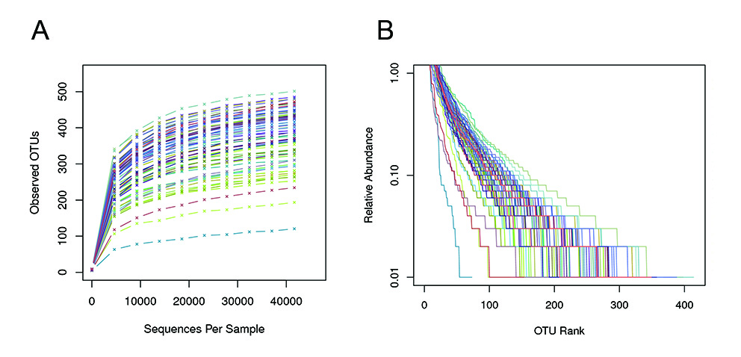
FIGURE 1. Feasibility analysis of cecum samples. the rank-abundance curve (A) and rarefaction curve (B).

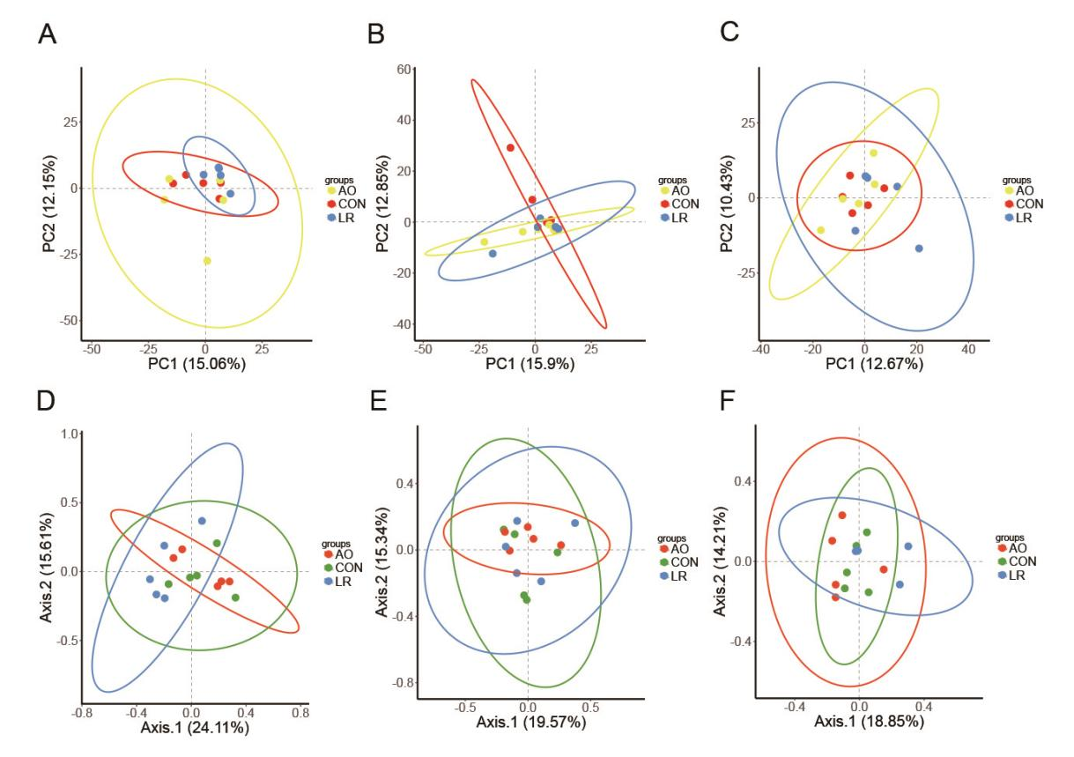
FIGURE 2. Principal component analysis (PCA) and principal co-ordinates analysis (PCoA) of S1 stage cecal microbiota in three groups was performed (A&D). PCA and PCoA of S2 stage in three groups (B&E). PCA and PCoA of S3 stage in three groups (C&F). Each dot represents a sample, and the same color indicates the same group.
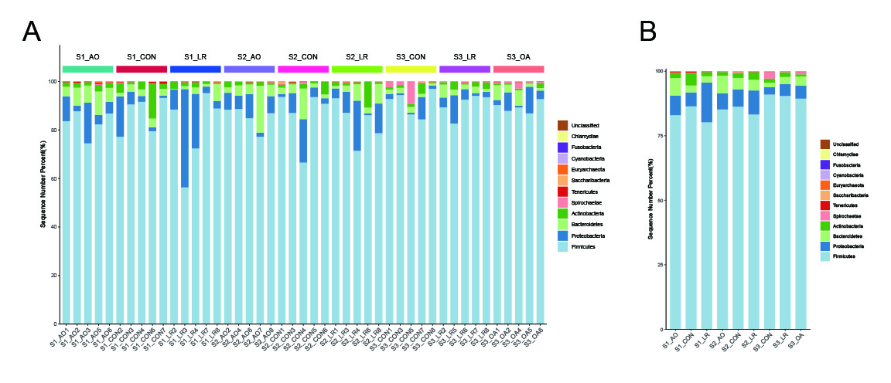
FIGURE 3. Relative abundance of intestinal microorganisms. Relative abundance of the most dominat cecal microbiota in each sample at the phylum levels (A). Relative abundance of cecal microbiota on the basis of the average number of each subfamily at the phylum (B).

