Supplementary Figures.
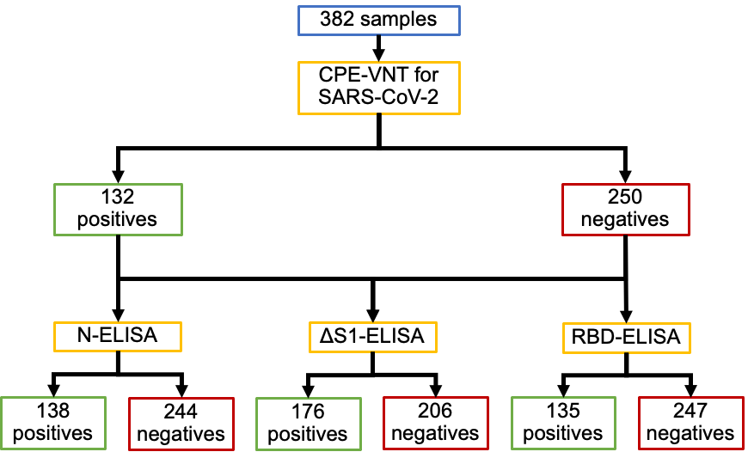
Figure 1S. CPE-VNT validation and in house evaluation of the study selected samples. The 382 samples previously selected for validation were evaluated by CPE-VNT regarding neutralizing antibodies and subsequently tested by three in house ELISA methodologies (N-ELISA, ΔS1-ELISA and RBD-ELISA) for detection of SARS-CoV-2 specific antibodies. The figure shows a flow chart indicating CPE-VNT and ELISA positive and negative samples.

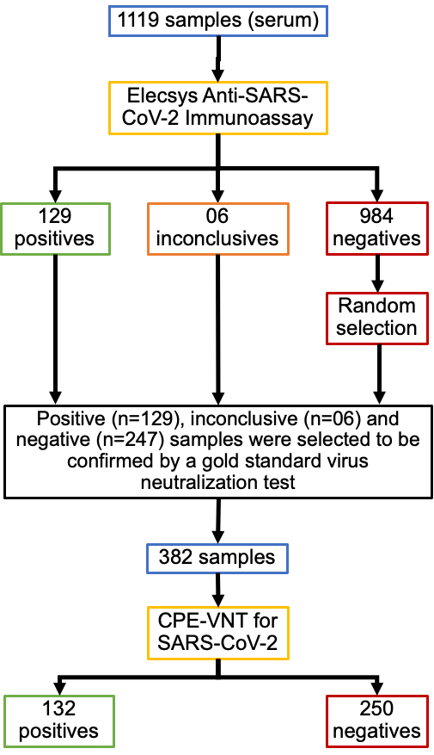
Figure 2S. Flow chart representing sample selection for the study. Elecsys® Anti-SARS-CoV-2 Immunoassay evaluated samples were selected for the study based on positive, inconclusive or negative results.

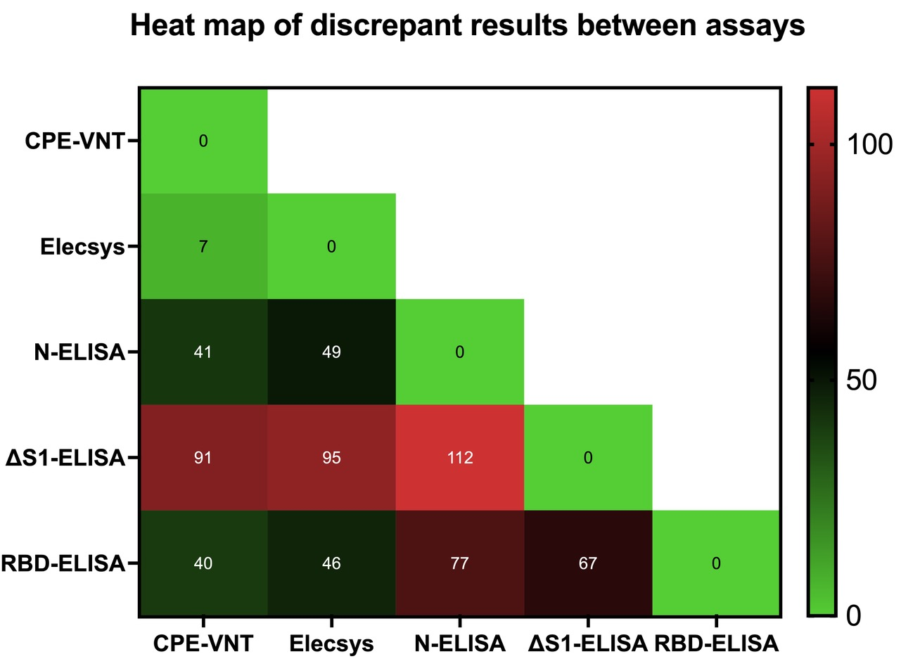
Figure 3S. Heat map of discrepant results between assays. The heat map represents, from light green to red colors, the respective crescent number of samples that had different results when evaluated by the assays of the study.

Supplementary Table.
Table S1. Inconclusive Elecsys results for CPE-VNT, N-ELISA, ΔS1-ELISA and RBD-ELISA tests.

Sample ID | Elecsys anti-SARS-CoV-2 immunoassay | CPE-VNT  * | N-ELISA  ** | ΔS1-ELISA  *** | RBD-ELISA  ****
0886625101 | Inconclusive | - | - | + | -
0886574301 | Inconclusive | - | - | - | -
0886667501 | Inconclusive | + | - | + | +
0886677001 | Inconclusive | - | - | - | -
0886630401 | Inconclusive | - | - | - | -
0886618801 | Inconclusive | + | + | + | +
* Positive (+) = VNT₁₀₀ ≥ 20; Negative (-) = VNT₁₀₀ < 20
** (+) = OD ≥ 0.554; (-) = OD < 0.554
*** (+) = OD ≥ 0.528; (-) = OD < 0.528
**** (+) = OD ≥ 0.336; (-) = OD < 0.336

