Supplementary information
Hiroki Sawaguri ª, Nobuyuki Gokon ^{a, b,} *, Kosuke Hayashi ª, Yoshikazu Iwamura ª, Daichi Yasuhara ^{b}

ª Graduate School of Science and Technology, Niigata University, 8050 Ikarashi 2-nocho, Niigata 950-2181, Japan
^{b} Department of Chemistry & Chemical Engineering, Faculty of Engineering, Niigata University, 8050 Ikarashi 2-nocho, Niigata 950-2181, Japan

* Correspondence:
Prof. Nobuyuki Gokon
ngokon@eng.niigata-u.ac.jp
Keywords: thermochemical cycle, CO₂ splitting, redox activity, perovskite oxides, X-ray photoelectron spectroscopy

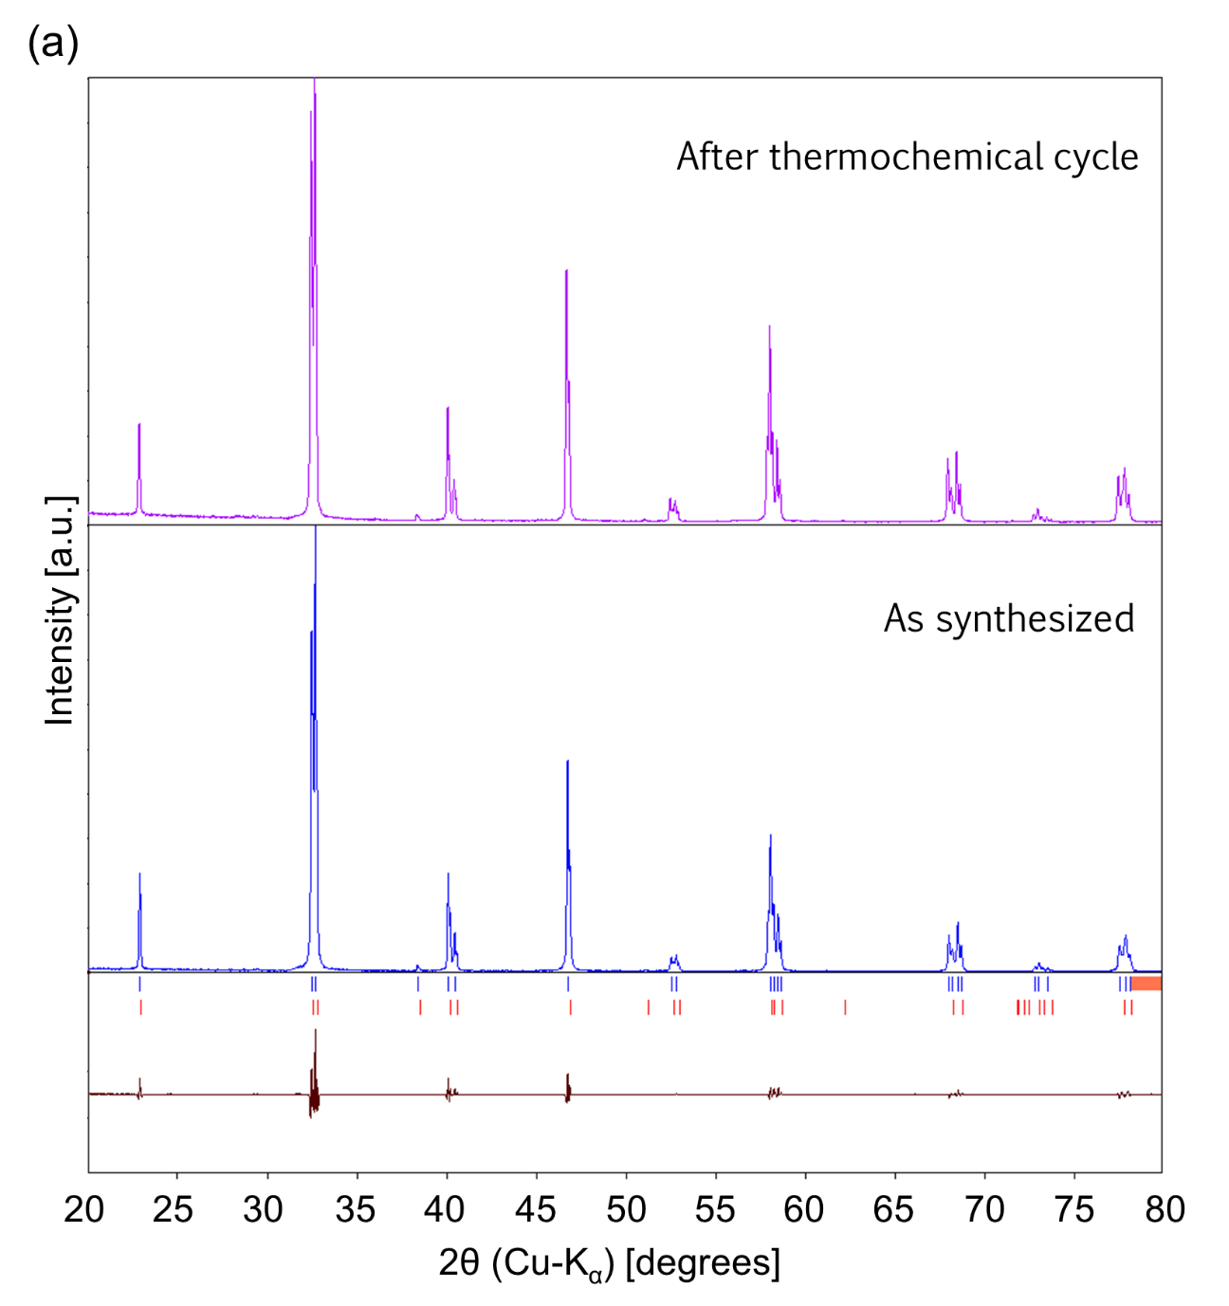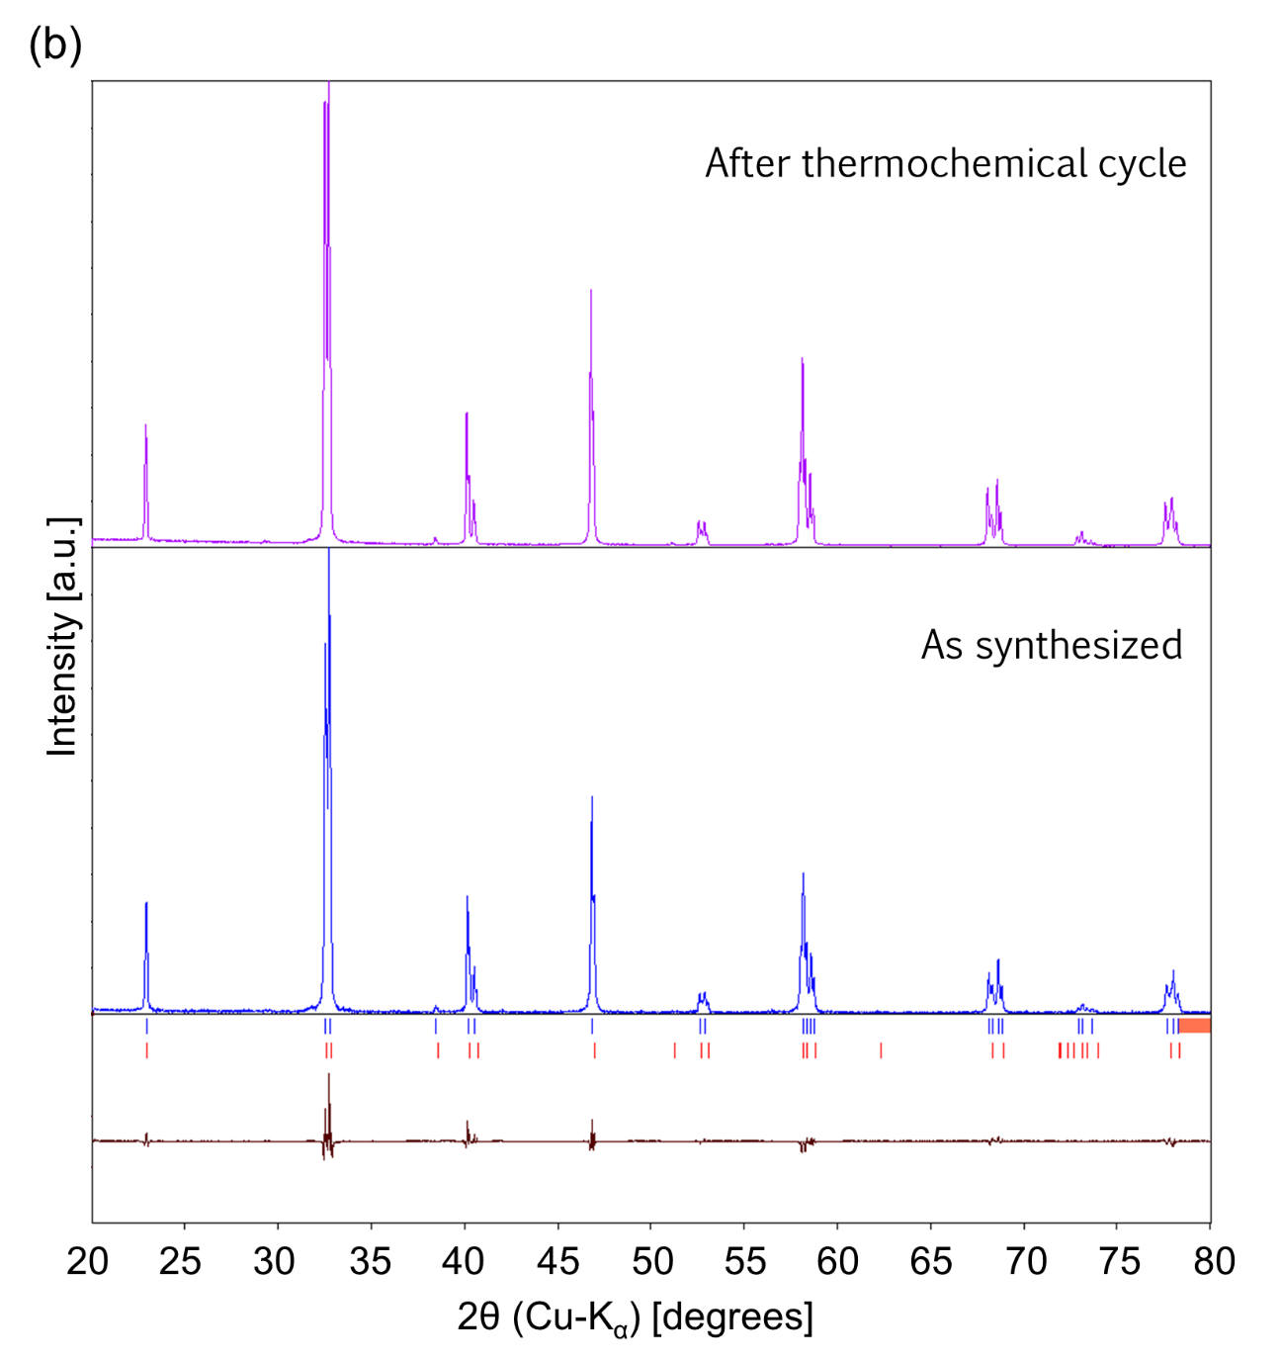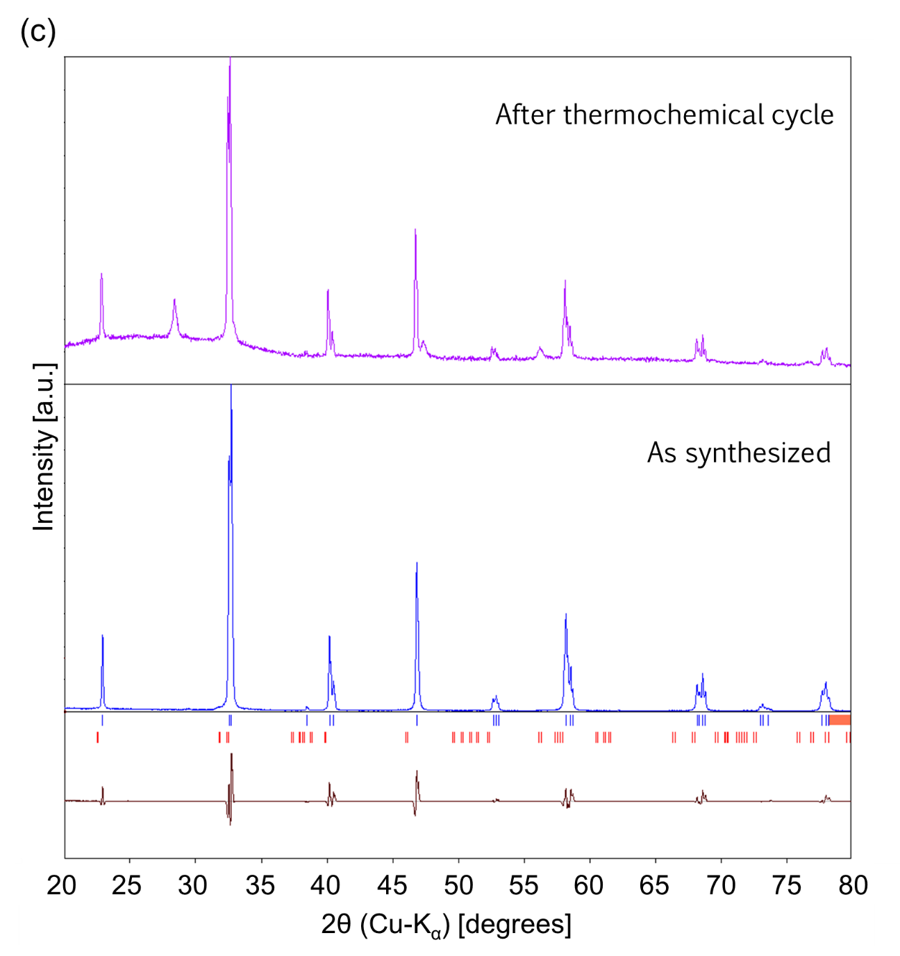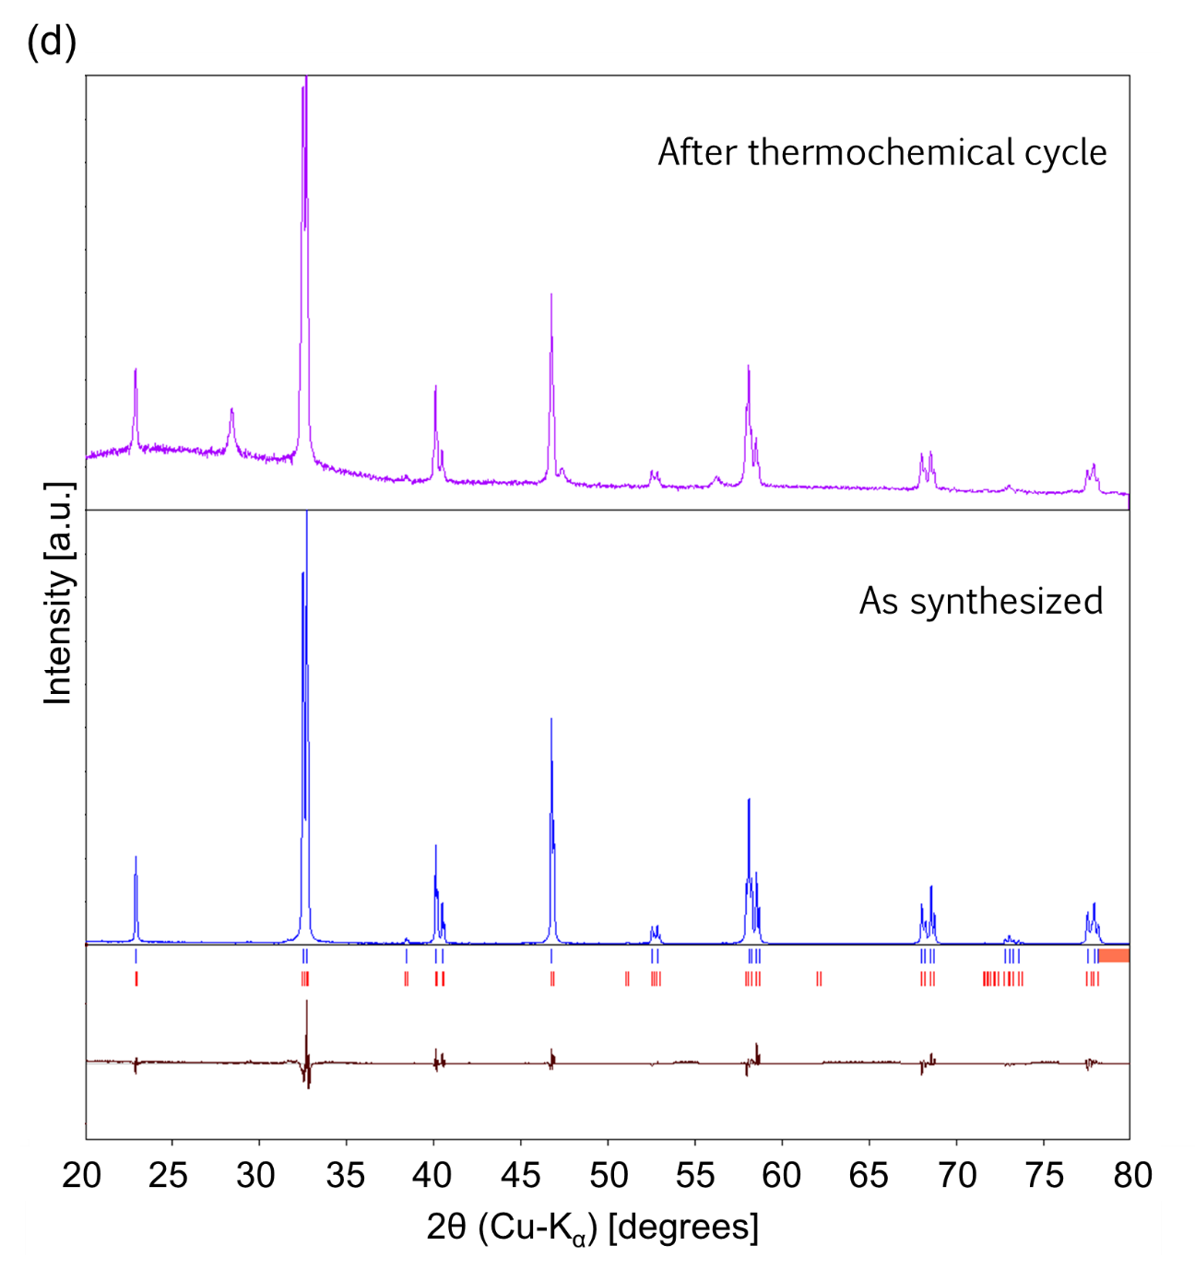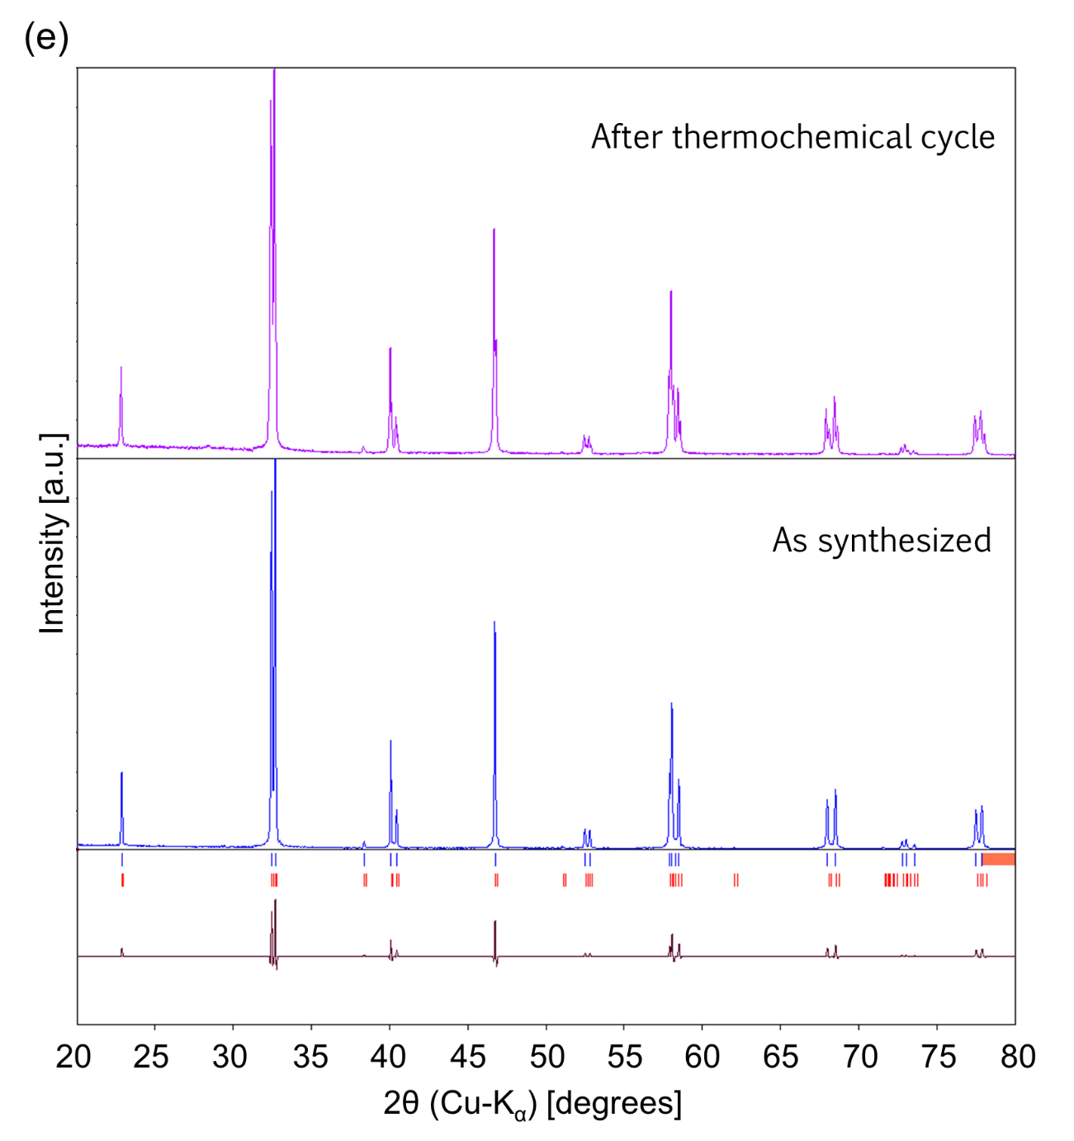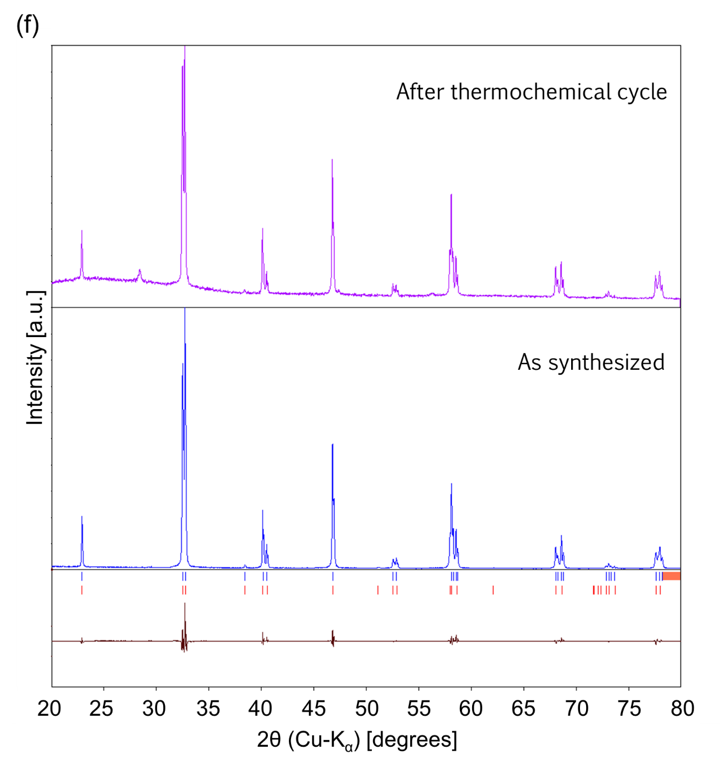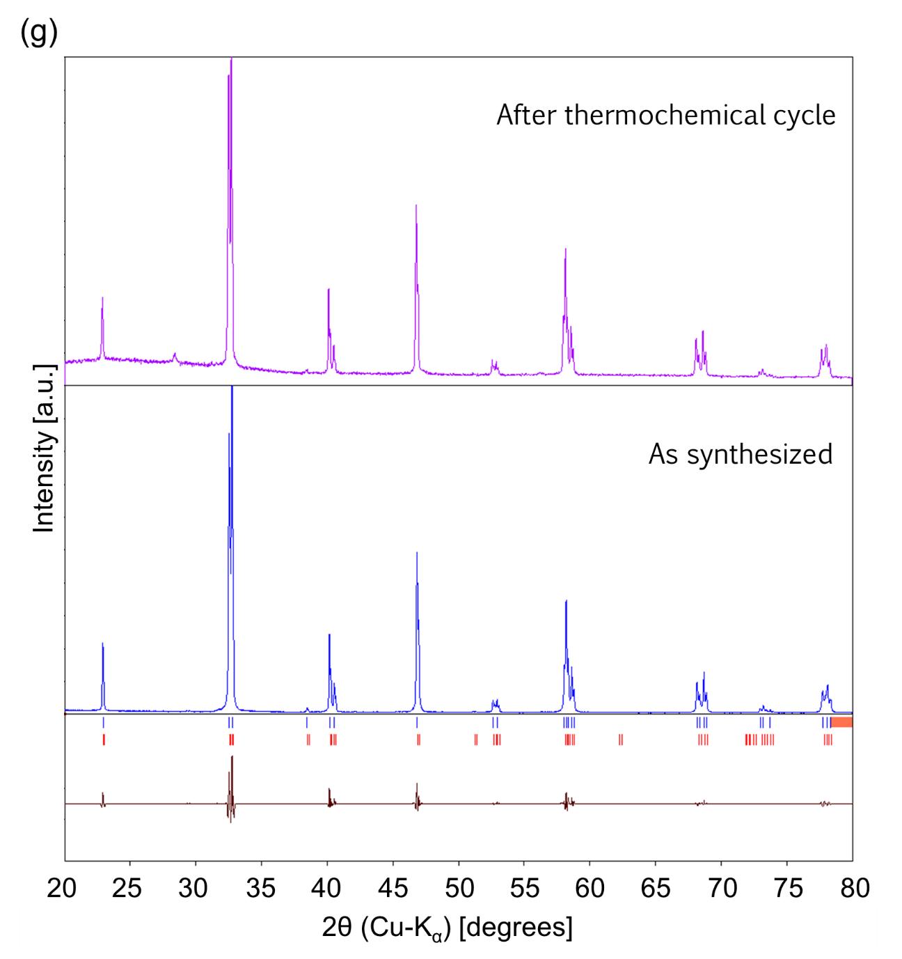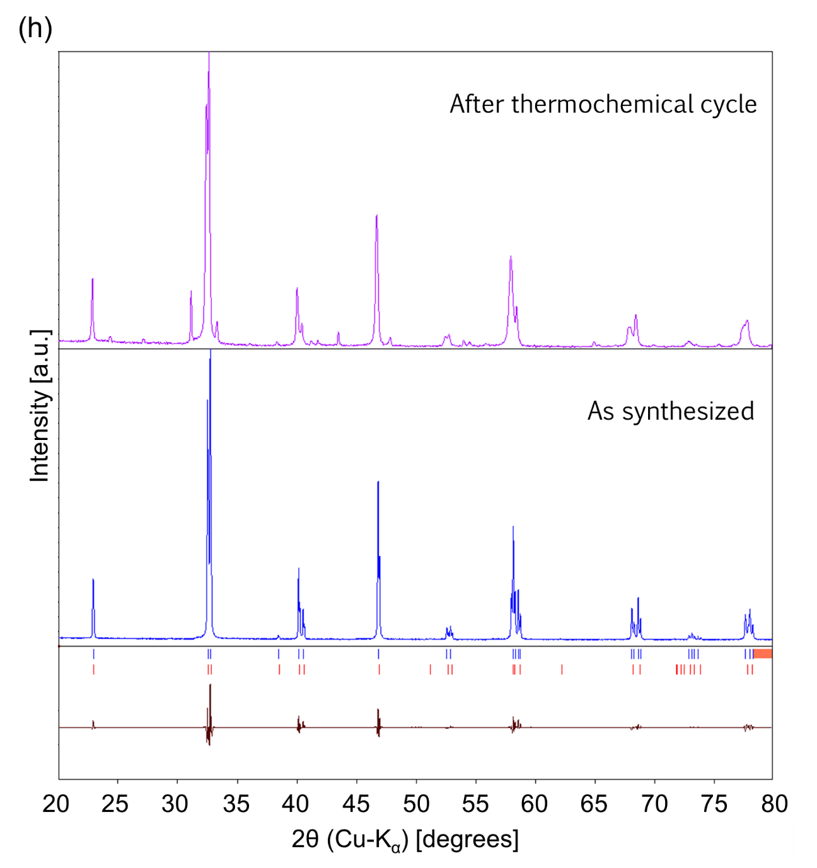
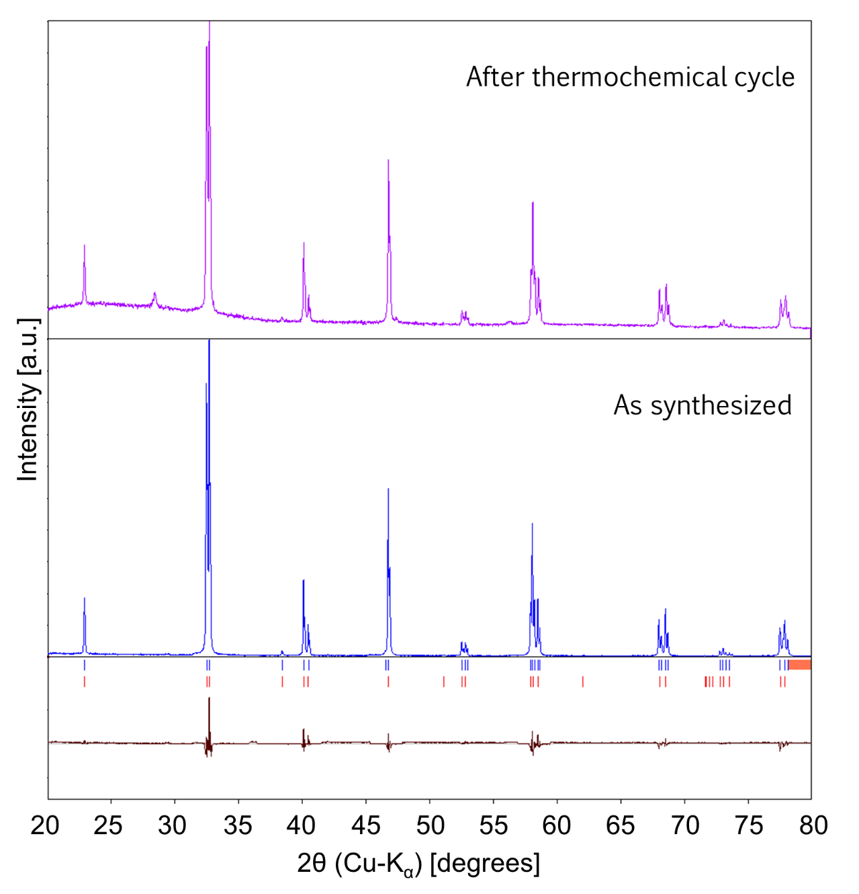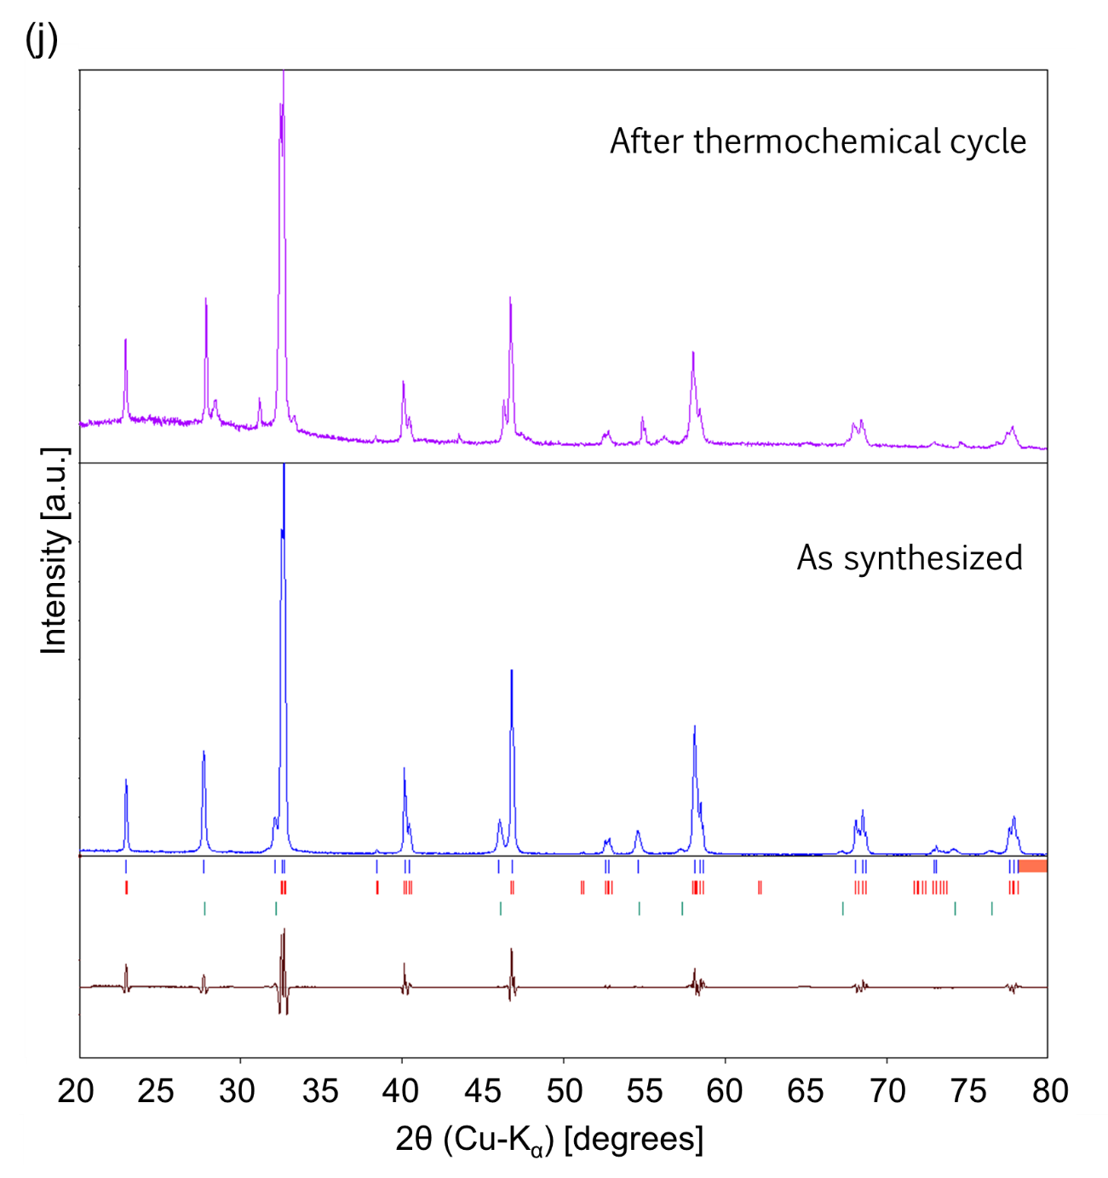
(i)
Fig. S1. XRD data of (a) non-substituted La_{0.7}Sr_{0.3}MnO₃ (LSM), and (b) Mg-, (c) Al-, (d) Cr-, (e) Fe-, (f) Co-, (g) Ni-, (h) Cu-, (i) Ga-, (j) Ce- substituted LSM obtained before (blue continuous line) and after (purple continuous line) redox experiments at the reduction temperature of 1400 ℃ and CO₂ splitting temperature of 1200 ℃. Blue vertical bars are peak positions of the pattern obtained before the redox cycle, and red and green vertical bars are peak positions of reference samples. References are shown in Table 1. Dark red continuous lines show difference between the pattern obtained before the redox cycle and Rietveld fitting.

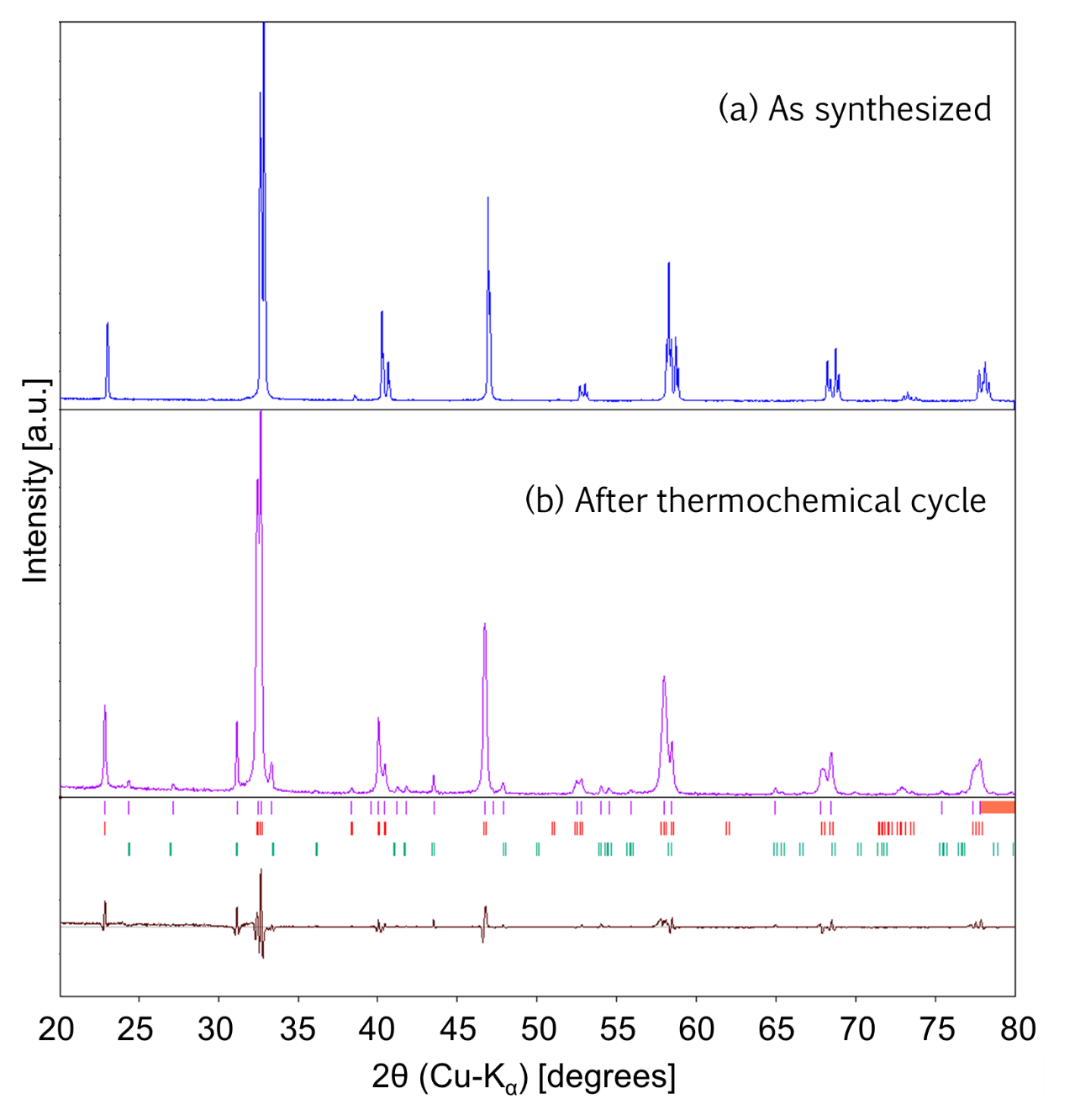
Fig. S2. XRD data of Cu-substituted LSM before (a) and after (b) redox experiments at the reduction temperature of 1400 ℃ and CO₂ splitting temperature of 1200 ℃. Purple vertical bars are peak positions of the pattern after the redox cycle, and red and green vertical bars are peak positions of reference samples [57, 58]. Dark red continuous line shows difference between the pattern obtained after the redox cycle and Rietveld fitting.

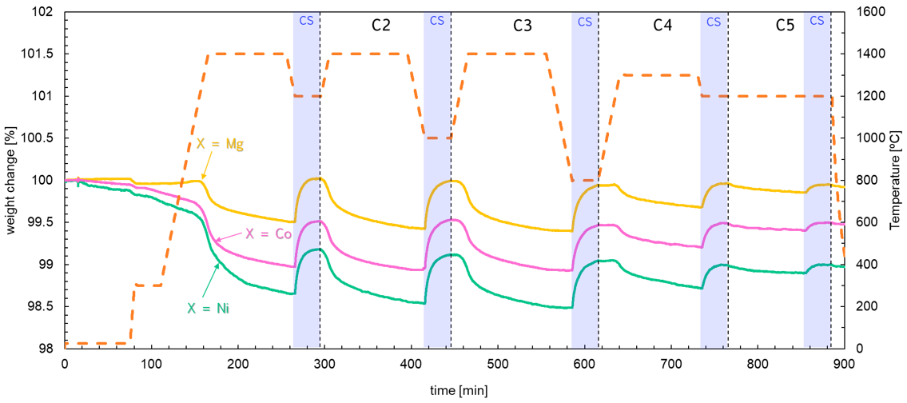Fig. S3. TGA profiles of Mg-, Co-, Ni-substituted LSMs with five temperature conditions for determination of temperature impact on reactivity. Temperature conditions in each run are described in Table 1. Heating, cooling and thermal reduction (TR) steps were performed under N₂ flow rate of 100 Ncm³/min. And CO₂ splitting (CS) steps were carried out with N₂ and CO₂ mixture consisting with N₂ flow rate of 50 Ncm³/min and CO₂ flow rate of 50 Ncm³/min.

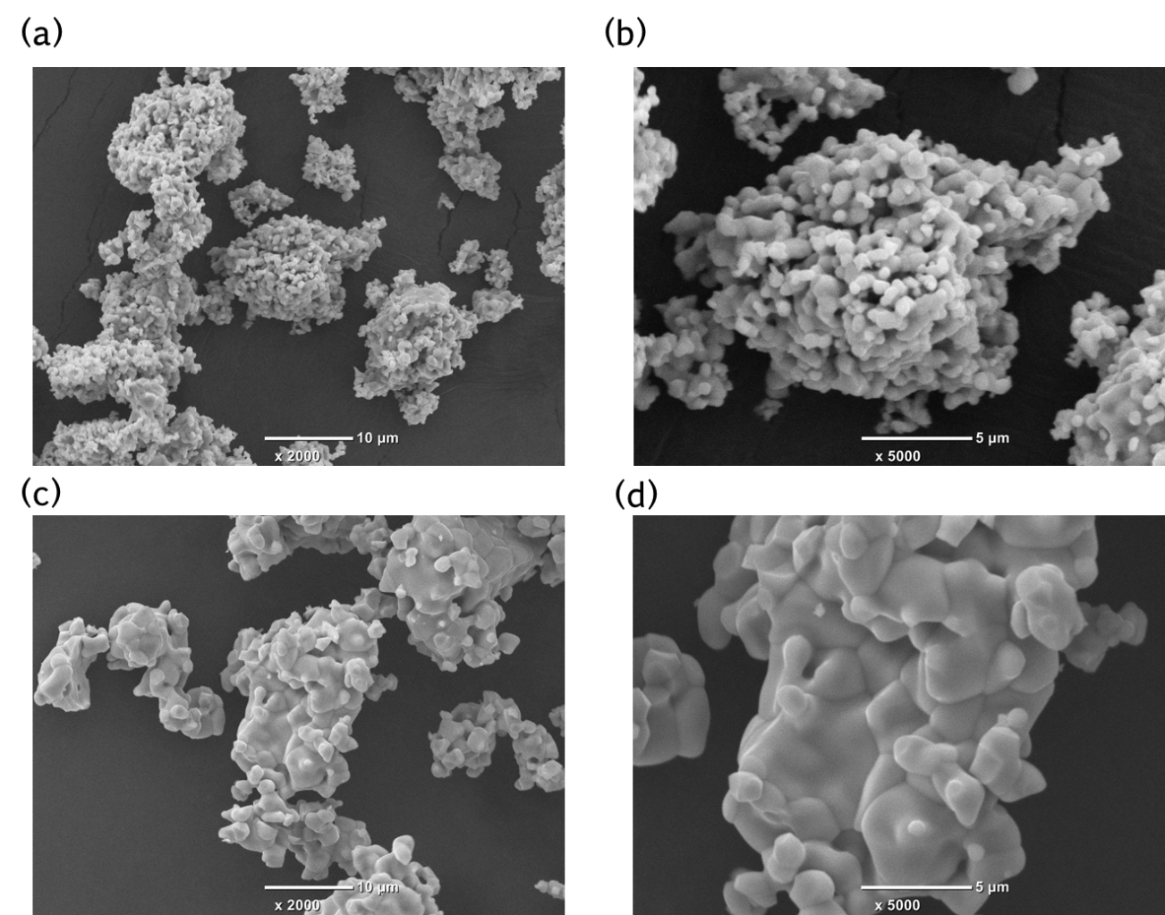
Fig. S4. SEM images of La_{0.7}Sr_{0.3}Mn_{0.9}Co_{0.1}O₃ (substituted B-site cation X = Co) as preparation observed at (a) low magnification of 2000 and (b) high magnification of 5000, and the sample obtained after the long-term redox experiment observed at (c) low magnification and (d) high magnification.
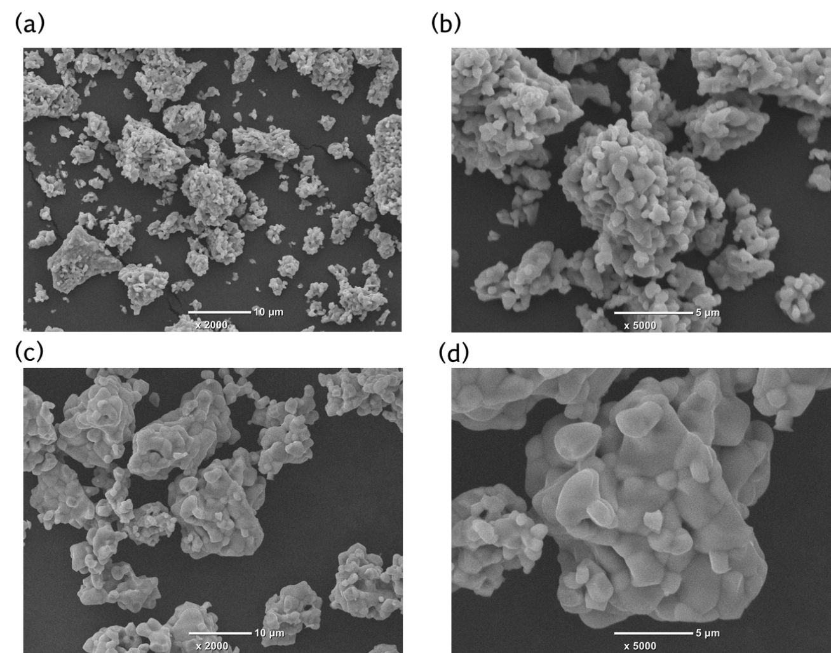
Fig. S5. SEM images of La_{0.7}Sr_{0.3}Mn_{0.9}Ni_{0.1}O₃ (substituted B-site cation X = Ni) as preparation observed at (a) low magnification of 2000 and (b) high magnification of 5000, and the sample obtained after the long-term redox experiment observed at (c) low magnification and (d) high magnification.

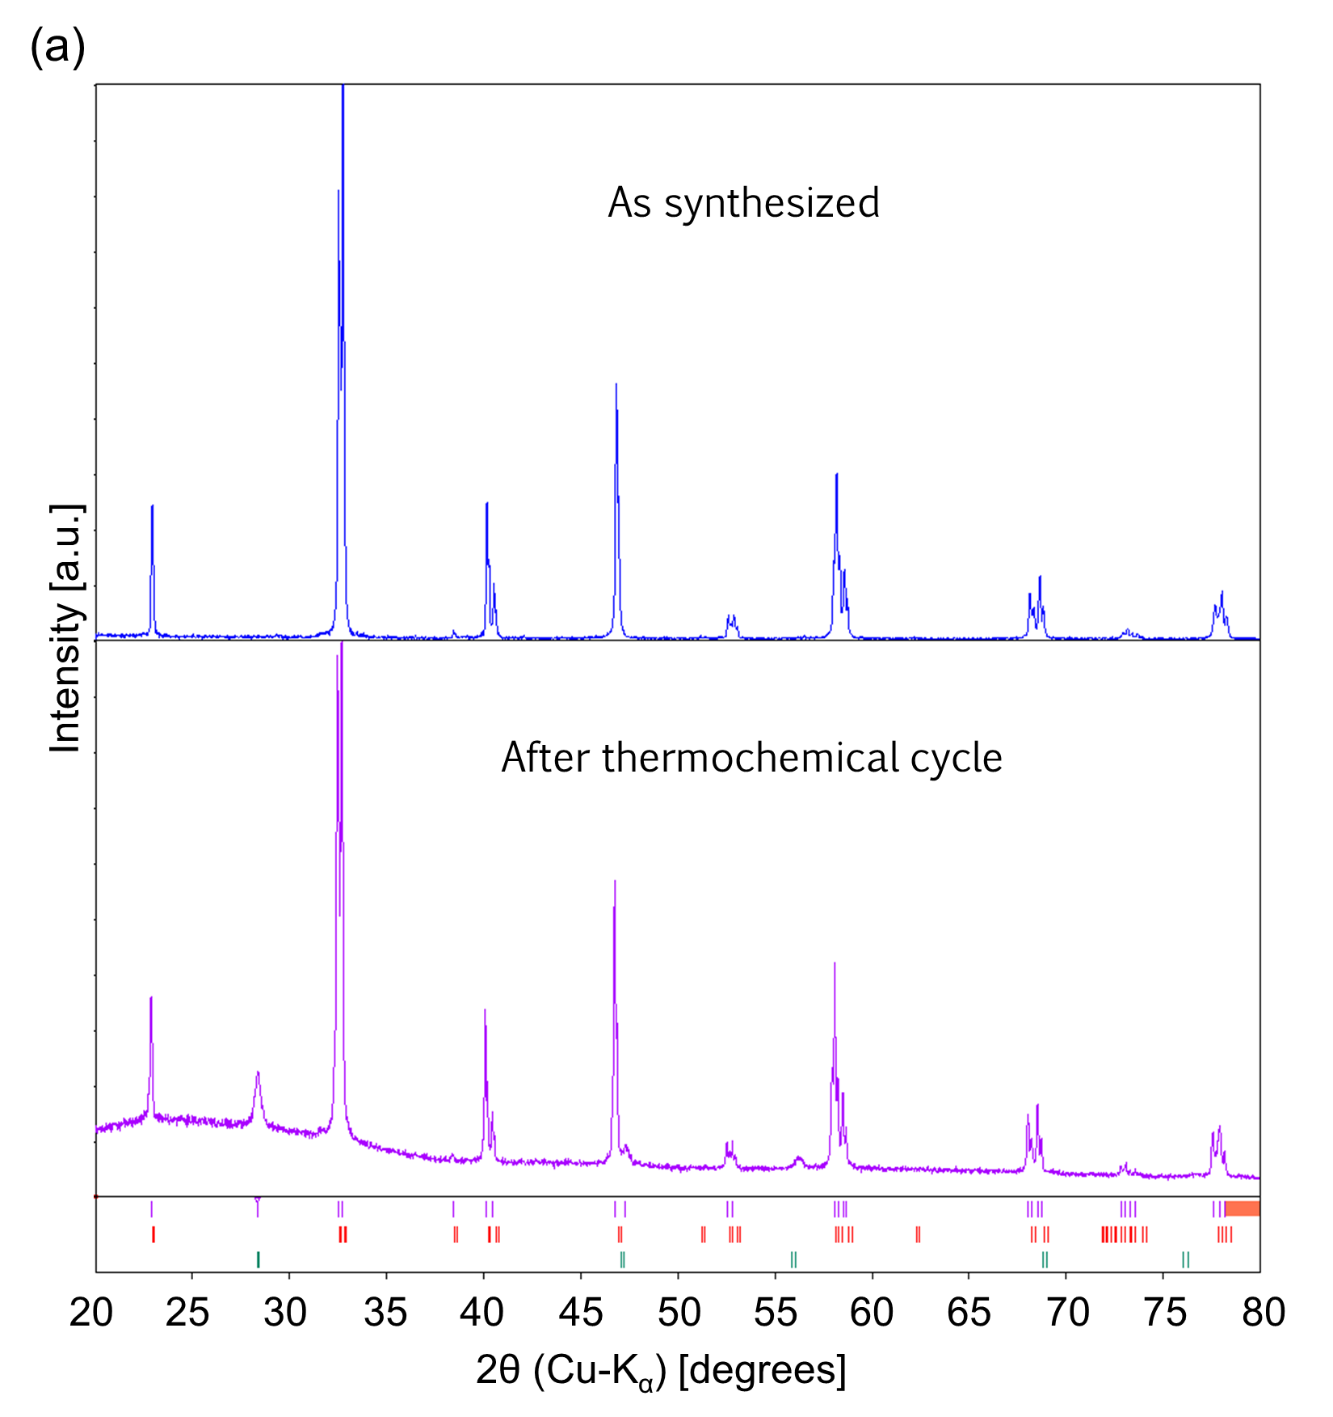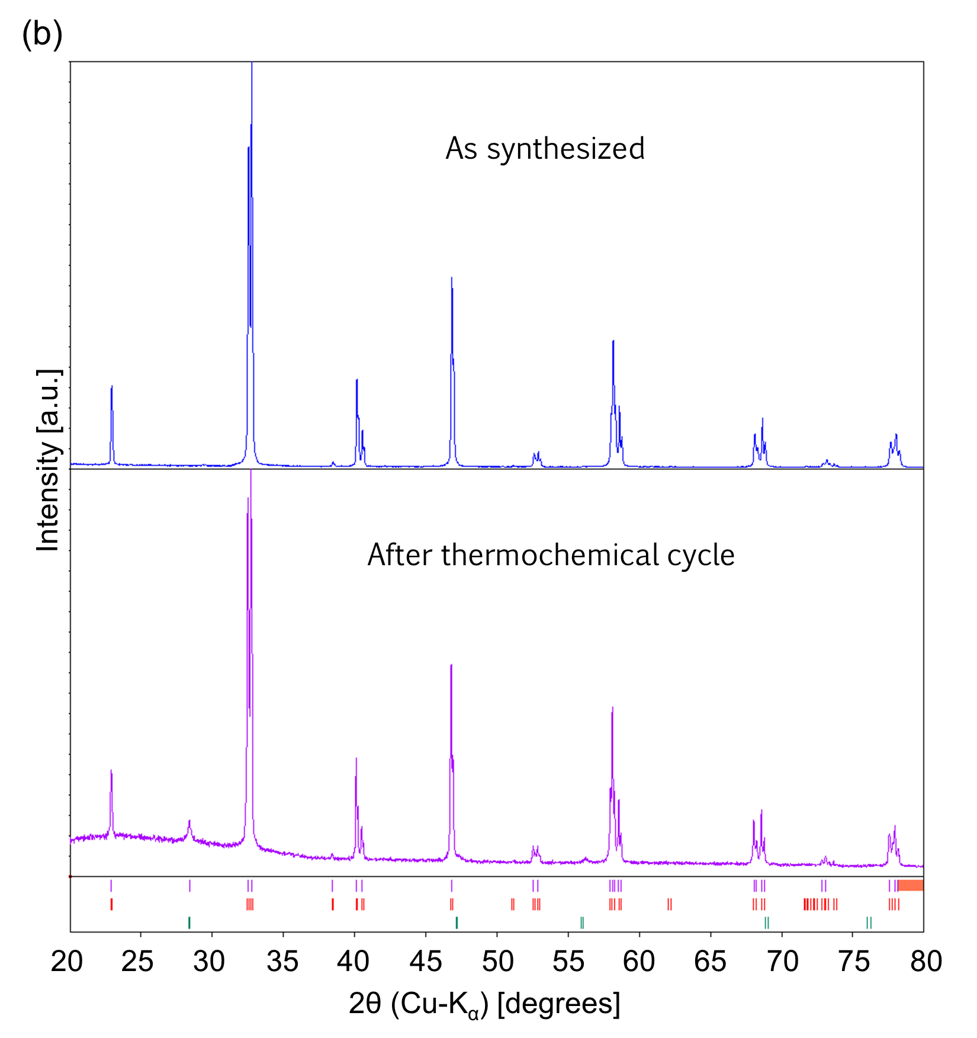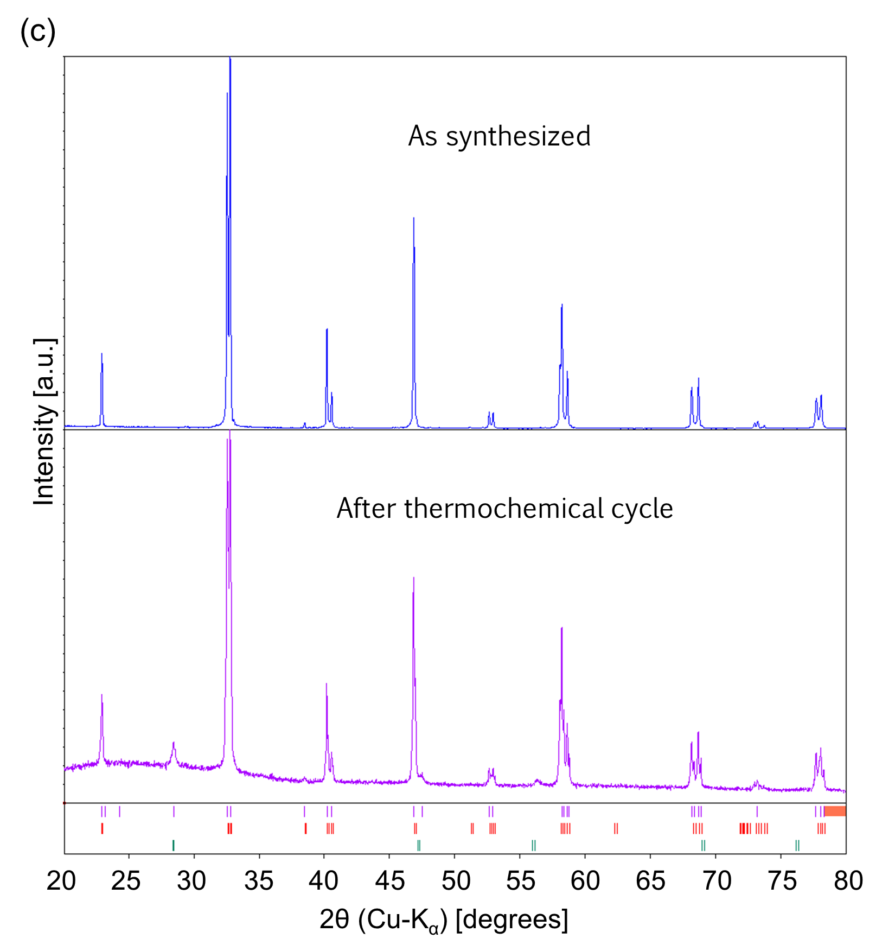
Fig. S6. Comparison with XRD patterns of each (a) Mg-, (b) Co-, and (c)Ni-substituted LSMs obtained before and after the long-term redox experiment. The patterns obtained before the experiment are depicted as blue continuous lines, and the patterns obtained after the experiment are depicted as purple continuous lines. Peak fitting was also performed for tested samples, and peaks positions of reference perovskite (described detail in Table 2) are displayed as red vertical bars. Peak position of Si derived from grass holder for XRD measurements are displayed as green vertical bars.

