Supplementary Material

1. Supplementary Figures and Tables

Supplementary Figures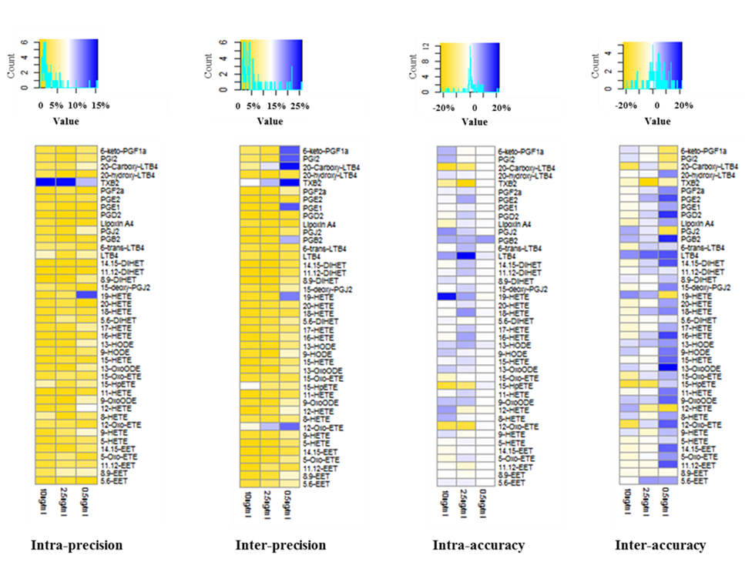

Supplementary Figure 1. Examination of the precision and accuracy of AA metabolites

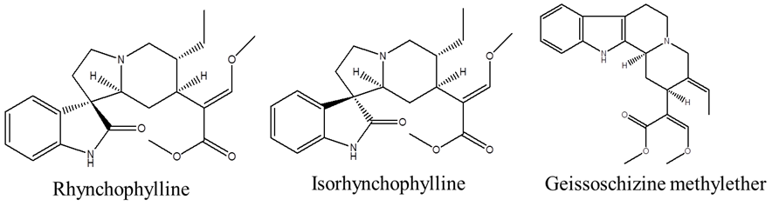
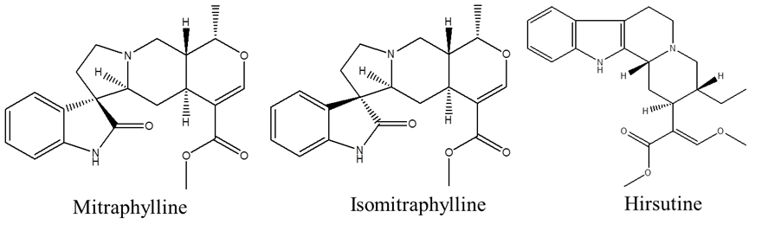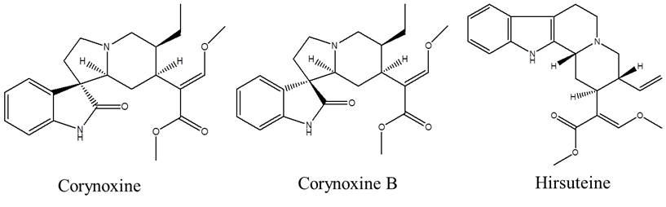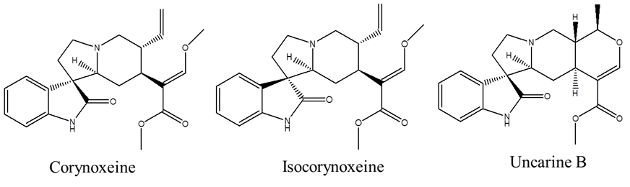
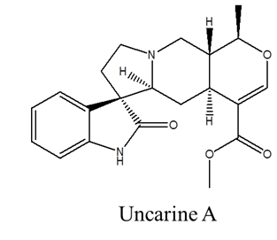
Supplementary Figure 2. Structures of 13 alkaloids

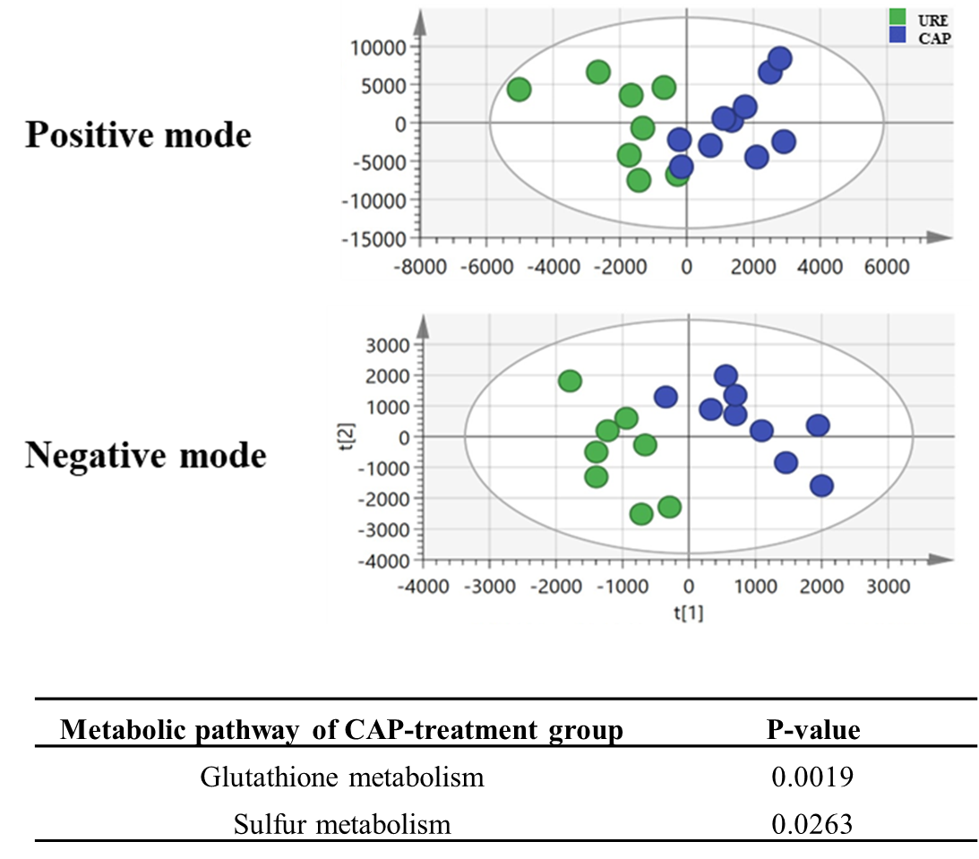

Supplementary Figure 3. PCA analysis of URE and CAP metabolomic profiles and the metabolic pathways in CAP-treatment group.

1.2 Supplementary Tables
Table S1 sEH hydrophobic interaction of A chain with CDU
Index | Residue | AA | Distance | Ligand Atom | Protein Atom
1 | 337A | VAL | 3.47 | 8194 | 2176
2 | 372A | VAL | 3.77 | 8200 | 2455
3 | 381A | TYR | 3.61 | 8186 | 2530
4 | 406A | PHE | 3.47 | 8183 | 2736
5 | 524A | TRP | 3.24 | 8183 | 3710

Table S2 sEH Hydrogen bonding interaction of A chain with CDU
Index | Residue | AA | Distance  H-A | Distance  D-A | Donor  Angle | Protein  donor | Sidechain | Donor  Atom
1 | 333A | ASP | 2.44 | 3.12 | 125.52 | NO | YES | 8190 [Nam]
2 | 333A | ASP | 2.70 | 3.56 | 146.44 | NO | YES | 8187 [Nam]
3 | 381A | TYR | 2.12 | 3.02 | 160.50 | YES | YES | 2533 [O3]
4 | 382A | GLN | 2.19 | 2.88 | 125.42 | YES | YES | 2542 [Nam]
5 | 465A | TYR | 1.76 | 2.64 | 156.72 | YES | YES | 3218 [O3]

