**Instabilities in a spherical liquid drop**

*Roger Prud'homme*

*Emeritus Research Director, UMR 7190 – Sorbonne-University, National Center for Scientific Research, Paris, France*

**Appendix**

**A1. Possible motions into a liquid drop**

***In the absence of external flow***, an internal thermal gradient in the liquid can cause internal motions for two reasons. At first, because the resulting density gradients lead to natural convection in the presence of gravity. Secondly, even without gravity, because the surface tension gradients caused by the surface thermal gradients are at the origin of the Marangoni effect which does not depend on gravity.

We know that these phenomena can come into play even in configurations having in principle solutions at rest, beyond instability thresholds. This is the case of the following two instabilities appearing classically in a flat horizontal layer configuration:

* *The Rayleigh-Bénard instability* which appears in a liquid layer of thickness *h* heated

from below in the presence of gravity[1], above a critical value of the Rayleigh number. Recall that the Rayleigh number is defined by $Ra=Gr_{Th}Pr$ where we find the thermal Grashov number $Gr_{Th}=Δρ{gL^{3}}/{ρν^{2}}$ and the Prandtl number $\operatorname{Pr}{=}ν/κ$. Finally, $Ra={αGgh^{4}}/{κν}$: with *G* thermal gradient of reference, $α$ coefficient of dilation . For a layer with two free boundaries, the critical Rayleigh number for which instabilities appear is equal to 657.511 for a reduced wavenumber of 2.2214. [2]

* *The Bénard-Marangoni instability* also appears in a liquid layer with transverse

thermal gradient presenting capillary surfaces. It is due to the sensitivity of surface tension to temperature [3], [4].

In the case of the drop, the curved configuration certainly involves both natural convection and the thermocapillary effect, which importance should be evaluated by using specific numbers of Rayleigh and Marangoni.

***The presence of an external flow*** in the reference configuration of the drop causes internal motions. Outflow may be due to natural convection in the gas phase (we can think of acoustic agitation), but the external flow can also be caused by the difference between internal speeds of the spray for the drop and for the gas phase.

The flow in a spherical liquid drop in the presence of relative flow can be modeled by a Hill vortex [5], [6]. It is a three-dimensional flow of revolution the stream functions are well defined in spherical coordinates by the relations given in section 2.

The following dimensionless numbers are used to evaluate and compare fluxes:

- *the Peclet number of the liquid,* which compares convection and heat conduction, *PeL=ReL PrL*  is the product of the Reynolds number and the Prandtl number. Therefore, it can be written: *PeL=2rL US R/kL* , with thermal diffusivity.

- *the Nusselt number of the liquid* which involves the convection coefficient $α$ and the thermal conductivity: $Nu={αL}/κ$. We then have $Nu_{L}=χNu_{L}\left(0\right)$, where $Nu_{L}\left(0\right)=6.58$ corresponds to the solid sphere. The heat conduction factor $χ$ is a Peclet function: $χ=1.86+0.86th\left[2.245\log_{10}{}\left({Pe_{L}}/{30}\right)\right]$. The figure A1 gives the curve $χ\left(Pe_{L}\right)$.

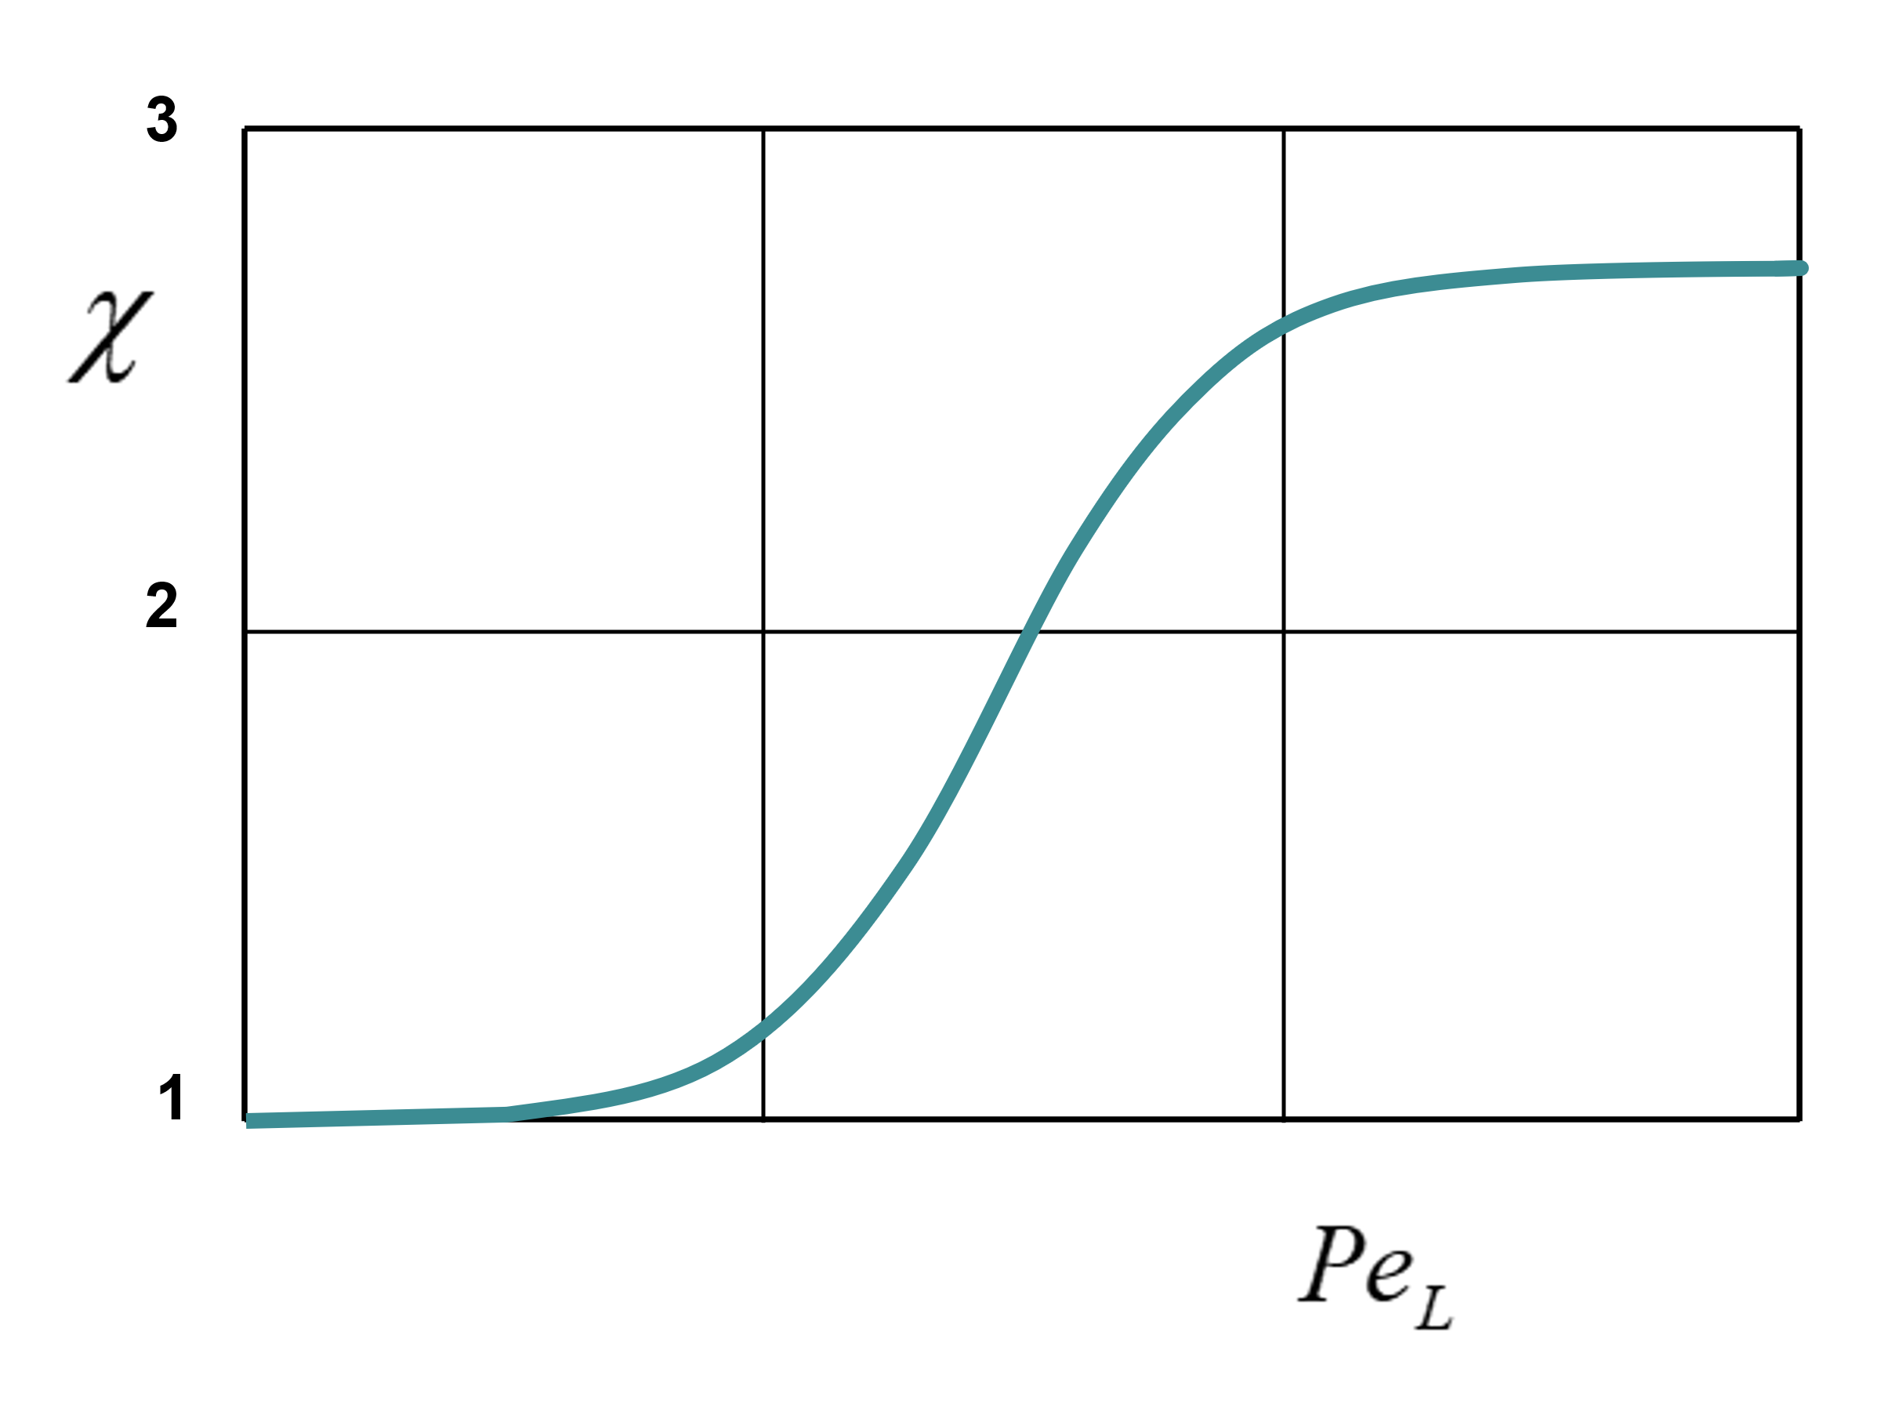

**Figure A1.** *Effective heat conduction factor depending on the Peclet number of the liquid* [7]

- On the side of the *gaseous phase*, the *modified Nusselt $Nu*$ and Sherwood $Sh*$ numbers* are used to characterize the transfers towards the drop. We thus have then for the mass flow rate of vaporization of the droplets of radius *rS*:

, with $B_{T}=c_{p}\left(T_{C}-T_{S}\right)/(l+{Q_{L}}/{\dot{M}})$, the Spalding thermal coefficient, and $\dot{M}=2πρDr_{S}Sh*\ln\left(1+B_{M}\right)$, with the Spalding mass diffusion coefficient $B_{M}=(Y_{FS}-Y_{FC})/(1-Y_{FS})$.

In these equations, we have *k* for the conduction coefficient, *cp* specific heat at constant pressure, *TC* and *TS* the absolute temperatures respectively far away the droplet an at the surface of the drop, the latent heat and *QL* the heat flux to the drop coming from outside, *Yj* the mass fraction of the species *j*, respectively.

Nusselt and Sherwood numbers are modified to account for evaporation as follows:

$Nu*=2+\frac{0.6{Re}^{1/2}{}{Pr}^{1/3}{}B_{T}}{{\left(1+B_{T}\right)}^{0.7}\ln\left(1+B_{T}\right)},$ with $B_{T}=c_{p}\left(T_{C}-T_{S}\right)/(l+{Q_{L}}/{\dot{M}})$, and :

$Sh*=2+\frac{0.6{Re}^{1/2}{}Sc^{1/3}B_{M}}{{\left(1+B_{M}\right)}^{0.7}\ln\left(1+B_{M}\right)},$ with $B_{M}=(Y_{FS}-Y_{FC})/(1-Y_{FS})$.

**A2. Acoustic excitation in a rocket engine**

The acoustic excitations in a rocket engine can give rise to standing waves of pressure or velocity depending on the position considered. The diagrams in the figure A2 show the situations of acoustic excitation by plane parallel emitters. In the case of the anti-nodes of speed, it will be necessary to specify the relative direction of the excitation in speed compared to the flow: parallel, perpendicular, specified angle.



**Figure** A2.*Thermo-acoustic streaming pattern. In this figure, the curves represent the velocity profile of the acoustic wave produced by the motor.* ***a)*** *The spherical liquid droplet[8] can be in a velocity anti-node (top), i.e. in a pressure node. Its position can also be a speed node (in the middle), i.e., a pressure anti-node. It can also undergo the effects of velocity and pressure (bottom) of the standing acoustic wave.* ***b)*** *In the case studied by Tanabe et all [9], another phenomenon is observed. When a droplet burns at anti-node (upper case), fuel vapour comes back to concentrate on the anti-node plane and the burned gas flows towards the node. At node (middle case), flows in opposite direction can be expected. In the middle of node and anti-node (lowercase), a natural convection-like flow occurs.*

In our studies, we are interested in liquid evaporating droplets flowing inside a rocket engine, and we assume that the flame surrounds a population of these droplets. A mean drop of this population will be considered.

**A3. The mean vaporizing droplet, continuously fed by a point source placed at its centre**.

In the present theory, we admit that the history of the droplets moving in a rocket engine can be described by a single mean droplet. This vaporizing liquid droplet submitted to the acoustic oscillations coming from the engine, is continuously fed, at its centre, by a liquid flow that compensate exactly the loss of mass by evaporation. This feeding mass rate is equal to this which would be vaporized during the stabilized unperturbed evolution.

The mean droplet is supposed to be situated at a velocity node such as represented in figure A2 (in the middle). Therefore, we only consider pressure perturbation and associate (but not speed perturbations) [10]. In addition, the study is limited to small perturbations, what permits then linearized calculations with several possible hypotheses concerning the feeding mode[11].

Applying this method, we find generally approximate analytic expressions for:

* The response factor, which permit the determination of sound frequency limits between stable and unstable regions.
* The temperature field inside the droplet.



Figure A3. *a) The mean vaporizing droplet, continuously fed by a point source placed at its centre. b) Boundary conditions for the supplied droplet.*

The geometrical configuration is given in Figure A3a, and the boundary conditions far away and at the droplet surface appear in Figure A3b.

In the equations $\dot{M}, \bar{\dot{M}}, T,Y_{j},p,ρ, r,{\bar{r}}_{S}, D,k, l,Q_{L}$ are respectively the instantaneous evaporating mass, the average feeding mass flow rate, the values of temperature, species mass fraction, pressure, density, radial coordinate, stabilized droplet radius, diffusion coefficient, heat conduction, latent heat, heat transferred from outside into the droplet. Indexes *L*, *C* and *S* are used for the liquid phase, the combustion chambre, and the droplet surface.

Simple results are obtained with an adiabatic feeding at the centre and neglecting the motion inside the droplet. The obtain results are of the form:

$N=αR\left\{\frac{iu}{1+iu}\frac{A+θE\left(u,θ\right)}{B-θE\left(u,θ\right)}\right\}$

for the response coefficient, and

$X=R\left\{\frac{A+B}{B-θE\left(u,θ\right)}\frac{\sinh\left[\left(1+i\right)\sqrt{{3u}/{2θ}}ξ\right]}{\sinh\left[\left(1+i\right)\sqrt{{3u}/{2θ}}\right]}e^{\frac{iu}{3}τ}\right\}$

for the reduced temperature perturbation inside the droplet.

In these formulae, constants *A,* *B,* and $α$ depends on the reference state thermal and chemical quantities. $u=3ω{\bar{τ}}_{v}, ω$ being the pulsation of the sound waveis a reduced frequency , $θ$ is the inverse of the Peclet number, $ξ,τ$ are reduced radius and time. We have:

$\left\{\begin{aligned}&θ=9κ_{L}{{\bar{τ}}_{v}}/{{\bar{r}}_{S}^{2}}={{\bar{τ}}_{v}}/{{\tilde{τ}}_{T}} \\ &E\left(u,θ\right)=1-\left(1+i\right)\sqrt{{3u}/{2θ}}\coth\left[\left(1+i\right)\sqrt{{3u}/{2θ}}\right]\end{aligned}\right.$

where ${\bar{τ}}_{v},{\tilde{τ}}_{T}$ are characteristic times for mass and heat exchange, and $κ_{L}$ is the heat diffusion coefficient of the liquid.

An example of the obtained results is presented in Figure A4. We observe in particular that increasing $θ$ (i.e., decreasing *Pe $={{\tilde{τ}}_{T}}/{{\bar{τ}}_{v}}$*) lead to enlarge the unstable frequency domain ($N/α>0$). We see too that, for a given value of $θ$, a frequency increasing reduces the penetration of the thermal wave inside the drop.



**Figure A4.**  *Spherical drop with adiabatic feeding regime for A=10, B=10. The reduced response factor $N/α$ as a function of u for several values of theta. The reduced temperature perturbation as a function of space and time for, $θ$ =10 and three values of the sound reduced frequency u.*

The case of an isothermal injection in place of the previous adiabaticity was also studied.

An extension of this study was made introducing a finite exchange injection coefficient at the centre of the drop.

We are interested to extend our research about the mean vaporizing droplet theory to the case of velocity steady acoustic waves. The present paper is a first step.

**A4. Effects of turbulence**

Turbulence can significantly alter exchanges through mixing. The results will be different depending on whether it is a micro-mix or a macro-mix.

There is generally a distribution of turbulence scales as shown in the figure's *Kolmogorov diagram* valid for a one-dimensional turbulent energy spectrum $E_{1}\left(k_{1}\right)$ (energy of velocity fluctuations per unit mass and wavenumber), showing the universality ${\left({k_{1}}/{k_{d}}\right)}^{-5/3}$ of Kolmogorov's law valid in the inertial zone.



**Figure 9**. Kolmogorov diagram $k_{d}$ is the Kolmogorov wave number $k_{d}={\left({\bar{ε}}/{ν^{3}}\right)}^{1/4}$ where $\bar{ε}$ is the rate of energy produced per unit mass in the large scales, equal by assumption to the rate of energy dissipated by viscosity in the small scales.

The *coupling between turbulence and combustion* is complex and is still the subject of numerous investigations. The interaction between evaporating drop and turbulence is also complex. It must be determined whether the size of the drops allows a direct interaction and also whether the gas transfer coefficients are modified.

In the case of evaporating drops, an evaporation time and a mixing time are defined, which are compared to the chemical time [12]:

- the evaporation time is deduced from the law “in d2” which is written: $d^{2}={d_{0}}^{2}-Kt$. We therefore find: $τ_{vap}={{{\bar{d}}_{0}}^{2}}/K$ where ${\bar{d}}_{0}$ is the mean diameter of the drops (Sauter diameter).

- the mixing time $τ_{mix}=D/{U_{ref}}$ is defined by means of the relation , where the outlet diameter *D* of the injector characterizes the large scales of the turbulence and where the reference speed $U_{ref}$ is defined from the total momentum $M_{0}$ of the jet according to identity: $M_{0}=\frac{π}{4}ρ_{moy}D^{2}{U_{ref}}^{2}$. We therefore find: .

- Chemical time $τ_{ch}$ also intervenes in this theory, the authors defining it for a premixed flame: $τ_{ch}=D/{s_{l}}$ ratio of the diffusion coefficient to the combustion rate of the adiabatic flat flame.

- Apparently the small scales of the turbulence do not intervene in this theory. Nevertheless, the ratio of the average diameter of the drops to the outlet diameter of the injector is considered.

The following reports are defined: $Δ_{1}={L_{liq}}/{L_{ent}},Δ_{2}={τ_{mix}}/{τ_{ch}},Δ_{3}={τ_{vap}}/{τ_{ch}},Δ_{4}={{\bar{d}}_{0}}/D$. The wavelengths should also be compared with those of the exciting vibrations of the engine. We

have seen that in rocket engines, the period $T={2π}/ω$ was of the same order as the heat transfer time ${\bar{τ}}_{T}$, which suggests the existence of coupling and in fact justifies our studies.

1. Chandrasekhar, S.: *Hydrodynamic and hydromagnetic stability*, Clarendon, Oxford, 1961.

  
2. Note that the case of the liquid sphere treated by Chandrasekhar corresponds to a central force field (case of the terrestrial globe) is very different. Nevertheless, the Rayleigh number can give valuable indications of possible convection.
3. Pearson, J.R.A.: On convection cells induced by surface tension, *J. Fluid Mech.*, **4**, 489-500 (1958)
4. Scriven, L.E. Sternling, C.V.: On cellular convection driven by surface-tension gradients: effects of mean surface tension and surface viscosity, *J. Fluid. Mech.*, **19**, 321-340 (1964)
5. Abramzon, B. & Sirignano, W. A. (1989): Droplet vaporization model for spray combustion calculations, *Int. J. Heat Mass Transfer*, **32**, Nº 9, pp. 1605-1618. doi:10.1016/0017-9310(89)90043-4.
6. Lamb, H.: *Hydrodynamics*, Cambridge University Press, Cambridge, 1945
7. Johns, L.E., Beckmann, R.B. (1966): Mechanism of dispersed-phase mass transfer in viscous, single-drop extraction system, *A.I.Ch.E. Jl.* **12**(1), 10-16.
8. In our studies, we are interested in liquid drops, and we assume that the flame surrounds a bundle of many evaporating drops. In the Heidmann configuration, the considered droplet is a mean one which represents the whole drops moving in the combustion engine.
9. Mitsuaki Tanabea, Takuo Kuwahara, Kimiyoshi Satoh, Toshiro Fujimori, Junichi Sato, Michikata Kono. Droplet combustion in standing sound waves. *Proceedings of the Combustion Institute***, 30** (2005) 1957–1964.
10. R. Prud’homme, M. Habiballah, L. Matuszewski, Y. Mauriot, and A. Nicole, Theoretical analysis of dynamic response of a vaporizing droplet to an acoustic oscillation, *J. Propulsion and Power*, **26**(1) (2010), pp. 74-83.
11. K. Anani, R. Prud’homme, and M. N. Hounkonnou, Dynamic response of a vaporizing spray to pressure oscillations: Approximate analytical solutions, *Combust. Flame* **193** (2018), pp. 295-305.
12. Delabroy, O., Lacas, F., Labegorre, B., Samaniego, J.-M. (1998): Paramètres de similitude pour la convection diphasique, *Revue Générale de Thermique*, **37**, 934-953.