Supplementary Information for
Cobalt demand for automotive electrification in China: Scenario analysis based on the Bass model

Qing Shiª*
ª Center of Data Economics & Network Study, ICOI, Shenzhen University, Shenzhen, Guangdong 518060, China
*Corresponding author: Dr. Qing Shi, shiqing@szu.edu.cn

Supplementary figures and tables

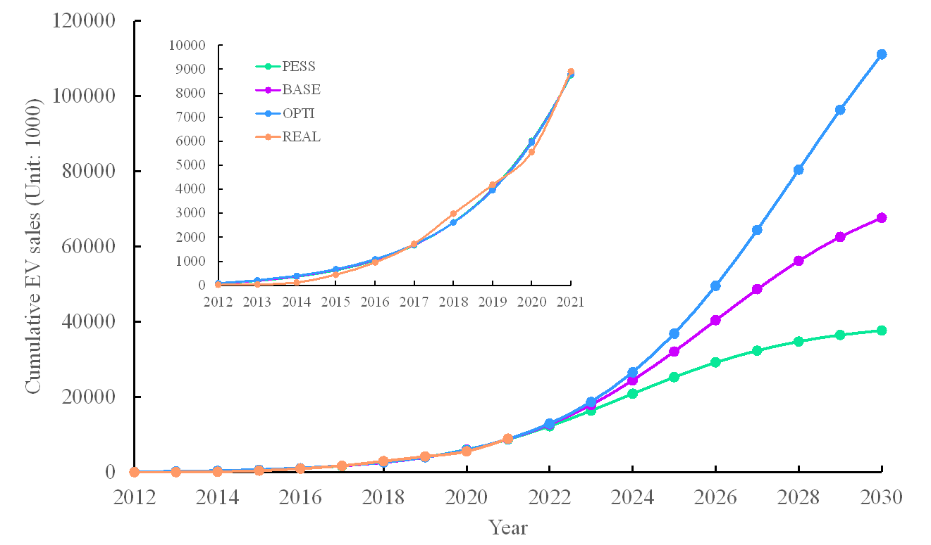
Figure S1: China’s cumulative EV sales projected until 2030. EV here includes BEV and PHEV. PESS is the pessimistic scenario, BASE is the baseline scenario, OPTI is the optimistic scenario. REAL is the historical data from 2012 to 2021, which is used to show the fitness of projected data and historical data.
Figure S2: China’s annual EV sales projected until 2030. EV here includes BEV and PHEV. PESS is the pessimistic scenario, BASE is the baseline scenario, OPTI is the optimistic scenario. REAL is the historical data from 2012 to 2021, which is used to show the fitness of projected data and historical EV sales data.
Figure S3: China’s annual installed battery capacity projected until 2030. PESS is the pessimistic scenario, BASE is the baseline scenario, OPTI is the optimistic scenario. REAL is the historical data from 2012 to 2021, which is used to show the fitness of projected data and historical EV sales data.
Table S1. Historical data for EV sales, stock, and annual battery capacity
Year | BEV Sales | PHEV Sales | Annual EV Sales | EV Cumulative sales | BEV Share | PHEV Share | Battery  Capacity
2012 | 11.375 | 1.416 | 12.791 | 16 | 89% | 11%
2013 | 14.604 | 3.038 | 17.6 | 33.6 | 83% | 17%
2014 | 45.048 | 29.715 | 74.8 | 108.4 | 60% | 40%
2015 | 247.482 | 83.61 | 331.1 | 439.5 | 75% | 25%
2016 | 409 | 98 | 506.6 | 946.1 | 81% | 19% | 28
2017 | 652 | 125 | 776.7 | 1722.8 | 84% | 16% | 36.24
2018 | 984 | 271 | 1256.2 | 2979 | 78% | 22% | 56.9
2019 | 972 | 232 | 1206 | 4185 | 81% | 19% | 62.2
2020 | 1115 | 251 | 1367 | 5552 | 82% | 18% | 63.6
2021 | 2761 | 598 | 3359 | 8911 | 82% | 18% | 154.5
Notes: (1) Units for EV sales and stock are 1000 unit. Annual installed battery capacity is measured in GWh.
(2)Annual EV sales are collected from China Association of Automobile Manufacturers, http://lwzb.stats.gov.cn/pub/lwzb/zxgg/202107/W020210723348607396983.pdf; BEV and PHEV are collected by the authors from the website of MarkLines, https://www.marklines.com/en/vehicle_sales/free.
(3) Annual installed battery capacity is collected by the authors from the news data issued by China Innovation Strategic Association for EV Battery Industry.

Table S2. Descriptive statistics for EV data

Statistics | BEV | PHEV | EV annual sales | EV cumulative sales
Mean | 721.15 | 169.28 | 890.78 | 2489.34
St. Dev. | 832.32 | 180.87 | 1012.41 | 2957.49
Min | 11.38 | 1.42 | 12.79 | 16.00
1st Qu. | 95.66 | 43.19 | 138.88 | 191.20
3rd Qu. | 981.00 | 246.25 | 1243.65 | 3883.50
Max | 2161.00 | 598.00 | 3359.00 | 8911.00

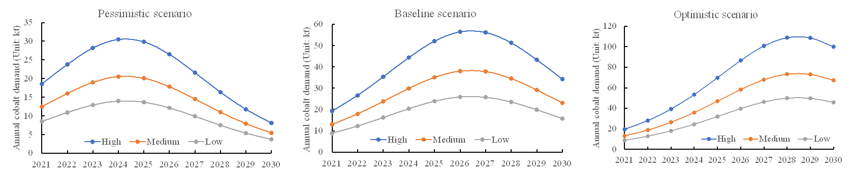
Figure S4: Annual cobalt demand for EVs under different scenarios. In the legend, High denotes the high cobalt scenario, Medium denotes the medium cobalt scenario, and Low represents the low cobalt scenario. This figure plots the medium scenario of ternary lithium battery market share (60%).

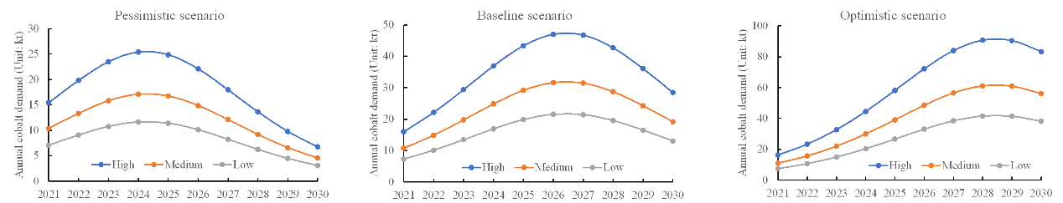
Figure S5: Annual cobalt demand for EVs under different scenarios. In the legend, High denotes the high cobalt scenario, Medium denotes the medium cobalt scenario, and Low represents the low cobalt scenario. This figure plots the low scenario of ternary lithium battery market share (50%).

