Table S1 Strains, plasmids, and antibodies used in this study
Strain and Plasmid | Feature | Source
Mycobacteria
M. smegmatis mc²-155 | Wild type strain of M. smegmatis | From National Institutes for Food and Drug Control of China
ΔcnpB | cnpB deletion mutant strain | This study
ΔcnpB::C | cnpB complementary strain | This study
ΔcnpB::O | cnpB overexpressed strain | This study
M. tuberculosis H37Ra | Wild type of M. tuberculosis attenuated strain | National Institutes for Food and Drug Control of China
E. coli
DH5α  BL21 | Plasmid construction  Expression of protein | This study  This study
Plasmids
pJV53 | Expressing homologous recombination enzymes of gp60 and gp61, Kan^{R} | Addgene
pMSG360zeo | loxp-zeo-loxp | Addgene
PW75 | Recombinant pMSG360zeo carrying cnpB upstream and downstream fragments, Zeo^{R} | This study
PW86 | Mycobacterium-E. coli cnpB single copy shuttle expression vector, Hyg^{R} | This study
PW87 | Mycobacterium-E. coli cnpB multiple copy shuttle expression vector, Hyg^{R} | This study
PW92 | CnpB prokaryotic expression vector of pET28a(+)-cnpB, Kan^{R} | This study
Antibodies
anti-CnpB pAb | Mouse polyclonal antibody to CnpB (MSMEG_2630) | Our lab
anti-Ag85 pAb | Mouse polyclonal antibody to Ag85 (MSMEG_6398), | Our lab
anti-PdxH pAb | Mouse polyclonal antibody to PdxH (MSMEG_5675) | Our lab

Table S2 Primers used in this study
Oligo sequence (5’ to 3’) ª | Description
Strains construction and verification
tttgatatcggccatcgagtacgagatc | cnpB upstream for knockout, forward
gcgaagcttggtcttgggatcggttgtcgtc | cnpB upstream for knockout, reverse
ttttctagagcgggatactccgcgacc | cnpB downstream for knockout, forward
gcgggtaccgaaagcatcggcaccgcaac | cnpB downstream for knockout, reverse
aactacatcgacccttccgc | cnpB internal, forward
gtgcatcggttcgatctcct | cnpB internal, reverse
gtgatctcggtgagccactc | MSMEG_6080 internal, forward
aagtccagcagttcgctgtc | MSMEG_6080 internal, reverse
tttggtaccatgccggtgacgacaacc | cnpB complementation, forward
tttggatcctcagccaagggcccgtgc | cnpB complementation, reverse
tttaagcttatgccggtgacgacaacc | cnpB overexpression, forward
tttaagctttcagccaagggcccgtgc | cnpB overexpression, reverse
qRT-PCR
cgacgacctcgactccgacgac | MSMEG_2758 (sigA), forward
gccttcctggatgaggtcgagga | MSMEG_2758 (sigA), reverse
agctgtacctgatcttcccg | MSMEG_1875 (mtrB), forward
ctcttcgagctgctggatct | MSMEG_1875 (mtrB), reverse
ggagccgacgactatgtgat | MSMEG_1874 (mtra), forward
gtatccccacacctgttcga | MSMEG_1874 (mtra), reverse
gatgcggcacaactcgatc | MSMEG_0246 (prrB), forward
cgctcaacaagatggagtcg | MSMEG_0246 (prrB), reverse
tacctgaccaaaccgttcga | MSMEG_0244 (prrA), forward
aagtcgtagccccacacc | MSMEG_0244 (prrA), reverse
cggctacgaagaggtgctc | MSMEG_2618, forward
tgcatcccaattcactaacg | MSMEG_2618,reverse
cctacgacgaggttttcgac | MSMEG_0954, forward
ccaccggtcttgatcatctc | MSMEG_0954, reverse
ccatcctgttctccgacatc | MSMEG_2780, forward
caccaggtaggaggccaac | MSMEG_2780, reverse
aggtcaccacagaagcgaac | MSMEG_4525, forward
agatgaggtcgaggttgacg | MSMEG_4525, reverse
gattccctggactggctgg | MSMEG_1638, forward
tagccgttctccatctcgac | MSMEG_1638, reverse
ctactacaaccccggcatga | MSMEG_0234 (zmp1), forward
tacttggcaccctgatcgtc | MSMEG_0234 (zmp1), reverse
acagaacaggtatgg | MSMEG_0066 (esat-6), forward
tcaggcaaacattcc | MSMEG_0066 (esat-6), reverse
catctgggtgtactgcggta | MSMEG_6398(ag85), forward
ctctgcgggaagttgaacac | MSMEG_6398(ag85), reverse
aagaatctgcccctcacaca | MSMEG_5350 (PPE 63), forward
acgtccttggtttccgtact | MSMEG_5350 (PPE 63), reverse
accaccatgagcacctatca | MSMEG_0619 (PPE4), forward
gtcatgaagtccgtcagcag | MSMEG_0619 (PPE4), reverse
tacagaacttcgtctcggcc | MSMEG_5392 (kdpA), forward
ggtgcccagttctttgatgg | MSMEG_5392 (kdpA), reverse
agtacttcgcgatcatcccg | MSMEG_5393 (kdpB), forward
cgatgagtttgatgccgagg | MSMEG_5393 (kdpB), reverse
aaggtgtacgggtcgagtg | MSMEG_5394 (kdpC), forward
caccgagaaatcccagcatg | MSMEG_5394 (kdpC), reverse
gccatcagatgtttcacgca | MSMEG_5395 (kdpD), forward
tacagaacttcgtctcggcc | MSMEG_5395 (kdpD), reverse
cctttggcatggacgagttc | MSMEG_5396 (kdpE), forward
cgcgtaaatagtgggtctcg | MSMEG_5396 (kdpE), reverse
gagaccgagaccaccaagtg | MSMEG_2771 (trkA), forward
tcattcggaatccaggtcgt | MSMEG_2771 (trkA), reverse
gcgcaacgaatggcttttc | MSMEG_2769 (trkB), forward
cagttcgtcaccaccttcga | MSMEG_2769 (trkB), reverse
a Underlined oligo DNA is restriction site.

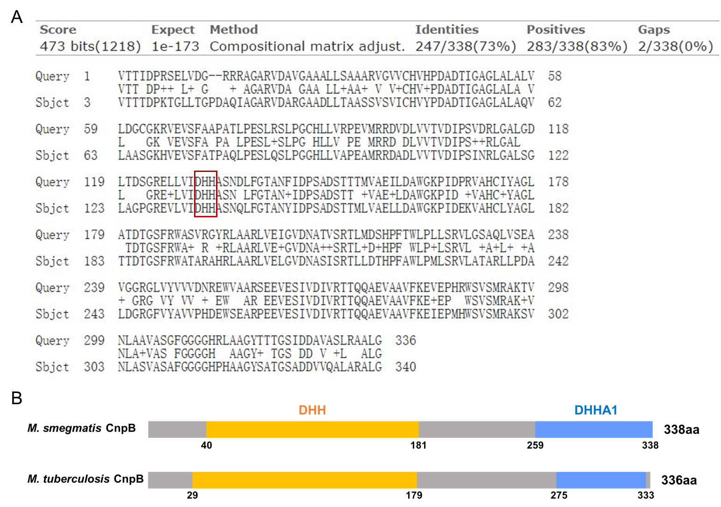
Figure S1 CnpB amino acid sequences alignment between M. tuberculosis and M. smegmatis. (A) Alignment of M. tuberculosis CnpB (Query) and M. smegmatis CnpB (Sbjct) sequences. The amino acids shown in the red rectangle is DHH motif. (B) Amino acid sites of DHH and DHHA1 domains of CnpB in M. tuberculosis and M. smegmatis, respectively.
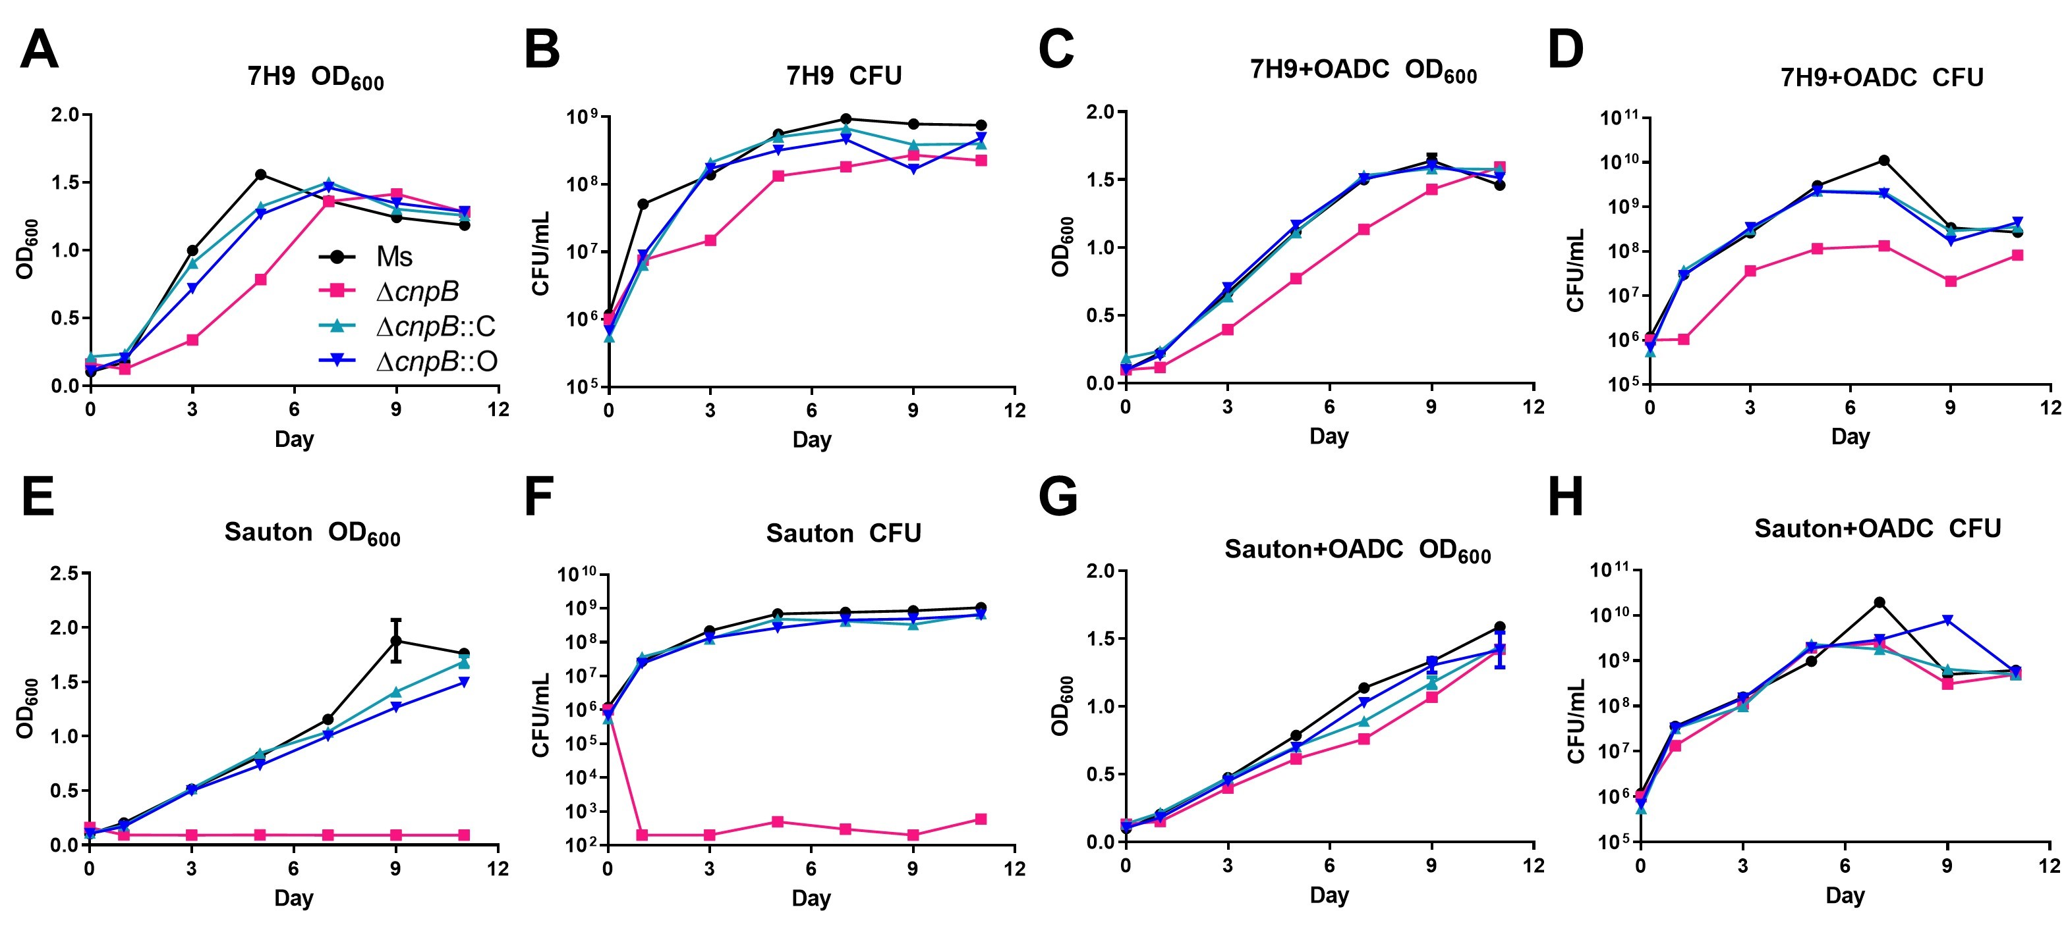
Figure S2 Detection of bacteria growth in broth liquid media (80rpm). Each strain was inoculated at 2.5×10⁶ CFU/mL in media of 7H9 (A), 7H9+OADC (C), Sauton’s (E), Sauton’s +OADC (G). Bacteria were monitored at OD₆₀₀ (A, C, E, G) and corresponding CFUs (B, D, F, H) numeration at indicated time points, respectively. The growth curves were generated according to three repeats.

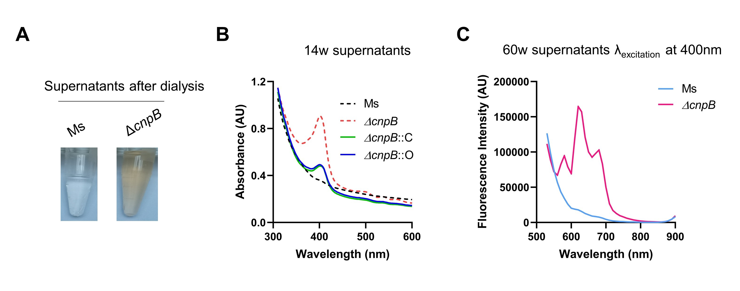
Figure S3 ΔcnpB produceds more brown pigment during the long-term static culture. (A) Observation of 14w supernatants after dialysis. (B) Absorption spectra of 14-week supernatants was recorded by full-wavelength (100 - 1 000 nm) scanning. (C) Fluorescence measurements of 60w supernatants were analyzed at the excitation wavelength (λ_{excitation}) 400 nm.
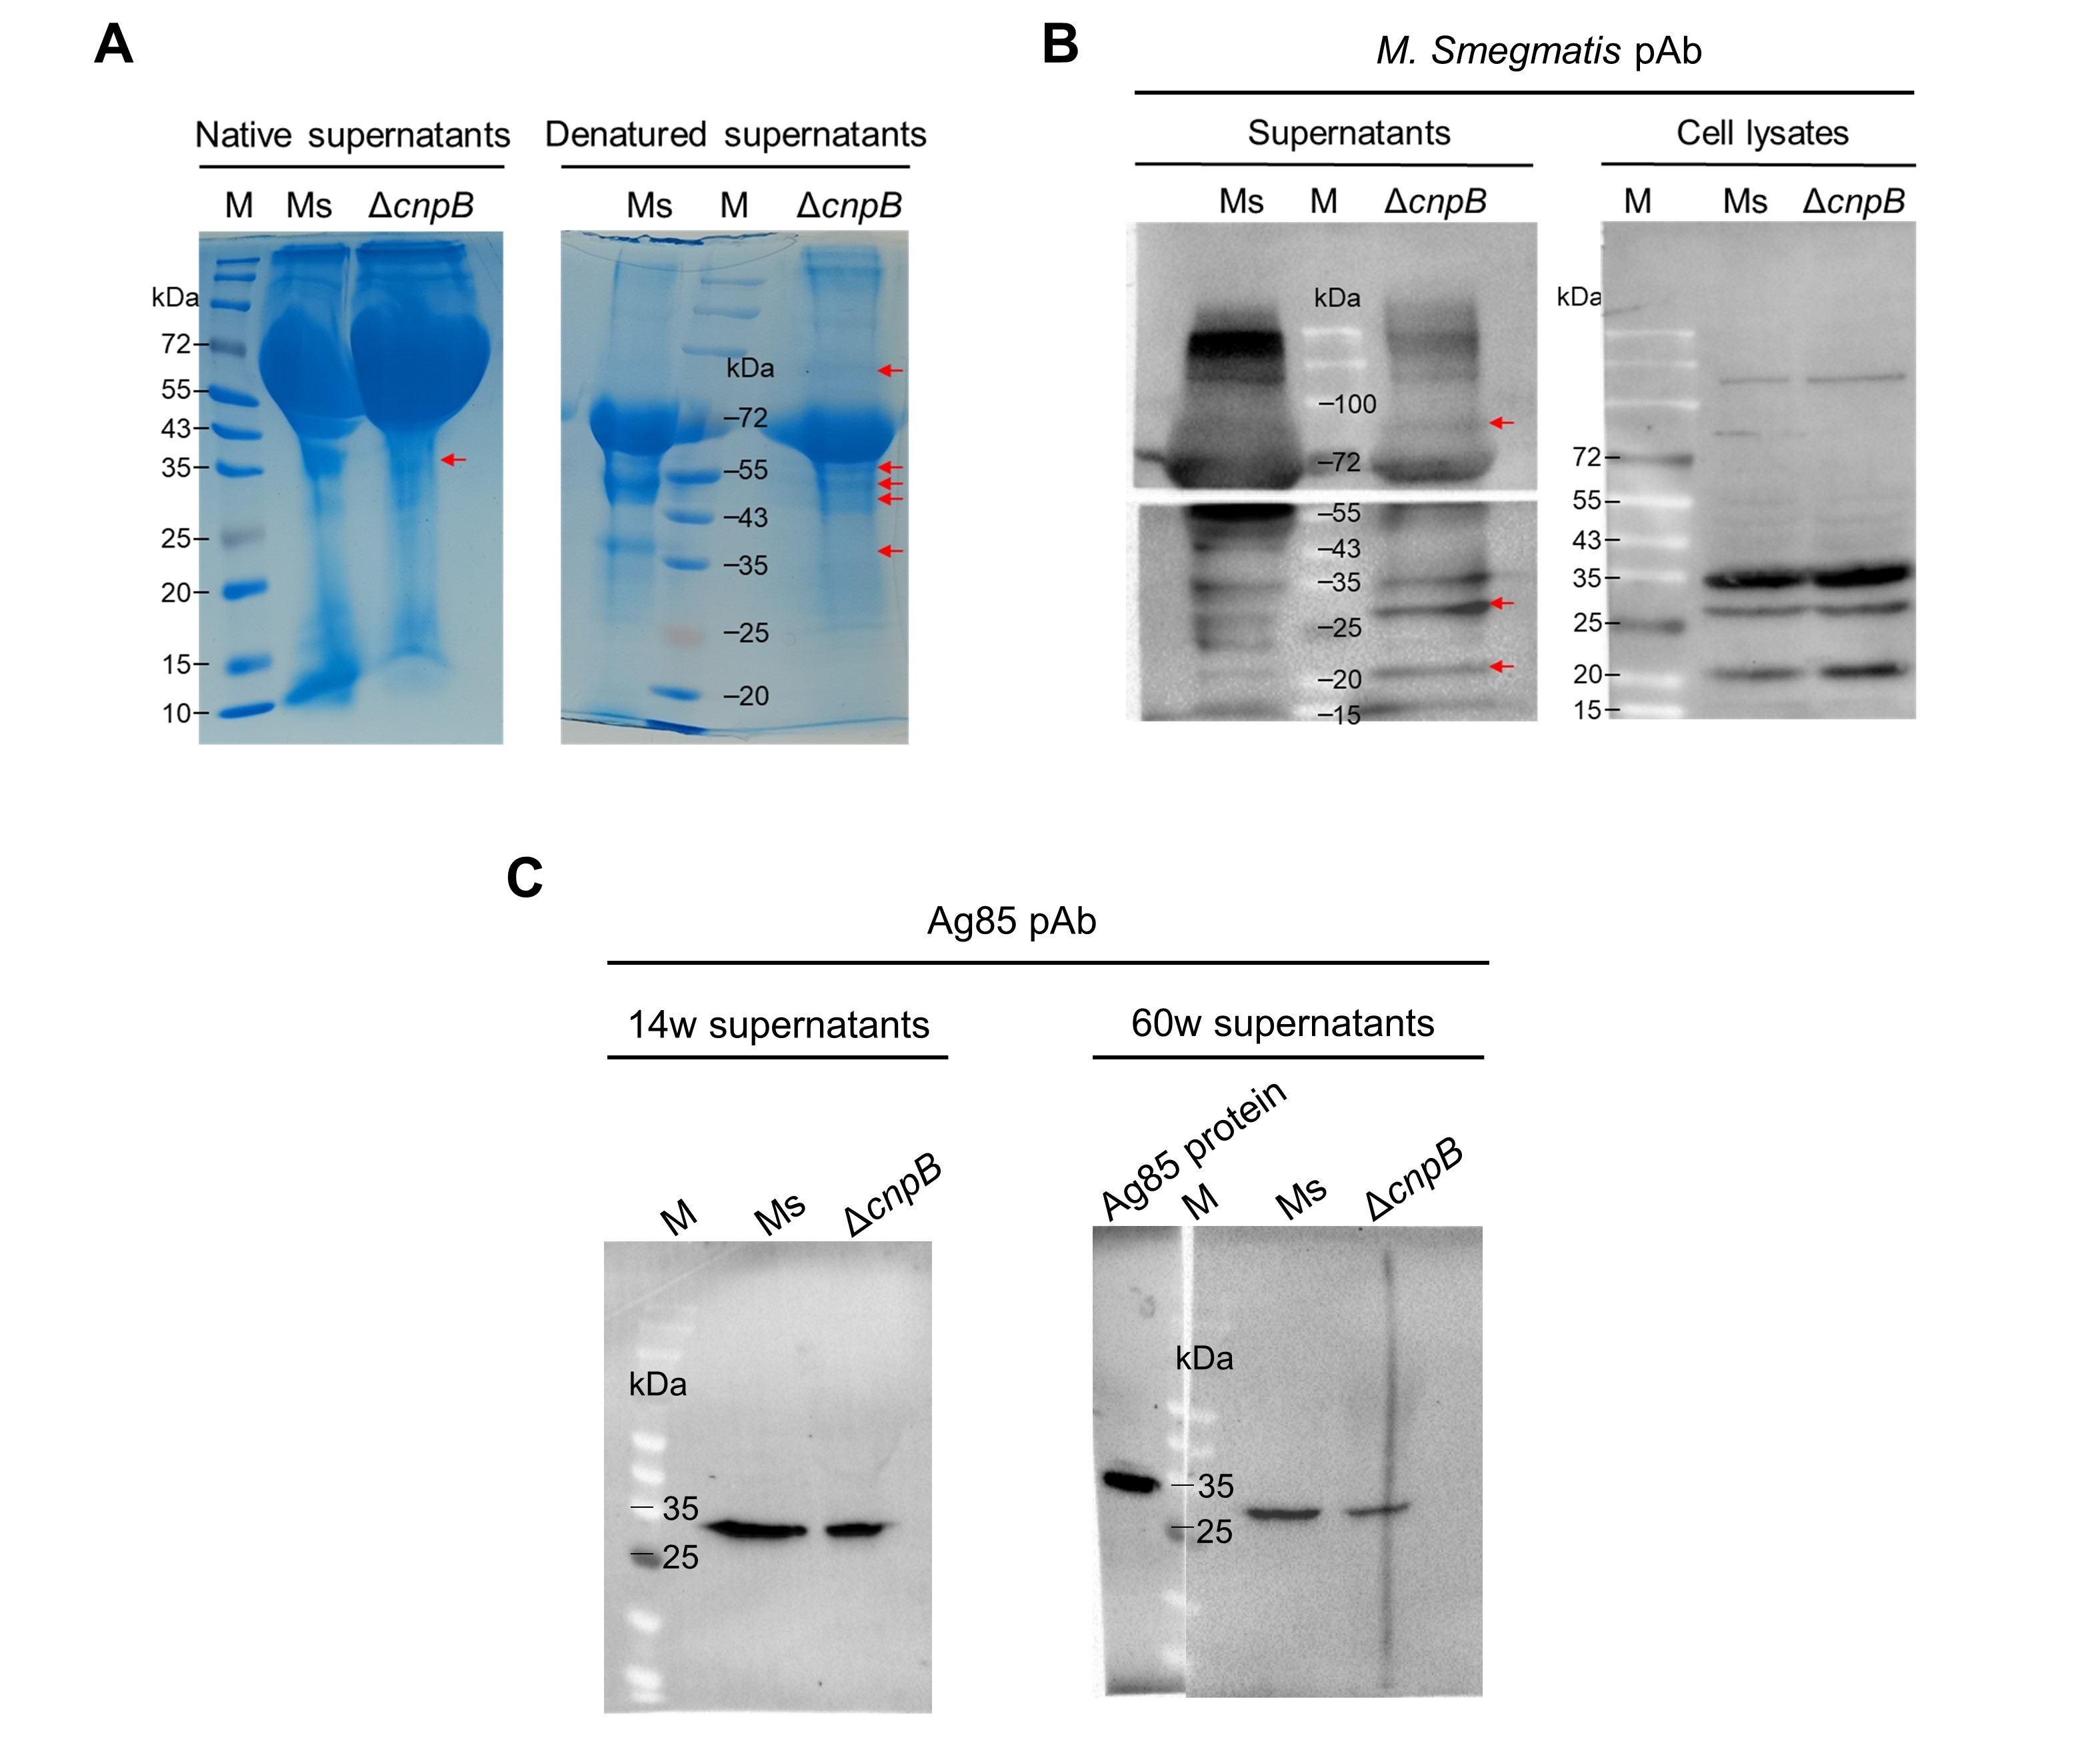
Figure S4 ΔcnpB produce (A) After 14-week of stationary culture, native and boil-denatured supernatants were analyzed by SDS-PAGE. The red arrows indicated possible new protein bands of ΔcnpB. (B) After 14-week of stationary culture, supernatants were condensed by saturated ammonium sulfate. Condensed-supernatants and bacteria lysates were analyzed by Western blot using M. smegmatis polyclonal antibody. The red arrows indicated the M. smegmatis-specific differential protein bands in ΔcnpB supernatant after 14-week culture. (C) Western blot analysis of Ag85 secretion levels in concentrated-supernatants at 14 and 60 weeks.

