Supplementary Material
Table e1. Scan Parameters
Scan | Parameters
T1w | repetition time [TR] = 1900 ms, echo time [TE] = 3.46 ms, inversion time [TI] = 900 ms, flip angle = 9˚, GRAPPA = 2, matrix size = 256 × 256, Field of View [FOV] = 250 × 250 mm², number of slices = 176, slice thickness = 0.98 mm, number of averages = 1, band width [BW] = 170 Hz/Px, echo spacing [ESP] = 8.4 ms, acquisition time [TA] = 4:26 min
PD/T2w | TR = 4500 ms, TE1/TE2 (PD/T2w) = 11/101 ms, flip angle = 90˚, refocusing angle = 150˚, matrix size = 256 × 192, FOV = 250 × 187.5 mm², number of slices = 54; slice thickness = 3.00 mm, BW= 250 Hz/Px, turbo factor = 6, number of averages = 1, spatial resolution = 0.98 × 0.98 × 3.00 mm³, TA = 3:45 min
FLAIR | TR = 9000 ms, TE = 100 ms, TI = 2499 ms, flip angle = 90˚, refocusing angle = 130˚, matrix size = 256 × 256, FOV = 240 × 240 mm², number of slices = 32, slice thickness = 4.00 mm, BW = 287 Hz/Px, ESP = 7.17 ms, turbo factor = 16, BW = 287 Hz/Px, number of averages = 1, spatial resolution = 0.94 × 0.94 × 4.00 mm³, TA = 5:06 min
HARDI | TR = 3284 ms, TE = 89.4 ms, flip angle = 90°, refocusing angle = 177°, matrix size = 106 × 102, FOV = 212 × 204 mm², number of slices = 80, slice thickness = 2.00 mm, MB factor = 4, number of averages = 1, BW = 1814 Hz/Px, ESP = 0.69 ms, phase partial Fourier = 6/8, spatial resolution = 2.00 × 2.00 × 2.00 mm³, TA = 6:34 min. This sequence was acquired twice, with opposite phase encoding directions – i.e., anterior-posterior (AP) and then posterior-anterior (PA) – for a total of 100 diffusion-weighted images (b=1500 s/mm²), 10 reference images (b=0 s/mm²), and an overall TA = 13:08 min

Table e2. Characteristics of healthy controls used to develop regression-based norms
Characteristic
N | 103
Age (year), mean (SD) | 38.7 (16.3)
Female, n (%) | 68 (66.0)
White, n (%) | 85 (82.5)
Years of education, mean (SD) | 16.7 (3.0)
Ever Smoker, n (%) | 13 (12.6)
BMI (kg/m²), mean (SD) | 25.5 (4.7)

Table e3. Spearman correlations (p-values) between magnetic resonance imaging measures
 | Whole Brain  Volume | Thalamus  Volume | Hippocampus  Volume | GM volume | WM volume | NAWM MD | WM MD | GM MD
Whole Brain  Volume | 1 | 0.78 | 0.65 | 0.85 | 0.83 | -0.26 | -0.51 | -0.73
 |  | <0.0001 | <0.0001 | <0.0001 | <0.0001 | 0.0082 | <0.0001 | <0.0001
Thalamus volume | 0.78 | 1 | 0.60 | 0.68 | 0.72 | -0.29 | -0.56 | -0.69
 | <0.0001 |  | <0.0001 | <0.0001 | <0.0001 | 0.0026 | <0.0001 | <0.0001
Hippocampus Volume | 0.65 | 0.60 | 1 | 0.58 | 0.56 | -0.17 | -0.30 | -0.42
 | <0.0001 | <0.0001 |  | <0.0001 | <0.0001 | 0.091 | 0.0018 | <0.0001
GM Volume | 0.85 | 0.68 | 0.58 | 1 | 0.49 | -0.31 | -0.44 | -0.65
 | <0.0001 | <0.0001 | <0.0001 |  | <0.0001 | 0.0015 | <0.0001 | <0.0001
WM Volume | 0.83 | 0.72 | 0.56 | 0.49 | 1 | -0.13 | -0.55 | -0.67
 | <0.0001 | <0.0001 | <0.0001 | <0.0001 |  | 0.18 | <0.0001 | <0.0001
NAWM MD | -0.26 | -0.29 | -0.17 | -0.31 | -0.13 | 1 | 0.55 | 0.33
 | 0.0082 | 0.0026 | 0.091 | 0.0015 | 0.18 |  | <0.0001 | 0.0005
WM MD | -0.51 | -0.56 | -0.30 | -0.44 | -0.55 | 0.5505 | 1 | 0.71
 | <0.0001 | <0.0001 | 0.0018 | <0.0001 | <0.0001 | <0.0001 |  | <0.0001
GM MD | -0.73 | -0.69 | -0.42 | -0.65 | -0.67 | 0.33 | 0.71 | 1
 | <0.0001 | <0.0001 | <0.0001 | <0.0001 | <0.0001 | 0.0005 | <0.0001
GM = gray matter, WM = white matter, MD = mean diffusivity

Table e4. Tests of multivariate normality
Variables | Doornik-Hansen Test for Multivariate Normality
Thalamic volume, hippocampal volume, MD NAWM, MD GM | χ2 = 14.0, p = 0.17
SDMT, CVLT-II, BVMT-R, Verbal fluency | χ2 = 11.1, p = 0.35
GM = gray matter, NAWM = normal appearing white matter, MD = mean diffusivity, SDMT = Symbol Digit Modalities Test, CVLT-II = California Verbal Learning Test, BVMT-R = Brief Visuospatial Memory Test-Revised

Table e5. Association of comorbidity with cognitive variate and magnetic resonance imaging (MRI) variate when smoking was incorporated into the vascular comorbidity count
 | MRI variate | Cognitive variate^{b} | Cognitive variate^{c}
 | β (95% CI)* | β (SE)* | β (SE)*
Vascular comorbidityª
1 | -0.23 (-0.67, 0.22)  p = 0.32 | -0.38 (-0.95, 0.17)  p = 0.18 | -0.24 (-0.81, 0.33)  p = 0.41
2 | -0.95 (-1.45, -0.45)  p = 0.0001 | -0.87 (-1.43, -0.31)  p = 0.002 | -0.43 (-1.06, 0.20)  p = 0.18
≥3 | -0.85 (-1.44, -0.27)  p = 0.004 | -0.79 (-1.39, -0.19)  p = 0.01 | -0.44 (-1.09, 0.20)  p = 0.17
Anxiety | 0.056 (-0.47, 0.58),  p = 0.84 | 0.52 (-0.047, 1.10)  p = 0.07 | 0.48 (-0.12, 1.09)  p = 0.12
Depression | 0.43 (-0.044, 0.90)  p = 0.075 | 0.028 (-0.52, 0.57)  p = 0.92 | -0.16 (-0.68, 0.36)  p = 0.55
Disease-modifying therapy | 0.042 (-0.33, 0.41)  p = 0.83 | 0.029 (-0.34, 0.39)  p = 0.92 | -0.010 (-0.36, 0.33)  p = 0.95
MRI variate |  |  | 0.45 (0.26, 0.63)  p = 0.0001
Adjusted R² | 0.14 | 0.13 | 0.24
*Based on 1000 bootstrap replications; a- reference group = 0; b-without adjustment for MRI variate; c- with adjustment for MRI variate; 23.6% effect of vascular comorbidity on cognition mediated by MRI variables

Table e6. Association of comorbidity with cognitive variate and magnetic resonance imaging (MRI) variate among individuals who were overweight or obese
 | MRI variate | Cognitive variate^{b} | Cognitive variate^{c}
 | β (95% CI)* | β (SE)* | β (SE)*
Vascular comorbidityª
1 | -0.54 (-1.06, -0.24)  p = 0.04 | -0.54 (-1.06, -0.024)  p = 0.04 | -0.30 (-0.82, 0.22)  p = 0.26
2 | -0.74 (-1.45, -0.023)  p = 0.043 | -0.74 (-1.45, -0.023)  p = 0.043 | -0.53 (-1.16, 0.097)  p = 0.18
≥3 | -1.42 (-2.03, -0.81)  p = 0.0001 | -0.1.42 (-2.03, -0.81)  p = 0.0001 | -0.88 (-1.60, -0.16)  p = 0.017
Anxiety | 0.39 (-0.30, 1.09),  p = 0.27 | 0.39 (-0.30, 1.08)  p = 0.27 | 0.31 (-0.42, 1.03)  p = 0.41
Depression | 0.51 (-0.12, 1.15)  p = 0.11 | 0.51 (-0.12, 1.15)  p = 0.11 | 0.24 (-0.31, 0.79)  p = 0.40
Disease-modifying therapy | -0.14 (-0.58, 0.30)  p = 0.54 | -0.14 (-0.58, 0.30)  p = 0.54 | -0.056 (-0.47, 0.36)  p = 0.79
MRI variate |  |  | 0.44 (0.26, 0.63)  p = 0.0001
Adjusted R² | 0.11 | 0.11 | 0.28
*Based on 1000 bootstrap replications; a- reference group = 0; b-without adjustment for MRI variate; c- with adjustment for MRI variate
26% effect of comorbidity on cognition mediated via MRI variables
Figure e1. Scatterplots of MRI variable z-scores against each other
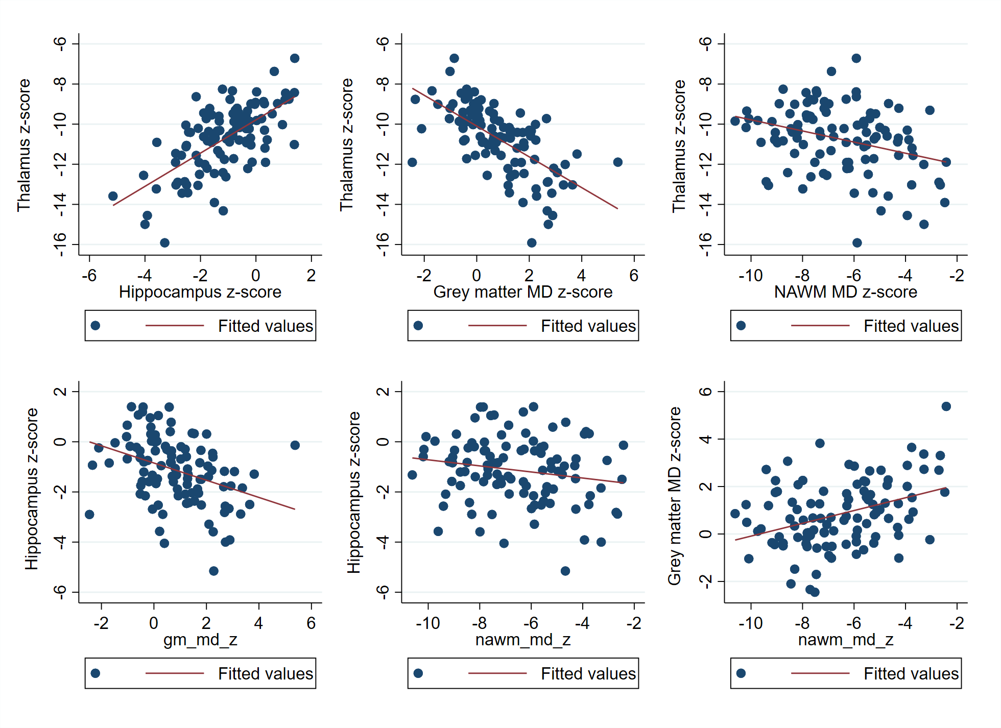

Figure e2. Scatterplots of cognitive test z-scores against each other
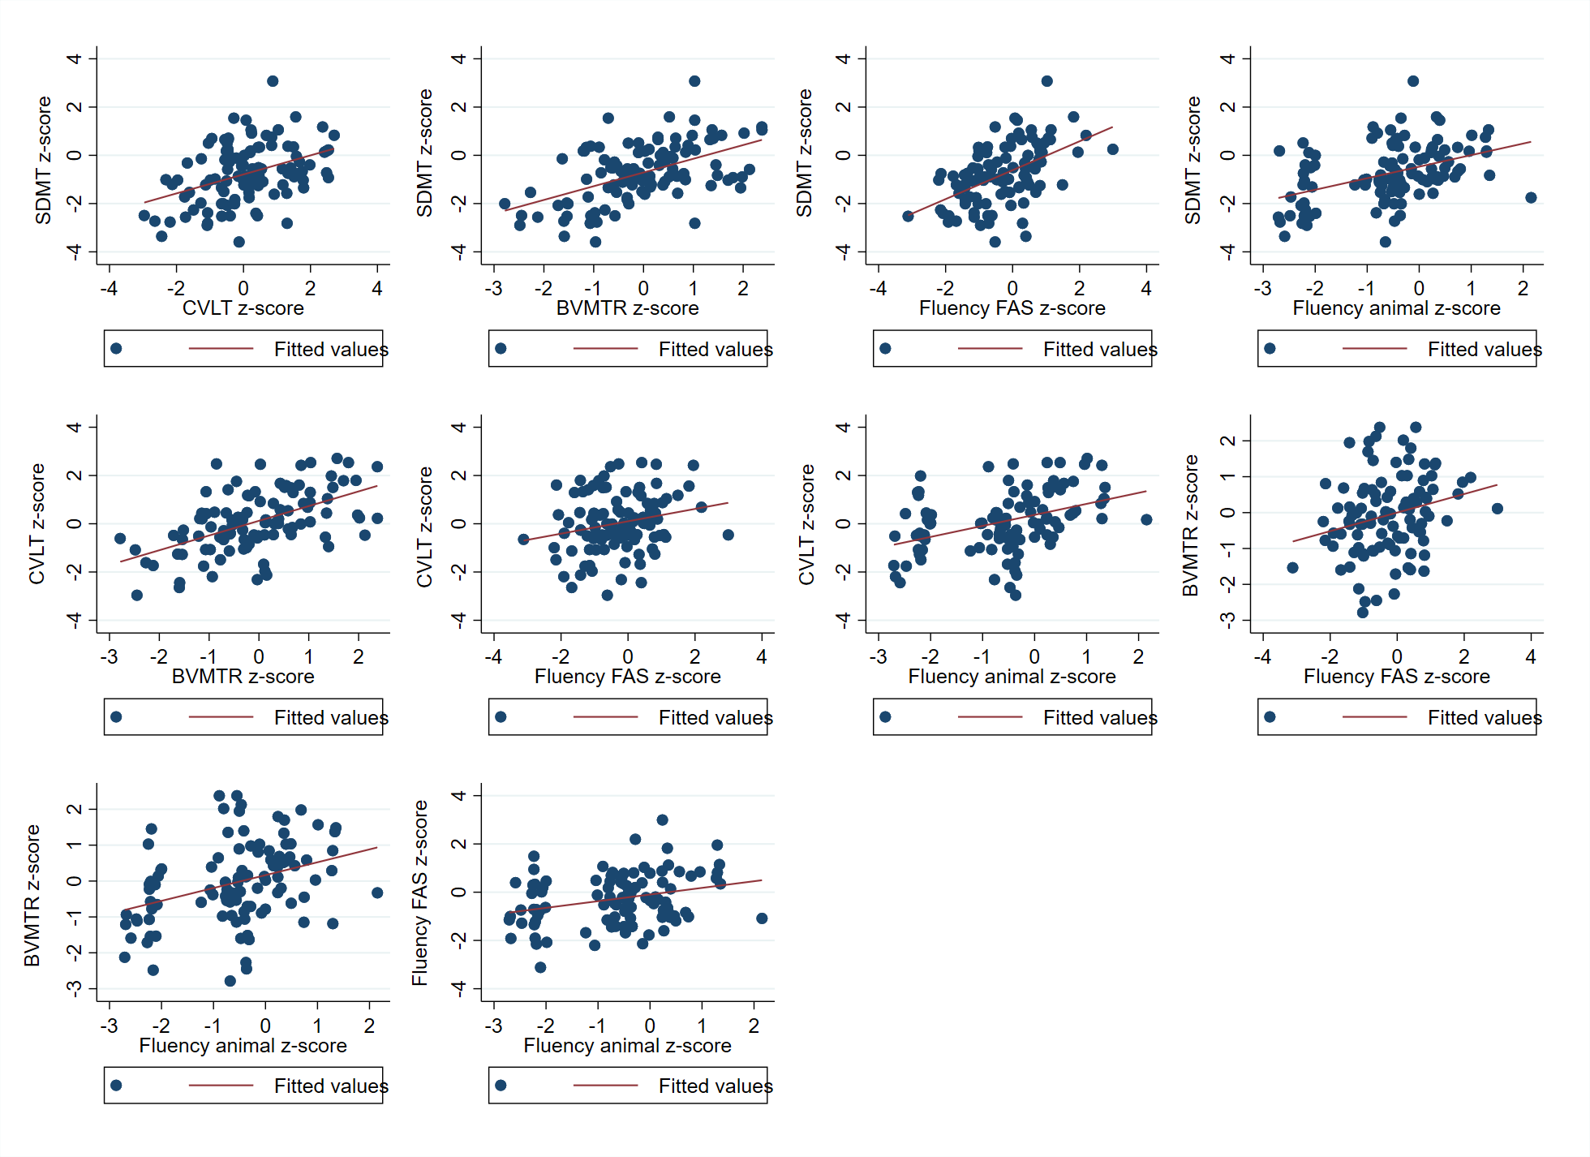
SDMT = Symbol Digit Modalities Test; CVLT-II = California Verbal Learning Test-II; BVMT-R = Brief Visuospatial Memory Test-Revised; COWAT = Controlled Oral Word Association Test/Fluency
Figure e3. Scatterplot of the association between the cognitive variate and the MRI variate

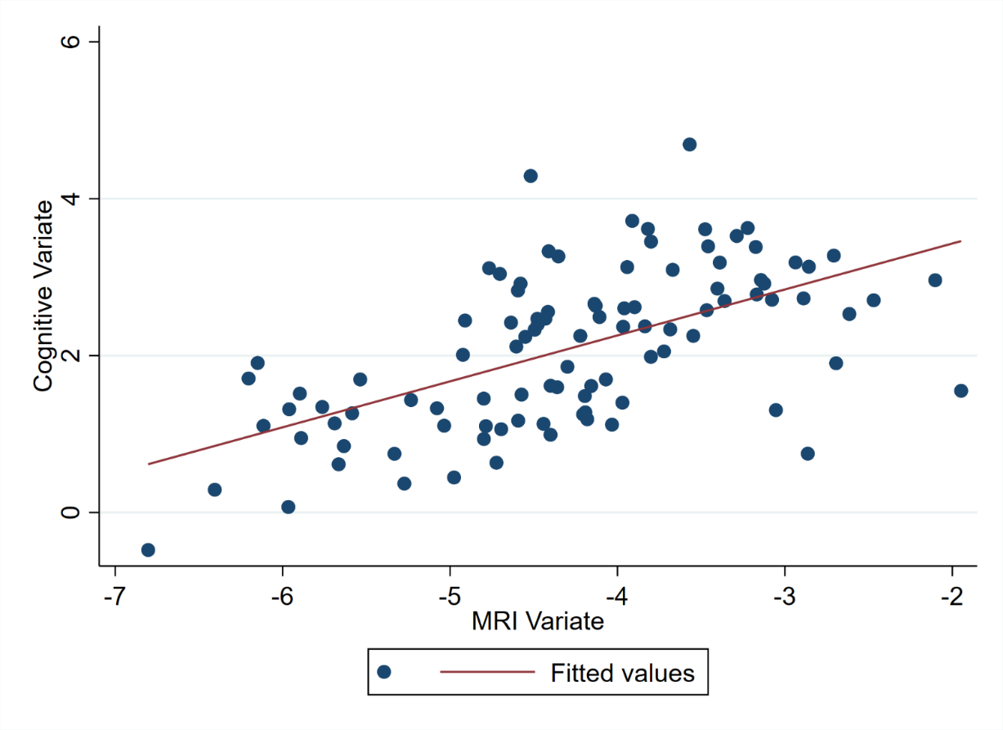

Figure e4. Scatterplots of cognitive test z-scores versus the cognitive variate
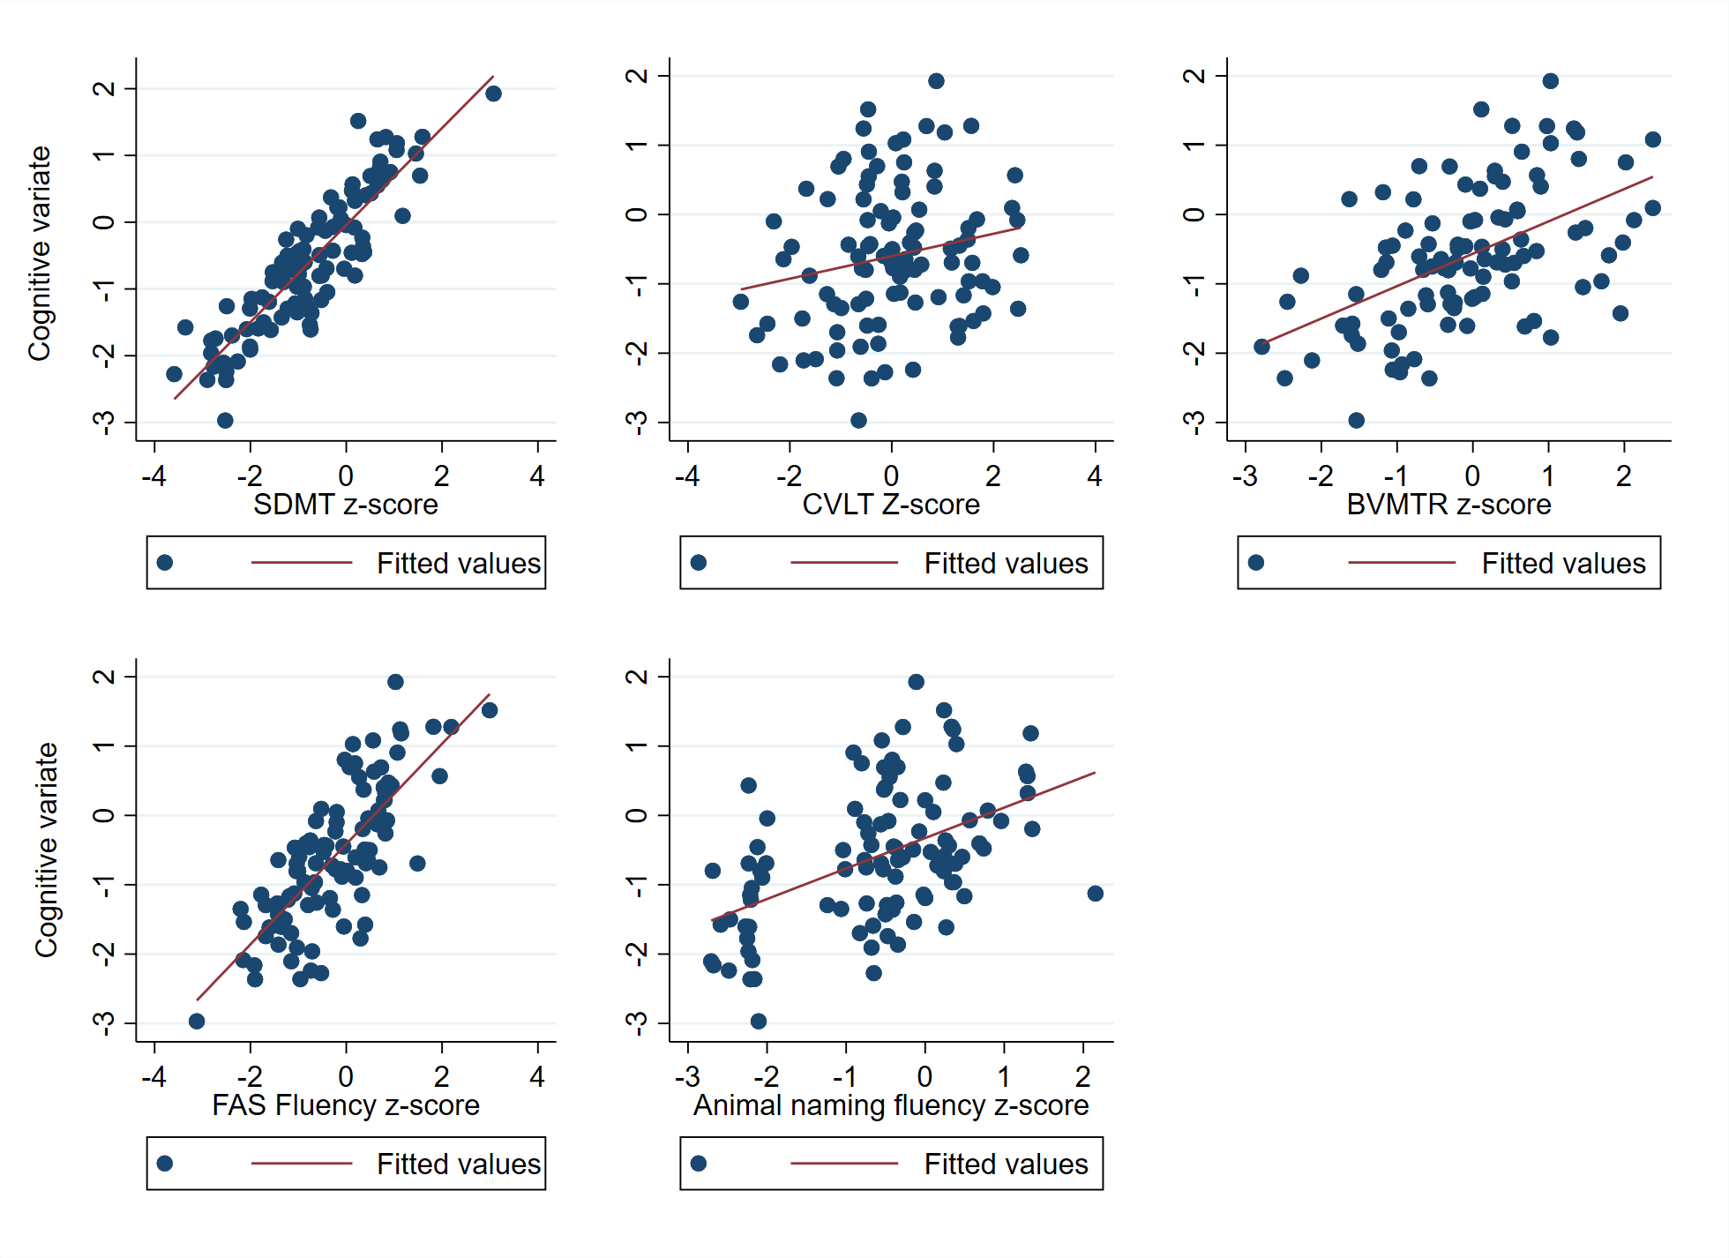
SDMT = Symbol Digit Modalities Test; CVLT-II = California Verbal Learning Test-II; BVMT-R = Brief Visuospatial Memory Test-Revised; COWAT = Controlled Oral Word Association Test/Fluency

Figure e5. Scatterplots of MRI variable z-scores versus the MRI variate
