Supplementary material

Table S1. Stages of 118 WT patients recruited

 | Stage I | Non-stage I |  |  | Total
 |  | Stage II | Stage III | Stage IV
WT cases | 48 | 43 | 18 | 9 | 118
Total | 48 | 70

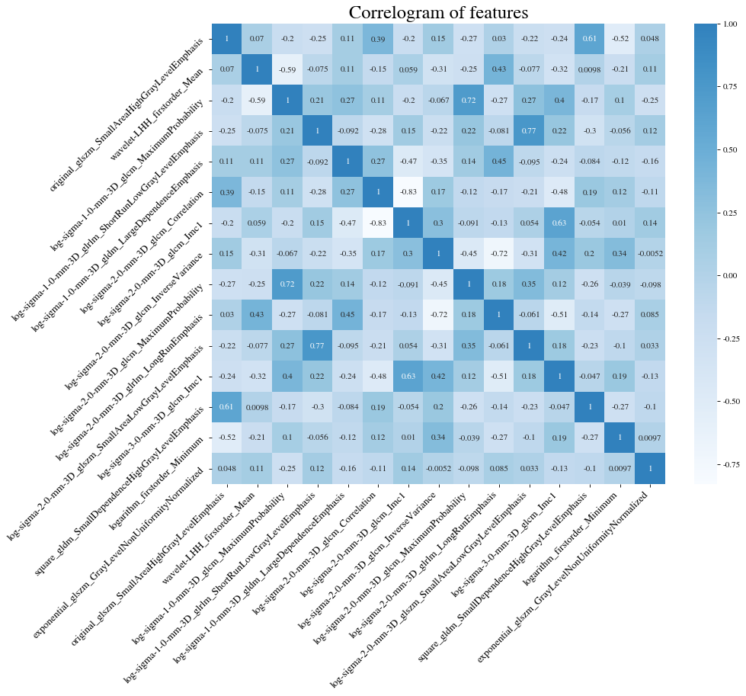
Fig. S1 Fifteen correlation coefficient heat map of radiomic features

Table S2 Fifteen features selected for machine learning along with their weights
Selected Features |  |  | Weight
Filters | Classes | Features
wavelet | Firstorder | Mean | 0.087998
logarithm | Firstorder | Minimum | -0.06448
LoG | GLCM | MaximumProbability | -0.03537
LoG | GLCM | Correlation | -0.06112
LoG | GLCM | Imc1 | 0.011275
LoG | GLCM | InverseVariance | 0.023932
LoG | GLCM | MaximumProbability | -0.06053
LoG | GLCM | Imc1 | 0.029728
LoG | GLDM | LargeDependenceEmphasis | 0.015652
square | GLDM | SmallDependenceHighGrayLevelEmphasis | 0.075376
LoG | GLRLM | ShortRunLowGrayLevelEmphasis | 0.045931
LoG | GLRLM | LongRunEmphasis | -0.12846
LoG | GLSZM | SmallAreaLowGrayLevelEmphasis | 0.080763
original | GLSZM | SmallAreaHighGrayLevelEmphasis | 0.026901
exponential | GLSZM | GrayLevelNonUniformityNormalized | 0.082749

