Descirption of Extrinsic factors
- Climatic variables
Oceanographic data has been routinely collected as part of the EU annual bottom-trawl survey (1988-2017). In this study all reference to annual values (temperature, salinity, CIL minimum temperature and thickness) must be interpreted as summer values.
Temperature: Temperature grids of the survey were computed using standard geostatistical techniques by extracting T values (ºC) corresponding to various depth levels. In our study, we used the bottom temperature-at-age defined as the temperature at the depth range at which each cod age class is more abundant. Cod shows an age (or size) related depth distribution, with older individuals living deeper whereas younger cod prefers shallower bottoms. Hence, cod growth is more likely to be influenced by temperature at the range at which each age is found.
The mean depth at which cod inhabits was estimated from the surveys indices that revealed,
when using the whole time series, a marked depth distribution by age, with younger cods living at shallower bottoms whereas older cods (age 8+) preferring bottoms close to 400 m (Table 1).

Table 1. Descriptive statistics of depth distribution of Atlantic cod at each age. Min = minimum, Max = maximum, Q = quartile (1st Q= 25%; 3st Q= 75%).
Cod age | Min. | 1st Qu. | Median | Mean | 3rd Qu. | Max.
1 | 145.5 | 170.6 | 195.5 | 202.7 | 229.1 | 257
2 | 157.4 | 223.4 | 229.7 | 234.7 | 248.7 | 297.5
3 | 139.9 | 230.6 | 241.4 | 246 | 269.6 | 302.5
4 | 165.3 | 253.9 | 269.6 | 270.2 | 283.9 | 350.1
5 | 177.1 | 271 | 290.3 | 298.5 | 314 | 408.3
6 | 138 | 301.6 | 312.4 | 313.7 | 330.9 | 427.3
7 | 156.7 | 316.6 | 333.7 | 330.6 | 350.3 | 422.9
8+ | 149.2 | 368.1 | 385.6 | 380.1 | 410.5 | 473.3

The temporal analysis of mean depth at-age showed a movement towards deeper waters of the
older ages at the begging of the time series, while moving back and abruptly to shallow waters
in during the last decade. Younger ages did not show any particular movement during the whole period. Nevertheless, since 2010 all age classes seem to occupy a narrower depth range living closer each other than earlier (Figure 1).
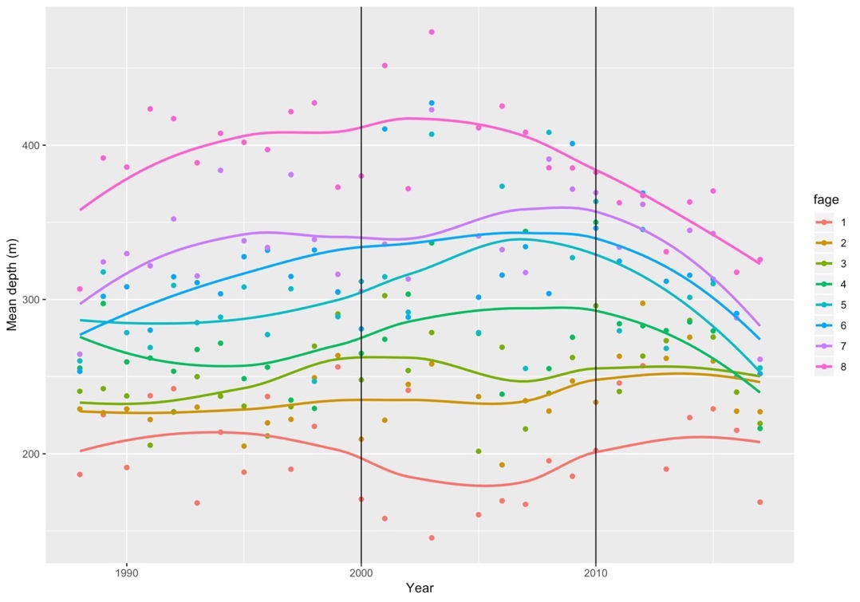
Figure 1. Temporal trend of cod mean depth at-age. Black lines indicates period of greater fluctuation on cod
vertical distribution.
The bottom temperature for the whole Flemish Cap decreased sharply in 1988-1990, although
the lack of earlier data prevents understanding this decrease (Figure 15.). Since then a steadily
increase of more than 1ÅãC was recorded until peak in at 4.5ÅãC in 2009-2011, decreasing slightly in recent years. The temperature at the depths where each class lives showed highest
fluctuation for age 1 (200m) while the temperature for older ages followed more the general
pattern described above (Figure 2).
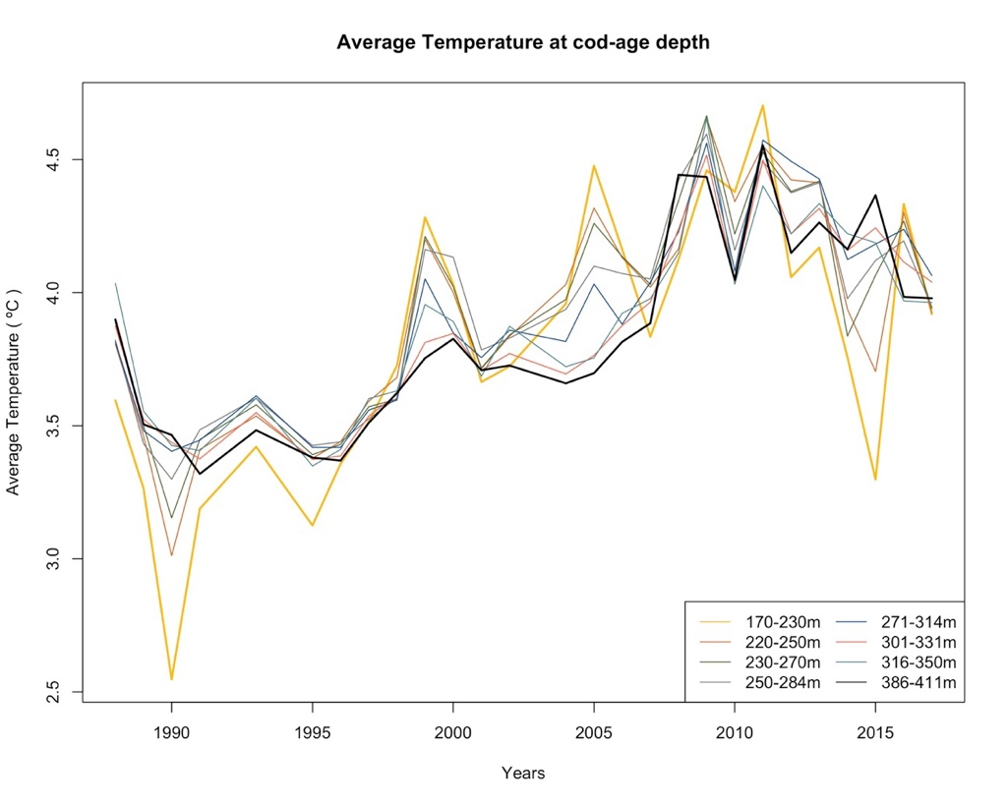
Figure 2. Temporal trend of bottom temperature at which cod-at-age inhabit.

Thickness of the cold intermediate layer (CIL): In Flemish Cap, the water masses that dominated the system are derived from a mixture of Labrador Current Slope Water (LSW) and North Atlantic Current Water (NAW) which produce waters with average sub-surface temperatures in the range of 3°C (the cold intermediate layer or CIL). During the cold years, the temperature of the CIL can reach 0°C. The thickness of the CIL gives valuable information since it acts as a barrier impeding energy transfer to deeper waters. Annual average values of CIL thickness were used as indices of the mixing degree.
The thickness of the cold intermediate layer increased from 1988 to 1990 (from 80 to 140 m).
After this period, thickness steeply decreased until 1996 and fluctuated at low levels for 15 years (the minimum was recorded in 2001 at 21.2 m). Then, CIL thickness sharply went down again, from 24.33 in 2010 to 118 m in 2015 (Figure 3).
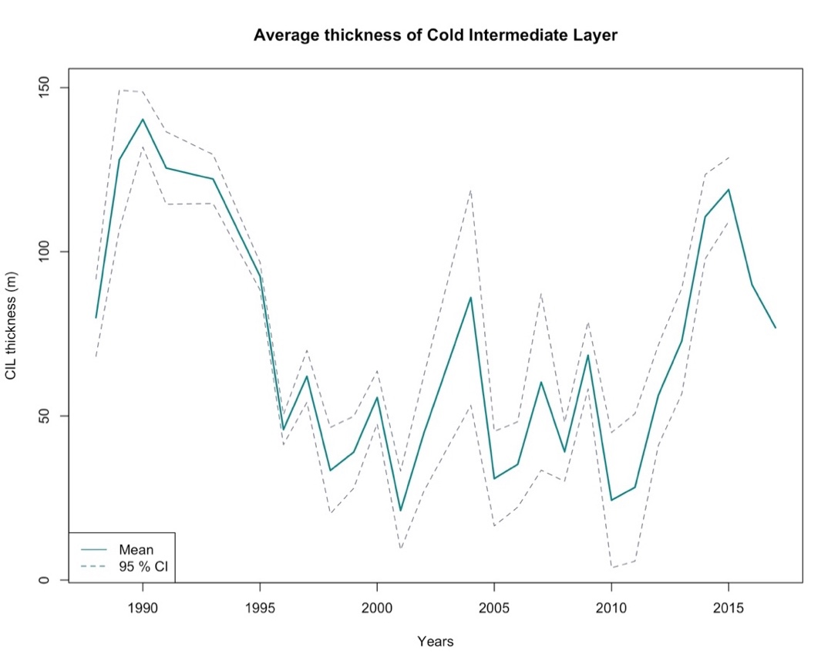
Figure 3. Temporal trend of the Cold Intermadiate Layer (CIL) thickness
The North Atlantic Oscillation (NAO) was also considered in the study although it was not included in the final analysis due to its strong correlation with bottom temperature.. NAO plays an important role in Flemish Cap oceanography as it sets the deep convection events in the Labrador Sea. NAO index data were obtained from the NOAA website: https://www.ncdc.noaa.gov/teleconnections/nao/. An average annual value was employed.
The NAO Index has fluctuated considerably during the 20th century, but three general trends
can be identified (Figure 4). From the 1950 to the early 1970s it was predominantly negative.
then, it turned mainly positive from the early 1970s to the mid-1990s and, after that period, it
fluctuated between negative and positive values, although it must be highlighted the strong
negative phase that took place in 1968 and 2010 (values lower than -0.5) and the strong positive
phases in 1989, 1990, 1992, 1994 and 2018 (values higher than 0.5), being the last one the
greatest, reaching values above 1. Moreover, there was an abrupt shift 1995 when, after 6 years
of strong positive values, the NAO becomes negative.

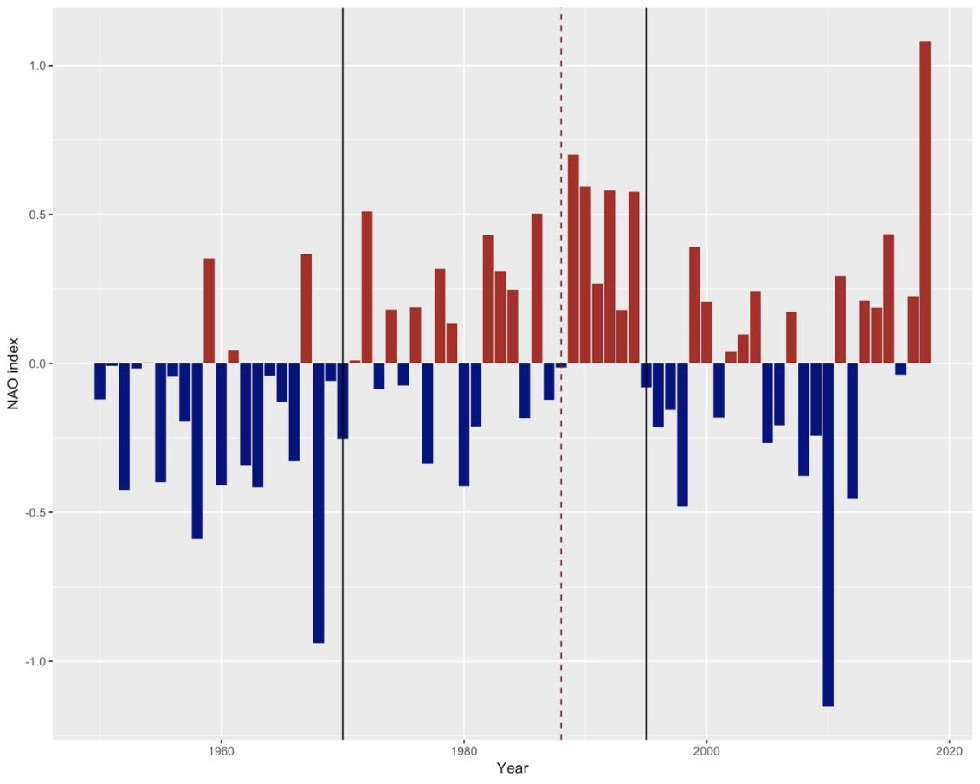
Figure 4. Temporal trend of NAO index. Negative phase (BLUE); Positive phase (Red); Black lines represent major shift in NAO Phases; Red dashed lines represent the beginning of out time series

- Prey availability
Pandalus borealis and Sebastes spp. have been identified as main prey for cod in Flemish Cap ecosystem (Pérez-Rodríguez et al. , 2011). There is a relationship between the cod age and prey type and size. Data of Pandalus and Sebastes abundance were obtained for the EU Flemish Cap surveys (Casas, 2018) and the relationship between cod size and prey size (Sebastes spp) was established using the data from the Gadget multispecies model. Pandalus is predated by all cod age-classes. In the case of Sebastes, a predator-prey size relationship was reported, as cod of year 1 and 2 do not feed on Sebastes and a cod cannot eat Sebastes bigger than its own size (Pérez-Rodríguez et al., 2016). To account for this predator-prey relationship, we have estimated the redfish biomass that is a potential prey for each cod age-class. First, we estimated the cod mean size at-age using the reported annual age-length key (Figure 5). Second, the predator-prey (cod-Sebastes) size relationship was calculated by fitting a linear regression using length data from the Gadget multispecies model (Pérez-Rodríguez, unpublished) (Figure 6). This allowed to estimate the preferred Sebastes size range for each cod size (age). Finally, the Sebastes abundance at size from the beaked redfish stock assessment was used (Ávila de Melo et al., 2017).

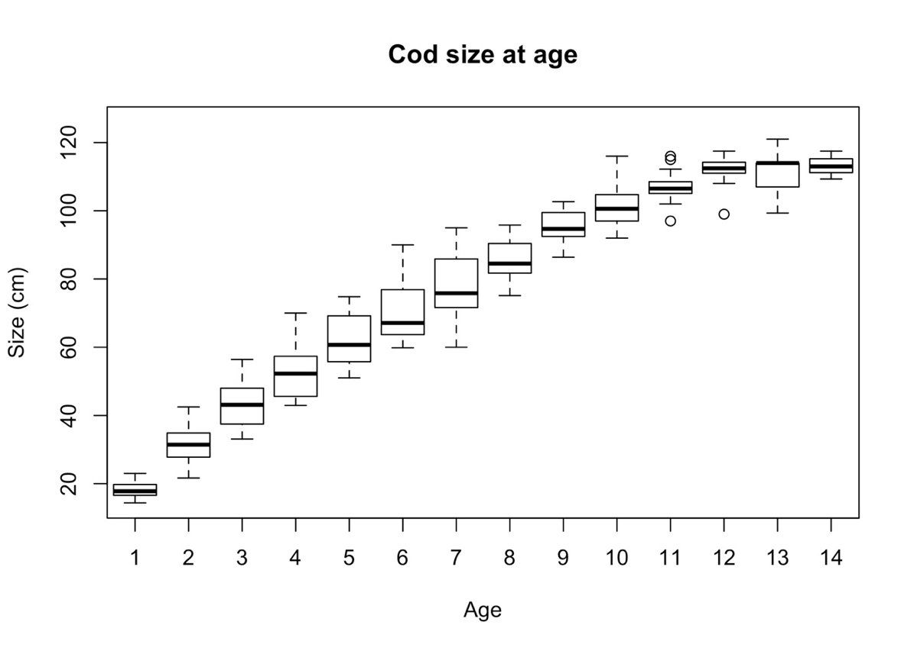
Figure 5. Box-and-whiskers plot of size at age with lines, boxes, and whiskers representing medians, interquartile range (IQR), and 1.5 IQR, respectively. White circles represent outliers.

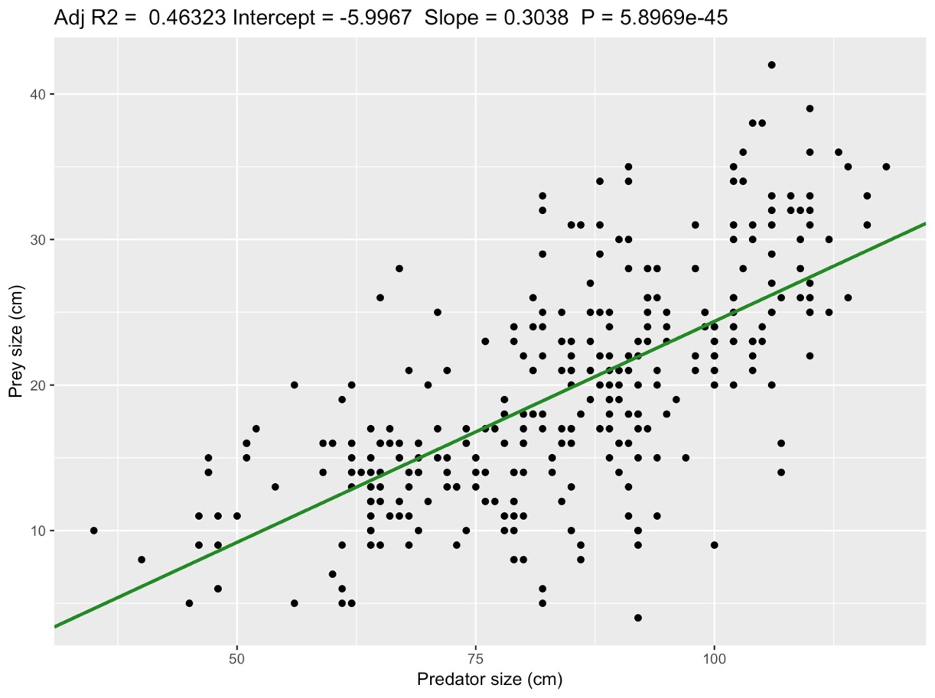
Figure 6. Cod-redfish predator- prey relationship. Adjusted R2 (Adj R2 = 0.46), Intercept = -5.99, Slope =0.30, P< 0.05)
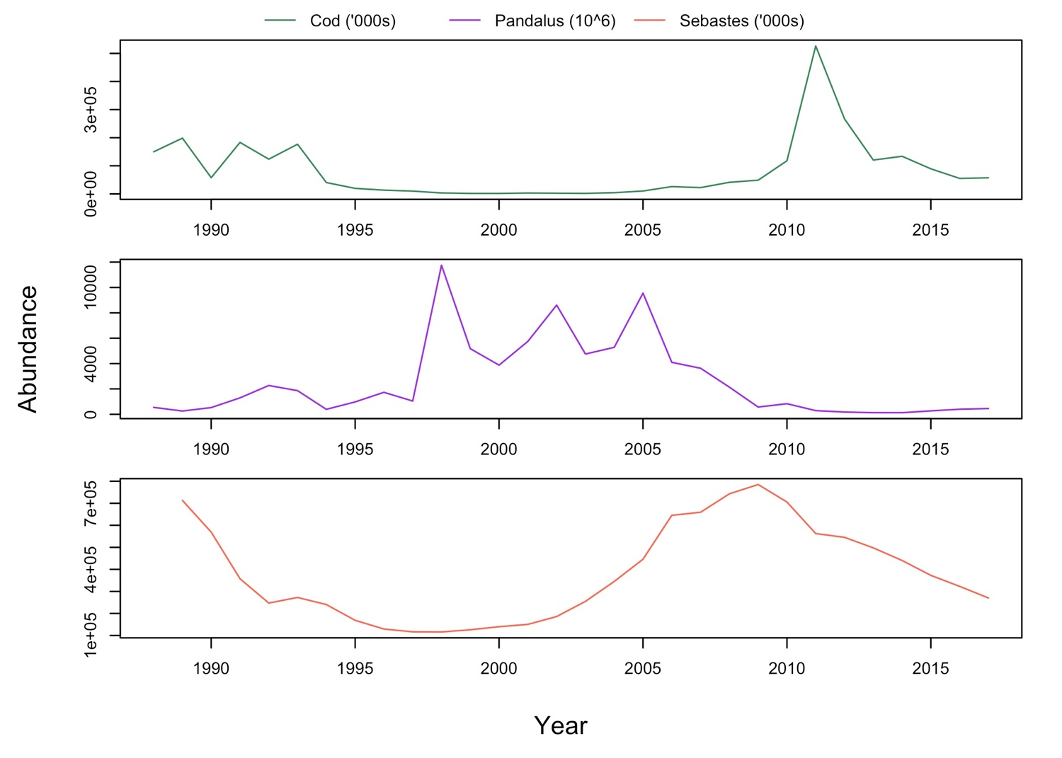
A final analysis on temporal trend of cod, Pandalus and Sebastes abundance was carried out to understand their fluctuation and identify patterns or correlations (Figure 7). A negative correlation can be observed between cod and Pandalus. In 1995, when abundance on cod decreased, Pandalus raised its abundance. The opposite trend can be observed when cod abundance increased in 2009. However, Sebastes abundance do not have a clear relationship with cod or Pandalus. It seems that, as in cod, it was a drop in Sebastes abundances, remaining very low since 1995. In 2000, the species started to rebound until 2009, when it gradually fall again.
Figure 7. Temporal trend of abundance of cod (green), Pandalus borealiss (purple) and Sebastes mantella and fasciatus (red).

- Density dependence processes
The effect of density-dependence processes on cod growth was studied by using the abundance of cod at age. The abundance of cod at age reflects the degree of competition between individuals of the same age, that inhabit at the same depth and prey on the same resources. Abundance at age comes from the EU bottom trawl survey (González-Troncoso et al., 2018) (Figure 8).
As mentioned before, the monitored and assessment of cod in Flemish Cap started when the stock showed problems in its abundance. Therefore, the abundance of cod when the stock was healthy is not known. However, it is clear that it was a drop in cod abundance in 1994 that persist until 2009. Then, a remarkable rise on abundance took place, reaching 60,000 thousands in 2011. Finally, abundance falls again to levels below 10,000 thousands (Figure 7-First plot). An extra analysis of cob abundance at age was carried out to understand which age class was contributing the most to the abundance (Figure 8). This graph shows that age 1 and 2 are the main contributors to cod abundance and responsible of the peak observed in 2011.
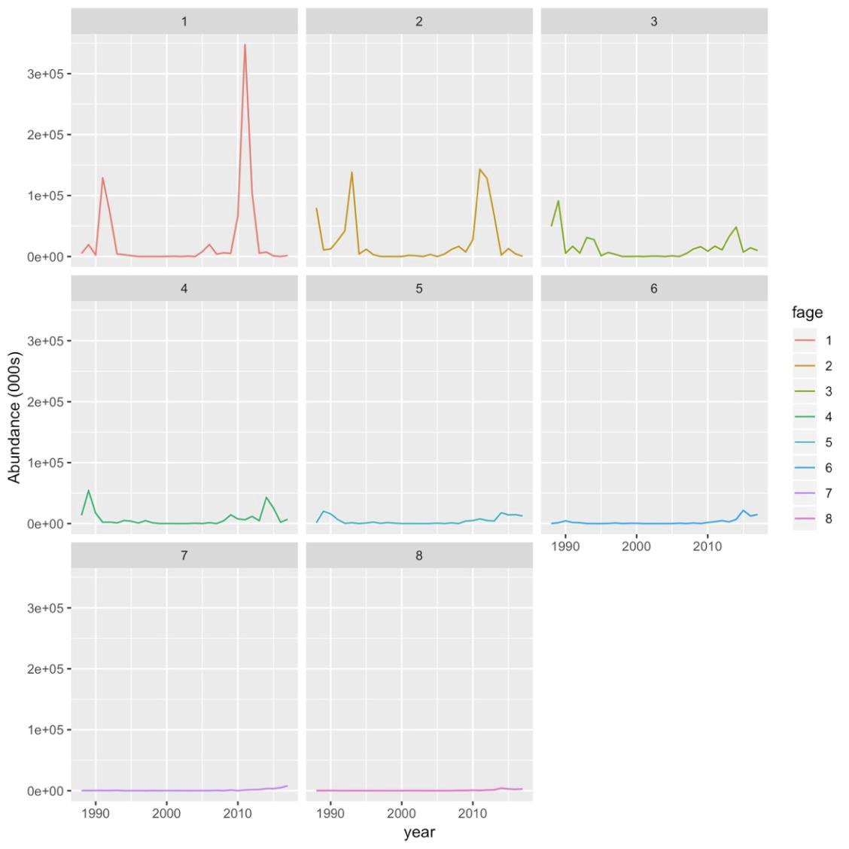
Figure 8. Temporal trend of cod abundance at age

- Fishing Mortality
Annual fishing mortality at age was obtained from the last stock assessment model performed, which used Bayesian methods (González-Troncoso et al., 2018). To test for the differences between periods with different levels of fishing effort, the analysis was done for 3 periods: Premoratoria: high fishing; Moratorial: Very low and Postmoratoria: Moderate fishing) .
Fishing is probably the anthropogenic pressure that is causing biggest changes on stocks productivity and ecosystem in general. In Flemish Cap, cod has been heavily exploited since Canada extended its exclusive economic zone (EEZ) in 1977 but, unfortunately, the stock do not started to be monitored until it began to showed deep problems in its productivity. From 1988 to 1998, fishing mortality was high for individuals older than 3 years old, reaching a mortality higher that 2.0 for the oldest individuals. However, cod of years 1 and 2 were almost exempts. In 1999 the moratorium was stablished and the fishery was reduced to nearly 0. The fishery was newly open in 2009 showing a slightly increment on fishing mortality (around 0.35), although it is far from the exploitation levels suffered before the collapse (Figure 9).
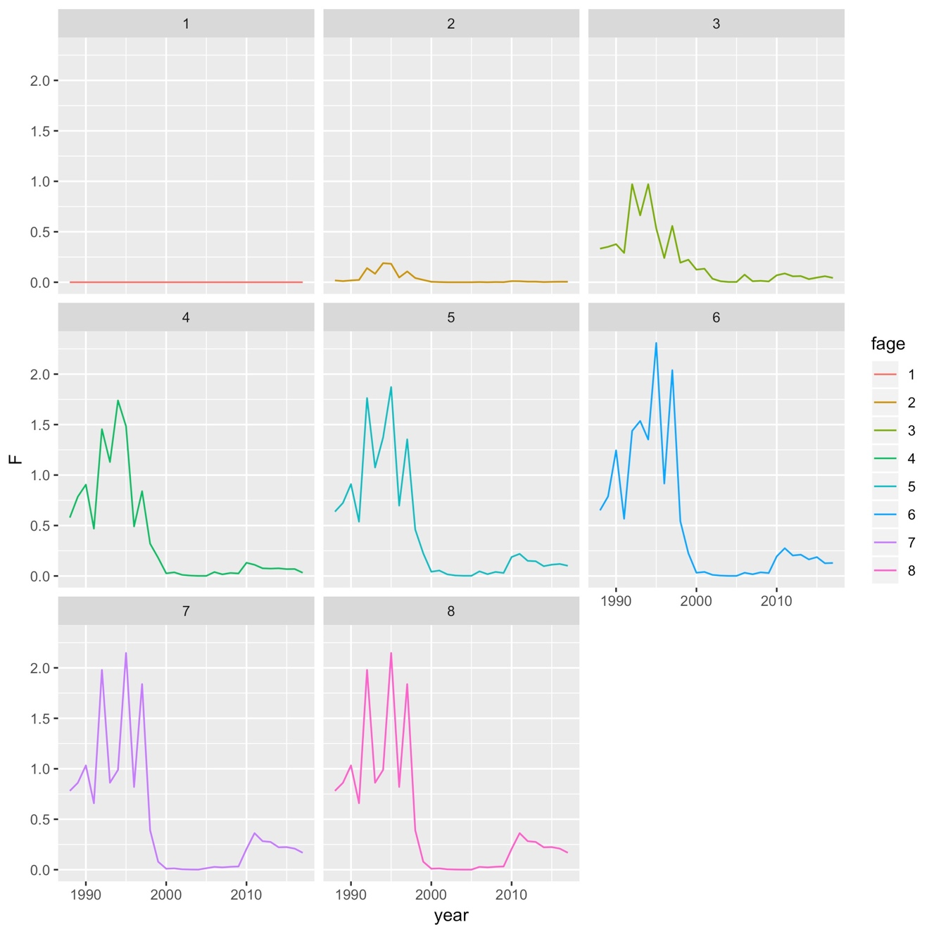
Figure 9. Temporal trend of fishing mortality at age
Cod in Flemish Cap has experienced alterations on its population performance as result of its collapse, which has been assigned to different reason (climate, fishing, seals predation). One of the traits that has showed variations is age at maturity (Figure 10). The age at which 50% of individuals reach maturity drops from a maximum of 5.36 before the collapse to a minimum of 2.89 in 2002.

Figure 10. Temporal trend of age at which 50% of the population reach maturity (a50)

Thermal window of the Flemish Cap cod.
An additional analysis to assess the optimum thermal window of cod of the Flemish Cap was performed, using the full data series and study the effect of bottom temperature on the master chronology (i.e. without splitting the database by periods). Hence, we include all the temperature variability observed registered in the region from 1988 to 2016 (Figure 1).
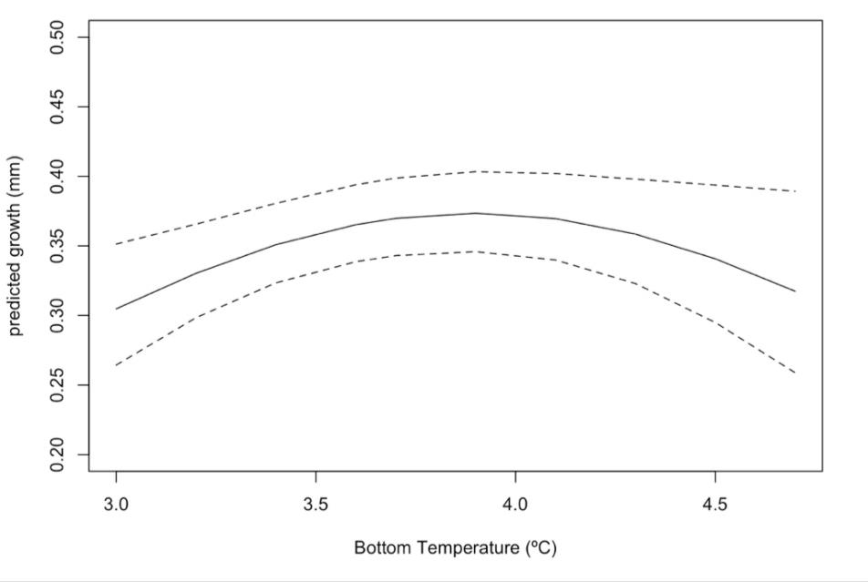
Figure 11. Predicted anual growth variation drived by bottom temperature

Cod size and otolith radius relationship
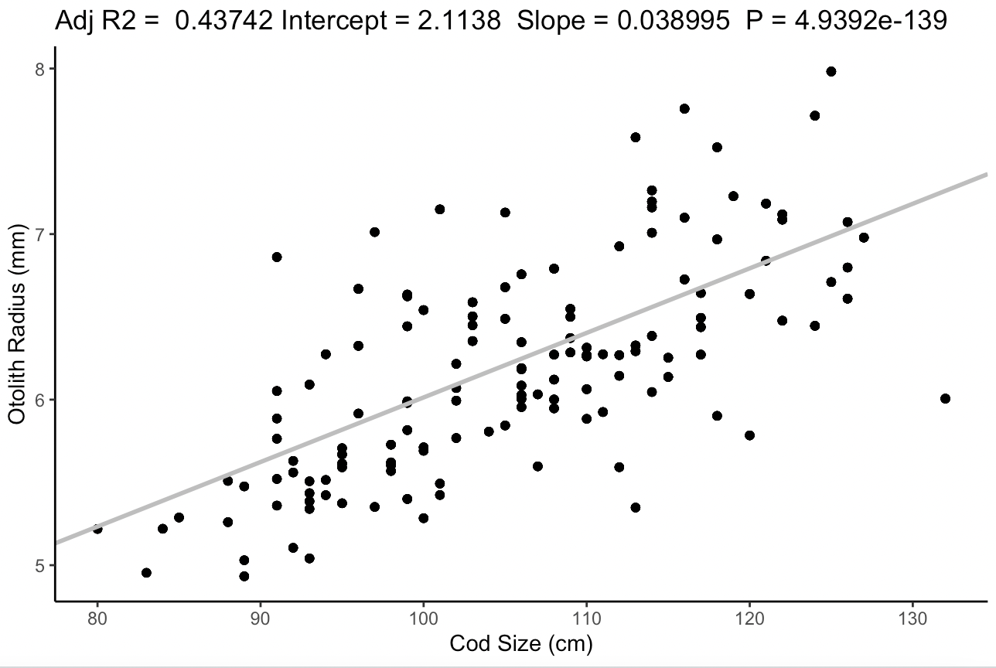
Figure 12. Figure 6. Cod size- otolith radius size relationship. Adjusted R2 (Adj R2 = 0.43), Intercept = 2.11, Slope =0.03, P< 0.01)

