Supplementary Material

# Supplementary Figures and Tables

## The VPTS dataset on stepped surfaces

For the measurement set in Figure 2B and D, the probes cross the steps that can be observed in SEM images. In Supplementary Figure S1, we reproduce Figure 2D with the red lines that denote the step positions as confirmed with the SEM image. We also provide table of *sij* values (in μm) measured from SEM images.

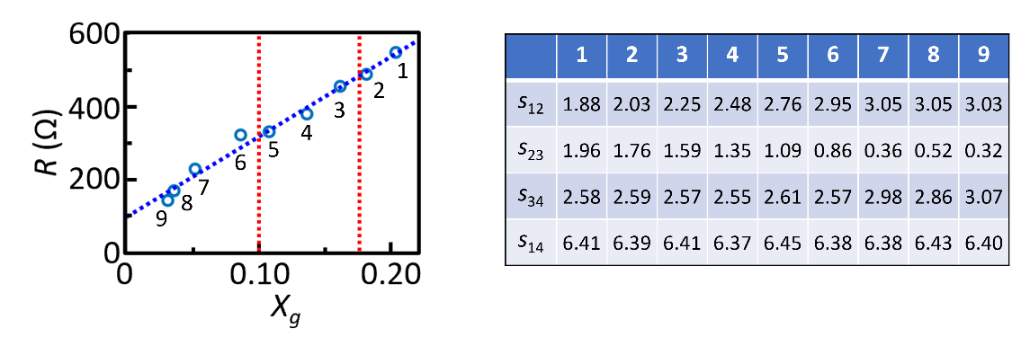

**Supplementary Figure S1.** (Left) The main text Figure 2D reproduced with the step positions marked with red dotted lines, and (Right) the table of *sij* for each measurement point.

## The comparison between the STP map and single scan lines

Using single scan lines for measuring voltage drop can create uncertainties from the choice of the scan line. To check the consistency between the STP map and single scan lines, we have compared the averaged voltage profile across the steps from the map at 100 μA (Figure 3D) and the single scan line at the same current (Figure 3G), and found a very good match between both methods (Supplementary Figure S2).

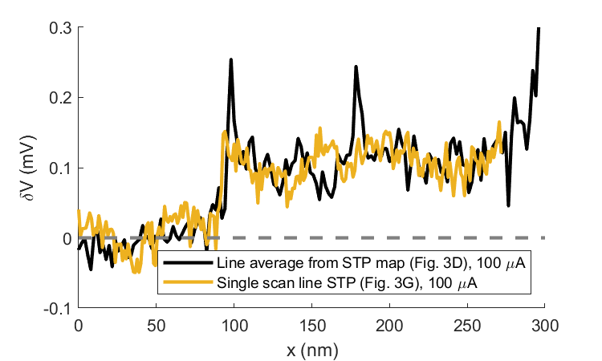

**Supplementary Figure S2.** The comparison of the line averaged voltage profile from Figure 3D and the single scan line at the same current in Figure 3G.

## The procedure of extracting terrace potentials from the STP line profiles

To extract the voltage drop between the adjacent terraces in Figure 4, we calculate the average and standard deviation of the voltages inside the single terraces and then subtract them to get the magnitude and error of voltage drop. For example, Supplementary Figure S3 shows an enlarged plot that exhibits the procedure applied to the *I* = 150 μA curve in Figure 3G.

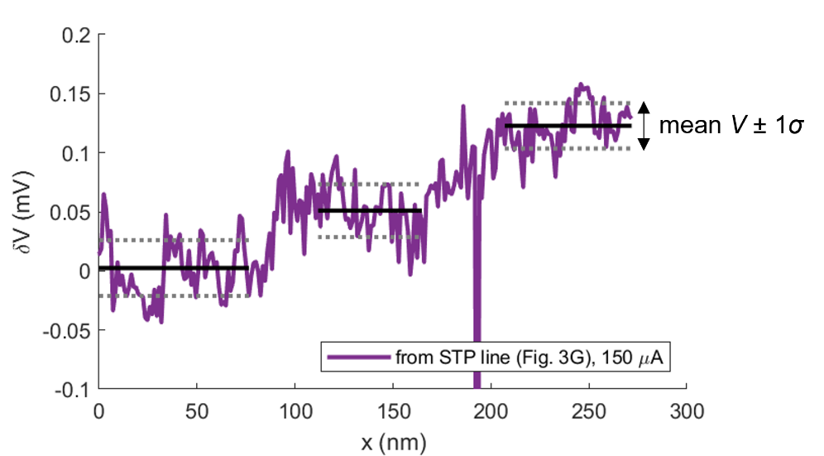

**Supplementary Figure S3.** The procedure of extracting mean and standard deviation of voltages inside the terraces.