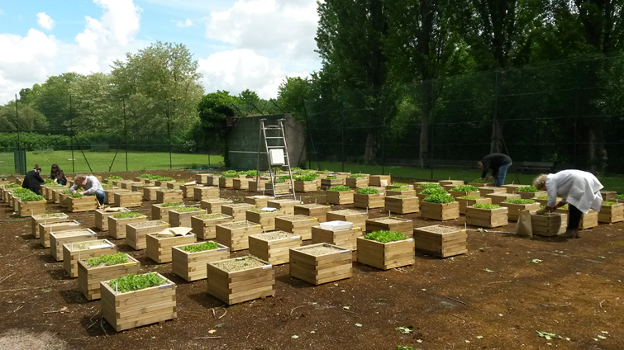

Figure S1: The experimental site located at the IRD Campus (Bondy, France) consisting in 96 wooden garden pots, divided into four blocks. Each block contains all 24 treatments randomly distributed. The picture was taken during the first harvest ((May 9th 2017).



Figure S2: Mean (solid line), minimum (lower dash line) and maximum (upper dash line) temperatures (A) and precipitations (bars) and sunshine (solid line) (B) over the year 2017 recorded at Le Bourget station (48°96′15″N; 2°43′75″E). The 3 growing seasons (S1, S2, S3) are indicated in the background in light grey.



Figure S3: Relationship between fresh and dry biomass for lettuce, arugula and spinach monocultures performed in the spring 2017. Solid lines represent the linear regression (*n*=32) and the dotted lines the 95% prediction interval.



Figure S4: Germination rate (ratio plants/seeds) of lettuce, arugula, spinach and co-culture obtained at each season (spring, summer and autumn) as function of earthworms presence for the three Technosols composition. The error bars are the standard errors of the mean (n=4). Different letters above the histogram indicate significant differences (*P*<0.05) between treatments.



Figure S5: Proportion of the pots surface (44cmx44cm) covered by leafs for monocultures of lettuce, arugula and spinach or the co-culture of all three plants as function of the compost proportion in Technosols with (triangles up, E10, E20, E30) or without (triangles down, C10, C20, C30) earthworms. The error bars are the standard errors of the mean (n=4).



Figure S6: Linear relationships between the pots surface (44cmx44cm) covered by leafs for monocultures of lettuce, arugula and spinach and the final biomass in spring, summer and autumn season (*n*=32; P<0.05).

Table S1: Statistical analysis of germination, plant cover, and biomass for lettuce, arugula, spinach, and co-culture obtained in each season (spring, summer, and fall) as a function of compost level and earthworms addition. Significant factors are indicated by a probability (0 ‘\*\*\*’, 0.001 ‘\*\*’, 0.01 ‘\*’, 0.05 ‘.’, 0.1, 1).

