The Mesoscopic Connectome of Cholinergic Neurons in the mouse Pontomesencephalic Tegmentum
Peilin Zhao¹, Huading Wang¹, Anan Li^{1, 2, 3}, Guangcai Liu¹, Yutong Han¹, Qingtao Sun², Jing Yuan^{1, 2}, Tao Jiang², Xueyan Jia², Xiangning Li^{1, 2} *, Hui Gong^{1, 2, 3,} *

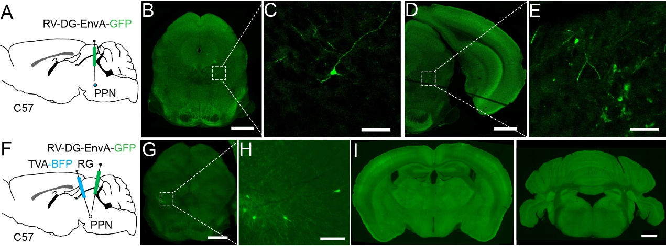
Supplementary figure S1. The specificity of virus. (A) RV was performed in the PPN of C57 mice directly. (B) (D) Several neurons were labeled in the inject site. (C) (E) Clear view of the labeled neurons. (F) AAV helpers were injected in the PPN of C57 mice and subsequent with modified RV 3 weeks later. (G) A few neurons presented in the inject site. (H) Clear view of the labeled neurons. (I) No neuron was infected in other input regions. Scale bar, (B, D, G, I) 1000 μm; (C, E, H) 100μm.

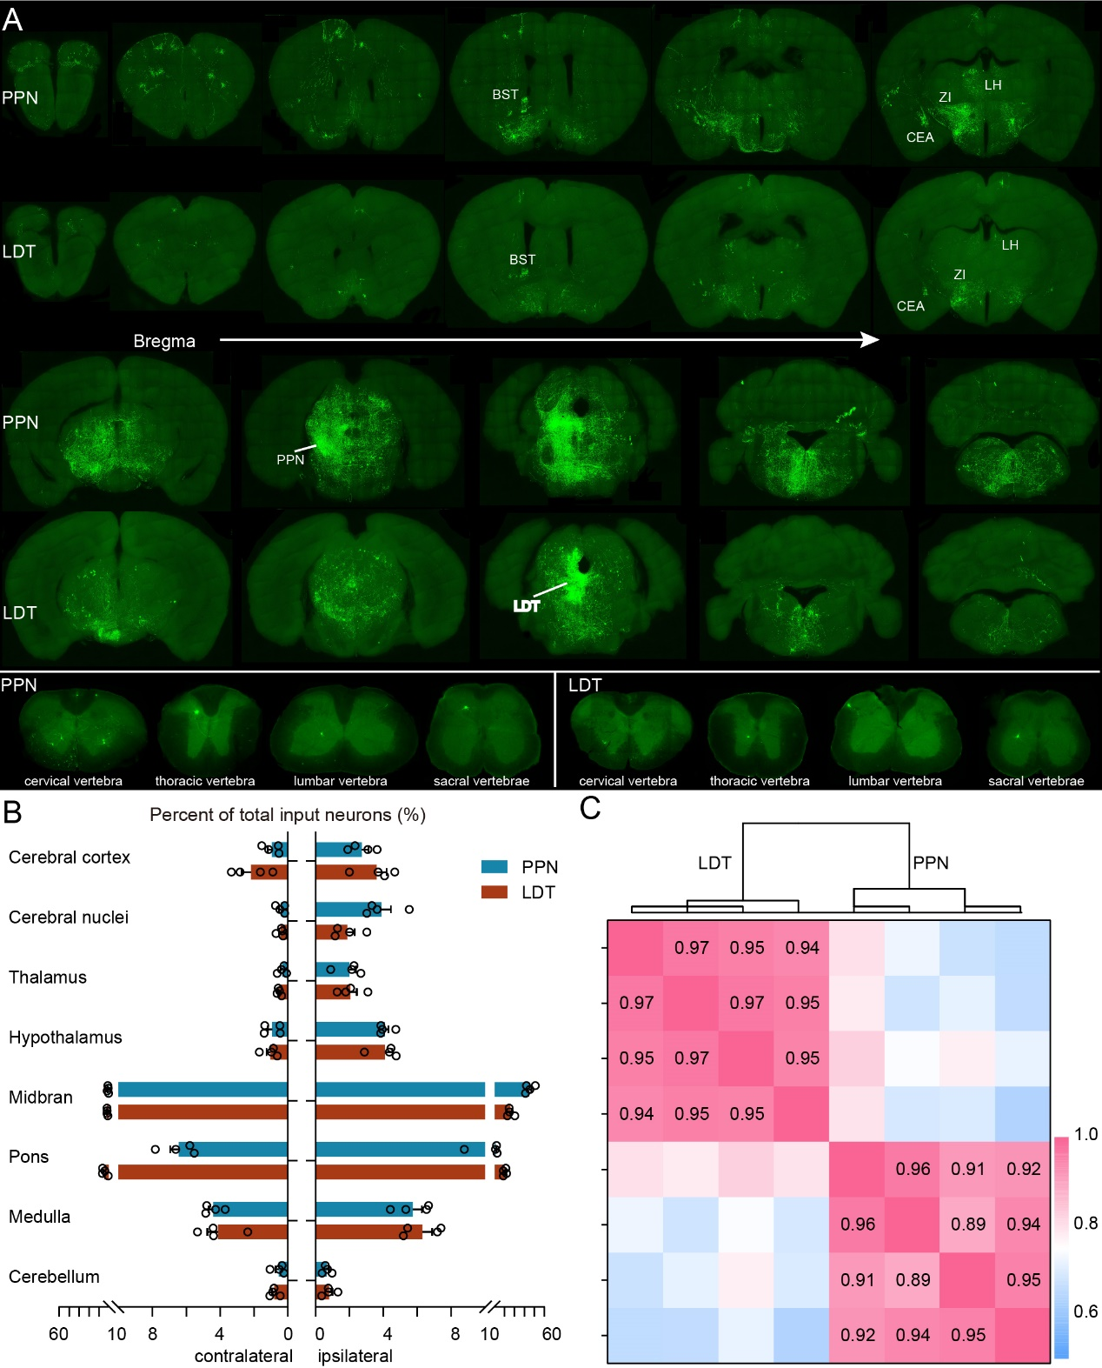
Supplementary figure S2. Overview of whole-brain input distribution. (A) whole-brain input to PPN and LDT. (B) Quantitative statistical proportion of eight input regions to whole-brain input neurons. Left side of vertical axis represents proportion of input neurons in the contralateral hemispheres, and the right side represents ipsilateral hemispheres. Data shown as Mean ± SEM. (C) Clustering analysis of all counted input samples according to the Pearson's correlation.

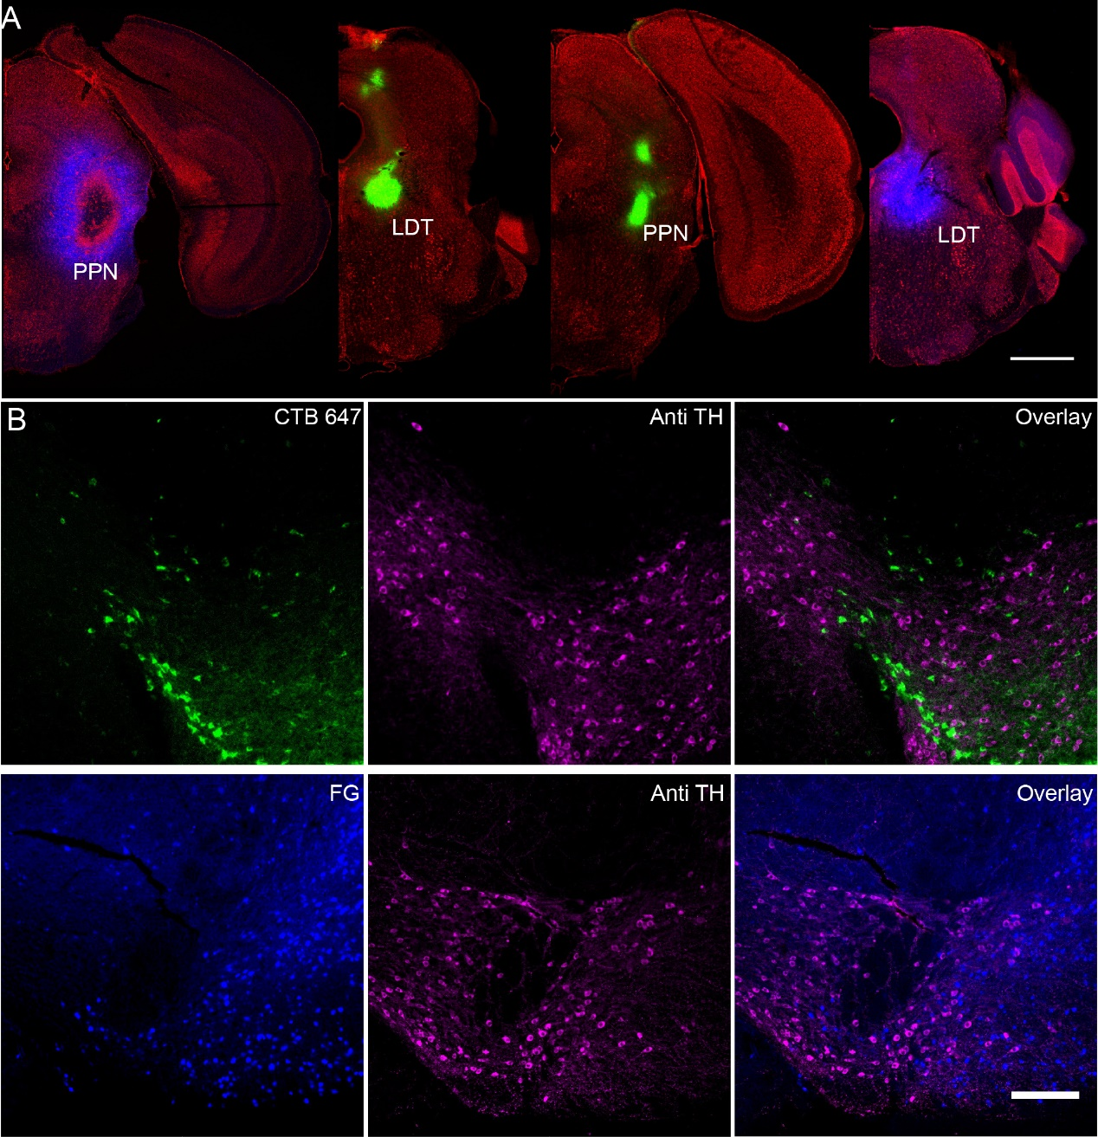
Supplementary figure S3. Retrograde tracing with CTB and FG. (A) 75nl 4% FG (blue) or CTB 647 (green) were injected in the PPN or LDT. (B) Immunofluorescence staining of labeled in the VTA. All neurons labeled with CTB or FG present TH-negative. Scale bar, (A) 1000 μm; (B) 200 μm.

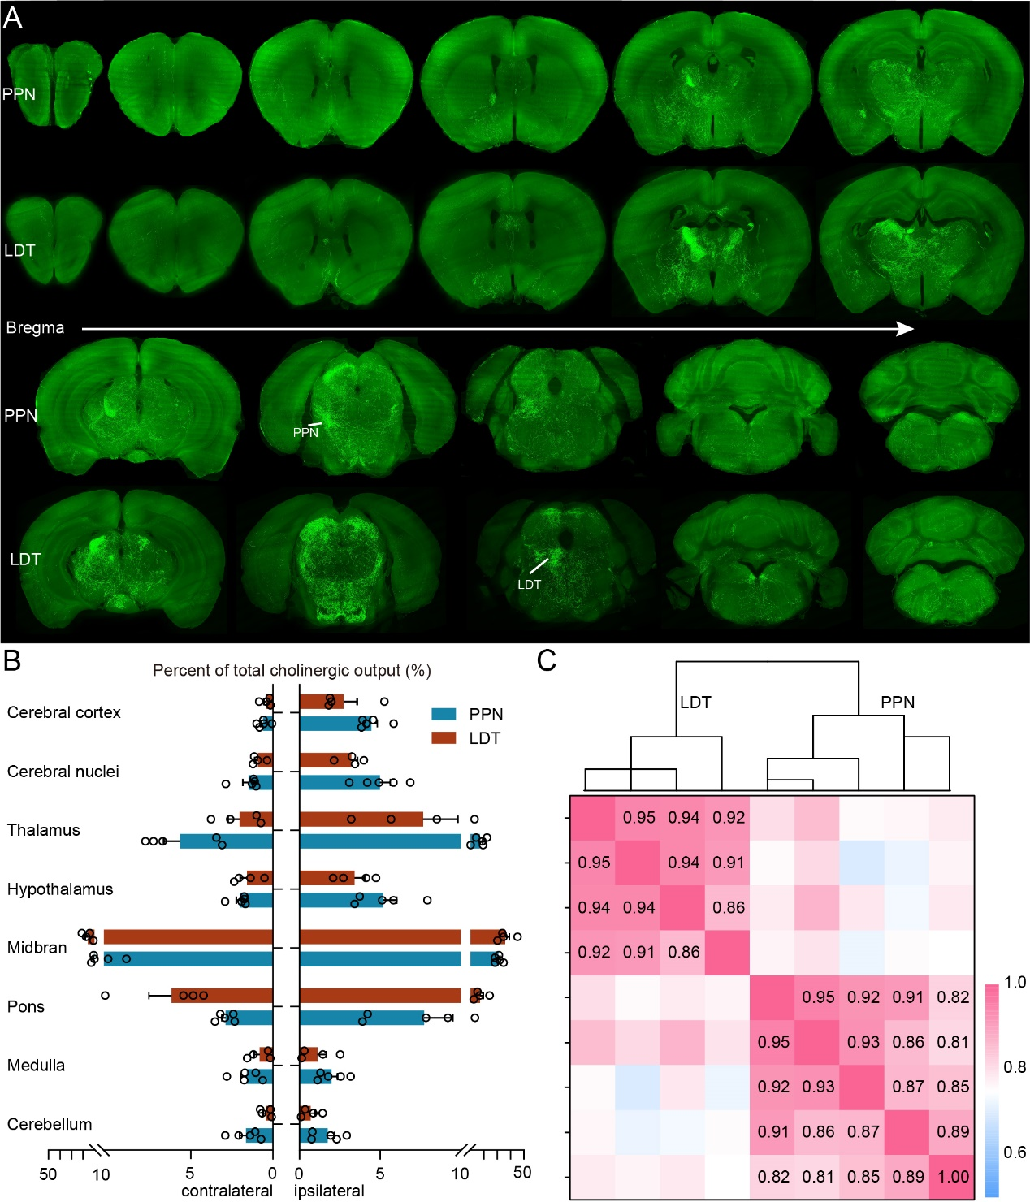
Supplementary figure S4. Overview of cholinergic fibers in the whole brain. (A) The whole brain projection of cholinergic neurons from PPN and LDT. (B) Quantitative statistical proportion of eight main target regions to whole-brain input neurons. Left side of vertical axis represents proportion of input neurons in the contralateral hemispheres, and the right side represents ipsilateral hemispheres. Data shown as Mean ± SEM. (C) Clustering analysis of all counted output samples according to the Pearson's correlation.

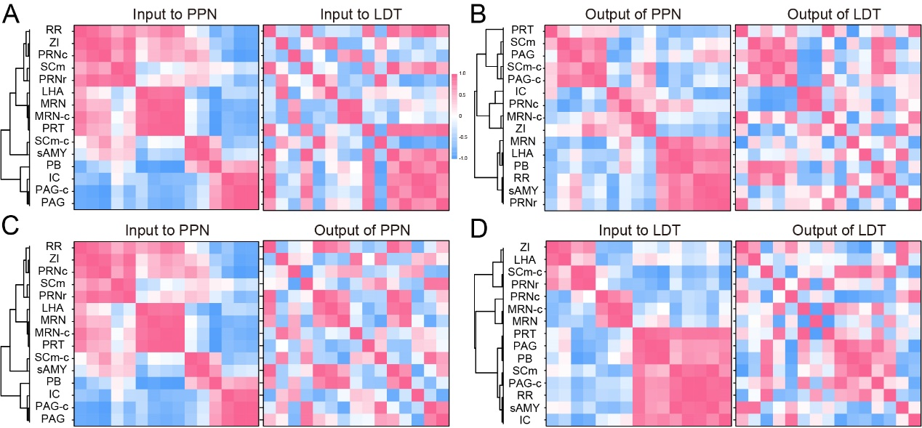
Supplementary figure S5. The clustering relation of nuclei strongly interconnect with PMT. (A) Clustering relation of input circuits. (B) Clustering relation of output circuits. (C) Clustering relation of input and output circuits for PPN. (D) Clustering relation of input and output circuits for LDT.

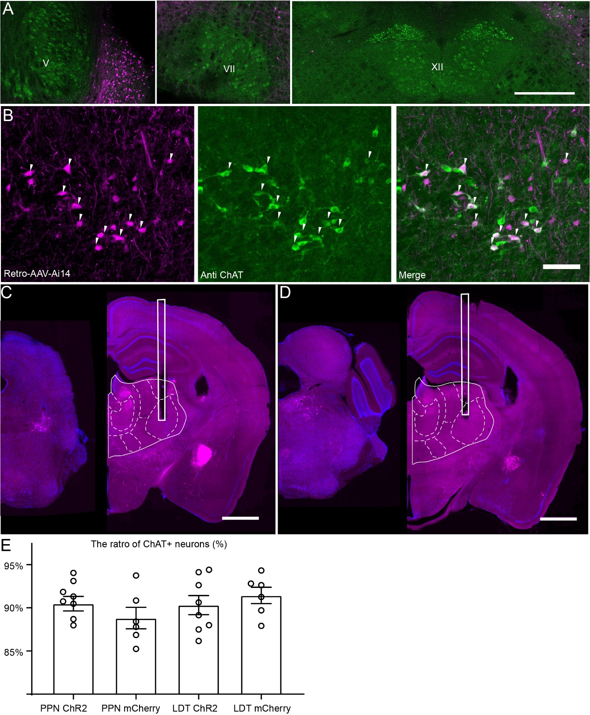
Supplementary figure S6. Tracing the cholinergic input of VP. (A) None of cholinergic neurons in the V, VII and XII projected to the VP directly. (B) A three-panel presentation with AAV-Ai14, anti-CHAT, and merged, arrows point out ChAT-positive neurons. (C, D) Inject site of PPN and LDT and tipical coronal plane of VP embedded with ceramic ferrule. (E) Statistical proportion of ChAT+ neurons labeled with ChR2 or mCherry. Scale bar, (A) 500 μm; (B) 100 μm; (C, D) 1000 μm.

Supplementary Table S1 The abbreviation of brain regions
Abbrevition | Full name
AI | Agranular insular area
AON | Anterior olfactory nucleus
ATN | Anterior group of the dorsal thalamus
AuD | Auditory areas
B | Barrington's nucleus
BF | basal forebrain
CBN | Cerebellar nuclei
CBX | Cerebellar cortex
CP | Caudoputamen
CS | Superior central nucleus raphe
CTXpl | cortical plate
CTXsp | cortical subplate
DORpm | Thalamus, polymodal association cortex related
DORsm | Thalamus, sensory-motor cortex related
DR | Dorsal nucleus raphe
DTN | Dorsal tegmental nucleus
ECT | Ectorhinal area
EPI | Epithalamus
GENd | Geniculate group, dorsal thalamus
GENv | Geniculate group, ventral thalamus
GRN | Gigantocellular reticular nucleus
GU | Gustatory areas
IC | Inferior colliculus
ILM | Intralaminar nuclei of the dorsal thalamus
IRN | Linear nucleus of the medulla
LAT | Lateral group of the dorsal thalamus
LDT | Laterodorsal tegmental nucleus
LHA | Lateral hypothalamic area
LSX | Lateral septal complex
LZ | Hypothalamic lateral zone
MARN | Magnocellular reticular nucleus
MBmot | Midbrain, motor related
MBsen | Midbrain, sensory related
MBsta | Midbrain, behavioral state related
MED | Medial group of the dorsal thalamus
MEZ | Hypothalamic medial zone
MOp | Primary motor area
MOs | Secondary motor area
mPFC | medial prefrontal cortex
MRN | Midbrain reticular nucleus
MY- mot | Medulla, motor related
MY-sat | Medulla, behavioral state related
MY-sen | Medulla, sensory related
NI | Nucleus incertus
OLF | olfactory areas
ORB | orbital area
PAG | Periaqueductal gray
PAL | pallidum
PALd | Pallidum, dorsal region
PALm | Pallidum, medial region
PALv | Pallidum, ventral region
PARN | Parvicellular reticular nucleus
PB | Parabrachial nucleus
PCG | Pontine central gray
PERI | Perirhinal area
PFL | Paraflocculus
PG | Pontine gray
P-mot | Pons, motor related
PPN | Pedunculopontine nucleus
PRNc | Pontine reticular nucleus, caudal part
PRNr | Pontine reticular nucleus
PRT | Pretectal region
P-sat | Pons, behavioral state related
P-sen | Pons, sensory related
PVR | periventricular region
PVZ | periventricular zone
RR | Midbrain reticular nucleus, retrorubral area
RT | Reticular nucleus of the thalamus
SAG | Nucleus sagulum
sAMY | Striatum-like amygdalar nuclei
SCm | Superior colliculus, motor related
SCs | Superior colliculus, sensory related
SLC | Subceruleus nucleus
SLD | Sublaterodorsal nucleus
SNr | Substantia nigra, reticular part
STR | striatum
STRv | Striatum ventral region
Tea | Temporal association areas
TRN | Tegmental reticular nucleus
VENT | Ventral group of the dorsal thalamus
VISC | Visceral area
VNC | Vestibular nuclei
VP | Ventral posterior complex of the thalamus
VTA | Ventral tegmental area
ZI | Zona incerta

Supplementary Table S2 Detail P values of significance analysis
PPN VS LDT | Input (P values) |  | PPN VS LDT | Output (P values)
 | Ipsilateral | Contralateral |  | Ipsilateral | Contralateral
ORB | ns | ns | OLF | ns | ns
mPFC | 0.0436 | ns | STRv | 0.0474 | ns
Mos | 0.0292 | ns | CP | 0.0369 | ns
CP | 0.0082 | ns | sAMY | ns | ns
sAMY | ns | ns | LSX | ns | ns
VENT | ns | ns | PALv | ns | ns
EPI | ns | ns | PALd | 0.0469 | ns
MEZ | 0.0294 | ns | PALm | ns | ns
ZI | ns | ns | RT | 0.0297 | ns
LHA | ns | ns | VP | 0.0110 | 0.0140
DR | ns | ns | VENT | 0.0082 | 0.0107
PPN | <0.0001 | ns | GENd | ns | ns
IC | ns | ns | MED | 0.0470 | ns
RR | ns | ns | LAT | 0.0335 | 0.0038
CUN | 0.0043 | 0.0370 | ILM | 0.0225 | ns
VTA | 0.4290 | ns | GENv | ns | ns
SNr | 0.0418 | ns | ATN | ns | ns
SCm | 0.0017 | ns | MEZ | ns | ns
PRT | 0.4387 | ns | ZI | 0.0055 | 0.0423
PAG | ns | ns | LHA | ns | ns
MRN | 0.0104 | ns | IPN | ns | ns
PB | ns | ns | PPN | 0.0001 | ns
SLD | 0.0407 | ns | SAG | 0.0206 | ns
PRNr | ns | ns | SCs | 0.0094 | 0.0137
NI | 0.0115 | 0.0166 | IC | ns | ns
LDT | 0.0039 | 0.0102 | RR | ns | ns
CS | 0.0124 | 0.0155 | CUN | ns | ns
DTN | 0.0160 | 0.0022 | VTA | ns | ns
B | 0.0048 | 0.0079 | SCm | 0.0002 | 0.0016
PRNc | 0.0371 | 0.0032 | PRT | ns | ns
PCG | <0.0001 | 0.0001 | PAG | ns | ns
PARN | 0.0102 | 0.0283 | MRN | 0.0332 | ns
MARN | ns | ns | PB | ns | ns
IRN | ns | ns | SLD | 0.0246 | ns
GRN | ns | ns | SLC | ns | ns
VNC | ns | ns | PRNr | ns | ns
PGRN | ns | ns | CS | 0.0211 | 0.0192
CBN | ns | ns | PG | ns | ns
 |  |  | DTN | 0.0114 | ns
 |  |  | B | 0.0364 | ns
 |  |  | TRN | ns | ns
 |  |  | PRNc | ns | ns
 |  |  | PCG | 0.0001 | 0.0002
 |  |  | CBX | 0.0408 | 0.0083

