SUPPLEMENTARY MATERIAL

A set of experimentally validated decoys for the human CC Chemokine Receptor 7 (CCR7) obtained by virtual screening

Matic Proj ¹, Steven De Jonghe ², Tom Van Loy ², Marko Jukič ^{3,4}, Anže Meden ¹, Luka Ciber ⁵, Črtomir Podlipnik ⁵, Uroš Grošelj ⁵, Janez Konc ⁶, Dominique Schols ², Stanislav Gobec ^{1,*}
¹ University of Ljubljana, Faculty of Pharmacy, Department of Pharmaceutical Chemistry, Ljubljana, Slovenia
² KU Leuven, Department of Microbiology, Immunology and Transplantation, Rega Institute for Medical Research, Laboratory of Virology and Chemotherapy, Herestraat 49, box 1043, 3000 Leuven, Belgium
³ University of Maribor, Faculty of Chemistry and Chemical Engineering, Laboratory of Physical Chemistry and Chemical Thermodynamics, Maribor, Slovenia.
⁴ University of Primorska, Faculty of Mathematics, Natural Sciences and Information Technologies, Koper, Slovenia.
⁵ University of Ljubljana, Faculty of Chemistry and Chemical Technology, Ljubljana, Slovenia
⁶ National Institute of Chemistry, Ljubljana, Slovenia

* Correspondence:
Stanislav Gobec
stanislav.gobec@ffa.uni-lj.si

Table of contents
FILTER configuration file S2
Supporting figures S3
Supporting tables S4
Chemistry – General Information S8
Supplementary references S14

FILTER configuration file
ELIMINATE_METALS Sc,Ti,V,Cr,Mn,Fe,Co,Ni,Cu,Zn,Y,Zr,Nb,Mo,Tc,Ru,Rh,Pd,Ag,Cd
ALLOWED_ELEMENTS H,C,N,O,F,P,S,Cl,Br,I
#-------------------------------------------------------------------
MIN_MOLWT 200 "Minimum molecular weight"
MAX_MOLWT 800 "Maximum molecular weight"
#-------------------------------------------------------------------
#Calculated LogP
MIN_XLOGP -4.0 "Minimum XLogP"
MAX_XLOGP 6.85 "Maximum XLogP"
#-------------------------------------------------------------------
AGGREGATORS true "Eliminate known aggregators"
PRED_AGG true "Eliminate predicted aggregators"
#-------------------------------------------------------------------
#functional groups which often eliminate compounds from consideration
RULE 0 aldehyde
RULE 0 acid_halide
RULE 0 peroxide
RULE 0 sulfonyl_halide
RULE 0 carbonate
RULE 0 isonitrile
RULE 0 isocyanate
RULE 0 isothiocyanate
RULE 0 acyl_cyanides
RULE 0 acylhydrazide
RULE 0 alphahalo_amine
RULE 0 alphahalo_ketone
RULE 0 anhydride
RULE 0 azide
RULE 0 aziridine
RULE 0 azocyanamides
RULE 0 oxaziridine
RULE 0 phosphoranes
RULE 0 dithioacetal
RULE 0 hydrazine
RULE 0 nitroso
RULE 0 triazine
RULE 0 disulfide
RULE 0 sulfinylthio
RULE 0 sulfonylnitrile
RULE 0 sulfinimine
RULE 0 fluorenylmethoxycarbonyl_Fmoc
RULE 0 HOBT_esters
RULE 0 trimethylsilyl_TMS
RULE 0 cation_C_Cl_I_P_or_S
RULE 0 oxygen_cation
RULE 0 lawesson_s_reagent
RULE 0 nonacylhydrazone
RULE 0 N_methoyl
RULE 0 N_P_S_Halides
RULE 0 NS_beta_halothyl
RULE 0 cytochalasin_derivatives
RULE 0 squalestatin_derivatives
RULE 0 monensin_derivatives
RULE 0 iodine
RULE 0 iodoso
RULE 0 iodoxy

Supporting figures

Figure S1. Known CCR7 antagonists that were used as a set of active compounds in the virtual screening campaign (Taveras et al., 2010; Jaeger et al., 2019).

Supporting tables
Table S1. Compounds active on multiple chemokine receptors (CCR1, CCR2, CCR3, CCR4, CCR5, CCR7, CCR8, CCR9, CCR10, CXCR1, CXCR2, CXCR3, CXCR4, and CXCR7), used to construct a chemokine receptor targeted compound library.
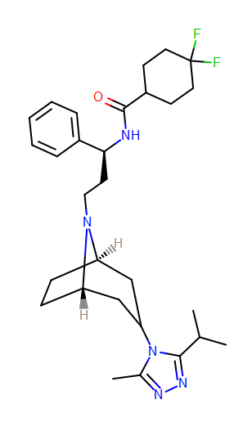  Maraviroc, CCR5 | 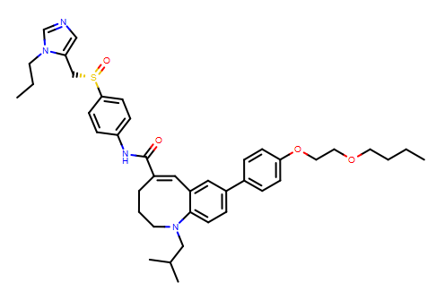  Cenicriviroc, CCR2, CCR5 | 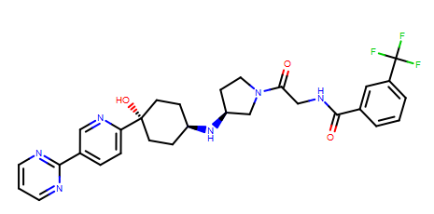  PF-4136309, CCR2 | 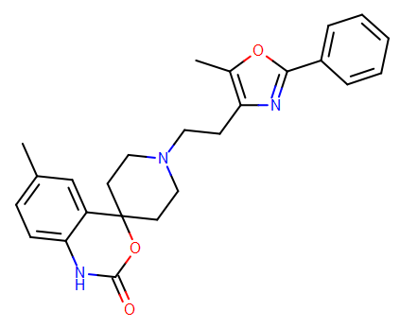  RS 504393, CCR2
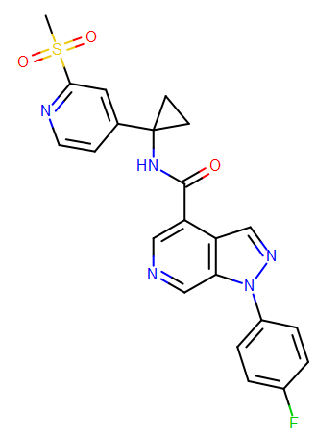  CCR1 antagonist 8, CCR1 | 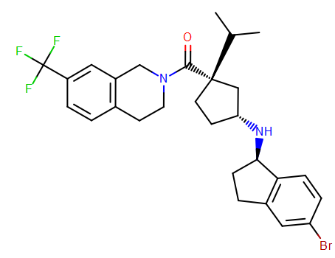  CCR2 antagonist 1, CCR2 | 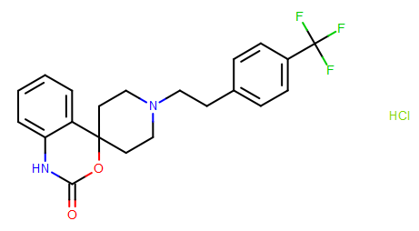  RS102895 hydrochloride, CCR1, CCR2 | 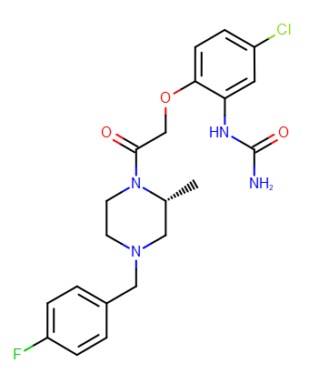  BX471, CCR1
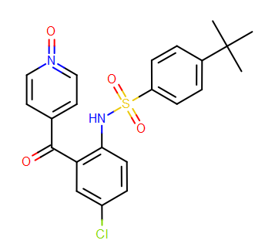  Vercirnon, CCR9 | 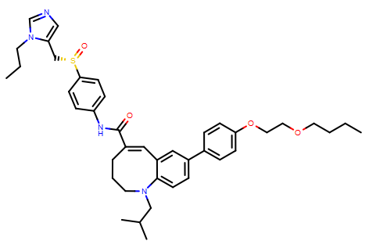  Cenicriviroc mesylate, CCR2, CCR5 | 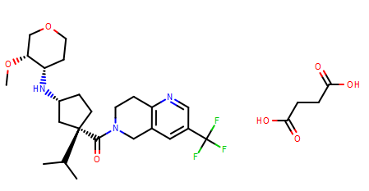  MK-0812 succinate, CCR2 | 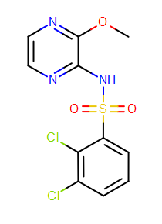  AZD2098, CCR4
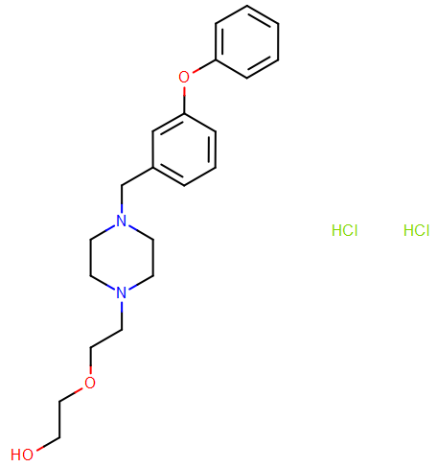  ZK756326 dihydrochloride, CCR8 | 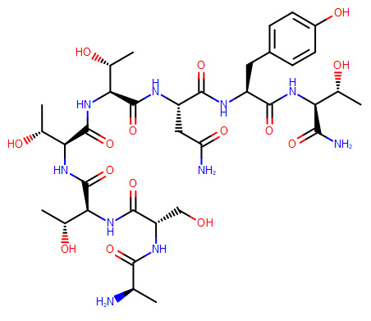  DAPTA, CCR5 | 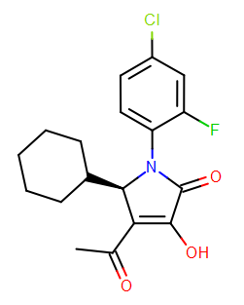  CCR2-RA-[R], CCR2 | 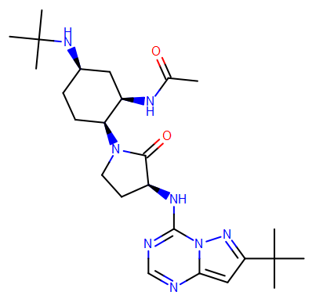  BMS-813160, CCR2, CCR5
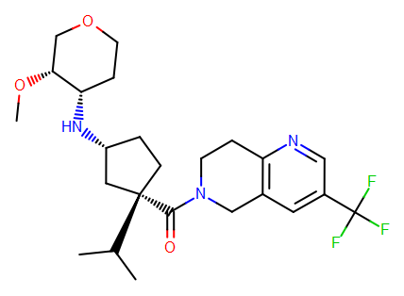  MK-0812, CCR2 | 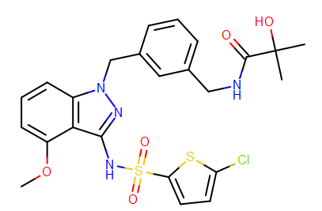  GSK2239633A, CCR4 | 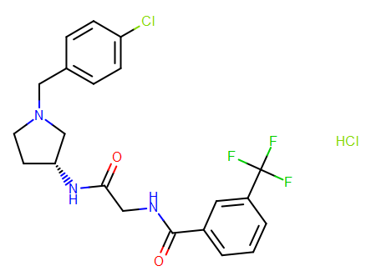  Teijin compound 1, CCR2 | 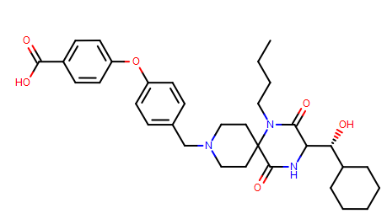  Aplaviroc, CCR5
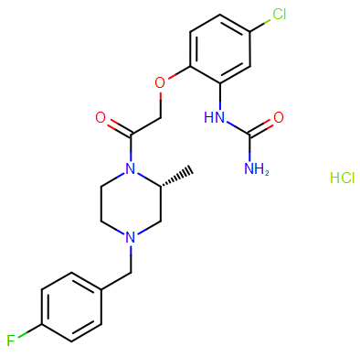  BX-471 hydrochloride, CCR1 | 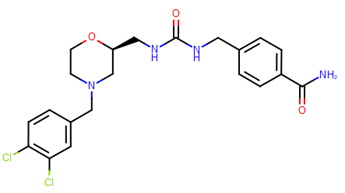  GW 766994, CCR3 | 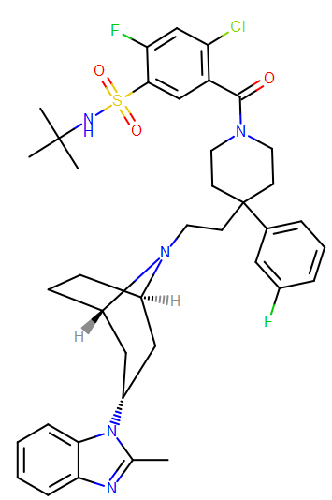  CCR5 antagonist 1, CCR5 | 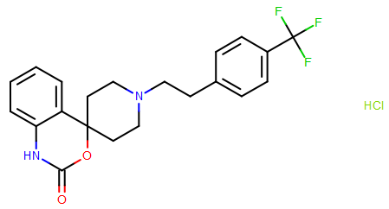  RS102895, CCR1, CCR2
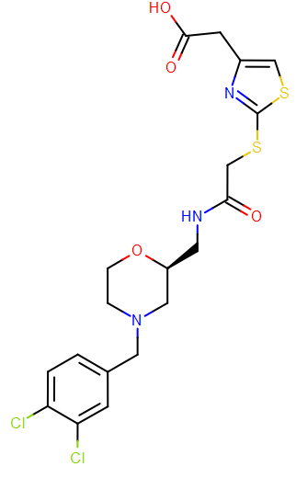  CCR3 antagonist 1, CCR3 | 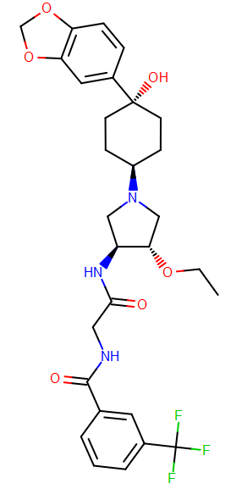  INCB3344, CCR2 | 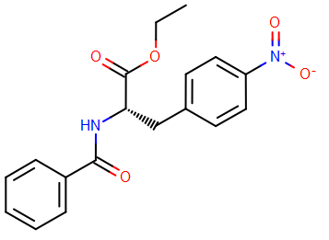  SB297006, CCR3 | 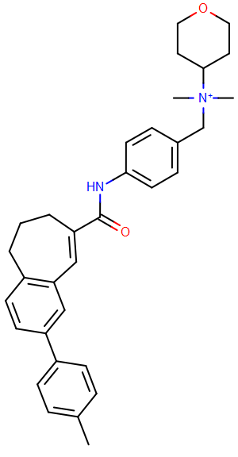  TAK-779, CCR3, CCR5, CXCR3
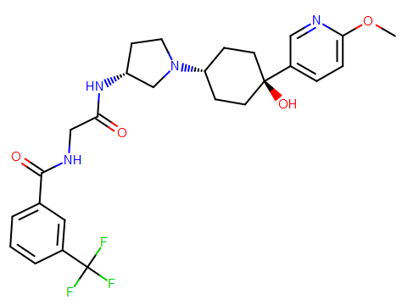  INCB 3284, CCR2 | 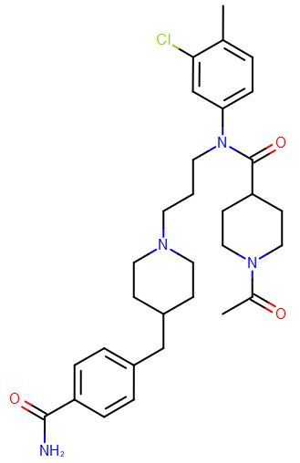  TAK-220, CCR5 | 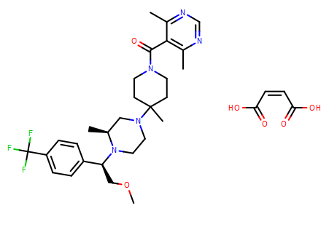  Vicriviroc maleate, CCR5 | 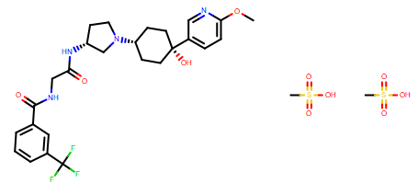  INCB 3284 dimesylate, CCR2
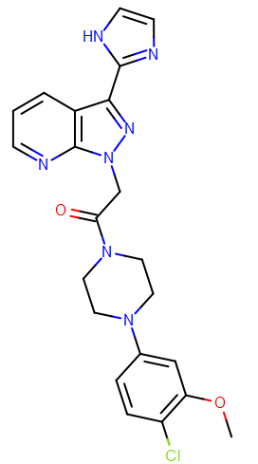  CCR1 antagonist 1, CCR1 | 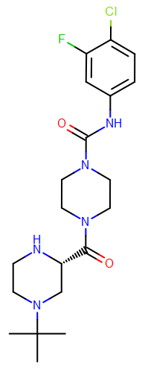  AZD2423, CCR2 | 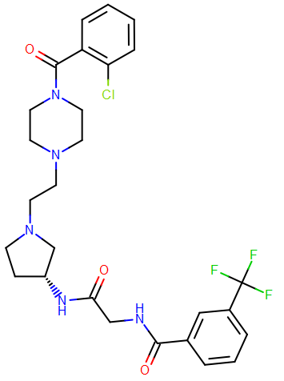  YJC-10592, CCR2 | 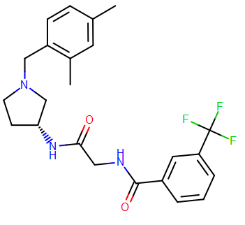  CCR251, CCR2
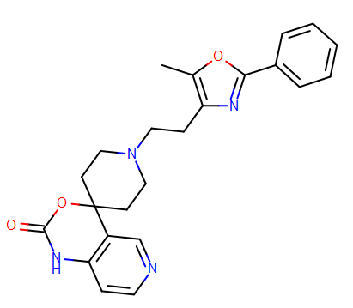  CCR252, CCR2 | 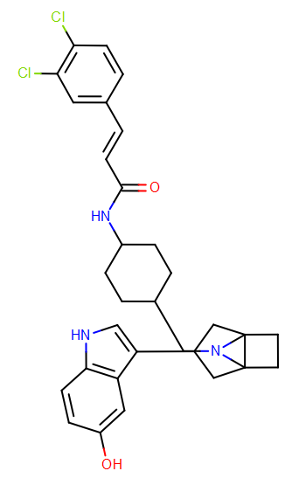  CCR253, CCR2 | 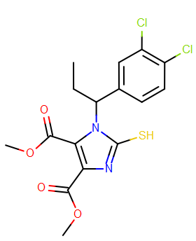  JNJ27553292, CCR2 | 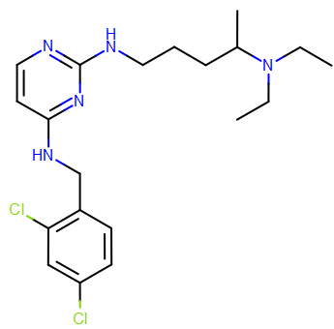  CCR4Ant1, CCR4
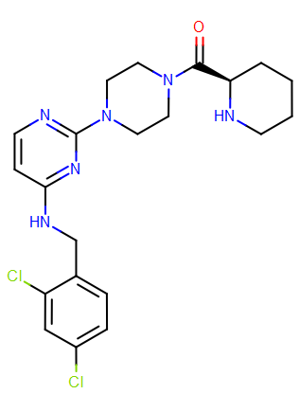  CCR4Ant2, CCR4 | 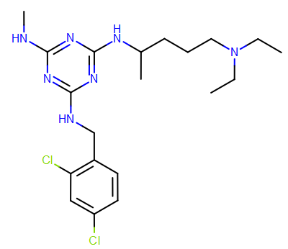  CCR4Ant3, CCR4 | 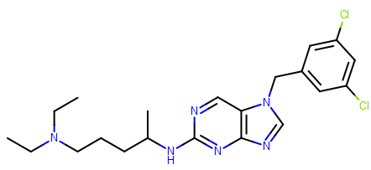  CCR4Ant11, CCR4 | 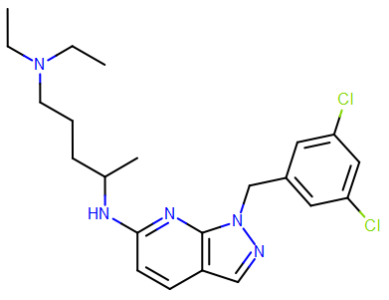  CCR4Ant15, CCR4
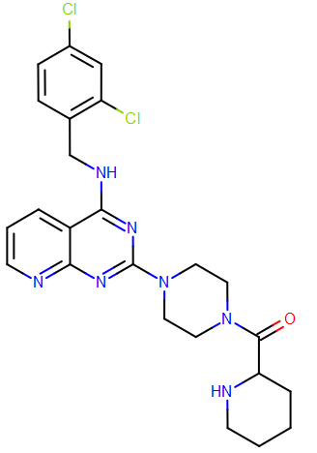  CCR4Ant22 | 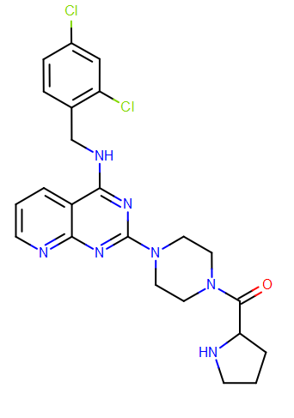  CCR4Ant23, CCR4 | 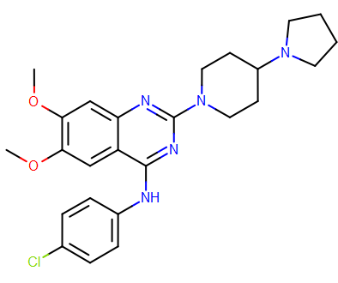  CCR4Ast, CCR4 | 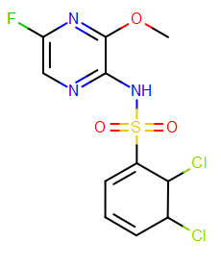  AZD1678, CCR4
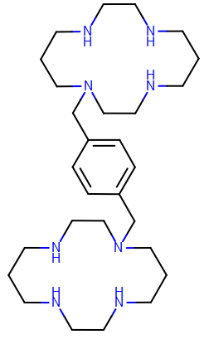  AMD3100 (Plerixafor), CCR7, CXCR4 | 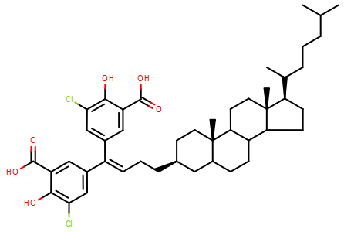  Cosalane, CCR7 | 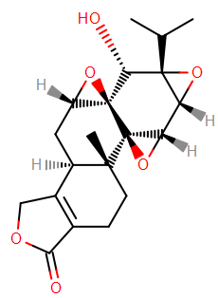  Triptolide, CCR7 | 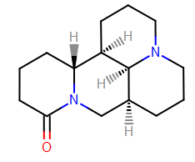  Matrine, CCR7
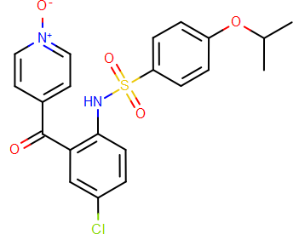  MLN3126, CCR9 | 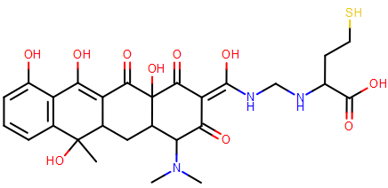  CCR9Ant31, CCR9 | 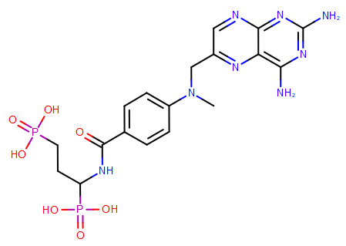  CCR9Ant32, CCR9 | 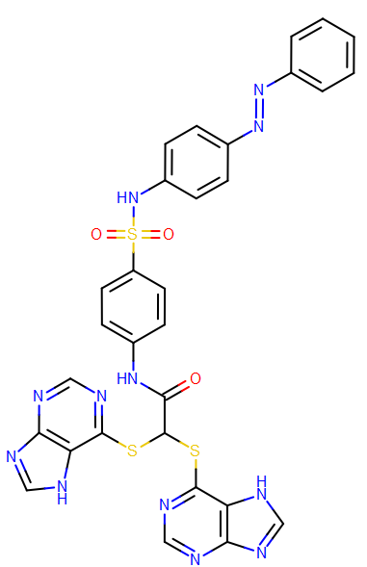  CCR9Ant33, CCR9
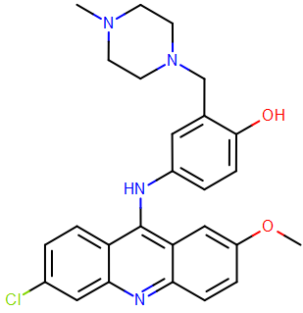  CCR9Ant34, CCR9 | 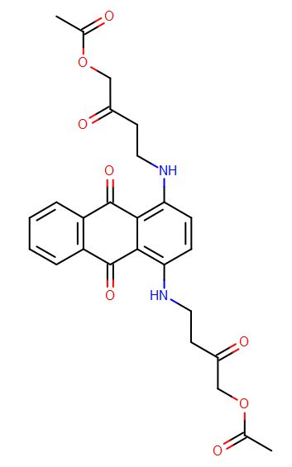  CCR9Ant35, CCR9 | 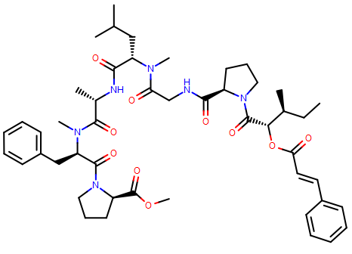  Brintonamide D, CCR10 (ACKR2), CXCR7 | 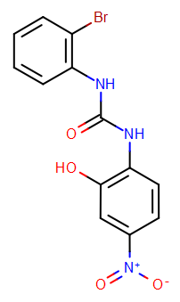  SB225002, CXCR2
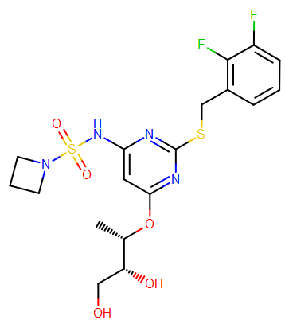  AZD 5096, CXCR2 | 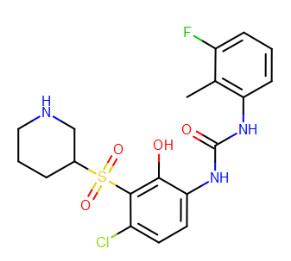  Danirixin, CXCR2 | 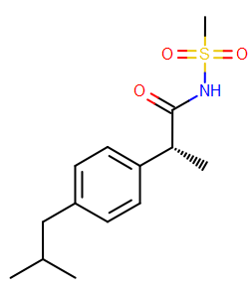  Reparixin, CXCR1, CXCR2 | 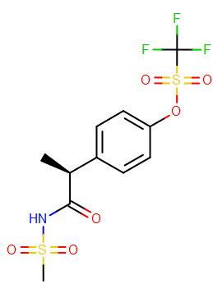  Ladarixin, CXCR2
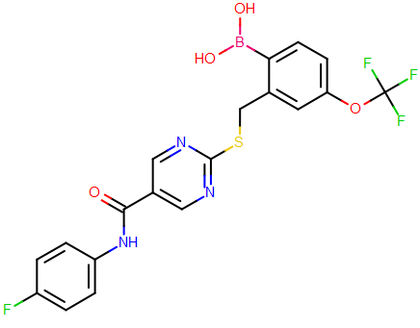  SX682, CXCR2 | 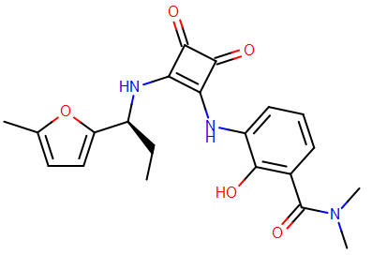  MK7123, CXCR2 | 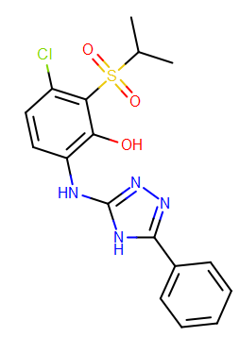  CXCR2Ant5, CXCR2 | 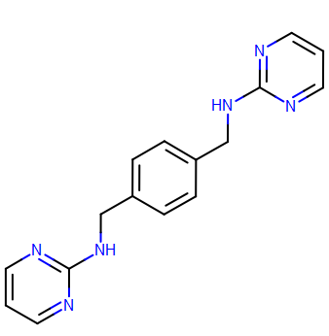  MSX122, CXCR4
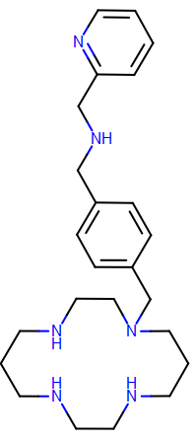  AMD3465, CXCR4 | 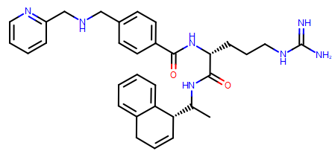  KRH1636, CXCR4 | 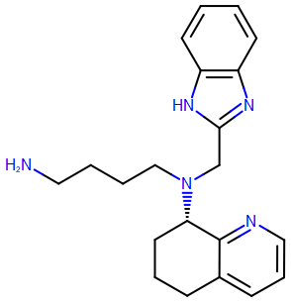  AMD11070, CXCR4 | 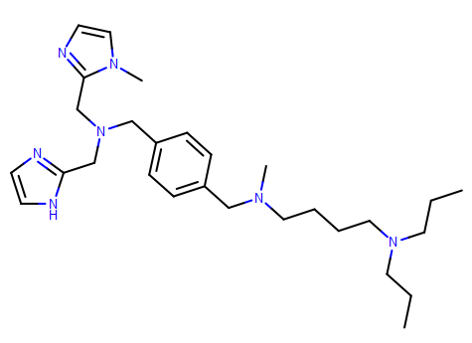  KRH3955, CXCR4
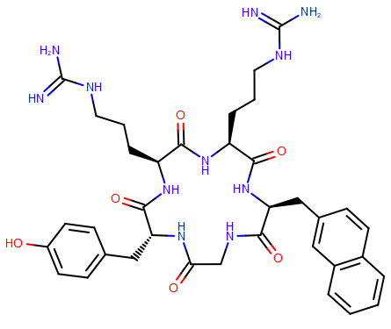  FC131, CXCR4 | 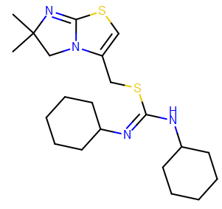  IT1t, CXCR4 | 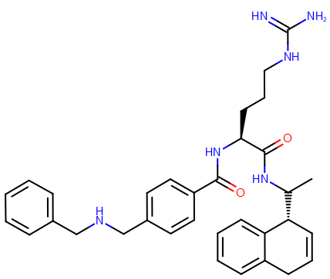  Zach5, CXCR4 | 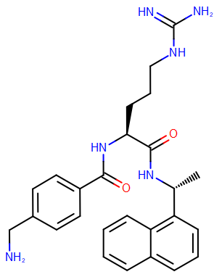  Zach6, CXCR4
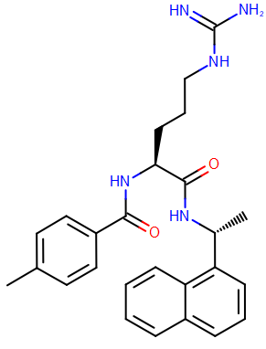  Zach7, CXCR4 | 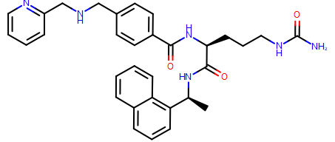  Zach8, CXCR4 | 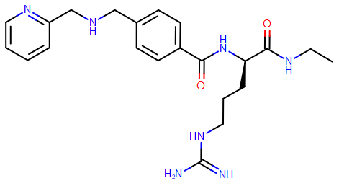  Zach9, CXCR4 | 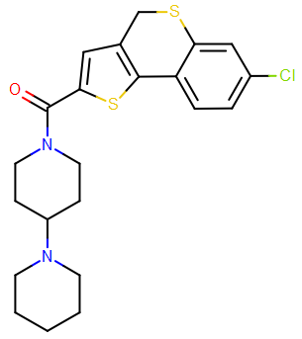  CXCR7Ant1, CXCR7
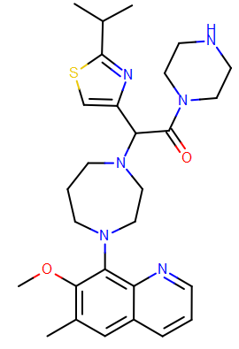  CXCR7Ant2, CXCR7 | 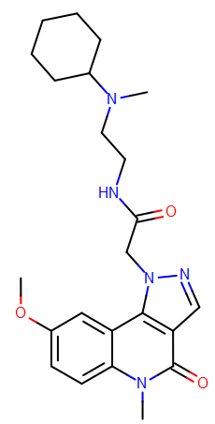  CXCR7Ant3, CXCR7 | 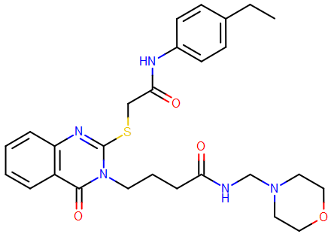  CXCR7Ant4, CXCR7 | 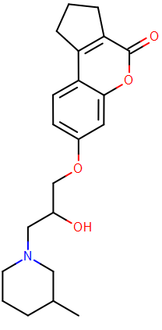  CXCR7Ant5, CXCR7
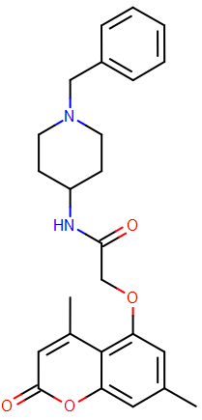  CXCR7Ant6, CXCR7 | 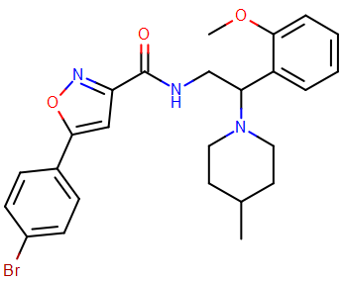  CXCR7Ant7, CXCR7 | 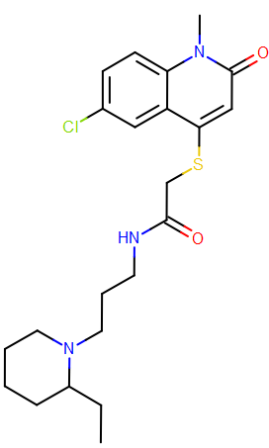  CXCR7Ant8, CXCR7 | 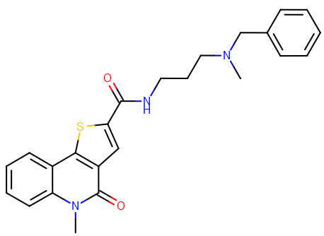  CXCR7Ant9, CXCR7
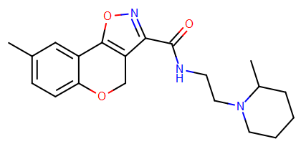  CXCR7Ant10, CXCR7 | 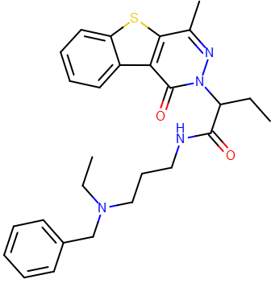  CXCR7Ant11, CXCR7 | 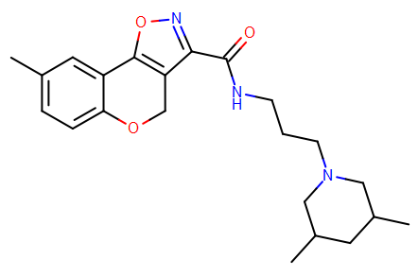  CXCR7Ant12, CXCR7 | 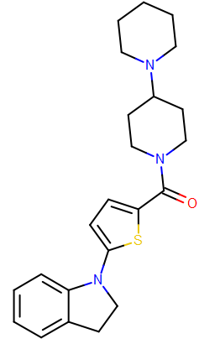  CXCR7Ant13, CXCR7
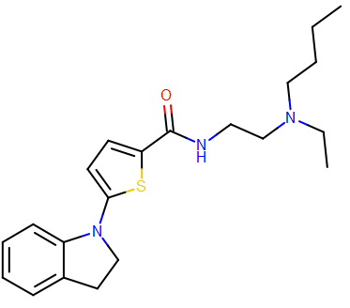  CXCR7Ant14, CXCR7 | 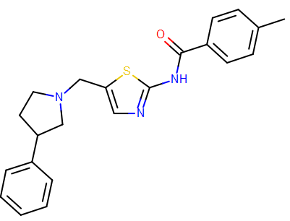  CXCR7Ant15, CXCR7 | 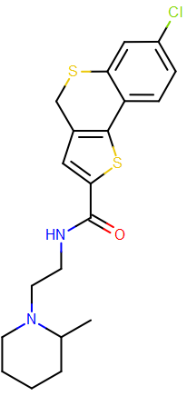  CXCR7Ant16, CXCR7 | 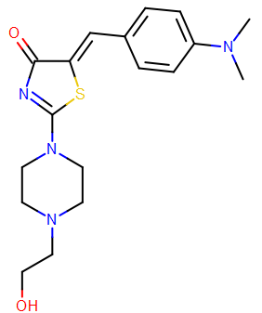  CXCR7Ant17, CXCR7
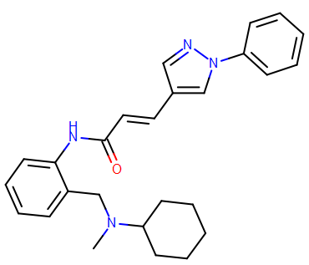  CXCR7Ant18, CXCR7 | 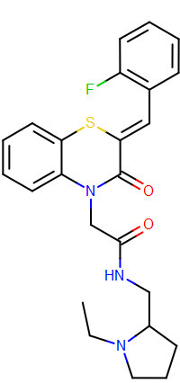  CXCR7Ant19, CXCR7 | 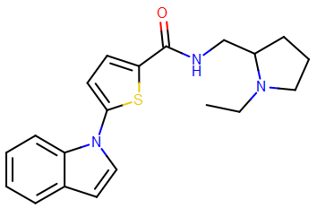  CXCR7Ant20, CXCR7 | 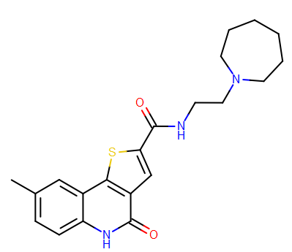  CXCR7Ant21, CXCR7
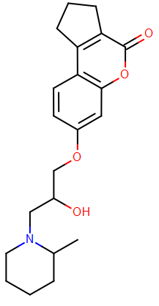  CXCR7Ant22, CXCR7 | 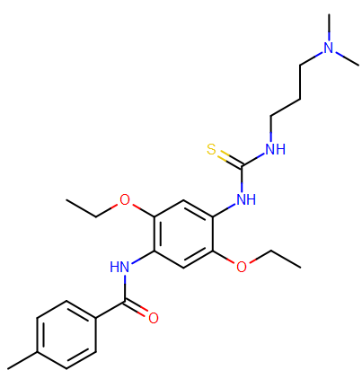  CXCR7Ant23, CXCR7 | 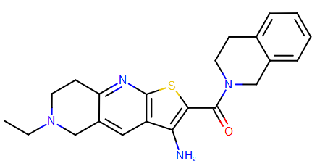  CXCR7Ant24, CXCR7 | 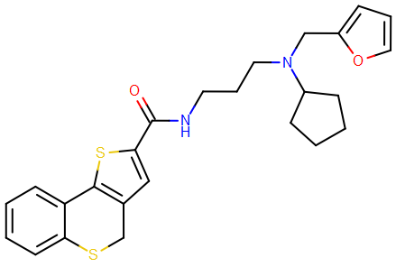  CXCR7Ant25, CXCR7

Chemistry – General Information
Compounds from libraries of commercially available compounds were obtained from various sources (AA Blocks, ChemBridge, ChemDiv, Enamine, Life Chemicals, Maybridge, Otava, Specs, UkrOrgSynthesis, and Vitas-M) and used as received. The purity of all compounds was above 90%, according to the suppliers. Purity of compounds from the FKKTlib academic compound library was determined to be above 90% (except for compound C019), see Supplementary Excel File.

The reagents and solvents were used as received from commercial suppliers. Reactions were monitored using analytical thin-layer chromatography (TLC) on silica gel 60 F₂₅₄ Al plates. Developed plates were inspected under UV light and, if necessary, visualized with ninhydrin, vanillin/sulfuric acid, Dragendorff’s or potassium permanganate stains. Melting points were determined with Büchi 535 Melting Point Appartus (uncorrected). Nuclear magnetic resonance spectra were recorded on a Bruker Avance III 500 MHz and Bruker Avance III 400 MHz spectrometers at 500 MHz (400 MHz) for ¹H, 126 MHz (101 MHz) for ¹³C, respectively, using DMSO-d₆ or CDCl₃ with TMS as the internal standard, as solvents. Chemical shifts are reported in parts per million (ppm), TMS peak was calibrated to 0 ppm or, alternatively, the central peak of the residual solvent resonance was used as the internal standard, i.e. for CDCl₃ at 7.27 ppm for ¹H and 77.16 ppm for ¹³C and DMSO-d₆ at 2.50 ppm for ¹H and 39.52 ppm for ¹³C, respectively. The multiplicities are reported as follows: s (singlet), d (doublet), t (triplet), q (quartet), m (multiplet), dd (doublet of doublets), ddd (doublet doublet of doublets), td (triplet of doublets), qd (quartet of doublets), and br (broad), number of equivalent nuclei (by integration), coupling constants (J) quoted in Hertz (Hz). Mass spectra were recorded on Agilent 6224 Accurate Mass TOF LC/MS and Thermo Scientific Q Executive Plus LC-MS/MS spectrometers, and IR spectra on Thermo Nicolet FT-IR spectrophotometer. UHPLC analyses were performed on Thermo Scientific Dionex UltiMate 3000 modular system (Thermo Fisher Scientific Inc.) with Waters Acquity UPLC® HSS C18 SB column (2.1 × 50 mm, 1.8 µm) thermostated at 40 °C, injection volume, 1–5 µL; sample, 0.1–0.2 mg/mL in MeOH; flow rate, 0.4 mL/min; detector λ, 220 and 254 nm; mobile phase A: 0.1% TFA (v/v) in water; mobile phase B: MeCN. Method I: 0–5 min, 20%–100% B; 5–6 min, 20% B. Method II: 0–2 min, 0% B; 2–8 min, 0%–100% B. Method III: 0–2 min, 20% B; 2–5 min, 20%–90% B; 5–8 min, 90% B.

3-((2-((2-Methoxyethyl)amino)-3,4-dioxocyclobut-1-en-1-yl)amino)benzonitrile (CS-2)
3-((2-Ethoxy-3,4-dioxocyclobut-1-en-1-yl)amino)benzonitrile (Mejuch et al., 2017) (230 mg, 0.945 mmol) and 2-methoxyethylamine (1.1 eq., 90 µL) in acetonitrile (5 mL) were stirred for 18h at 60 °C. The reaction mixture was cooled in an icebath for 5 min, the precipitate was filtered, washed with ice-cold acetonitrile (2 x 5 mL), diethyl ether (30 mL) and dried in air to afford 3-((2-((2-methoxyethyl)amino)-3,4-dioxocyclobut-1-en-1-yl)amino)benzonitrile (Jaeger et al., 2019). Yield: 175 mg (0.645 mmol, 67.9%) of yellowish solid. mp = 242.6–243.8 °C. ESI-HRMS: m/z = 272.1028 (MH⁺); C₁₄H₁₄N₃O₃ requires: m/z = 272.1030 (MH⁺). ν_{max} 3269, 3206, 3145, 3090, 3062, 2944, 2234, 1794, 1664, 1607, 1587, 1551, 1489, 1441, 1307, 1112, 1016, 864, 710, 630 cm^{–1}. Purity: UPLC (method I, 254 nm): t_{r} = 1.667 min, 96.1% total area. ¹H NMR (400 MHz, DMSO-d₆): δ 3.32 (s, 3H), 3.51 (t, J = 5.0 Hz, 2H), 3.75 – 3.81 (m, 2H), 7.45 (dt, J = 1.1, 7.5 Hz, 1H), 7.53 (t, J = 7.9 Hz, 1H), 7.61 – 7.66 (m, 1H), 7.89 (s, 1H), 7.93 (s, 1H), 9.94 (s, 1H). ¹³C NMR (101 MHz, DMSO-d₆): δ 43.49, 58.06, 71.28, 112.15, 118.67, 120.81, 122.55, 125.81, 130.71, 139.99, 162.82, 169.49.

Ethyl 4-((2-((2-methoxyethyl)amino)-3,4-dioxocyclobut-1-en-1-yl)amino)piperidine-1-carboxylate (CS-3)
Ethyl 4-((2-ethoxy-3,4-dioxocyclobut-1-en-1-yl)amino)piperidine-1-carboxylate (Antane et al., 1996) was in situ prepared from ethyl 4-aminopiperidine-1-carboxylate (250 mg, 1.45 mmol) and diethyl squarate (1.1 eq., 236 µL) in absolute ethanol (2 mL). After 24h stirring at room temperature, 2-methoxyethylamine (1.5 eq., 190 µL) was added, and the stirring continued for 24h. Ethyl 4-((2-((2-methoxyethyl)amino)-3,4-dioxocyclobut-1-en-1-yl)amino)piperidine-1-carboxylate (Jaeger et al., 2019) was isolated using reversed-phase column chromatography (RP-CC) (Isolera Biotage One Flash Chromatography system, SNAP Biotage KP-C18-HS column, 12 g) using a gradient of 0.1% TFA in deionized water and MeCN as eluent (gradient 10–100% MeCN in 15 column volumes (300 mL); 100% MeCN for 5 column volumes (100 mL)). After the RP-CC, fractions containing the product were combined, and the organic solvent removed in vacuo. The remaining aqueous solution was neutralized with saturated sodium bicarbonate solution and extracted with DCM (2 x 30 mL). The combined organic phases were dried over anhydrous sodium sulfate, filtered, and volatile components evaporated in vacuo to afford the pure product. Yield: 365 mg (1.12 mmol, 77.4%) of beige solid. mp = 157.1–158.4 °C. ESI-HRMS: m/z = 326.1707 (MH⁺); C₁₅H₂₄N₃O₅ requires: m/z = 326.1711 (MH⁺). ν_{max} 3221, 2962, 1794, 1669, 1577, 1538, 1431, 1262, 1232, 1147, 1098, 1020, 788, 747, 700 cm^{–1}. Purity: UPLC (method I, 254 nm): t_{r} = 3.133 min, 97.1% total area. ¹H NMR (400 MHz, CDCl₃): δ 1.19 (t, J = 7.1 Hz, 3H), 1.47 – 1.59 (m, 2H), 1.88 – 1.97 (m, 2H), 2.89 (t, J = 10.1 Hz, 2H), 3.27 (s, 3H), 3.49 (t, J = 5.1 Hz, 2H), 3.73 – 3.81 (m, 2H), 3.96 – 4.14 (m, 5H), 7.62 (s, 1H), 7.88 (s, 1H). ¹³C NMR (101 MHz, CDCl₃): δ 14.63, 32.84, 42.17, 44.12, 51.41, 58.75, 61.42, 71.84, 155.36, 167.50, 167.85, 181.72, 182.54.

Supplementary references
Antane, M. M., Butera, J. A., Hirth, B. H., and Antane, S. A. (1996). Diaminocyclobutene-3,4-diones. Available at: https://patents.google.com/patent/US5530025A/en.
Jaeger, K., Bruenle, S., Weinert, T., Guba, W., Muehle, J., Miyazaki, T., et al. (2019). Structural Basis for Allosteric Ligand Recognition in the Human CC Chemokine Receptor 7. Cell 178, 1222-1230.e10. doi:10.1016/j.cell.2019.07.028.
Mejuch, T., Garivet, G., Hofer, W., Kaiser, N., Fansa, E. K., Ehrt, C., et al. (2017). Small-Molecule Inhibition of the UNC119–Cargo Interaction. Angew. Chem. Int. Ed. 56, 6181–6186. doi:10.1002/anie.201701905.
Taveras, A. G., Chao, J., Biju, P. J., Yu, Y., Aki, C. J., Merritt, J. R., et al. (2010). Thiadiazoledioxides and thiadiazoleoxides as CXC- and CC-chemokine receptor ligands. Available at: https://patents.google.com/patent/US7691856/en?oq=US20070264230A1.

