Supplemental Information
Supplementary Figure 1.
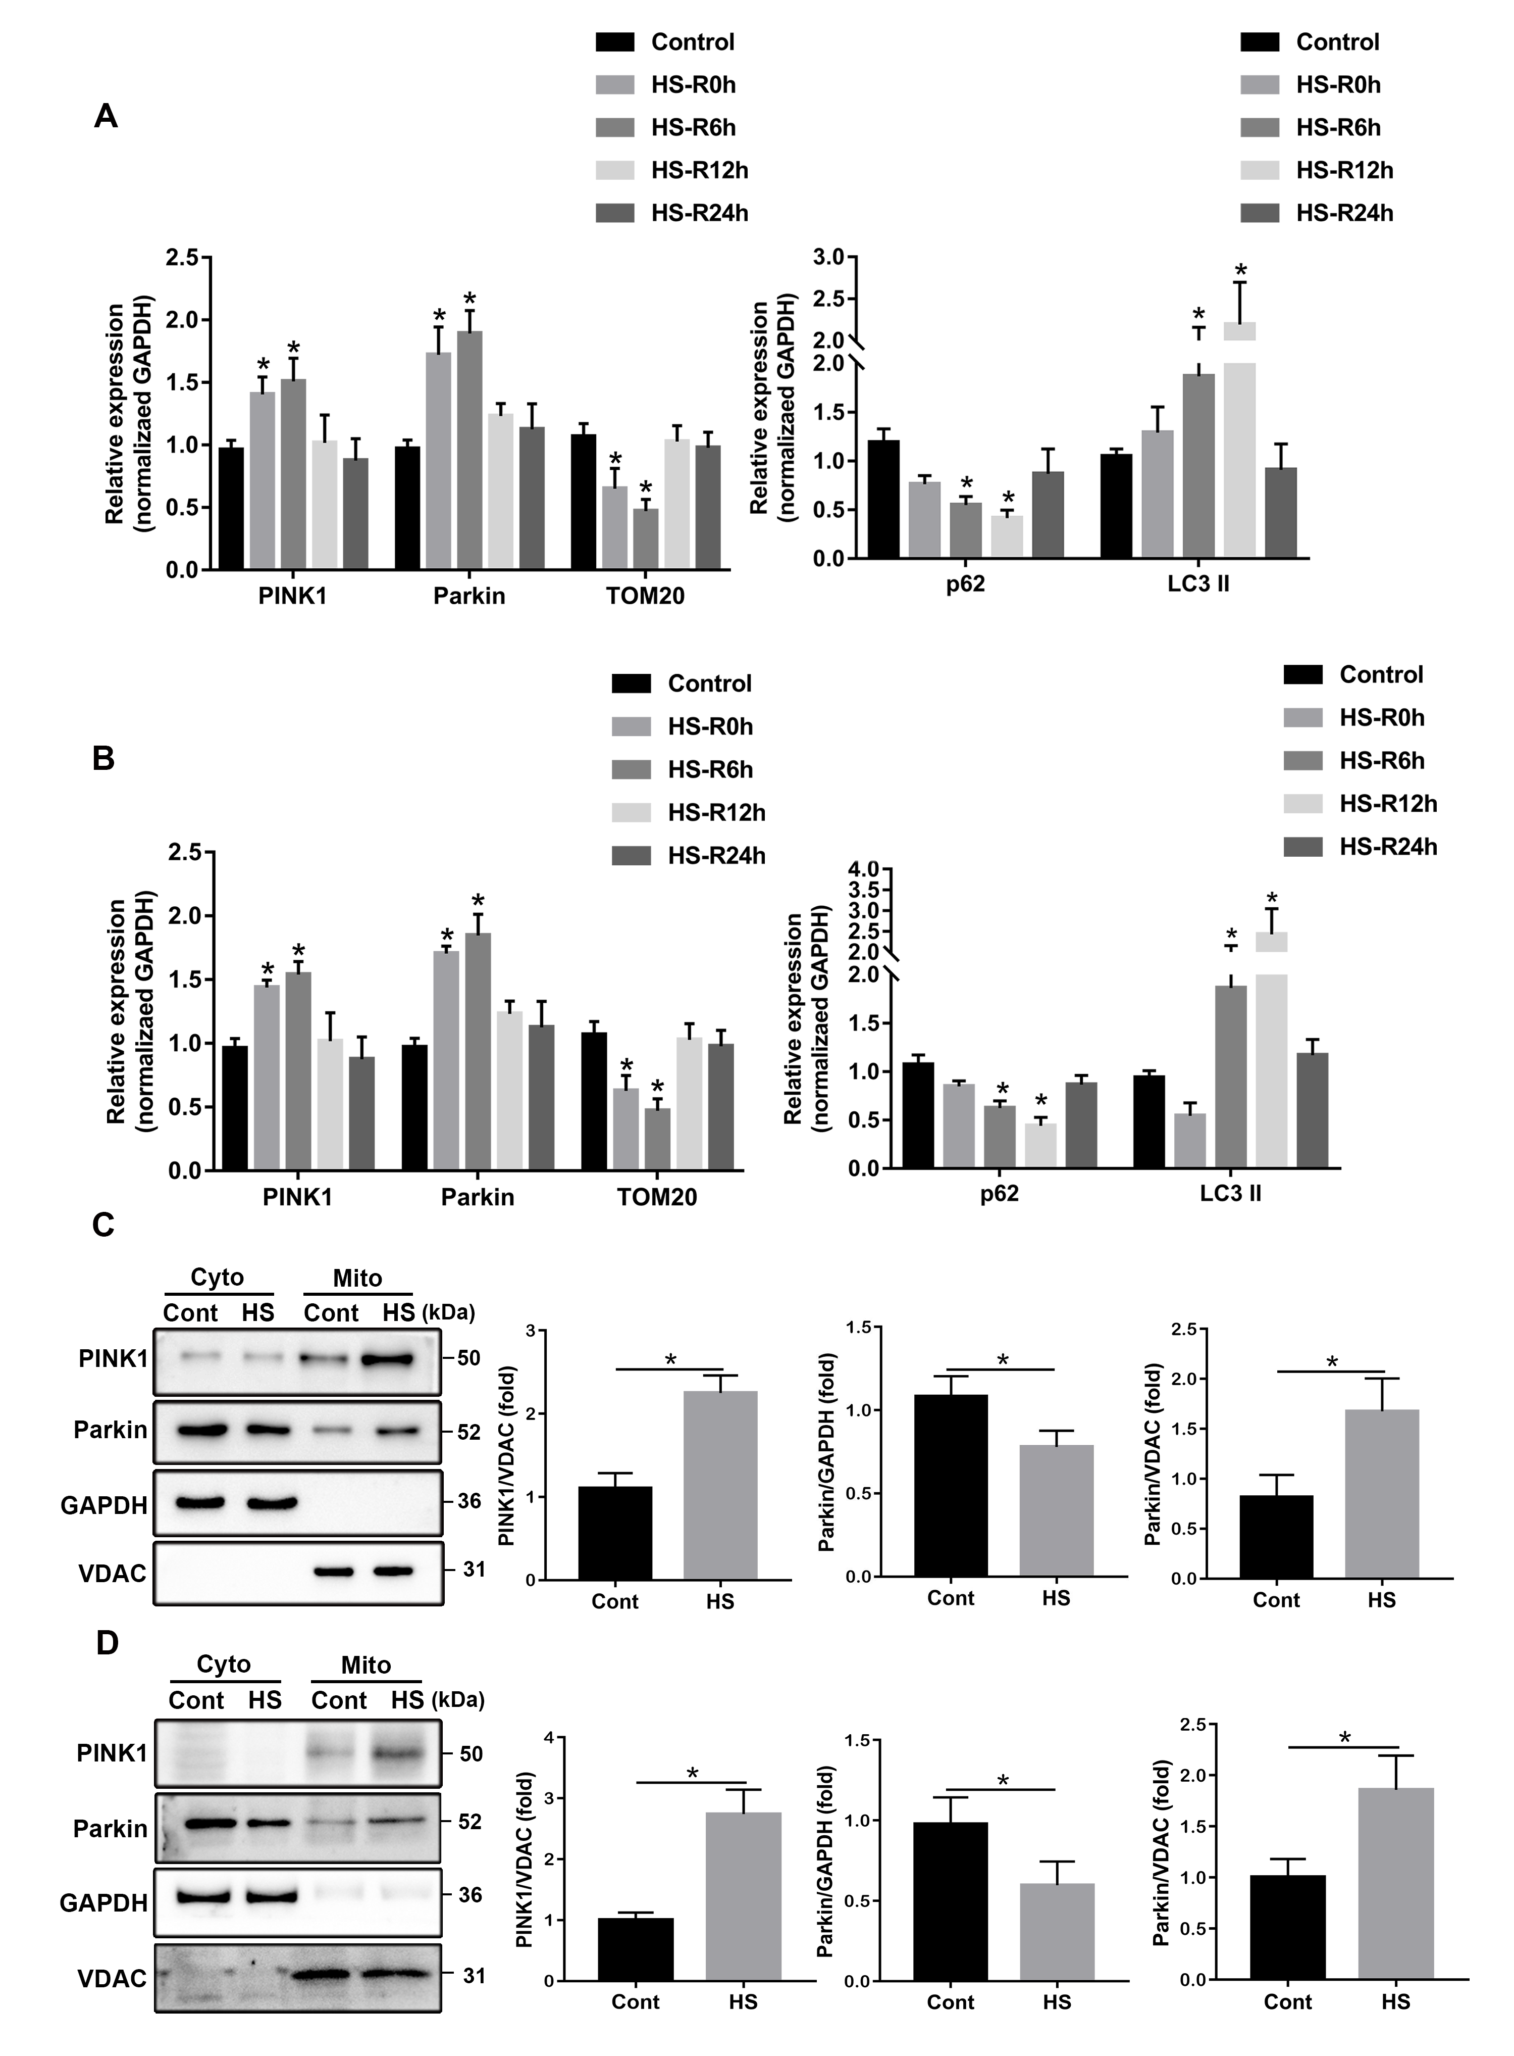
FIGURE S1 | Mitophagy is induced by HS in vivo and in vitro. (A) Immunoblot analysis and quantification of mitophagy-related proteins, including PINK1, Parkin, TOM20, LC3 II, and p62 in liver tissues. (B) Immunoblot analysis and quantification of mitophagy-related proteins, including PINK1, Parkin, TOM20, p62, and LC3 II in LO2 cells. (C) Liver tissues were obtained from HS and sham control mice at 6 h after HS. Immunoblot analysis and quantification of the mitophagy-related proteins PINK1 and Parkin in the cytoplasm and mitochondrial fractions of livers, n=3-4. (D) LO2 cells were exposed to 42°C for 3 h for HS treatment and then incubated at 37°C for 6 h later. Immunoblot analysis and quantification of the mitophagy-related proteins PINK1 and Parkin in the cytoplasm and mitochondrial fractions of LO2 cells, n=3-4. Data are shown as the mean ± SD. *p < 0.05.

Supplementary Figure 2.
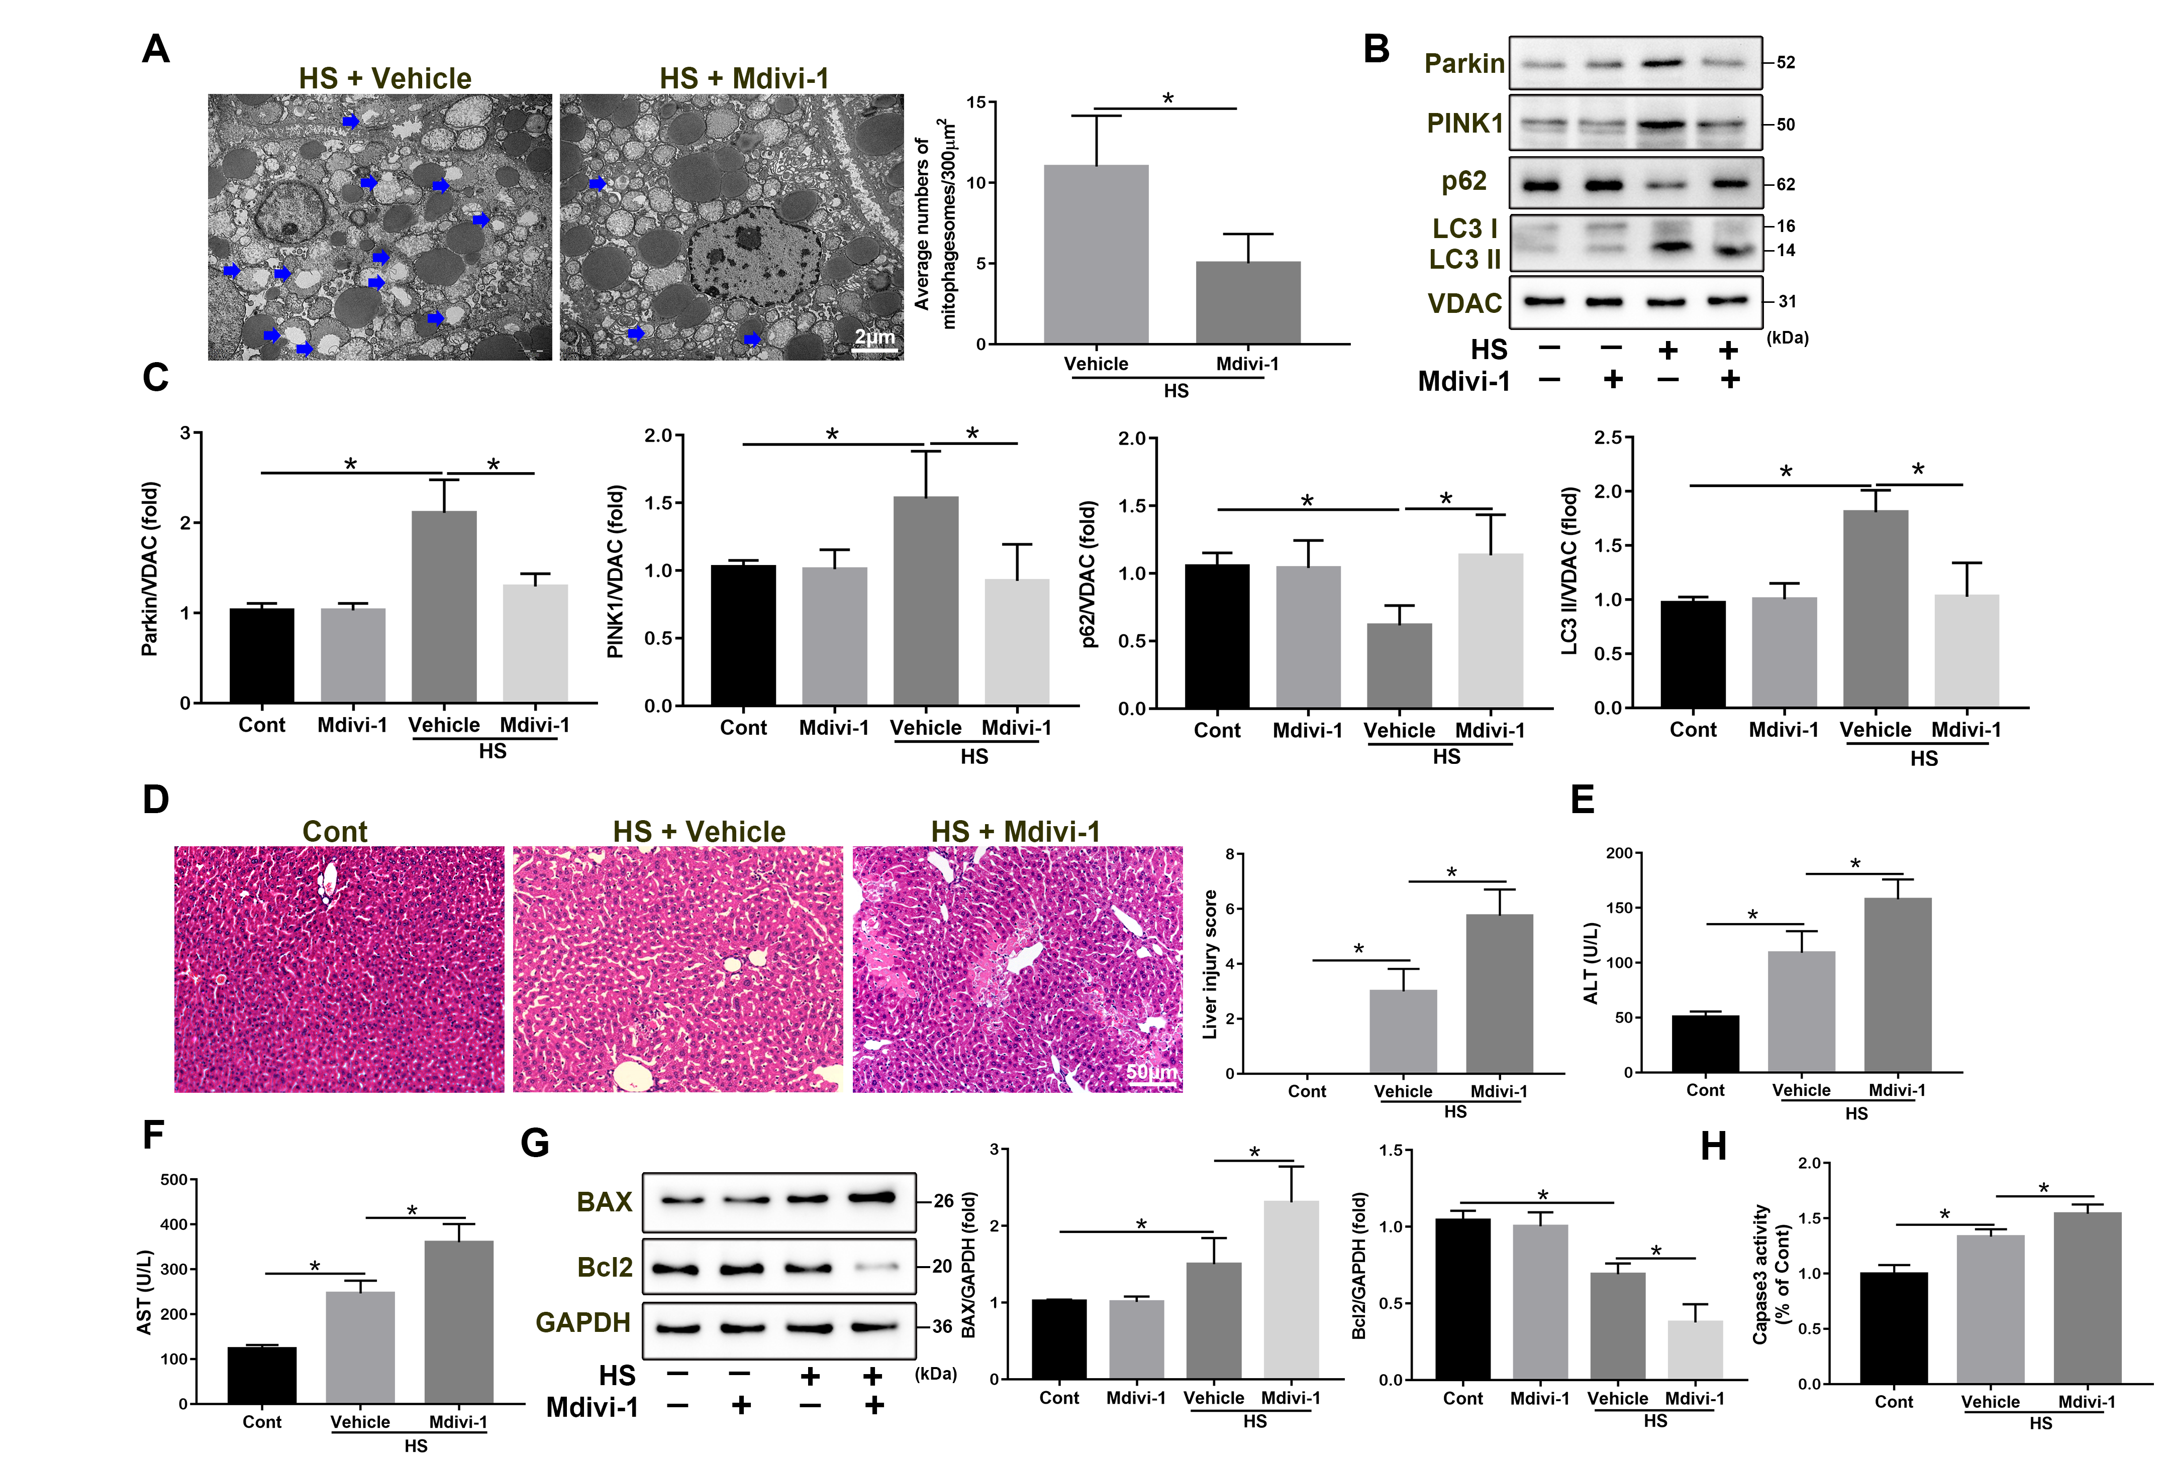
FIGURE S2 | Midiv-1 treatment increases apoptosis in HS-ALI by inhibiting mitophagy. Midiv-1 treatment increases apoptosis in HS-ALI by inhibiting mitophagy. Mice were pretreated with Mdivi-1 (25 mg/kg, i.p.) for 2 h and then subjected to sham-untreated or HS. Livers and serum were collected 6 hours after HS. (A) Representative TEM images of mitochondrial morphology in hepatocytes after HS. Blue arrows: mitophagosome and mitolysosome. Scale bar: 2 μm. (B-C) Immunoblot analysis and quantification of mito/autophagy-related proteins, including Parkin, PINK1, p62, and LC3 II in the mitochondrial fractions of livers. (D) Representative histology and pathological score of liver samples by H&E staining. Scale bar: 50 μm. (E-F) Relative serum ALT and AST levels. (G) Immunoblot analysis and quantification of BAX and Bcl2 in liver tissues. (H) The enzymatic activity of Caspase 3 was subsequently measured, n=4. Data are shown as the mean ± SD. *p < 0.05.

Supplementary Figure 3.

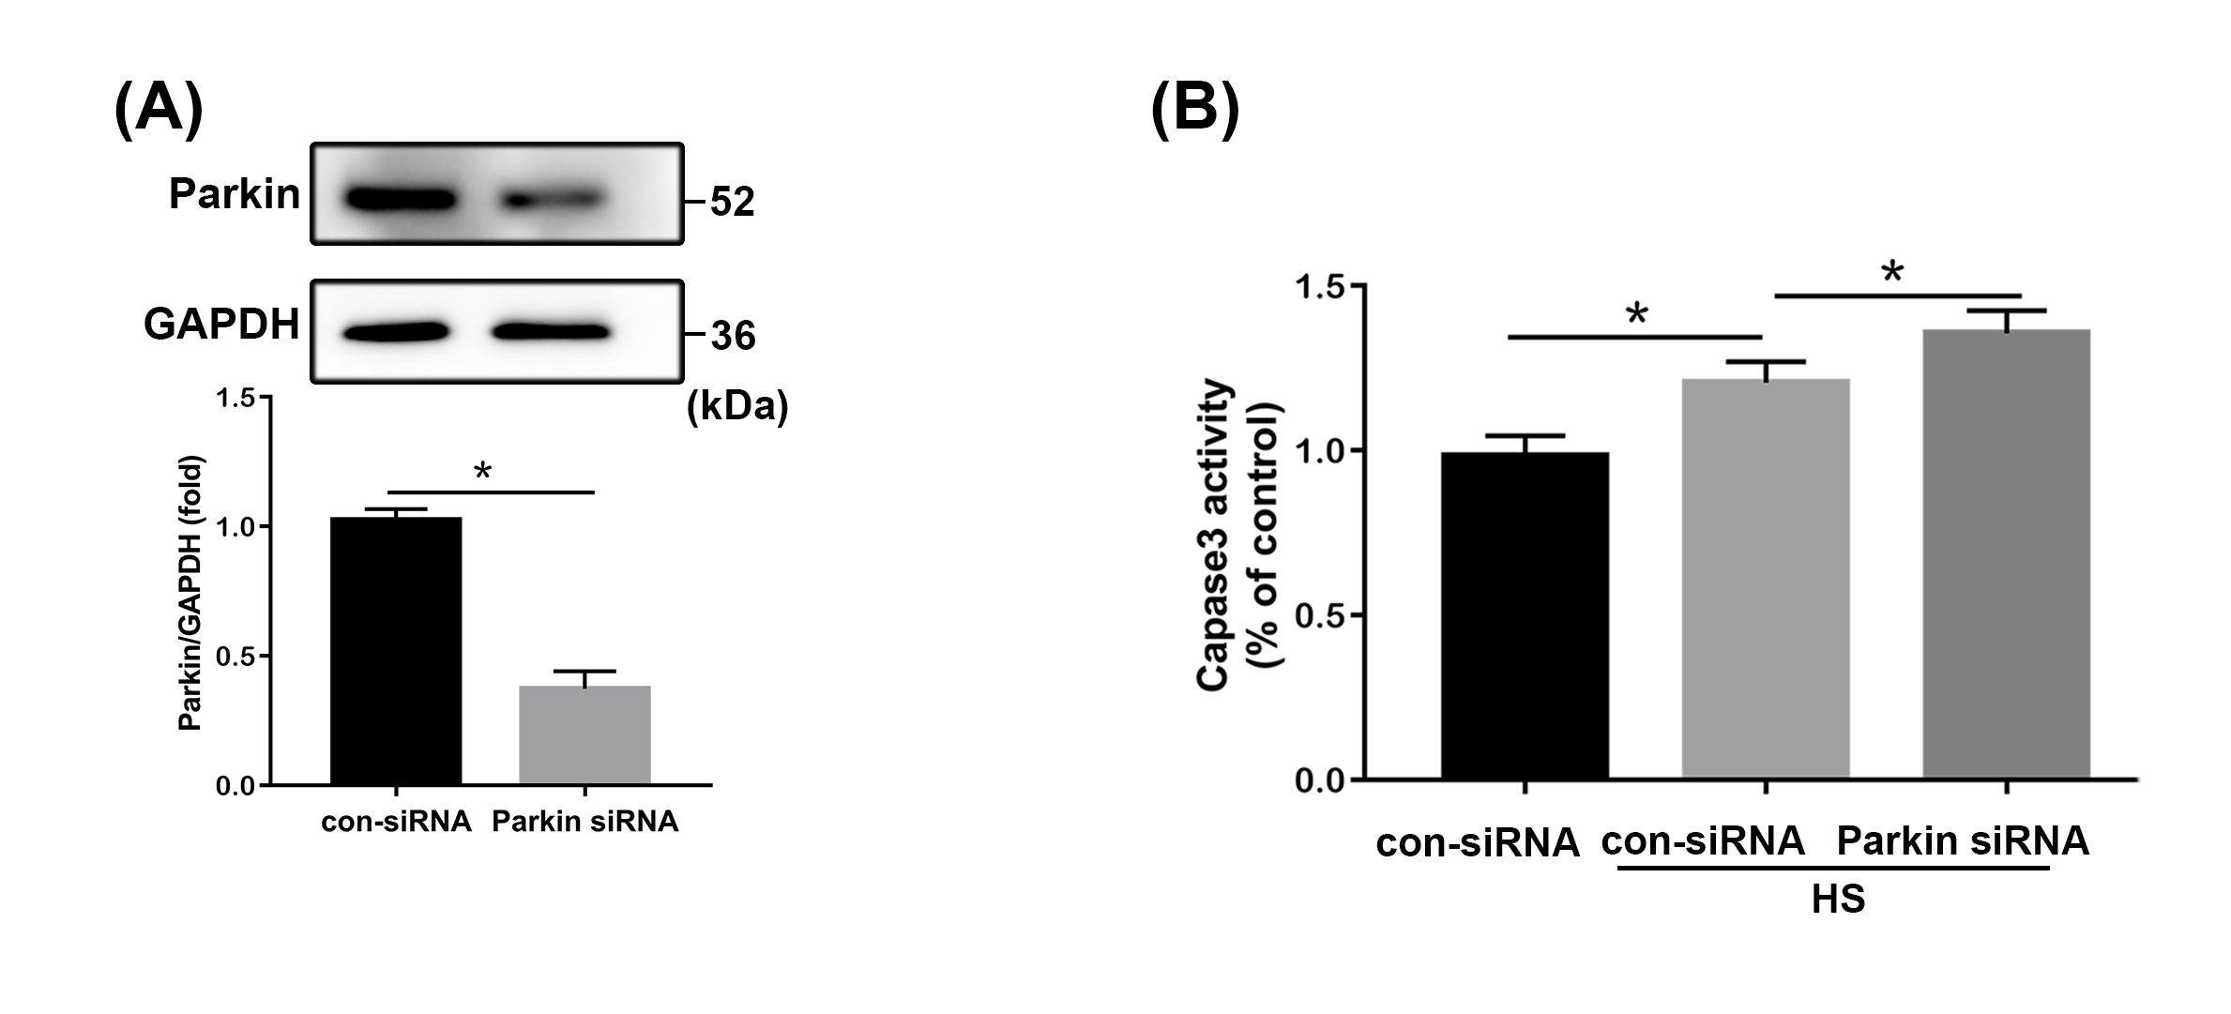
FIGURE S3 | Confirmation of Parkin siRNA-mediated Parkin knockdown. After transfection with con-siRNA or Parkin siRNA for 8 h, LO2 cells were exposed to 42 °C for 3 h and then incubated at 37°C for 6 h. (A) Confirmation of Parkin siRNA-mediated Parkin knockdown by western blot. (B) The enzymatic activity of Caspase 3 was measured, n=4. Data are shown as the mean ± SD. *p < 0.05.
Supplementary Figure 4.
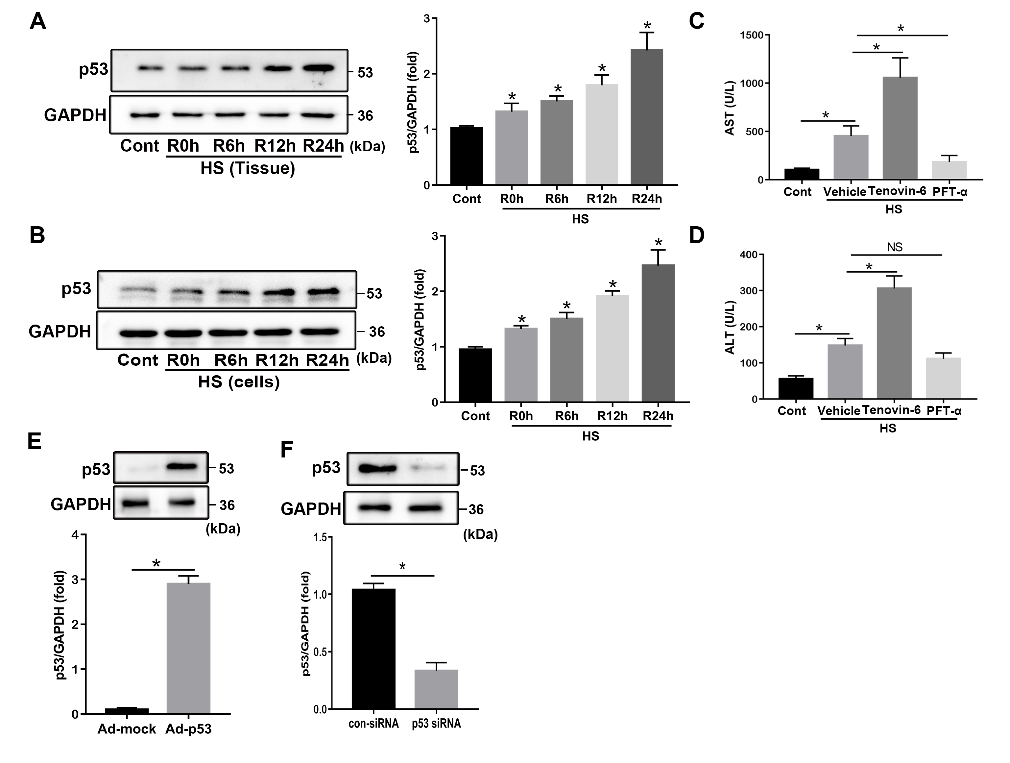
FIGURE S4 | p53 gradually increased following HS in vivo and in vitro. Confirmation of adenovirus-induced p53 overexpression and siRNA-induced p53 silencing. (A) LO2 cells were exposed to 42°C for 3 h for HS treatment and then incubated at 37°C for 0 h and 6 h, 12 h, and 24 h later. Immunoblot analysis and quantification of p53 in liver tissues. (B) Immunoblot analysis and quantification of p53 in HS-treated LO2 cells. (C, D) p53 regulates Parkin-dependent mitophagy and apoptosis in HS-ALI. Mice were pretreated with the selective p53 agonist Tenovin-6 (25 mg/kg, i.p.) or the p53 inhibitor PFT-α (2.2 mg/kg, i.p.) for 2 h and then subjected to HS, these livers and blood were collected 6 hours after HS. Relative serum ALT and AST levels. (E) Confirmation of the effect of adenovirus-induced p53 overexpression using western blot. (F) Confirmation of the efficiency of p53 silencing by western blot, n=4. Data are shown as the mean ± SD. *p < 0.05, NS = not significant.

