Supplementary Material

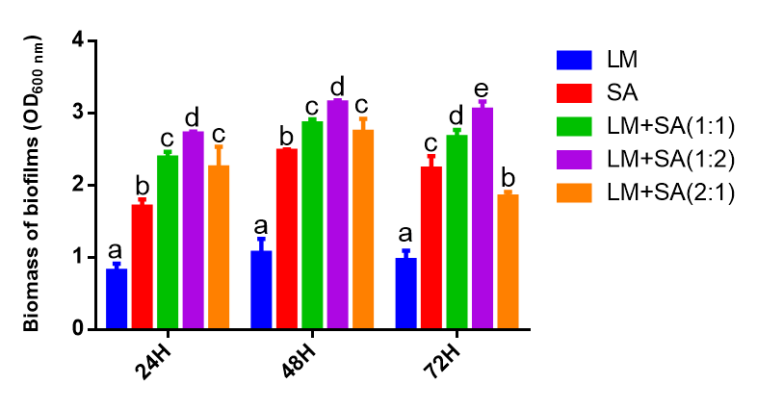
Supplementary Figure 1. Effect of different ratio of L. monocytogenes and S. aureus Biomass of biofilms on biomass of the mixed-species biofilm.

