Supplementary to Frontiers in Earth Science
Tectonic juxtaposition of two independent Paleoproterozoic arcs by Cenozoic duplexing in the Arun Tectonic Window of the eastern Nepalese Himalaya
Rui Li^{1,2,3,4,*}, Songjian Ao^{5,4,} Wenjiao Xiao^{1,2,3,4,5,*}, Karel Schulmann⁶, Qigui Mao^{1,2,3,4}, Dongfang Song^{5,4}, Hao Wang^{1,2,3,4}, Zhou Tan^{1,2,3,4}, Saunak Bhandari ⁷
¹ State Key Laboratory of Desert and Oasis Ecology, Xinjiang Institute of Ecology and Geography, Chinese Academy of Sciences, Urumqi 830011, China;
² Xinjiang Key Laboratory of Mineral Resources and Digital Geology, Urumqi 830011, China;
³ University of Chinese Academy of Sciences, Beijing 100049, China
4 Innovation Academy for Earth Science, Chinese Academy of Sciences, Beijing 100029, China
⁵ State Key Laboratory of Lithospheric Evolution, Institute of Geology and Geophysics, Chinese Academy of Sciences, Beijing 100029, China
⁶ Centre for Lithospheric Research, Czech Geological Survey, Klárov 131/3, Prague, Czech Republic
⁷ Department of Mines and Geology, Government of Nepal, Kathmandu, Nepal
Corresponding author: Rui Li (lirui@ms.xjb.ac.cn)
Wenjiao Xiao (wj-xiao@mail.iggcas.ac.cn)

Supplementary figure
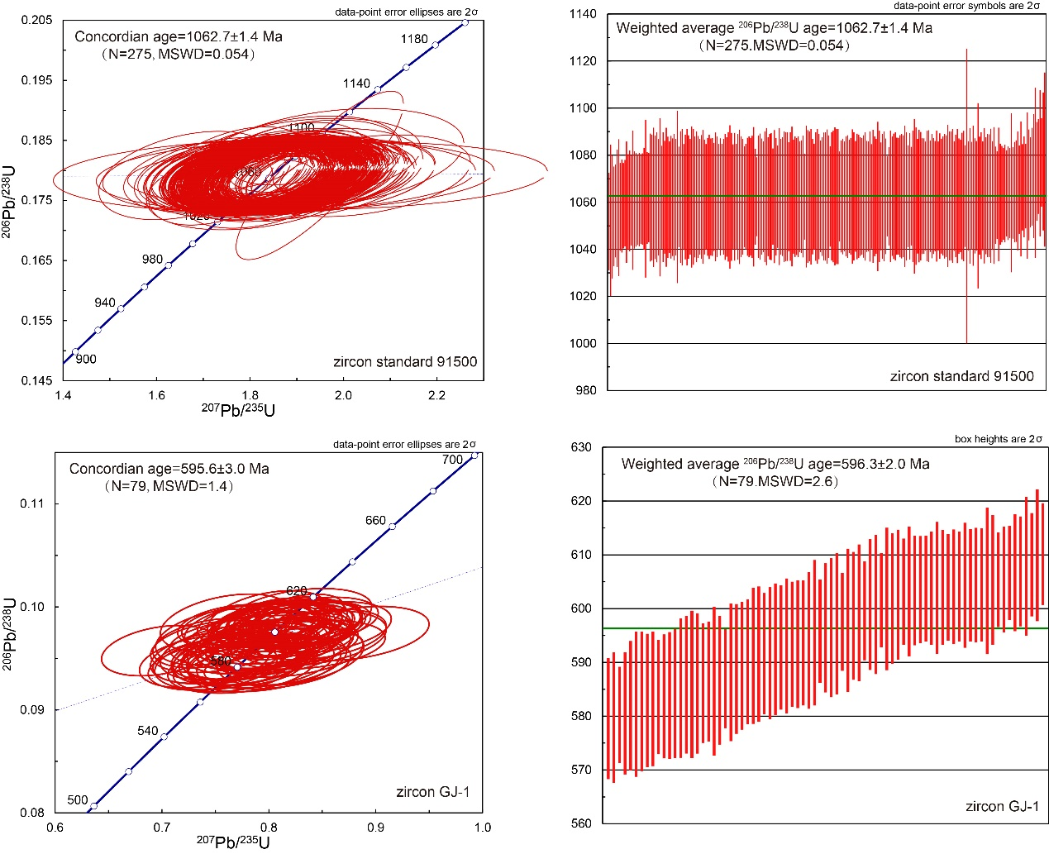Figure S1. Diagrams wetherill concordia plot and weighted average plot of standard sample Zircon 91500 and GJ-1.

