Supplementary material 2

TABLE 1 The descriptive analysis of the scores from judges in the overlapping sample
number | Panel of 69 judges |  | Panel of 36 judges
 | mean | SD | mean | SD
A01 | 1.3188 | 0.6881 | 1.1111 | 0.3187
A02 | 2.8116 | 0.6299 | 2.6388 | 0.4871
A03 | 1.2464 | 0.4185 | 1.1666 | 0.4472
A04 | 2.2174 | 0.5875 | 2.3333 | 0.6761
A05 | 1.9130 | 0.6279 | 2.0277 | 0.6963
A06 | 1.5797 | 0.7647 | 1.6666 | 0.6761
A07 | 1.1594 | 0.6737 | 1.2500 | 0.5000
A08 | 1.8841 | 0.6616 | 1.8055 | 0.7490
A09 | 1.4928 | 0.4296 | 1.5277 | 0.6087
A10 | 2.4493 | 0.4296 | 2.6666 | 0.4780
A11 | 2.0145 | 0.5136 | 2.0000 | 0.5855
A12 | 1.6087 | 0.3392 | 1.7222 | 0.5662
E01 | 2.6377 | 0.7503 | 2.8888 | 0.3187
E02 | 1.1884 | 0.6058 | 1.1666 | 0.4472
E03 | 2.6377 | 0.6564 | 2.4444 | 0.6068
E04 | 1.3623 | 0.6141 | 2.2222 | 0.6808
E05 | 1.6812 | 0.5835 | 1.9166 | 0.8062
E06 | 2.2899 | 0.4694 | 2.5277 | 0.6087
E07 | 1.4493 | 0.6702 | 1.2500 | 0.5000
E08 | 1.6087 | 0.5283 | 1.5555 | 0.5039
E09 | 1.9710 | 0.2054 | 1.7777 | 0.6808
E10 | 2.1739 | 0.7092 | 2.4444 | 0.6522
E11 | 1.9710 | 0.7043 | 2.0000 | 0.5345
E12 | 1.2609 | 0.7046 | 1.3333 | 0.5345

TABLE 2 The descriptive analysis of the scores from judges in the two panels
Sample | Panel of 69 judges |  | Panel of 36 judges
 | mean | SD | mean | SD
Total | 1.8517 | 0.4661 | 1.8256 | 0.4917

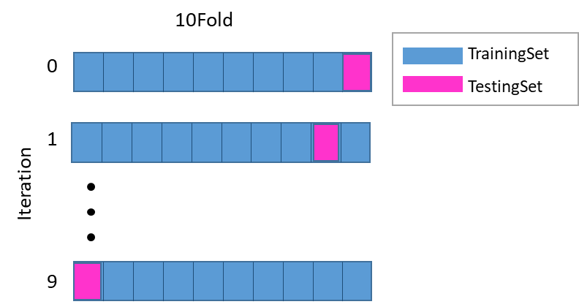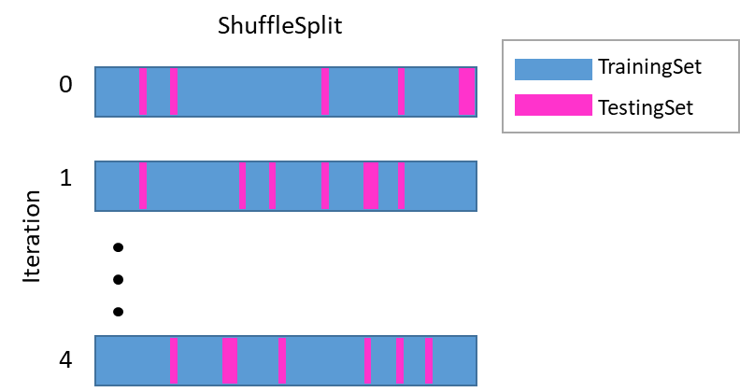
FIGURE 1 Interation processing of 10-Fold (left) and ShuffleSplit (right)

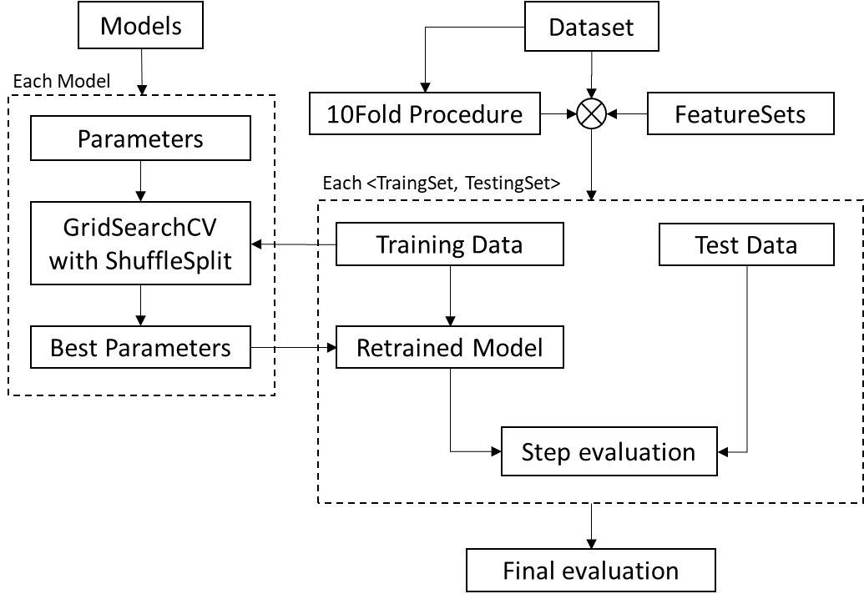
FIGURE 2 The flowchart of our cross-validation workflow from scratch to evaluate the performance of each model after feature selection

