Supplementary Table 1. List of primers used in the RT-PCR analysis of gene expression in ATDC5 cells.
Primer ID | Primers (5’- 3’)
GAPDH-F | TGTGTCCGTCGTGGATCTGA
GAPDH-R | TTGCTGTTGAAGTCGCAGGAG
Agg-F | AGTGGATCGGTCTGAATGACAGG
Agg-R | AGAAGTTGTCAGGCTGGTTTGGA
Col II-F | AGGGCAACAGCAGGTTCACATAC
Col II-R | TGTCCACACCAAATTCCTGTTCA
Col X-F | CTCCTACCACGTGCATGTGAA
Col X-R | ACTCCCTGAAGCCTGATCCA
Col I-F | ATGCCGCGACCTCAAGATG
Col I-R | TGAGGCACAGACGGCTGAGTA

Supplementary Table 2. List of primers used in the RT-PCR analysis of gene expression in chondrocytes.
Primer ID | Primers (5’- 3’)
GAPDH-F | CACCCACTCCTCTACCTTCG
GAPDH-R | GGTCTGGGATGGAAACTGTG
Agg-F | GGAGGTCGTGGTGAAAGGTG
Agg-R | CTCACCCTCCATCTCCTCTG
Col II-F | GTGGAAGAGCGGTGACTAC
Col II-R | TAGGTGATGTTCTGGGAGC
Col X-F | AGTTCTTCATTCCCTATGCCA
Col X-R | CAATGTCTCCTTTCGGTCCA
Col I-F | GGTGCTGCTGGTAAAGAAGG
Col I-R | GTCTACCCAAAGCACCAG

Supplementary Figure 1. Cell viability of ATDC5 cells when treated with different concentrations of galactose. (A) IC₅₀ curves of ATDC5 towards galactose. Cells were cultured for 72 h. IC₅₀ value of ATDC5 simulated by GraphPad is about 99.6 mM. (B) Proliferation histogram of ATDC5 co-cultured with a range of concentrations of galactose up to 7 days.

Supplementary Figure 2. (A) Quantitative analysis of Alcian blue staining of GAG accumulation in ATDC5 cells on day 3, 7, 14 and 21. (B) Quantitative analysis of GAG/DNA in ATDC5 cells, the amount of GAG was below detection limit on day 3.

Supplementary Figure 3. Immunofluorescence staining for type X collagen (A) and type I collagen (B) of ATDC5. Type X collagen and type I collagen were stained with red and nuclei was stained with blue. Scale bar = 50 µm.

Supplementary Figure 4. Cell viability of chondrocytes when treated with different concentrations of galactose. (A) IC₅₀ curves of chondrocytes towards galactose. Cells were cultured for 72 h. IC₅₀ value of chondrocytes simulated by GraphPad is about 498.5 mM. (B) Proliferation histogram of chondrocytes co-cultured with a range of concentrations of galactose up to 7 days.

Supplementary Figure 5. (A) Quantitative analysis of Alcian blue staining of GAG accumulation in chondrocytes on day 3, 7, 14 and 21. (B) Quantitative analysis of GAG/DNA in chondrocytes, the amount of GAG was below detection limit on day 3.

Supplementary Figure 6. Immunofluorescence staining for type X collagen (A) and type I collagen (B) of chondrocytes. Type X collagen and type I collagen were stained with red and nuclei was stained with blue. Scale bar = 50 µm.

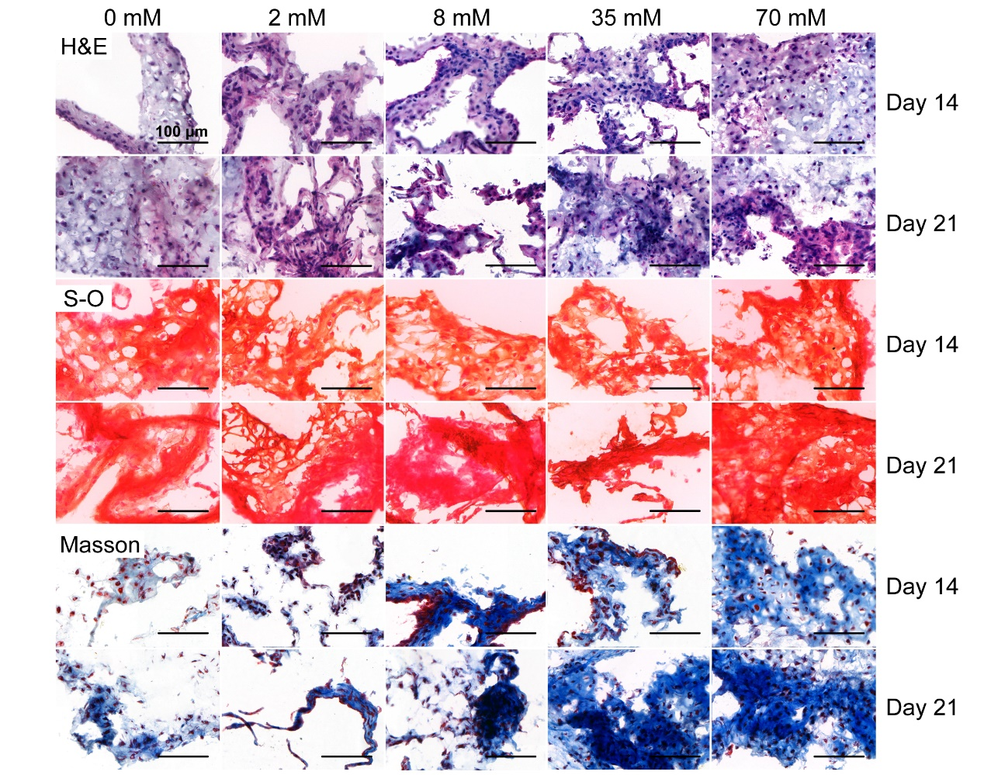
Supplementary Figure 7. Histological staining of chondrocyte masses (H&E, Safranin-O and Masson). Scale bar = 100 µm.

