Supplementary Material

Supplementary Figures and Tables

Supplementary Figures
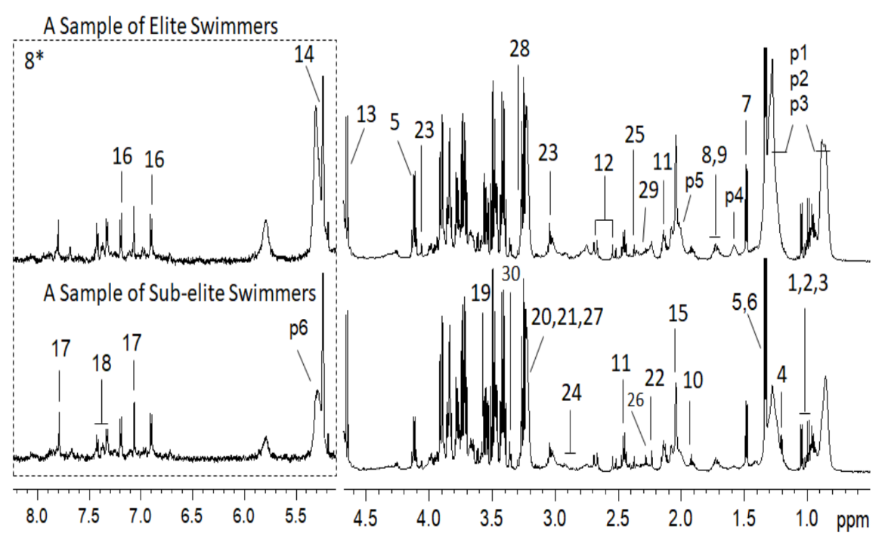
Supplementary Figure 1. Typical serum one-dimensional ¹H NMR spectra.
Supplementary Figure 2. Metabolites with distinct patterns between the two groups in male
Supplementary Figure 3. Metabolites with distinct patterns between the two groups in female
Supplementary Figure 4. LASSO regression analysis of serum metabolites
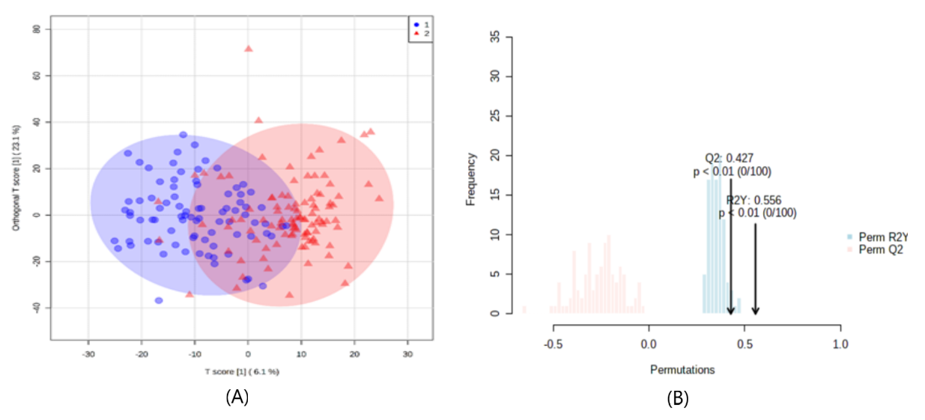
Supplementary Figure 5. OPLS-DA between sub-elite group and elite group using MetaboAnalyst.

Supplementary Tables
Supplementary Table 1 ¹H NMR assignments for serum metabolites in swimmers
No. | metabolites | moieties | δ 1H (ppm) and multiplicityª
1 | Valine | αCH | 3.62(d)
 |  | βCH | 2.28(m)
 |  | γCH₃ | 1.05(d)
 |  | γ′CH₃ | 0.99 (d)
 |  | COOH
2 | Isoleucine | αCH | 3.67(d)
 |  | βCH | 1.98(m)
 |  | γCH₂ | 1.47(m)
 |  | γCH₂' | 1.25(m)
 |  | γ′CH₃ | 1.01(d)
 |  | δCH₃ | 0.94 (t)
 |  | COOH
3 | Leucine | αCH | 3.74(d)
 |  | βCH₂ | 1.71(m)
 |  | γCH | 1.69(m)
 |  | δCH₃ | 0.97(d)
 |  | δ′CH₃ | 0.96(d)
 |  | COOH
4 | 3-Hydroxybutytrate | αCH | 2.31(dd)
 |  | αCH' | 2.41(dd)
 |  | βCH₂ | 4.16(m)
 |  | γCH₃ | 1.20(d)
5 | Lactate | αCH | 4.12(q)
 |  | βCH3 | 1.33(d)
 |  | COOH
6 | Threonine | αCH | 3.59(d)
 |  | βCH₂ | 4.26(m)
 |  | γCH₃ | 1.33(d)
 |  | COOH
7 | Alanine | αCH | 3.78(q)
 |  | βCH₃ | 1.48(d)
 |  | COOH
8 | Lysine | αCH | 3.76(t)
 |  | βCH₂ | 1.90(m)
 |  | γCH₂ | 1.46(m)
 |  | δCH₂ | 1.71(m)
 |  | CH₂ | 3.01(t)
 |  | COOH
9 | Arginine | αCH | 3.78(t)
 |  | βCH₂ | 1.92(m)
 |  | γCH₂ | 1.68(m)
 |  | δCH₂ | 3.24(t)
 |  | COOH
10 | Acetate | CH₃ | 1.92(s)
 |  | COOH
11 | Glutamine | αCH | 3.77(t)
 |  | βCH₂ | 2.14(m)
 |  | γCH₂ | 2.46(m)
 |  | COOH
 |  | CO
12 | Citrate | CH₂ | 2.53(d)
 |  | CH₂' | 2.68(d)
 |  | C-OH
 |  | COOH
 |  | COOH
13 | β-Glucose | 1-CH | 4.65(d)
 |  | 2-CH | 3.26(dd)
 |  | 3-CH | 3.50(dd)
 |  | 4-CH | 3.40(dd)
 |  | 5-CH | 3.47(dd)
 |  | 6-CH | 3.74(dd)
 |  | 6′-CH | 3.90(dd)
14 | α-Glucose | 1-CH | 5.24(d)
 |  | 2-CH | 3.54(dd)
 |  | 3-CH | 3.73(dd)
 |  | 4-CH | 3.42(dd)
 |  | 5-CH | 3.83(dd)
 |  | 6-CH₂ | 3.83(dd)
15 | N-Acetylated Glycoproteins (NAG) | CH₃ | 2.04(s)
16 | Tyrosine | 3 or 5-CH | 6.90(d)
 |  | 2 or 6-CH | 7.19(d)
 |  | αCH | 3.94(dd)
 |  | β′CH₂ | 3.20(dd)
 |  | βCH₂ | 3.07(dd)
 |  | C(ring)
 |  | C-OH(ring)
 |  | COOH
17 | Histidine | 4-CH | 7.06(s)
 |  | 2-CH | 7.79(s)
18 | Phenylalanine | 2 or 6-CH | 7.33(dd)
 |  | 3 or 5-CH | 7.43(dd)
 |  | 4-CH | 7.37(m)
 |  | βCH₂ | 3.12(dd)
 |  | β′CH₂ | 3.25(dd)
 |  | αCH | 3.98(dd)
 |  | COOH
19 | Glycine | CH₂ | 3.56(s)
 |  | COOH
20 | Choline | N(CH₃)₃ | 3.20(s)
 |  | N-CH₂ | 3.52(m)
 |  | O-CH₂ | 4.07(m)
21 | Phosphocholine | N(CH₃)₃ | 3.21(s)
 |  | N-CH₂ | 3.59(m)
 |  | O-CH₂ | 4.17(m)
22 | Acetone | CH₃ | 2.23(s)
23 | Creatinine | CH₃ | 3.05(s)
 |  | CH₂ | 4.06(s)
 |  | C=NH
 |  | COOH
24 | Asparagine | βCH₂ | 2.86(dd)
 |  | βCH₂' | 2.95(dd)
 |  | αCH | 4.00(dd)
 |  | COOH
25 | Pyruvate | CH₃ | 2.37(s)
26 | Acetoacetate | CH₃ | 2.28(s)
 |  | CH2 | 3.43(s)
27 | Glycerophosphocholine | N(CH₃)₃ | 3.23(s)
 |  | N-CH₂ | 3.66(m)
 |  | O-CH₂ | 4.32(m)
28 | Betaine | N(CH₃)₃ | 3.27(s)
 |  | OCH₂ | 3.90(s)
29 | Glutamate | αCH | 3.76(t)
 |  | βCH₂ | 2.08(m)
 |  | γCH₂ | 2.35(m)
 |  | COOH
30 | Methanol | CH₃ | 3.36(s)
31 | HDL |  | 0.86(brs)
32 | LDL |  | 0.88(brs)
33 | VLDL |  | 0.90(brs)
34 | Lipids |  | 1.59(brs)
35 | Lipid (Unsatured Fatty Acids) |  | 2.00(brs)
36 | Unsatured Fatty Acids |  | 5.30(brs)
keys for multiplicity in parenthesis: s, singlet; d, doublet; t, triplet; q, quartet; m, multiplet; dd, doublet of doublet; brs, broad singlet.

Supplementary Table 2 36 serum metabolites between elite and sub-elite level swimmers in total, male and female
Metabolites | Elite level swimmers vs.Sub-elite level swimmers
 | Fold (Elite/Sub-elite,Total) | P value | Fold (Elite/Sub-elite,Male) | P value | Fold (Elite/Sub-elite,Female) | P value
Valine | 0.942 | 8.06E-02 | 0.937 | 1.30E-02 | 0.975 | 3.79E-01
Isoleucine | 0.923 | 8.89E-04 | 0.894 | 2.24E-04 | 0.971 | 3.66E-01
Leucine | 0.963 | 5.70E-02 | 0.947 | 2.32E-01 | 0.992 | 7.70E-01
3-hydroxybutyric acid | 0.904 | 3.22E-02 | 0.946 | 2.05E-01 | 0.826 | 2.40E-02
Lactic acid | 1.123 | 3.39E-04 | 1.053 | 4.40E-02 | 1.195 | 4.89E-04
Threonine | 0.975 | 4.48E-01 | 0.981 | 6.02E-01 | 0.969 | 2.07E-01
Alanine | 1.010 | 7.05E-01 | 0.976 | 4.55E-01 | 1.076 | 1.18E-01
Lysine | 1.015 | 4.18E-01 | 1.028 | 2.55E-01 | 1.016 | 5.25E-01
Arginine | 0.967 | 1.14E-01 | 0.969 | 2.33E-01 | 0.996 | 8.87E-01
Acetate | 0.964 | 1.28E-01 | 0.978 | 2.77E-01 | 0.968 | 1.82E-01
Glutamine | 0.936 | 2.44E-05 | 0.929 | 1.15E-04 | 0.955 | 5.90E-02
Citrate | 0.976 | 2.30E-01 | 0.955 | 1.75E-01 | 1.010 | 7.32E-01
β-Glucose | 0.967 | 2.57E-01 | 0.961 | 2.18E-01 | 0.975 | 5.76E-01
α-glucose | 0.931 | 4.09E-09 | 0.920 | 4.39E-07 | 0.945 | 4.46E-03
N-Acetylated Glycoproteins | 0.943 | 1.98E-01 | 0.937 | 9.70E-02 | 0.947 | 2.16E-01
Tyrosine | 0.969 | 1.11E-01 | 0.956 | 1.53E-01 | 1.008 | 8.09E-01
Histidine | 0.993 | 6.04E-01 | 0.985 | 4.56E-01 | 1.017 | 4.04E-01
Phenylalanine | 1.010 | 5.38E-01 | 1.006 | 7.85E-01 | 1.034 | 1.84E-01
Glycine | 0.945 | 5.66E-04 | 0.934 | 2.04E-03 | 0.970 | 2.00E-01
Choline | 1.001 | 9.53E-01 | 1.003 | 9.06E-01 | 1.030 | 2.79E-01
Phosphocholine | 1.016 | 4.77E-01 | 1.013 | 6.49E-01 | 1.059 | 7.50E-02
Acetone | 0.886 | 5.52E-02 | 0.924 | 4.02E-01 | 0.847 | 1.21E-01
Creatinine | 1.011 | 5.17E-01 | 1.023 | 2.26E-01 | 1.039 | 1.66E-01
Asparagine | 0.981 | 2.68E-01 | 0.991 | 6.84E-01 | 0.984 | 5.46E-01
Pyruvate | 1.000 | 9.98E-01 | 0.976 | 4.78E-01 | 1.047 | 3.06E-01
Acetoacetate | 0.934 | 2.78E-02 | 0.969 | 3.59E-01 | 0.887 | 7.00E-02
Glycerophosphorylcholine | 1.063 | 8.28E-02 | 0.983 | 6.56E-01 | 1.081 | 1.54E-01
Betaine | 1.016 | 3.66E-01 | 1.002 | 9.07E-01 | 1.071 | 1.17E-01
Glutamate | 1.002 | 9.31E-01 | 0.991 | 6.83E-01 | 1.056 | 8.10E-02
Methanol | 1.292 | 2.97E-04 | 1.213 | 2.50E-02 | 1.451 | 1.37E-03
High-density lipoprotein | 1.123 | 8.63E-04 | 1.101 | 2.60E-02 | 1.148 | 8.00E-03
Low-density lipoprotein | 0.961 | 4.00E-01 | 0.964 | 5.85E-01 | 0.960 | 5.68E-01
Very low-density lipoprotein | 0.965 | 1.33E-01 | 0.954 | 2.21E-01 | 0.971 | 5.55E-01
Lipids | 0.933 | 8.50E-02 | 0.920 | 4.23E-01 | 0.951 | 6.88E-01
Lipid (Unsaturated Fatty Acids) | 0.958 | 2.57E-01 | 0.961 | 1.98E-01 | 0.951 | 2.34E-01
Unsaturated fatty acids | 1.110 | 1.19E-02 | 1.059 | 3.03E-01 | 1.101 | 4.10E-02

