**Supporting Information**

**DMSP production by coral-associated bacteria**

Felicity W.I. Kuek1,2,3,4, Cherie A. Motti1,4*, Jia Zhang3,4, Ira R. Cooke3,4, Jonathan D. Todd5, David J. Miller2,3,4*, David G. Bourne1,6,7*, Jean-Baptiste Raina8*

1AIMS@JCU, James Cook University, Townsville, QLD 4811, Australia.

2ARC Centre of Excellence for Coral Reef Studies, James Cook University, Townsville, QLD 4811, Australia.

3Centre for Tropical Bioinformatics and Molecular Biology, James Cook University, Townsville, QLD 4811, Australia.

4College of Public Health, Medical and Veterinary Sciences, James Cook University, Townsville, QLD 4811, Australia.

5School of Biological Sciences, University of East Anglia, Norwich Research Park, Norwich, United Kingdom

6Australian Institute of Marine Science, Townsville, QLD 4810, Australia.

7College of Science and Engineering, James Cook University, Townsville, QLD 4811, Australia.

8Climate Change Cluster (C3), University of Technology Sydney, Ultimo, NSW 2007, Australia.

* These authors have contributed equally to this work.

**Supplementary Figures**

P1134#yIS1

**Figure S1:** Multiple sequence alignment of DMSP biosynthesis protein DsyB from *Labrenzia aggregata* (Curson et al., 2017) and the DsyB protein amplicons from *dsyB*-positive coral-associated bacteria strains (n=14). The reference protein sequence of *L. aggregata* (AOR83342) is highlighted in blue. Residues that have consensus identity are shaded in black, while conserved substitutions are shaded in grey. Amino acid residues that are conserved across all 15 sequences are marked with asterisks below.

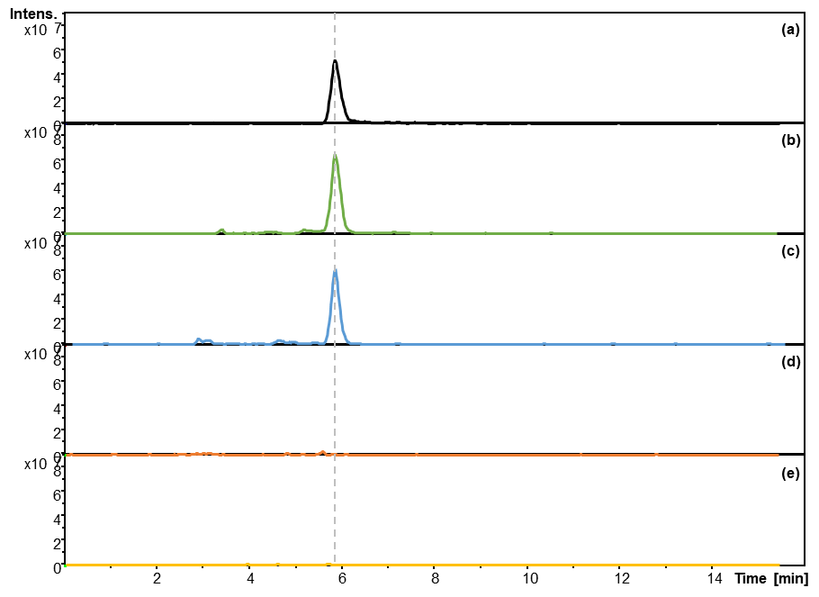

**Figure S2:** An example of LC-MS extracted ion chromatograms (EIC) at 135 *m/z* of (a) a dimethylsulphoniopropionate (DMSP) standard (C5H10O2S; MW=134.197) compared to bacterial extracts of *Shimia* sp. AMM-P-2 cultured in (b) modified minimal basal media (MBM) spiked with DMSP, (c) modified MBM, (d) yeast tryptone sea salts (YTSS) media, and (e) marine broth, demonstrating that DMSP was only produced by the bacterium when cultured in modified MBM. DMSP was not detected in extracts of the bacterium grown in YTSS media or marine broth.

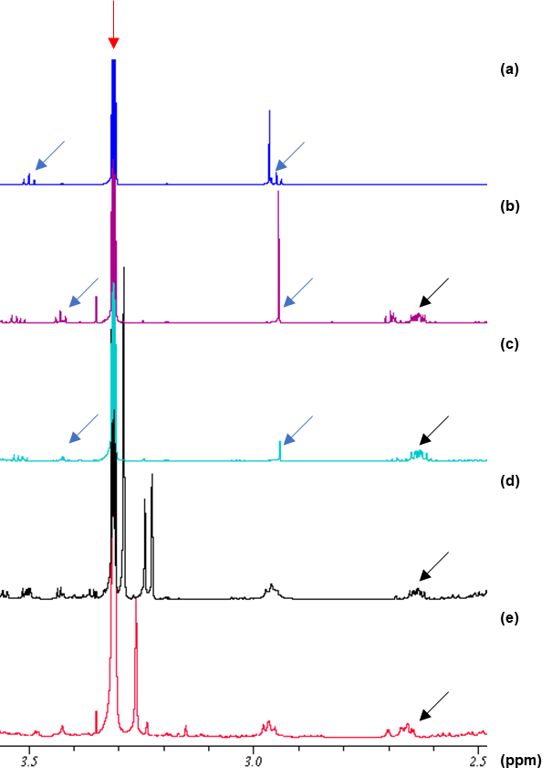

**Figure S3:** An example of 1H NMR spectra of: (a) 4mM dimethylsulphoniopropionate (DMSP) standard in deuterated methanol (CD3OD) compared to bacterial extracts of *Shimia* sp. AMM-P-2 cultured in (b) modified minimal basal media (MBM) spiked with DMSP, (c) modified MBM, (d) yeast tryptone sea salts (YTSS) media, and (e) marine broth, demonstrating that DMSP was only produced by the bacterium when cultured in modified MBM. The spectra of bacterial extracts were referenced to the CD3OD signal (red arrow) and normalised to the signal at 2.65 ppm (black arrows), with blue arrows showing the position of DMSP signals (singlet at δH ~2.95 ppm and triplet at δH ~3.45 ppm). DMSP spiking was done to confirm the shift in DMSP signals in the bacterial extract. DMSP was not detected in extracts of the bacterium grown in YTSS media or marine broth.

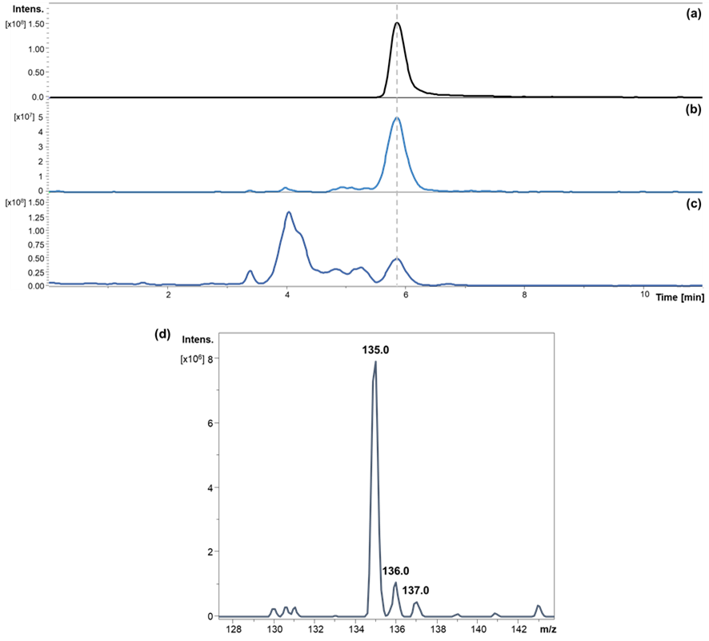

**Figure S4:** Detection of dimethylsulphoniopropionate (DMSP) in the *dsyB*-positive *Shimia* sp. AMM-P-2 (a) DMSP standard (C5H10O2S; MW=134.197) - extracted ion chromatogram (EIC) of the [M+H]+ ion = 135 *m/z* , and (b) EIC 135 *m/z* of the *Shimia* sp. AMM-P-2 extract*,* (c) the corresponding base peak chromatogram showing signal resolution, and (d) expanded region of the EIC 135 *m/z* at retention time 5.9 min. LC-MS confirms the production of DMSP by *Shimia* sp.

P1236#yIS1

**Figure S5:** 1H-1H COSY spectrum of a *Shimia* bacterium (isolate AMM-P-2) extract, cultured in methionine enriched minimal basal medium (MBM), run in CD3OD. The correlation between the two methylene groups (δH 3.45 - δH 2.70) is annotated in blue.

P1241#yIS1

**Figure S6:** 1H-13C HMBC spectrum of a *Shimia* bacterium (isolate AMM-P-2) extract, cultured in methionine enriched minimal basal medium (MBM) run in CD3OD. Observed correlations for DMSP are annotated in blue.

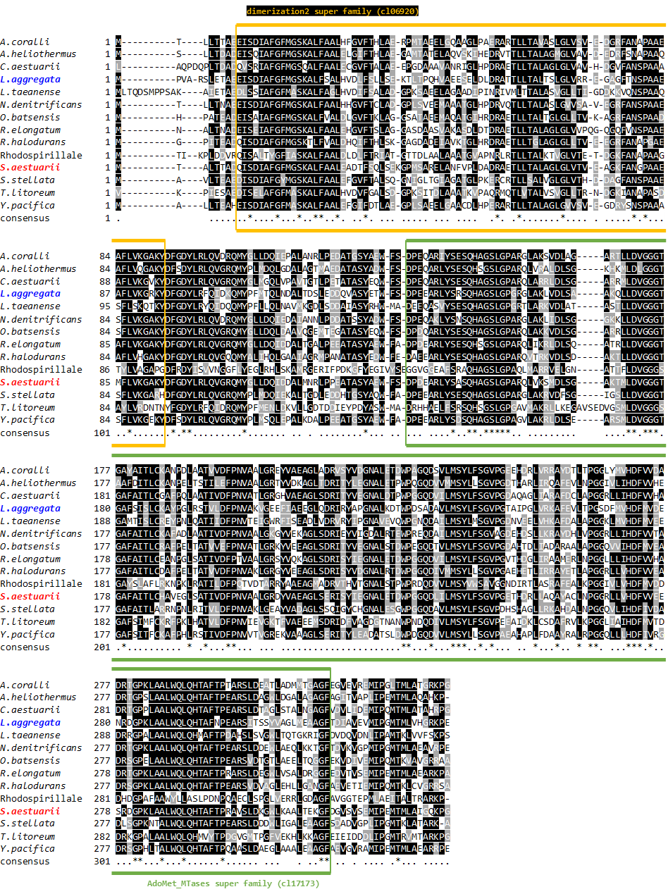

**Figure S7:** Multiple sequence alignment of DsyB homologues from different Alphaproteobacteria (n=14) representing the diversity of this protein family. Residues that are identical are shaded in black, while conserved substitutions are shaded in grey. Amino acid residues that are conserved across all 14 sequences are marked with asterisks below. The reference strain *Labrenzia aggregata* LZB033 and the *Shimia aestuarii* AMM-P-2 isolate are highlighted in blue and red, respectively. Conserved domains that were found within the protein are indicated with a yellow and green box, which represent the S-adenosylmethionine-dependent methyltransferases class I superfamily (cl17173) and dimerization2 superfamily (cl06920), respectively.

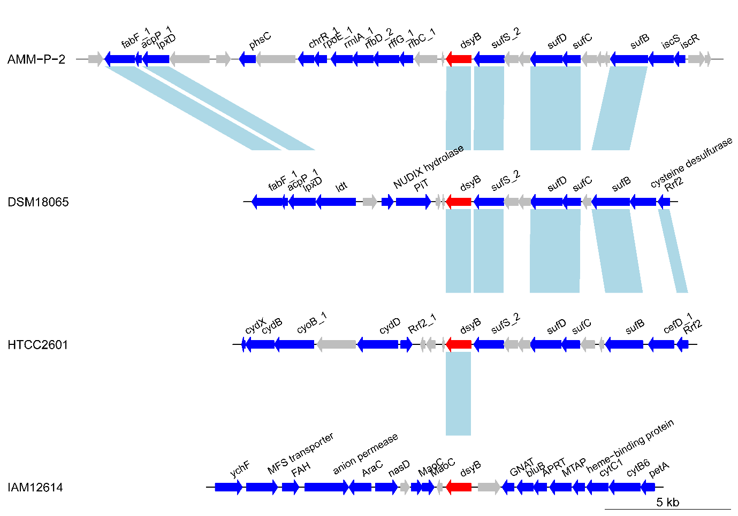

**Figure S8:** Microsynteny plot showing gene arrangement in four *dsyB*-containing bacteria. Bacteria are labelled according to taxonomic codes as follows: AMM-P-2, *Shimia aestuari*; DSM18065, *Pseudooceanicola nanhaiensis*; HTCC2601, *Pelagibaca bermudensis*; IAM12614, *Labrenzia aggregata*. Relationships between orthologous genes are shown in light blue bars. Genes with unknown function (hypothetical protein) are shown in grey arrows. The *dsyB* gene is shown in red arrows, while predicted genes are shown in dark blue arrows, and are denoted as follows: *fabF*, 3-oxoacyl-[acyl-carrier-protein] synthase II; *acpP*, acyl carrier protein; *lpxD*, UDP-3-O-acylglucosamine N-acyltransferase; *phsC*, thiosulphate reductase cytochrome B subunit; *chrR*, anti-sigma-E factor; *rpoE*, ECF RNA polymerase sigma factor; *rmlA*, glucose-1-phosphate thymidylyltransferase; *rfbD*, dTDP-4-dehydrorhamnose reductase; *rffG*, dTDP-glucose 4,6-dehydratase 2; *rfbC*, dTDP-4-dehydrorhamnose 3,5-epimerase; *dsyB*, 2-hydroxy-4-(methylsulphanyl)butanoate S-methyltransferase; *sufS*, cysteine desulphurase; *sufD*, Fe-S cluster assembly protein; *sufC*, Fe-S cluster assembly ATP-binding protein; *sufB*, Fe-S cluster assembly protein; *iscS*, cysteine desulphurase; *iscR*, HTH-type transcriptional regulator; *ldt*, L-2CD-transpeptidase family protein; *PiT*, inorganic phosphate transporter; *rrf2*, Rrf2 family transcriptional regulator; *cydX*, cytochrome bd-I oxidase subunit; *cydB*, cytochrome d ubiquinol oxidase subunit II; *cyoB*, cytochrome ubiquinol oxidase subunit I; cydD, thiol reductant ABC exporter subunit; *cefD*, aminotransferase class V-fold PLP-dependent enzyme; *ychF*, redox-regulated ATPase; FAH, fumarylacetoacetate hydrolase family protein; *araC*, AraC family transcriptional regulator; *nasD*, NAD(P)-dependent oxidoreductase; *maoC*, MaoC family dehydratase; *gnat*, GNAT family N-acetyltransferase; *bluB*, 5,6-dimethylbenzimidazole synthase; *aprt*, adenine phosphoribosyltransferase; *mtap*, S-methyl-5'-thioadenosine phosphorylase; *cytC*, cytochrome c1; *cytB*, cytochrome b/b6; *petA*, ubiquinol-cytochrome c reductase iron-sulphur subunit.