Supplementary Material

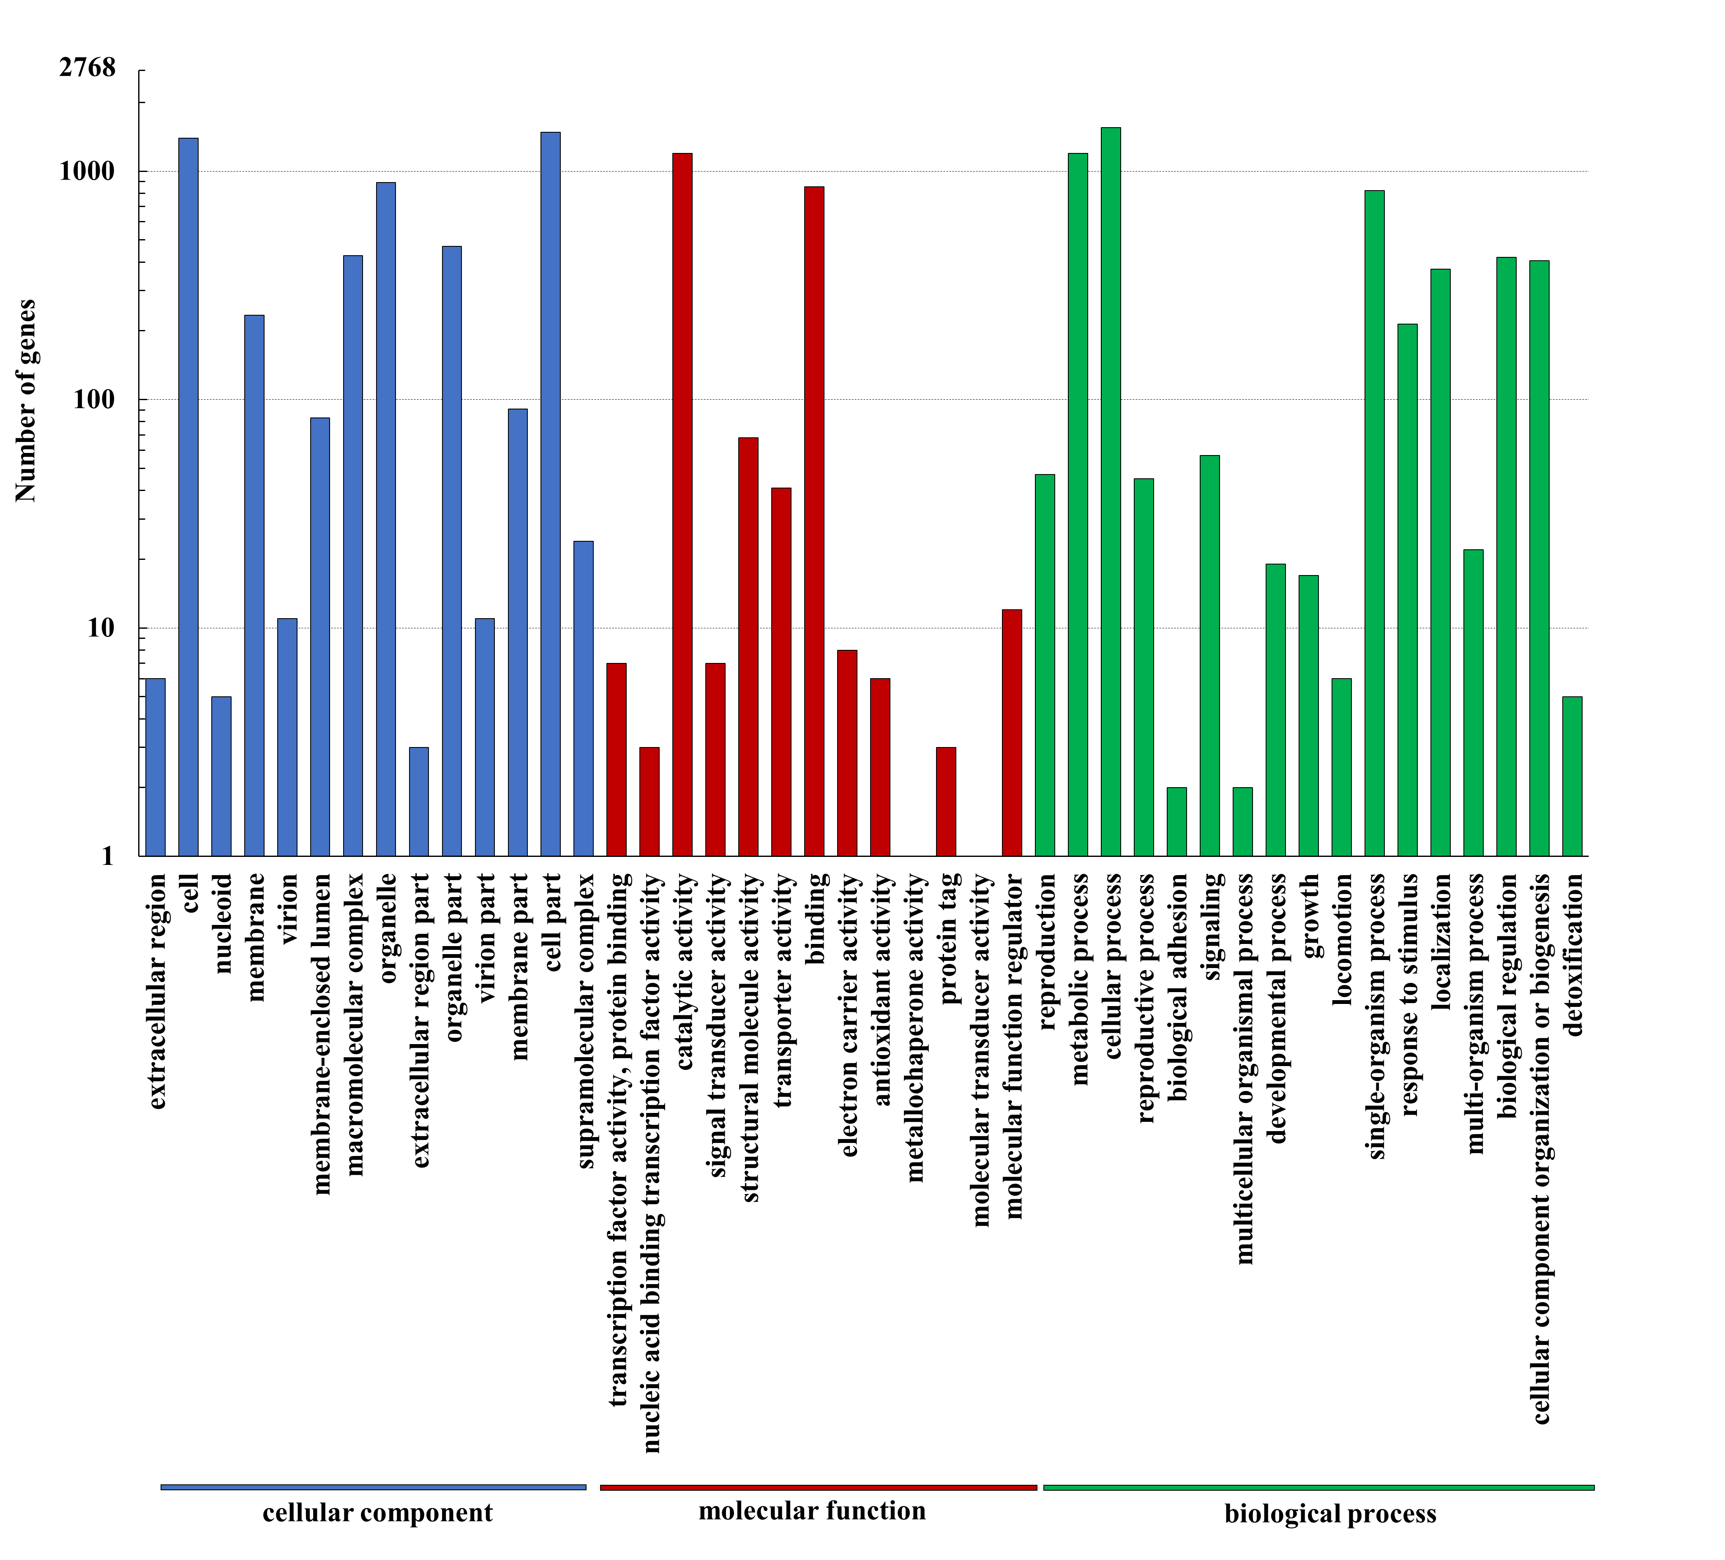
Figure S1. Gene ontology (GO) enrichment analysis of ATCC 26185 transcriptome. The columns indicate the number of identified genes. All genes were classified into three groups: cellular component, molecular function, and biological process.
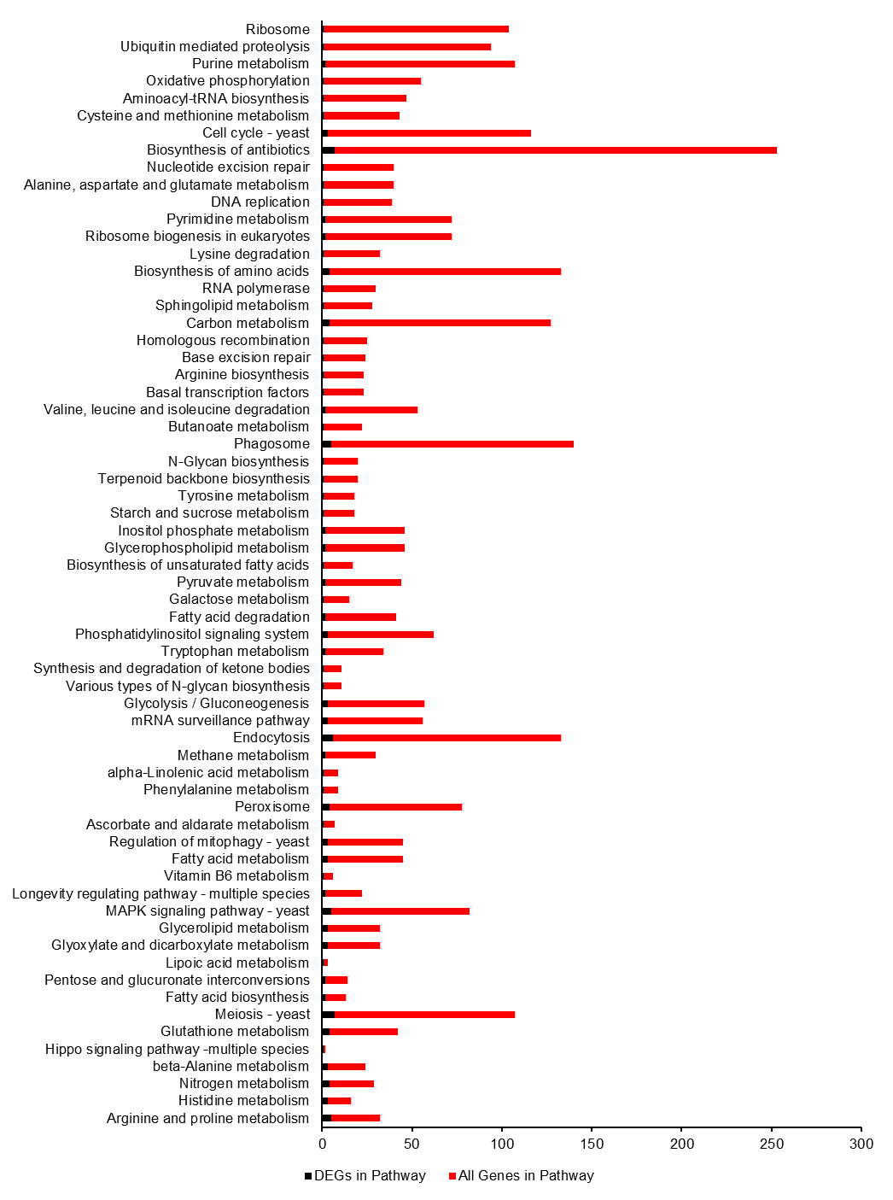
Figure S2. Different Expression Unigene KEGG Enrichment Analysis. No significantly (FDR ≤ 0.01) enriched KEGG pathways were detected.
Figure S3. Time course of biomass, squalene concentration and yield during the cultivation of ATCC 26185 strain in optimal medium containing: (A) 0 g/L NaCl and (B) 5 g/L NaCl.

Table S1. Culture conditions for the experiments performed under the OFAT and orthogonal experimental designs.
Experiment | Variable | Culture condition
Single-factor experiments
Growth conditions | Single-factor:  (1) cultivation time:  1 d, 2 d, 3 d, 4 d, 5 d, 6 d, 7 d, 8 d  (2) cultivation temperature:  18 ℃, 23 ℃, 28 ℃, 33 ℃ | SQU medium:30 g glucose, 2 g yeast extract, 2 g monosodium glutamate, 0.2 g (NH₄)₂SO4, 0.3 g KH₂PO₄, 25 g NaCl, 1 g KCl, 5 g MgSO₄•7H₂O, 0.1 g NaHCO₃, 0.3 g CaCl₂, 2.9 mg FeCl₃•6H₂O, 0.02 mg CuSO₄•5H₂O, 0.26 mg CoCl•6H₂O, 0.6 mg ZnSO₄•7H₂O, 8.6 mg MnSO₄•H₂O, 1000 mL H₂O.  Temperature: (1) 28 ℃  Rotating rate: 170 rpm  Seed age: 2 days  Inoculum size: 10%  Cultivation time: 3 days
Carbon source | Single-factor:  1. glucose  2. fructose  3. sucrose  4. glycerol  5. lactose  6. corn starch  concentration: 30 g/L  Optimal level:  glucose: 10-50 g/L | Medium: 2 g yeast extract, 2 g monosodium glutamate, 0.2 g (NH₄)₂SO₄, 0.3 g KH₂PO₄, 25 g NaCl, 1 g KCl, 5 g MgSO₄•7H₂O, 0.1 g NaHCO₃, 0.3 g CaCl₂, 2.9mg FeCl₃•6H₂O, 0.02 mg CuSO₄•5H₂O, 0.26 mg CoCl•6H₂O, 0.6 mg ZnSO₄•7H₂O, 8.6 mg MnSO₄•H₂O, 1000 mL H₂O.  Temperature: 28 ℃  Rotating rate: 170 rpm  Seed age: 2 days  Inoculum size: 10%  Cultivation time: 3 days
Nitrogen source | Single-factor:  1. yeast extract  2. tryptone  3. peptone  4. ammonium sulfate  5. sodium nitrate  6. monosodium glutamate (MSG)  7. urea  concentration: 5 g/L  Optimal level:  Yeast extract: 5-30 g/L | Medium: 30 g glucose, 0.3 g KH₂PO₄, 25 g NaCl, 1 g KCl, 5 g MgSO₄•7H₂O, 0.1 g NaHCO₃, 0.3 g CaCl₂, 2.9 mg FeCl₃•6H₂O, 0.02 mg CuSO₄•5H₂O, 0.26 mg CoCl•6H₂O, 0.6 mg ZnSO₄•7H₂O, 8.6 mg MnSO₄•H₂O, 1000 mL H₂O.  Temperature: 28 ℃  Rotating rate: 170 rpm  Seed age: 2 days  Inoculum size: 10 %  Cultivation time: 3 days
NaCl concentration | Concentration:  0-30 g/L | Medium:30 g glucose, 5 g yeast extract, 0.3 g KH₂PO₄, 1 g KCl, 5 g MgSO₄•7H₂O, 0.1 g NaHCO₃, 0.3 g CaCl₂, 2.9 mg FeCl₃•6H₂O, 0.02 mg CuSO₄•5H₂O, 0.26 mg CoCl•6H₂O, 0.6 mg ZnSO₄•7H₂O, 8.6 mg MnSO₄•H₂O, 1000 ml H₂O.  Temperature:28 ℃  Rotating rate: 170 rpm  Seed age: 2 days  Inoculum size: 10 %  Cultivation time:3 days
Orthogonal Experimental Design
Major factor | glucose:25-35 g/L  yeast extract: 2.5-7.5 g/L  NaCl: 2.5-7.5 g/L | Medium: 0.3 g KH₂PO₄, 1 g KCl, 5 g MgSO₄•7H₂O, 0.1 g NaHCO₃, 0.3 g CaCl₂, 2.9 mg FeCl₃•6H₂O, 0.02 mg CuSO₄•5H₂O, 0.26 mg CoCl•6H₂O, 0.6 mg ZnSO₄•7H₂O, 8.6 mg MnSO₄•H₂O, 1000 mL H₂O.  Temperature:28 ℃  Rotating rate: 170 rpm  Seed age: 2 days  Inoculum size: 10%  Cultivation time: 3 days

Table S2. Length distribution of assembled transcripts and unigenes.
Length Range (bp) | Transcripts | Unigenes
200-300 | 4848 (15.90 %) | 4298 (18.79 %)
300-500 | 4729 (15.51 %) | 3787 (16.56 %)
500-1000 | 6449 (21.15 %) | 4817 (21.06 %)
1000-2000 | 8027 (26.33 %) | 5695 (24.90 %)
>2000 | 6436 (21.11 %) | 4272 (18.68 %)
Total Number (bp) | 30,490 | 22,869
Total Length (bp) | 41,489,354 | 28,680,721
N50 Length (bp) | 2140 | 2014
Mean Length (bp) | 1360.75 | 1254.13

Table S3. Mean value analysis of the orthogonal experimental results.
Levels | Factors
 | Glucose | Yeast extract | NaCl
1 | 283.38 | 341.49 | 285.81
2 | 397.42 | 288.62 | 353.62
3 | 262.18 | 312.89 | 303.56
*The values represent the concentration of squalene in mg/L.

