Supplemental Text S4. An example about unFEPG algorithm.
We took a subgraph in Figure 2 as an example to describe the flow of the unFEPG algorithm and the frequent subgraphs obtained. This subgraph was shown in Figure 1 below. Specific process was shown in Figure 2 below.
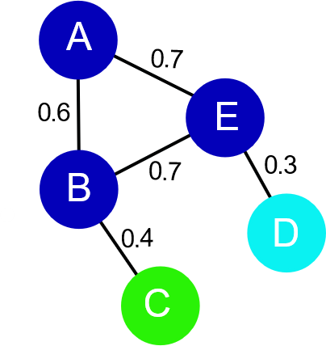
Fig. 1. A graph. The node includes {A, B, C, D, E}. The value of edge represents the probability value of each edge..
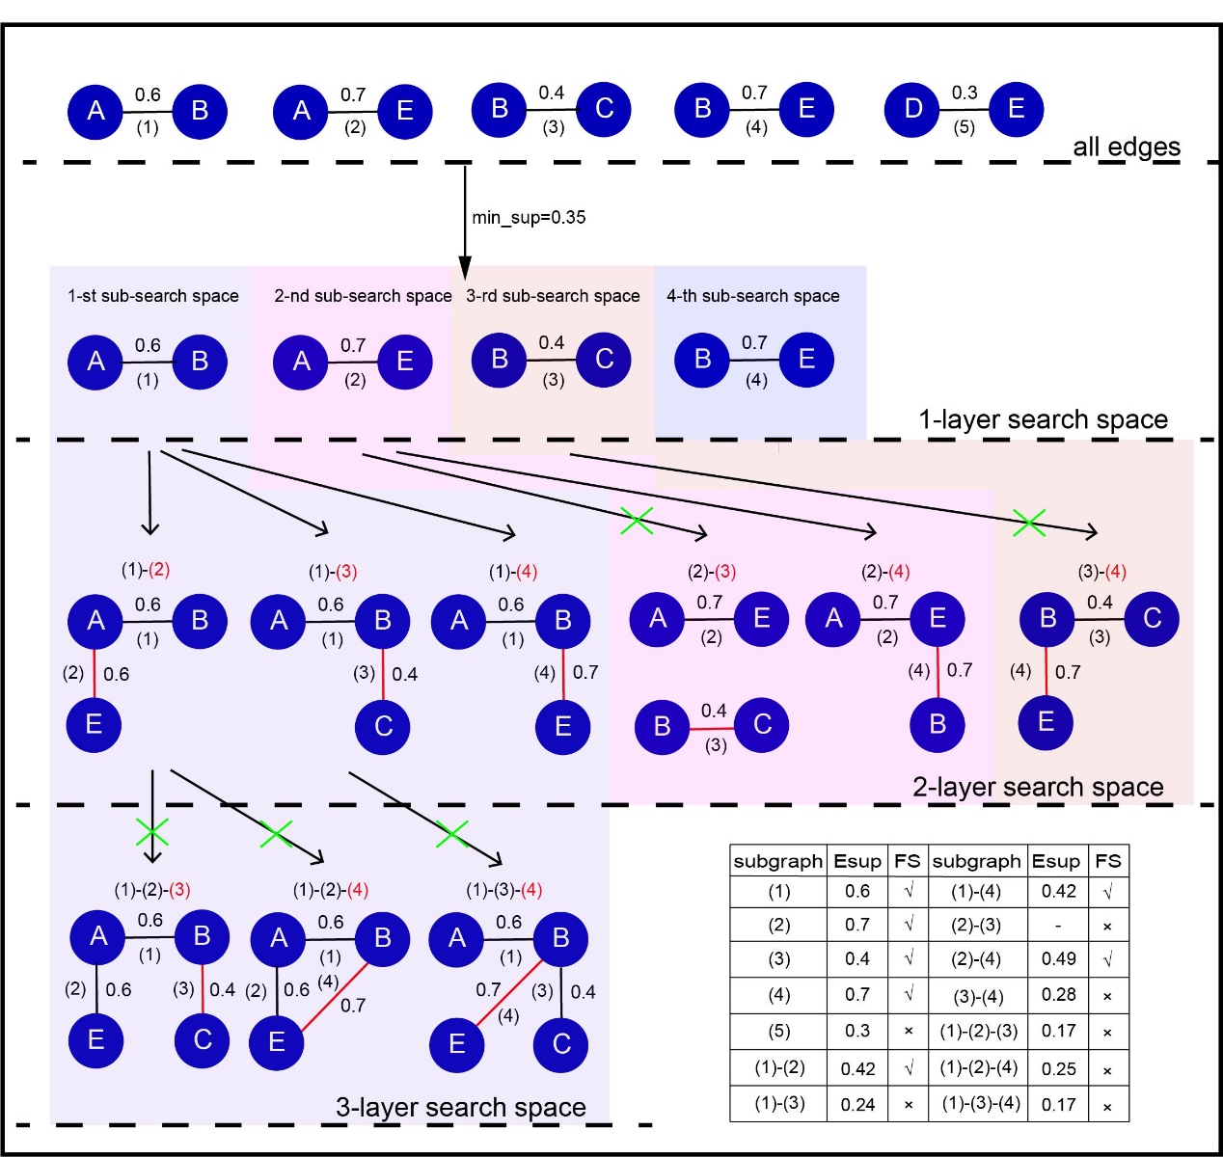
Fig. 2. Specific process about unFEPG algorithm. The min_sup represents minimum support degree. FS represents frequent subgraph. Esup represents the expected support degree in the subgraph. The (i) (i=1,2,...,5) represents edge label. Red edges represent frequent edges added on the basis of previous subgraph pattern set. The ‘×’ represents this subgraph iss not a frequent subgraph and is pruned. Different colored backgrounds indicate different sub-search spaces. A subgraph of one edge is a 1-layer search space. A subgraph of two edges is a 2-layer search space. A subgraph of three edges is a 3-layer search space.

