Supplementary Material

Bimetallic Cobalt-Copper Nanoparticles Decorated Hollow Carbon Nanofibers for Efficient CO₂ Electroreduction

Congyi He, Siyu Wang, Xingxing Jiang, Qi Hu, Hengpan Yang*, Chuanxin He*

Shenzhen Key Laboratory for Functional Polymer, College of Chemistry and Environmental Engineering, Shenzhen University, Shenzhen, Guangdong, 518060, China

* Corresponding Authors:
Dr. Hengpan Yang, E-mail: hpyang@szu.edu.cn
Prof. Chuanxin He, E-mail: hecx@szu.edu.cn

Contents:
Supplementary Figures 1 to 13
Supplementary Tables 1

- Materials and Characterizations
All reagents were used as received.
Linear sweep voltammograms (LSV), double-layer capacitance (C_{dl}), electrochemical impedance spectroscopy (EIS) and potentiostatic electrolysis were recorded using a CHI 660C electrochemical Station (Shanghai Chenhua Instruments Company). Liquid phase products were resolved by ¹H-NMR spectra recorded on an Ascend 400 (500 MHz, Bruker, Germany) spectrometer. Gas phase products were resolved by Gas Chromatography (Shimadzu, GC-2014c) with a flame ionization detector (FID) and a thermal conductivity detector (TCD).
The micromorphology was characterized by a field emission scanning electron microscope (FE-SEM, FEI JEOL-7800F). The crystalline structure and element mapping were obtained using transmission electron microscopy (TEM) and high-resolution TEM (HR-TEM) images and element mapping analysis using JEM-2100F field emission electron microscope. The metal amount in as-synthesized catalyst were detected by inductively coupled plasma-optical emission spectrometry (ICP-OES, OPTIMA2100DV). N₂ adsorption/desorption curves were achieved by a specific surface and porosity analyzer (Micromeritics ASAP 2460) and calculated using the Brunauer-Emmett-Teller (BET) equation. X-ray diffraction (XRD) patterns were recorded with an X-ray powder diffractometer (Rigaku MiniFlex 600) with Cu Kα radiation (k= 1.5406 Å). Raman spectra were acquired with a laser Raman spectrometer (LabRAM HR Evolution, HORBIA FRANCE SAS) with a 633 nm laser excitation. X-ray photoelectron spectra (XPS) were recorded on an X-ray photoelectron spectrometer (ThermoVG Scientific ESCALAB 250) with Al Kα X-ray as the source.
- Synthesis of Catalysts and CO₂ Reduction
  - Synthesis of five samples
All the five samples in this manuscript were prepared by electrospinning technology. The preparation steps are as follows: 7 mL of N, N-dimethylformamide, 0.5 g polyacrylonitrile (PAN) and 0.75 g ZIF-8 nanoparticles were put into a beaker and stirred until they were evenly mixed into a white viscous solution. Then, 0.2183 g of Co(NO₃)₂·6H₂O (0.00075 mol) and 0.061 g of Cu(NO₃)₂·3H₂O (0.00025 mol) were added, and kept stirring for at least 20 hours until fully mixed to obtain a purple viscous spinning precursor solution. This precursor solution was injected into the syringe and electrospun to polymer fibers. After spinning, the polymer fibers were put into vacuum drying oven at 60 ℃for at least 12 hours, and the dried polymer fiber were pre-oxidized in a muffle furnace. Then those pre-oxidized fibers were carbonized in nitrogen atmosphere. The initial temperature was set at 25 ℃, raised to 900 ℃ at the rate of 5 ℃/min, and kept for another 2 hours. The as-synthesized catalyst is named as Co₃Cu/CFs.
Another four catalysts with different metal ratio can be obtained by changing the molar ratio of metal precursors Co(NO₃)₂·6H₂O and Cu(NO₃)₂·3H₂O, including 1/0, 1/1, 1/3, and 0/1. The as-prepared samples were named as Co/CFs, CoCu/CFs, CoCu₃/CFs and Cu/CFs.
  - CO₂ Reduction Procedure
Linear sweep voltammograms, double-layer capacitance, electrochemical impedance spectroscopy and potentiostatic electrolysis were conducted in a in typical H-type electrochemical cell separated by an anion exchange membrane between cathode and anode compartment, with a platinum mesh as the counter electrode and an Ag/AgCl as reference electrode in 0.5 M KHCO₃ solution. The CO₂ or N₂ gas was A specific volume of the catalyst (Co₃Cu/CFs, Co/CFs, CoCu/CFs, CoCu₃/CFs and Cu/CFs) ink was then drop-casted on carbon paper (SGL Carbon Corporate) electrode to acquire an 0.5 mg cm⁻² loading amount and then dried at room temperature. This carbon paper would be used as the working cathode for CO₂ electrolysis. The catalyst ink was prepared via the following steps: specific amount catalyst powder (Co₃Cu/CFs, Co/CFs, CoCu/CFs, CoCu₃/CFs and Cu/CFs) was put into a mixture solution of 110 µL of Nafion solution (5 wt%, Dupond) and 890 µL of ethanol. The mixed solution was sonicated for 30 min to get a highly dispersed ink.
The original potentials measured in this manuscript were converted to the reversible hydrogen electrode (RHE) via the Nernst equation:
$$E\left(RHE\right)=E\left(Ag/AgCl\right)+0.199+0.059× pH (1)$$
Product from CO₂ reduction were analysed at various cathodic potentials with a fixed time of 15 minutes, and the gaseous components were directly injected into gas chromatography. The liquid-phase products were detected via ¹H NMR spectra. The faraday efficiencies of products were calculated via the following equation. Q is the total charge transferred through the working electrode at different potentials. m is the number of electrons transferred, which is 2 for HCOOH, CO and H₂, 4 for CH₄. n is the mole numbers of products, and F is the Faradaic constant (96,485 C mol⁻¹).
$$FE=\frac{Q_{product}}{Q_{total}}=\frac{m×n×F}{Q_{total}} (2)$$

- Characterizations of catalysts
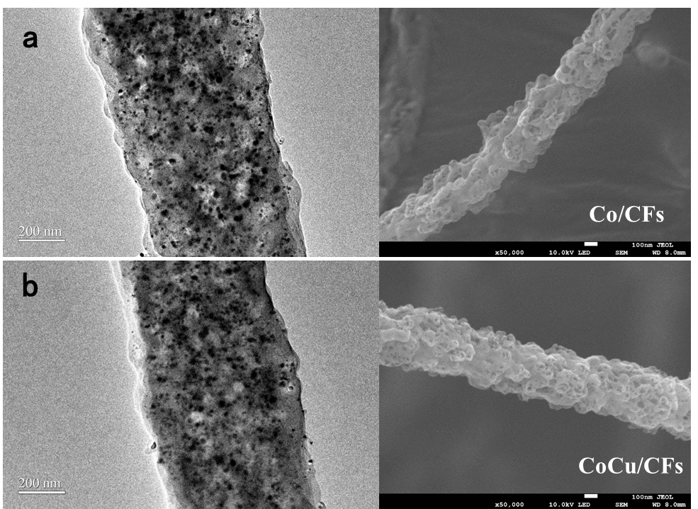
Supplementary Figure 1. TEM and SEM images of Co/CFs (a) and CoCu/CFs (b).

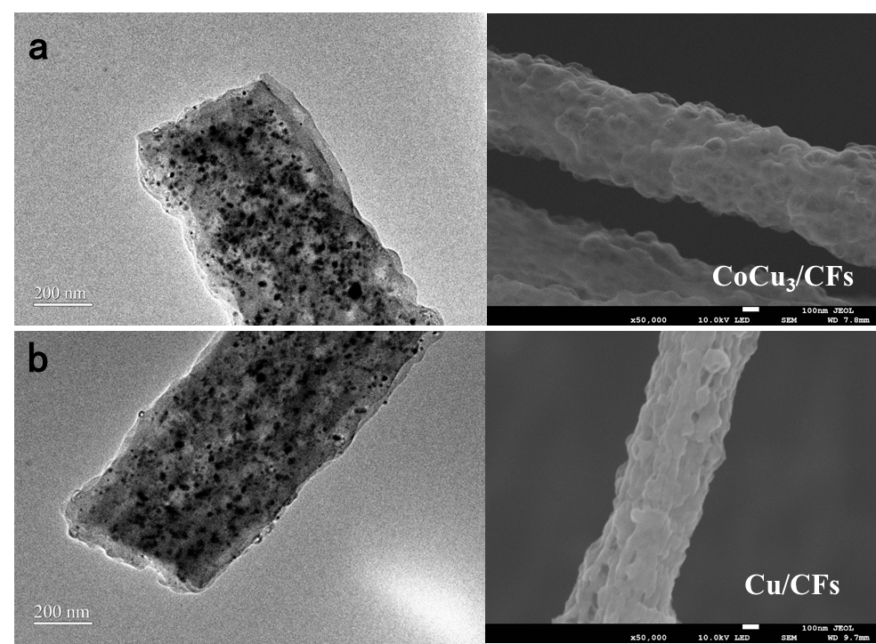
Supplementary Figure 2. TEM and SEM images of CoCu₃/CFs (a) and Cu/CFs (b).

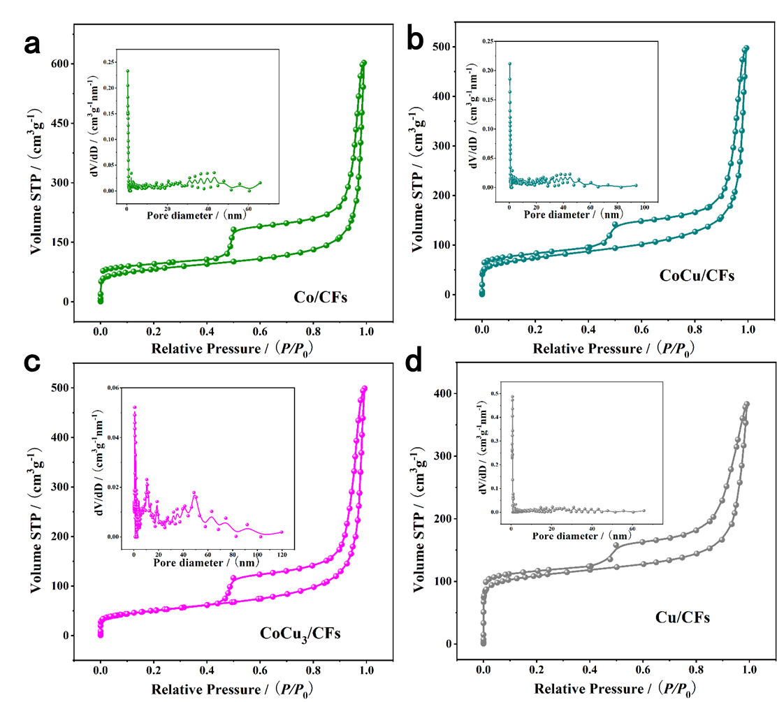
Supplementary Figure 3. N₂ sorption isotherms and pore size distributions of Co/CFs (a), CoCu/CFs (b), CoCu₃/CFs (c) and Cu/CFs (d), respectively.

Table S1 BET data of various catalysts.
Sample | Total pore volume / cm³ g⁻¹ | Specific surface area / m² g⁻¹
Co/CFs | 0.7155 | 265
Co₃Cu/CFs | 0.9176 | 292
CoCu/CFs | 0.7359 | 261
CoCu₃/CFs | 0.7336 | 181
Cu/CFs | 0.7085 | 178

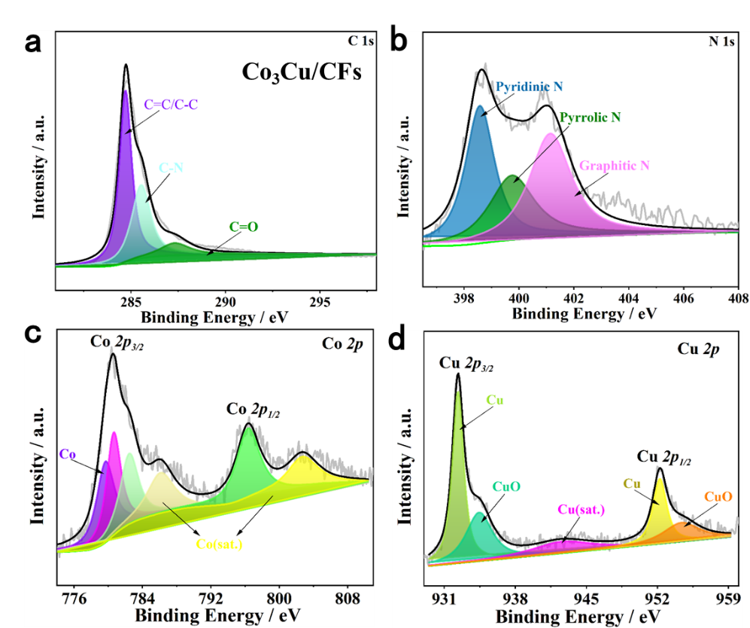
Supplementary Figure 4. C 1s (a), N 1s (b), Co 2p (c) and Cu 2p (d) XPS spectra of Co₃Cu/CFs.

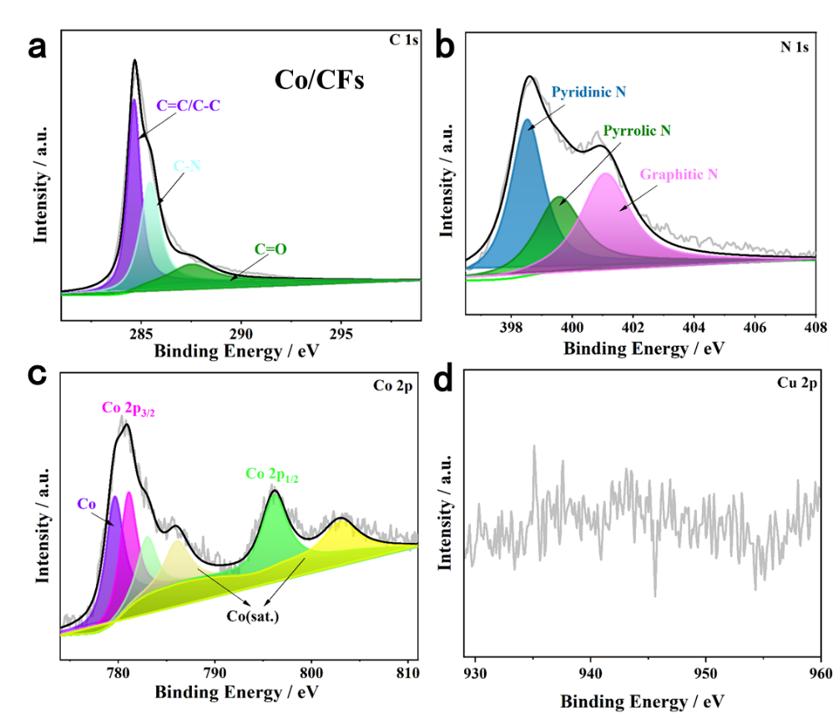
Supplementary Figure 5. C 1s (a), N 1s (b), Co 2p (c) and Cu 2p (d) XPS spectra of Co/CFs.
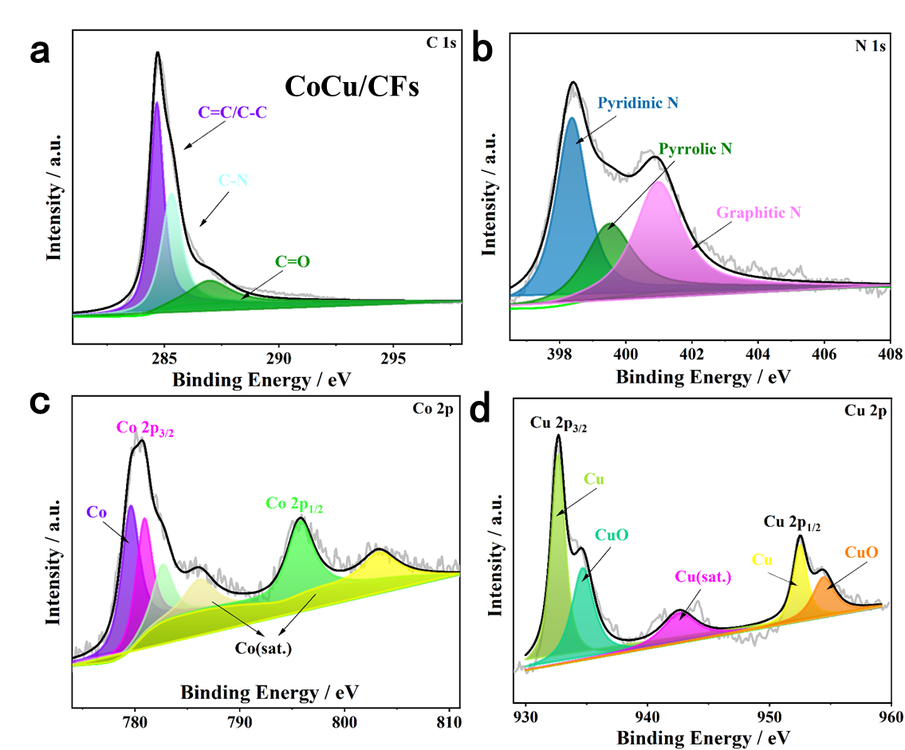
Supplementary Figure 6. C 1s (a), N 1s (b), Co 2p (c) and Cu 2p (d) XPS spectra of CoCu/CFs.
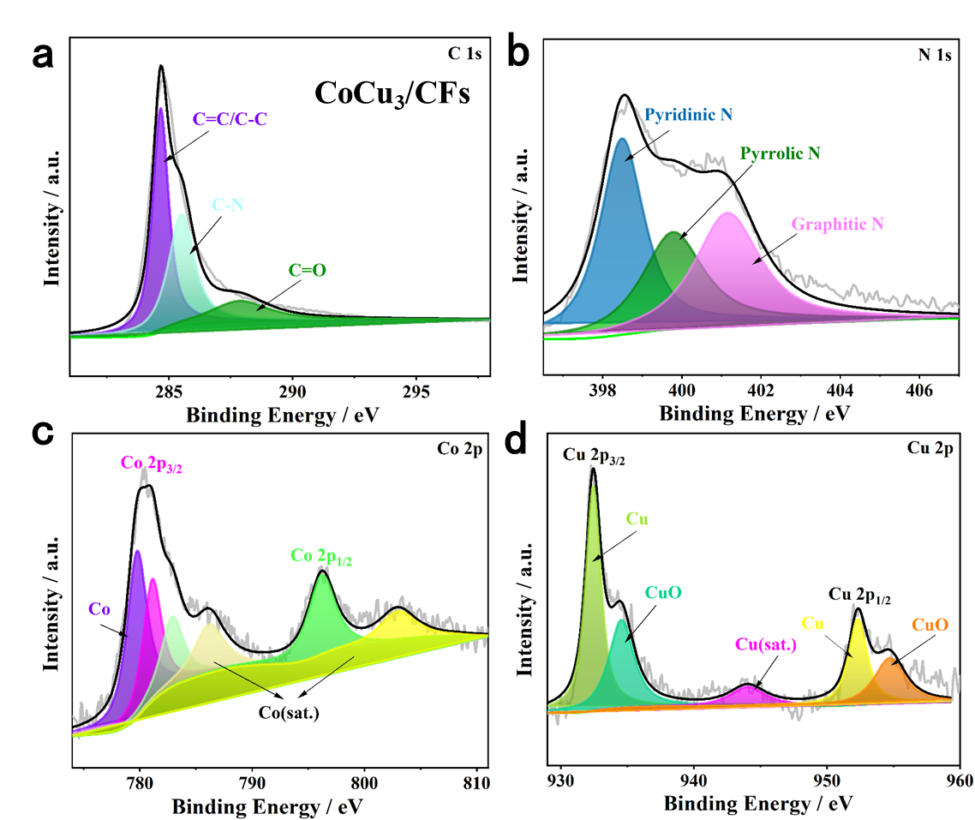
Supplementary Figure 7. C 1s (a), N 1s (b), Co 2p (c) and Cu 2p (d) XPS spectra of CoCu₃/CFs.
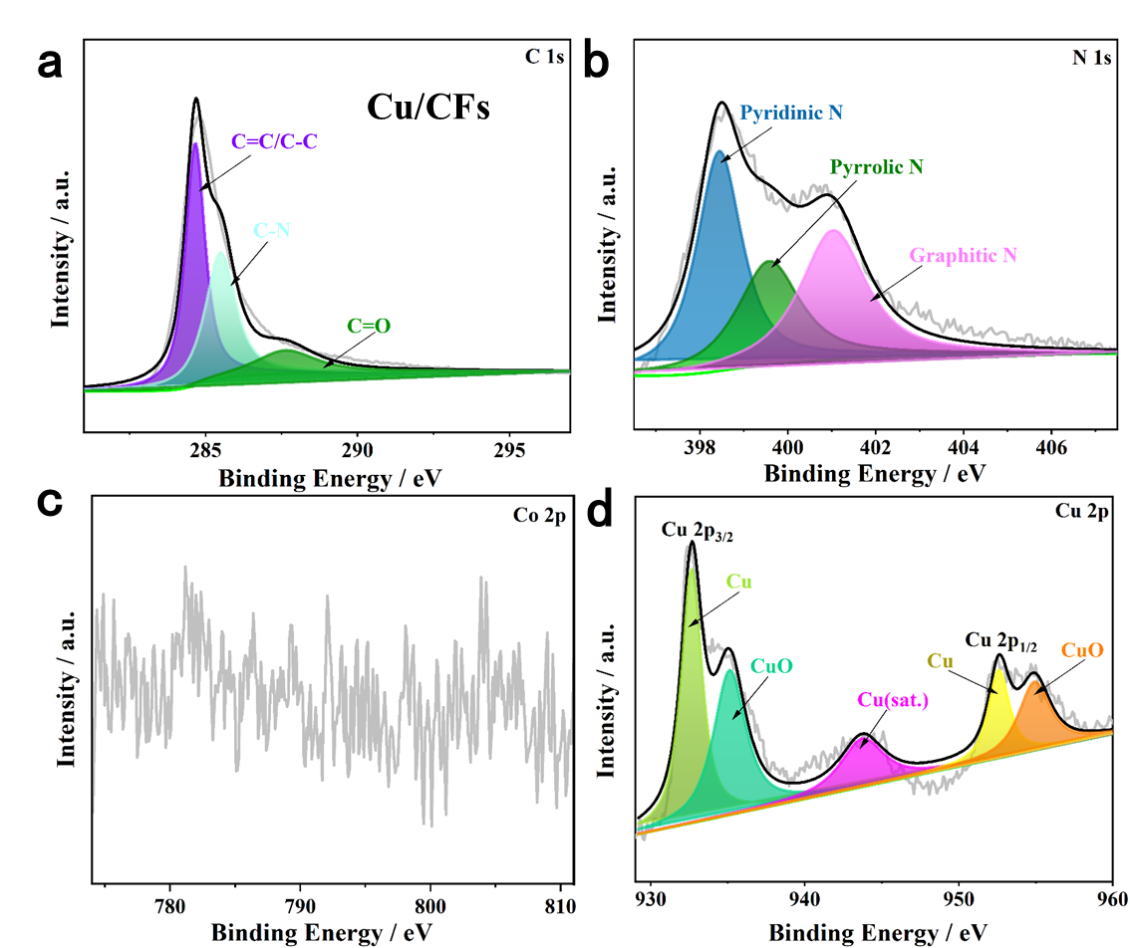
Supplementary Figure 8. C 1s (a), N 1s (b), Co 2p (c) and Cu 2p (d) XPS spectra of Cu/CFs.

- Electrochemical reduction of CO₂ using different catalysts
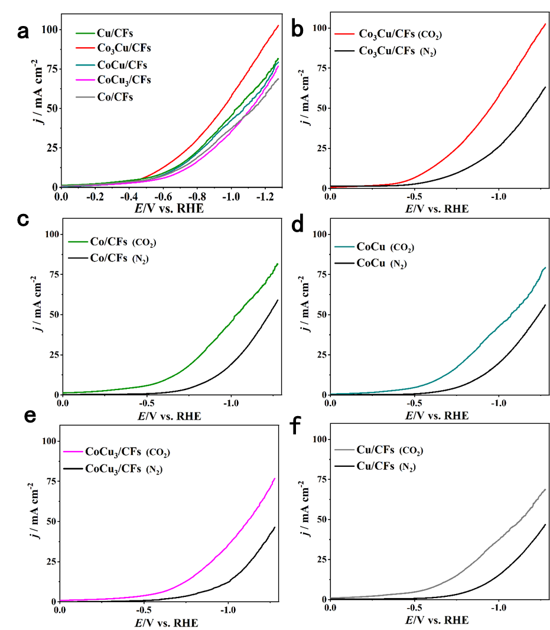
Supplementary Figure 9. LSV curves in CO₂-saturated and N₂-saturated 0.5 M KHCO₃ solution in H-type cell using five catalysts.

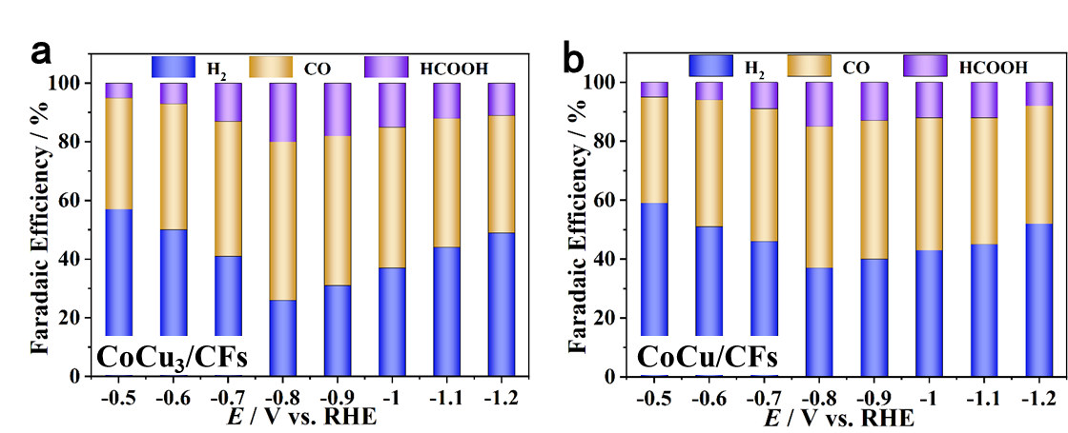
Supplementary Figure 10. Faradaic efficiencies of reduction products using CoCu₃/CFs (a), CoCu/CFs (b).
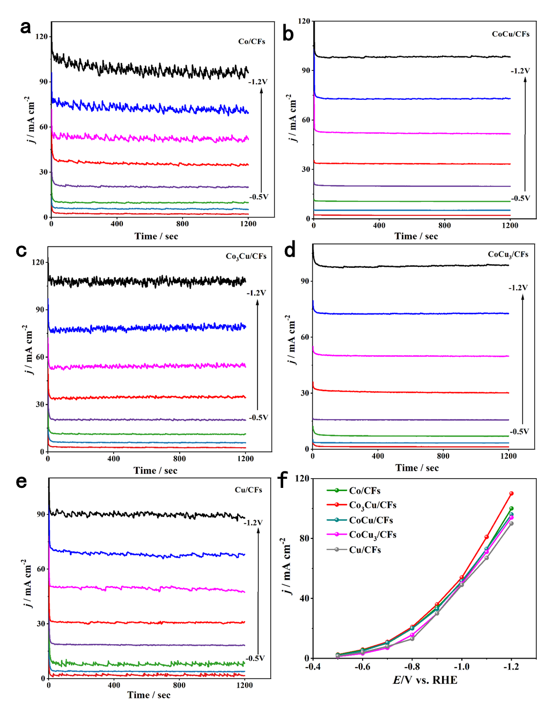
Supplementary Figure 11. Total current density of five samples at −0.5 V_{RHE} to −1.2 V_{RHE} cathode potentials in 0.5 M KHCO₃ electrolyte.

Supplementary Figure 12. The TEM image of Co₃Cu/CFs after long-term electrolysis.

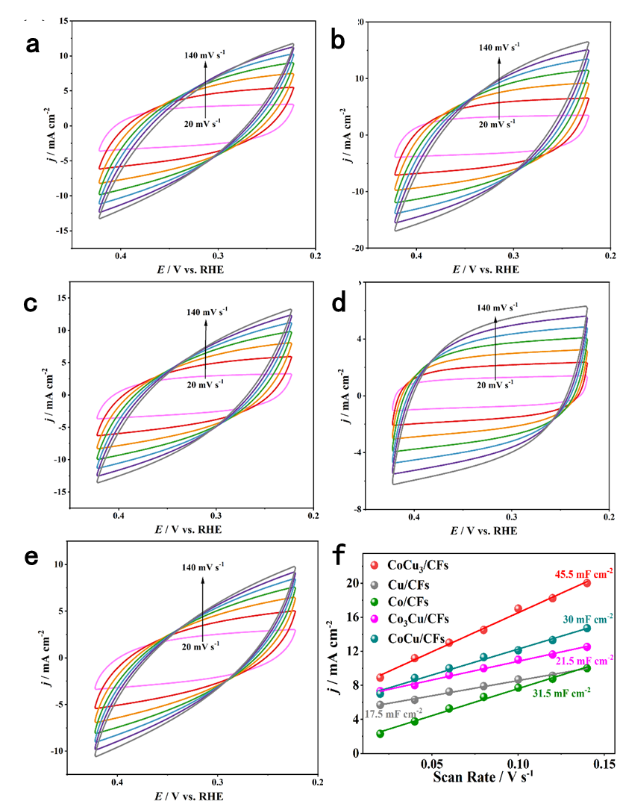
Supplementary Figure 13. CVs of five samples (a-e) from 0.2 to 0.4 V_{RHE} at various scan rates (0.02 to 0.14 V s⁻¹); double layer capacitances of five samples (f).

