Changes in phytochemical profiles and biological activity of olive leaves treated by two drying methods
Chengcheng Zhang¹, Jianming Zhang¹, Xiaoting Xin¹, Shenlong Zhu², Erli Niu², Qinghang Wu¹, Ting Li¹, Daqun Liu^{1,*}
1 Food Science Institute, Zhejiang Academy of Agricultural Sciences, Hangzhou 310021, China
2 Institute of Crop and Nuclear Technology Utilization, Zhejiang Academy of Agricultural Sciences, Hangzhou 310021, China

*Corresponding author:
Daqun Liu, E-mail: liudaqun@zaas.ac.cn

Table S1. Calibration curves used for HPLC quantification.
Compounds | Rt (min) | Calibration curves | R² | Linear range  (μg/mL)
Hydroxytyrosol | 5.337 | Y = -11733+9341.9*X | 0.9999 | 13.75-275
Chlorogenic acid | 7.070 | Y =-3292+6252.1*X | 0.9998 | 4.6-91.7
Secoxyloganin | 8.430 | Y =1395+4572.1*X | 1.0000 | 23.1-461.5
Plantamajoside | 9.550 | Y =-1654+2404.5*X | 0.9995 | 13.8-276.9
Rutin | 11.671 | Y =-432+6939.3*X | 0.9994 | 4.8-96.7
Luteolin-7-O-glucoside | 12.597 | Y =3006+7658.7*X | 0.9994 | 5.1-102.8
Apigenin-7-O-neohesperidoside | 13.803 | Y =3426+5625.8*X | 0.9983 | 6.7-133.4
Taxifolin | 14.055 | Y = -1568+16950.9*X | 0.9998 | 18.5-369.2
Quercetin | 14.35 | Y = -11817+12587.5*X | 0.9999 | 8.8-175.6
Oleuropein | 16.419 | Y =1459+5382.6*X | 0.9998 | 25.6-513.3
Eriodictyol | 20.234 | Y = -1236+6175.2*X | 1.0000 | 28.8-576.8
Luteolin | 21.134 | Y = -5079+19174.8*X | 0.9995 | 2.2-43.3
Kaempferol | 24.857 | Y = -13367+18813.5*X | 1.0000 | 5.8-116.6
Apigenin | 26.870 | Y = -12297+17367.4*X | 0.9999 | 5.3-100.5
Asiatic acid | 3.554 | Y =2560.5+ 4126.9*X | 0.9999 | 3.24-323
Oleanonic acid | 4.725 | Y = -1451.8+4198.4*X | 0.9996 | 3.7-369
Maslinic acid | 5.865 | Y = -4574.9+3976.8*X | 0.9999 | 3.24-323
Corosolic acid | 6.187 | Y =779.67+4236.5*X | 1.0000 | 3.92-392
Oleanolic acid | 9.927 | Y=1613.1+5762.8*X | 0.9999 | 2.3-230
Ursolic acid | 10.232 | Y= 8616.1+4334.9*X | 1.0000 | 3.46-346
Rt, retention times; R², correlation coefficients.

Table S2. Spearman’s correlation co-efficient analysis between chemical constituents and the bioactivities (DPPH; ABTS; FRAP; α-amylase, α-glucosidase, and ACE inhibition) of olive leaf extracts.
Analytes | DPPH | FRAP | ABTS | α-amylase | α- Glucosidase | ACE
Apigenin | 0.4595 | 0.4652 | 0.4966 | 0.7711 | 0.3283 | 0.4889
Apigenin-7-O-glucoside | 0.0532 | -0.0290 | -0.0458 | -0.2618 | -0.3447 | -0.3879
Apigenin-7-O-neohesperidoside | -0.2146 | -0.2167 | -0.0602 | -0.2118 | 0.0795 | -0.1876
Asiatic acid | 0.0316 | 0.0303 | 0.0756 | 0.0371 | 0.0422 | -0.0566
Chlorogenic acid | 0.5866 | 0.5430 | 0.5040 | 0.3509 | 0.3927 | 0.6157
Corosolic acid | 0.2195 | 0.1953 | 0.1953 | 0.4644 | 0.2371 | 0.3040
Coumarin | 0.3706 | 0.2805 | 0.2373 | -0.1910 | -0.0893 | 0.0754
Diosmetin-7-O-neohesperidoside | 0.6036 | 0.4888 | 0.4859 | 0.2154 | 0.4533 | 0.4528
Eriodictyol | 0.7745 | 0.6635 | 0.6602 | 0.5315 | 0.5109 | 0.6466
Esculin | 0.5824 | 0.5333 | 0.4779 | 0.2203 | 0.0247 | 0.3326
Hispidulin | 0.5137 | 0.4872 | 0.5850 | 0.8152 | 0.7477 | 0.6260
Hydroxytyrosol | 0.8486 | 0.8051 | 0.7418 | 0.4556 | 0.4855 | 0.6237
Hydroxytyrosol 4-O-glucoside | 0.2095 | 0.1738 | 0.1189 | -0.1741 | 0.2302 | 0.1968
Kaempferol | 0.0994 | 0.0407 | 0.0789 | 0.3399 | 0.3758 | 0.1433
Kaempferol-7-O-glucoside | 0.7323 | 0.6298 | 0.6033 | 0.3099 | 0.2515 | 0.5390
Luteolin | 0.5142 | 0.5191 | 0.5631 | 0.7977 | 0.6301 | 0.5848
Luteolin-3',7-di-O-glucoside | 0.5659 | 0.4562 | 0.4905 | 0.1426 | 0.3612 | 0.3981
Luteolin-4'-O-glucoside | 0.6126 | 0.5181 | 0.4718 | 0.1580 | 0.3902 | 0.5202
Luteolin-7-O-glucoside | 0.6205 | 0.5245 | 0.4594 | 0.1910 | 0.0762 | 0.3459
Maslinic acid | 0.5513 | 0.5698 | 0.4548 | 0.0129 | 0.0981 | 0.2731
Oleanolic acid | 0.6141 | 0.5871 | 0.6537 | 0.3091 | 0.6512 | 0.6170
Oleanonic acid | 0.5498 | 0.5325 | 0.4473 | 0.1995 | 0.0880 | 0.2062
Oleuropein | 0.3570 | 0.2692 | 0.1240 | -0.2940 | -0.2296 | -0.0299
Plantamajoside | -0.2539 | -0.0880 | -0.0187 | 0.0923 | 0.0424 | 0.0456
Quercetin | 0.7842 | 0.6742 | 0.6650 | 0.4355 | 0.4962 | 0.5647
Quercetin-3-O-glucoside | 0.6586 | 0.6669 | 0.6329 | 0.4342 | 0.1526 | 0.4710
Quercetin-4'-O-glucoside | 0.1674 | 0.1028 | 0.1689 | 0.3436 | 0.3222 | 0.1842
Rutin | 0.4108 | 0.2808 | 0.2715 | 0.1125 | 0.3133 | 0.1689
Secoxyloganin | 0.3137 | 0.2236 | 0.1148 | -0.3784 | -0.1470 | -0.0082
Taxifolin | 0.4599 | 0.4960 | 0.5343 | 0.4216 | 0.5405 | 0.5184
Taxifolin-3-glucoside | 0.4839 | 0.4169 | 0.4779 | 0.0847 | 0.4847 | 0.4880
TFC | 0.9024 | 0.8069 | 0.7763 | 0.5575 | 0.5645 | 0.6883
Tiliroside | 0.4128 | 0.2998 | 0.1377 | 0.2443 | 0.0427 | 0.0667
TPC | 0.7706 | 0.6267 | 0.5534 | 0.5828 | 0.3400 | 0.4978
Ursolic acid | 0.2630 | 0.2000 | 0.3021 | 0.4005 | 0.4680 | 0.3076

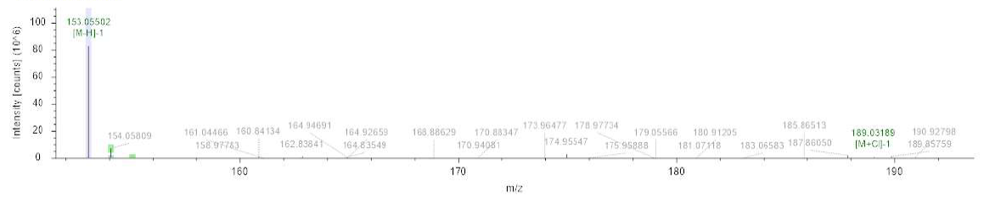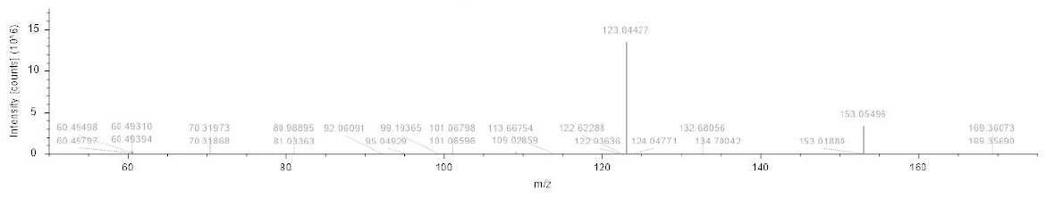
1. Hydroxytyrosol

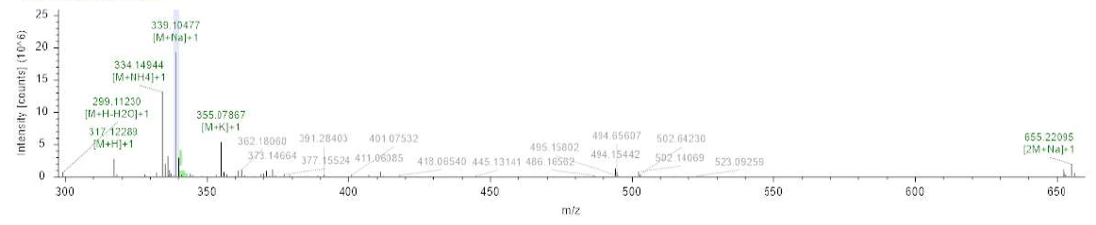
2. Hydroxytyrosol 4-O-glucoside

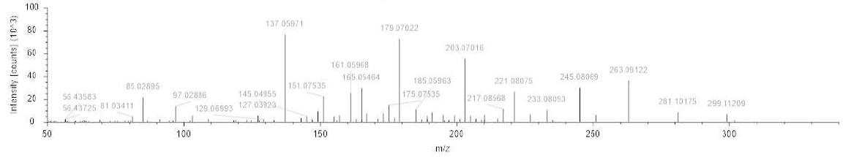

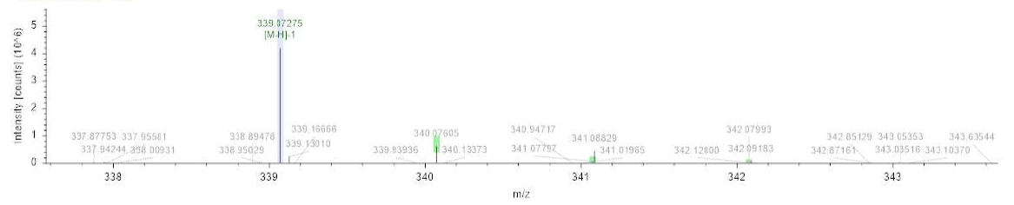
3. Esculin

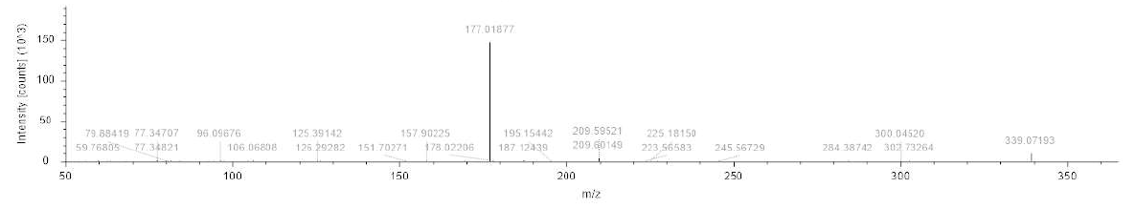
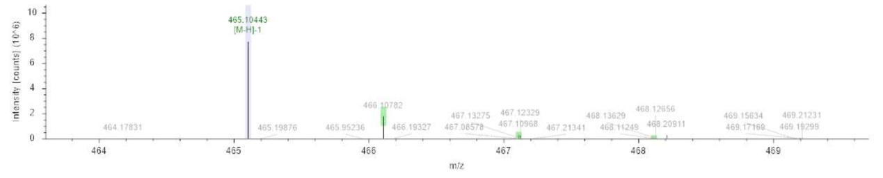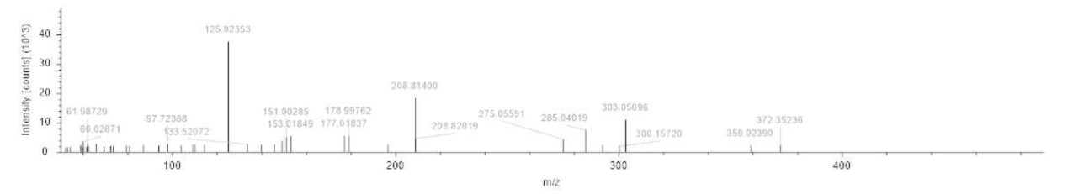
4. Taxifolin-3-glucoside

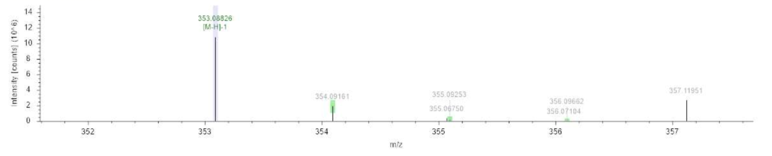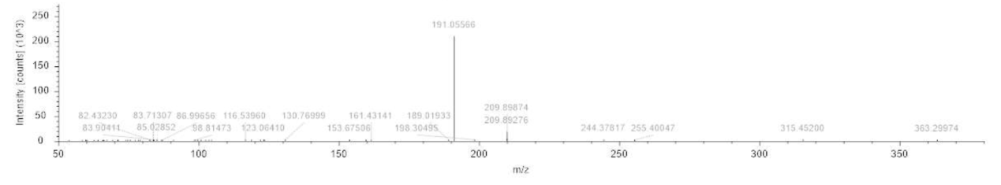
5. Chlorogenic acid

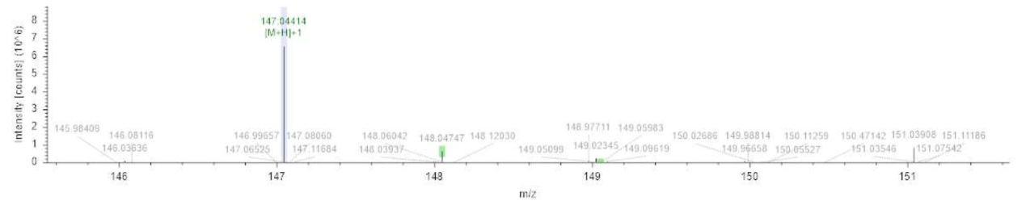
6. Coumarin
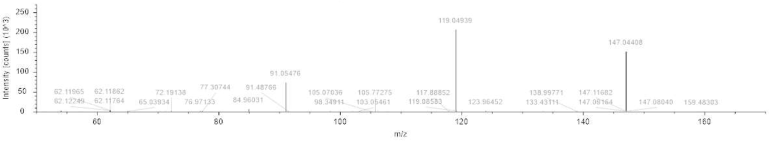

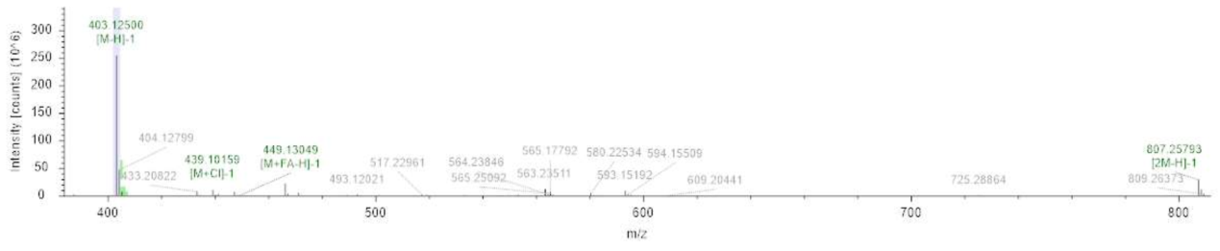
7. Secoxyloganin
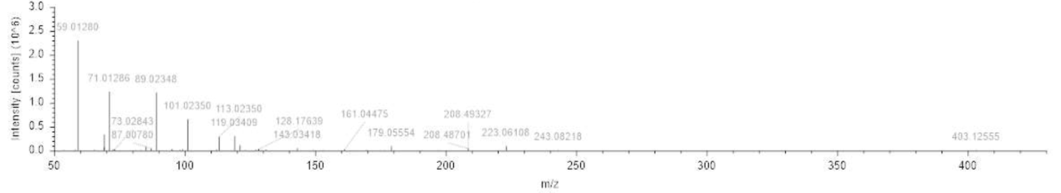

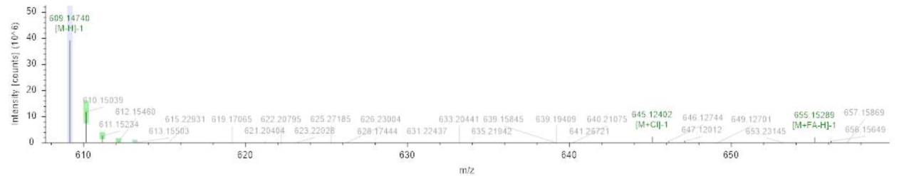
8. Luteolin-3',7-di-O-glucoside

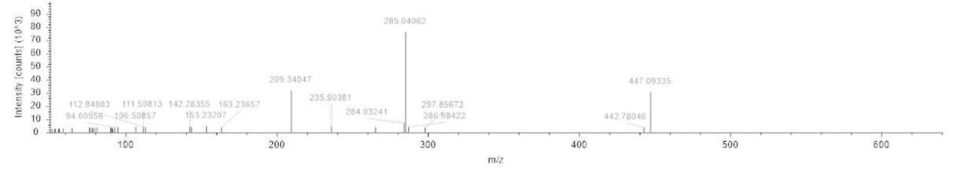

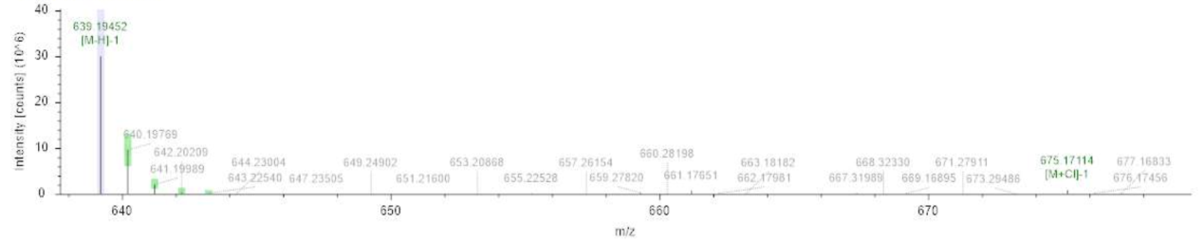
9. Plantamajoside
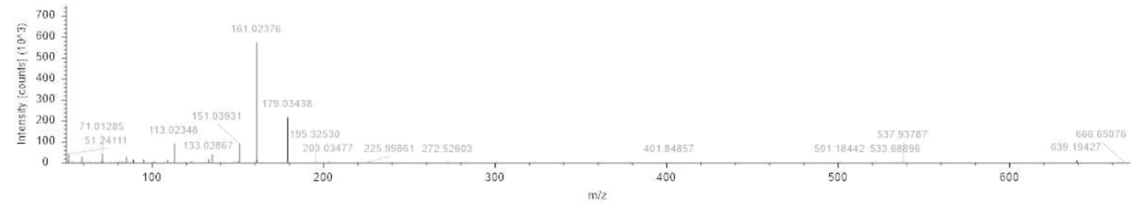
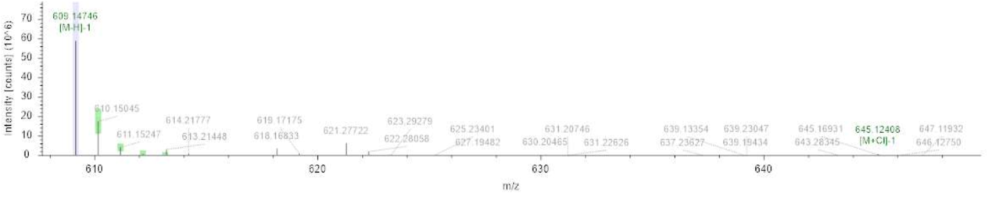
10. Rutin

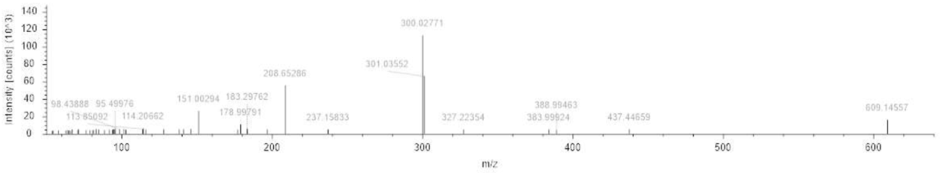

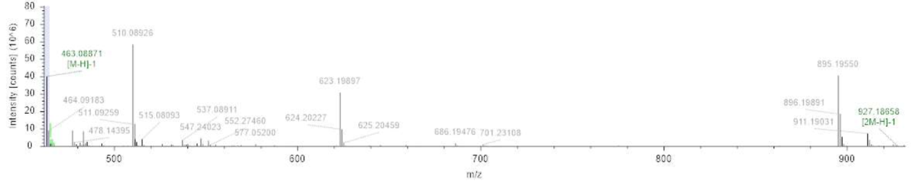
11. Quercetin-3-O-glucoside
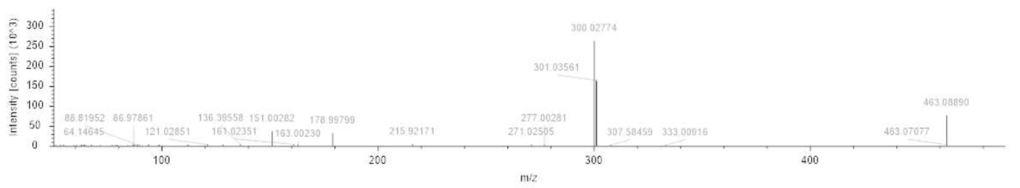

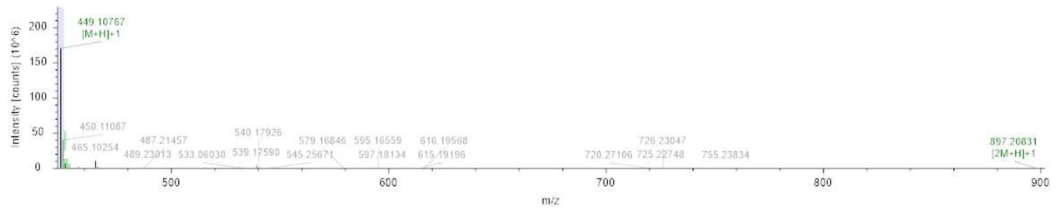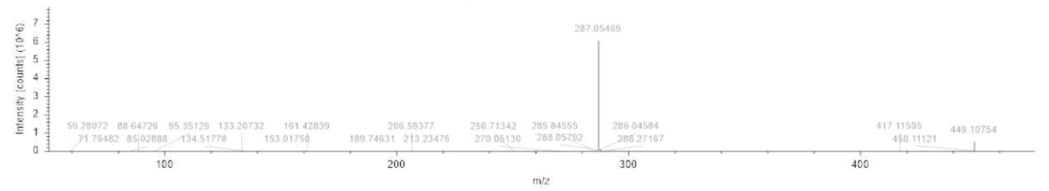
12. Luteolin-7-O-glucoside

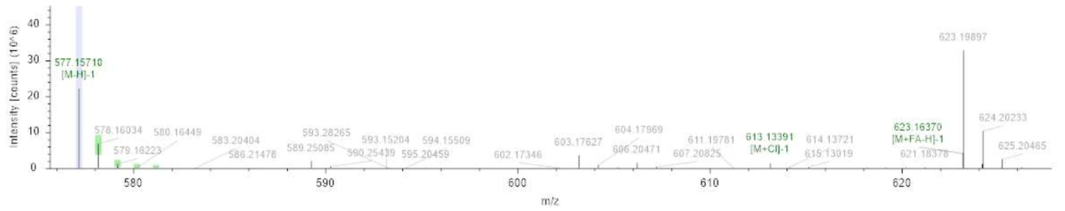
13. Apigenin-7-O-neohesperidoside

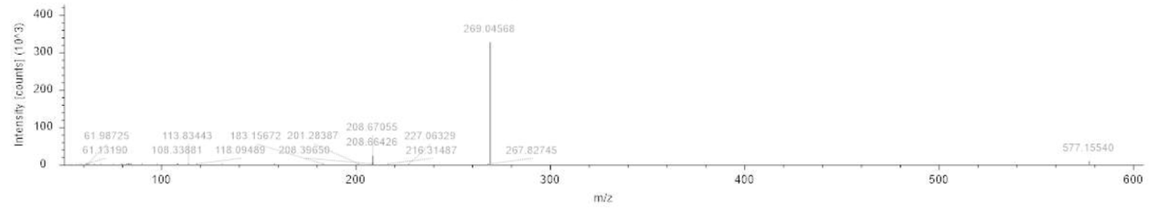

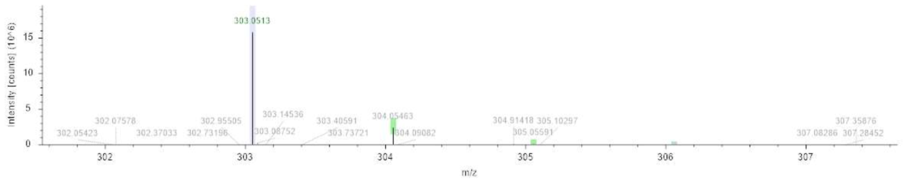
14. Taxifolin

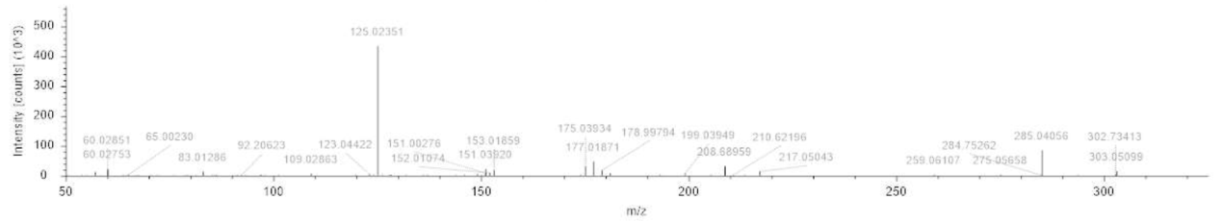

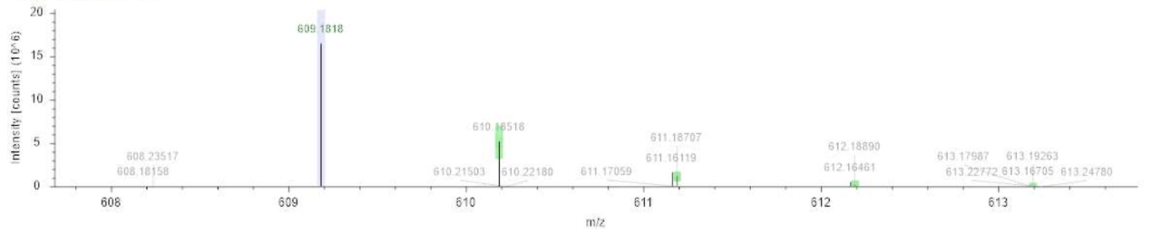
15. Diosmetin-7-O-neohesperidoside
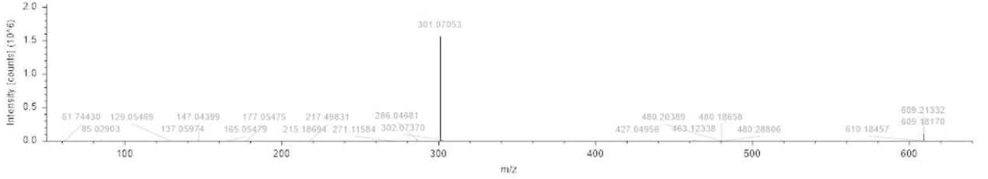

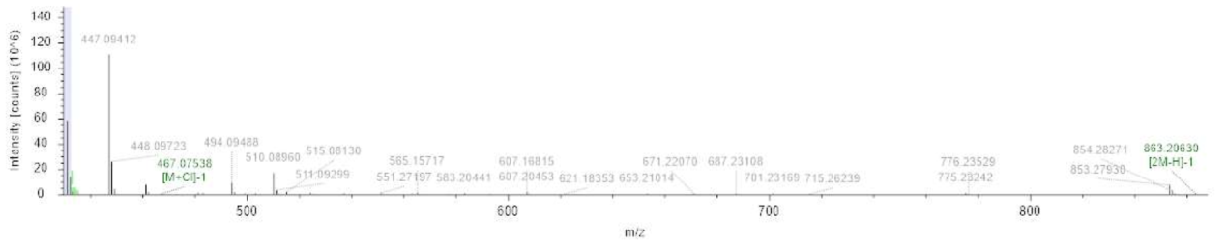
16. Apigenin-7-O-glucoside
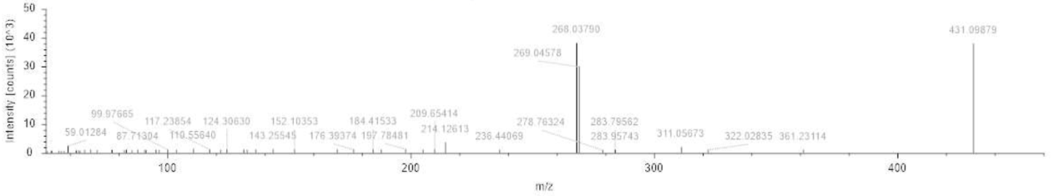

17. Kaempferol-7-O-glucoside

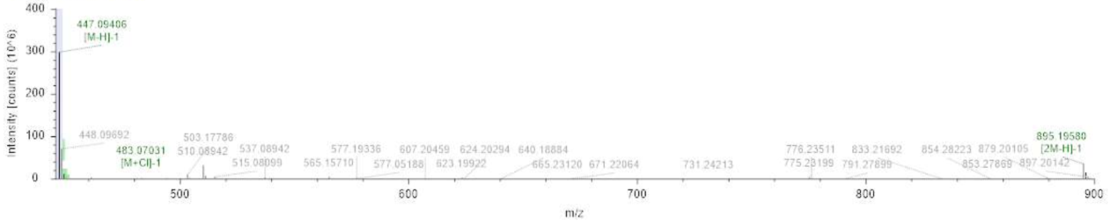
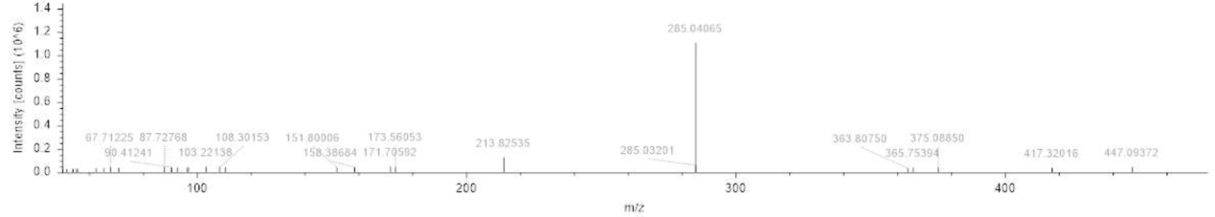

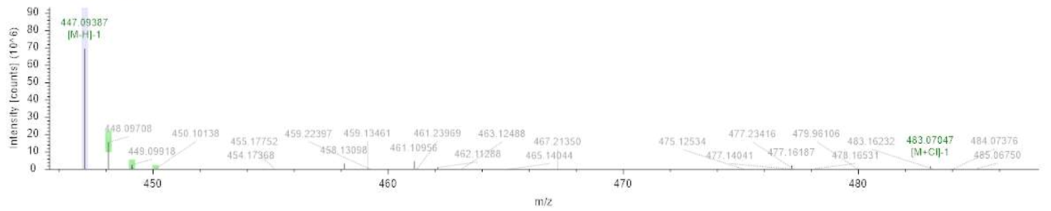
18. Luteolin 4'-O-glucoside
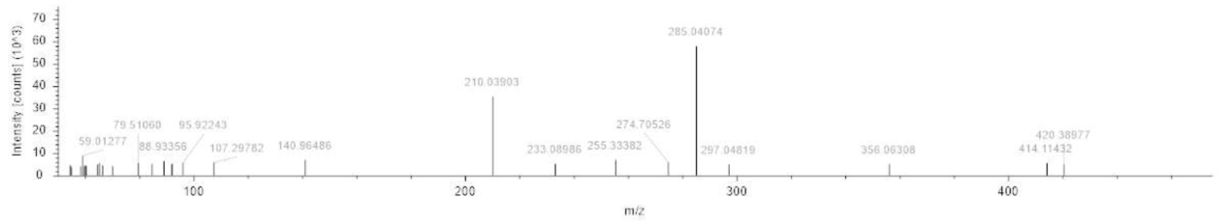

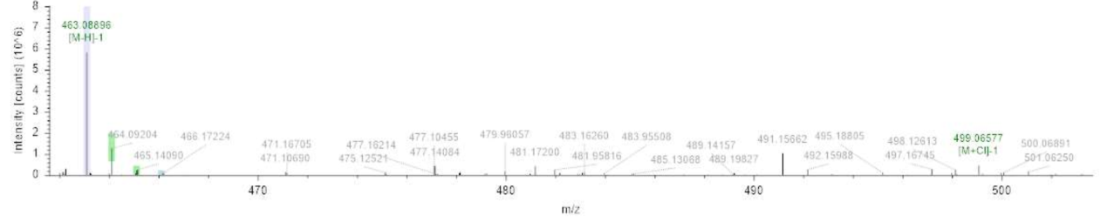
19. Quercetin-4'-O-glucoside
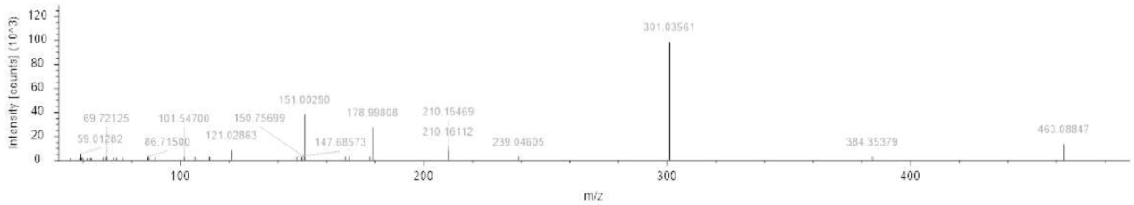

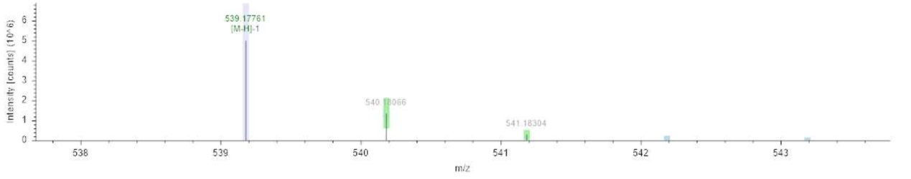
20. Oleuropein

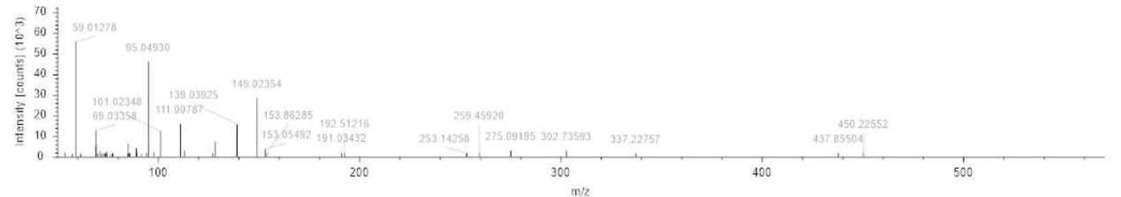

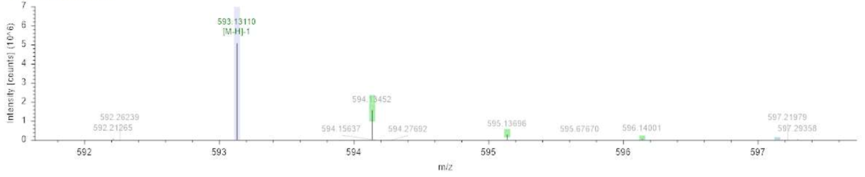
21. Tiliroside

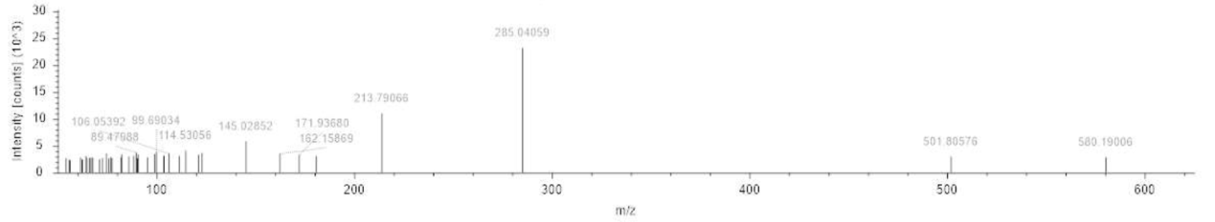

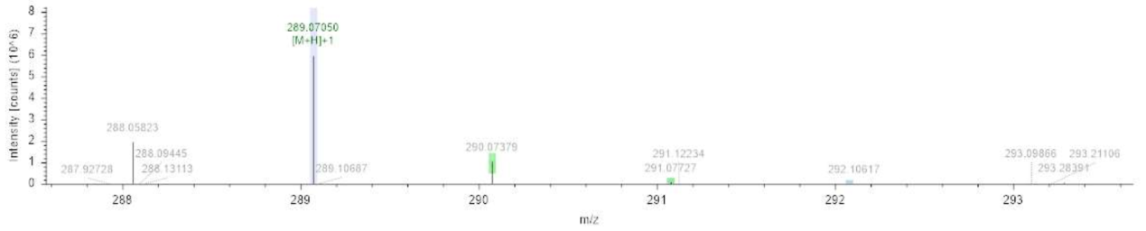
22. Eriodictyol

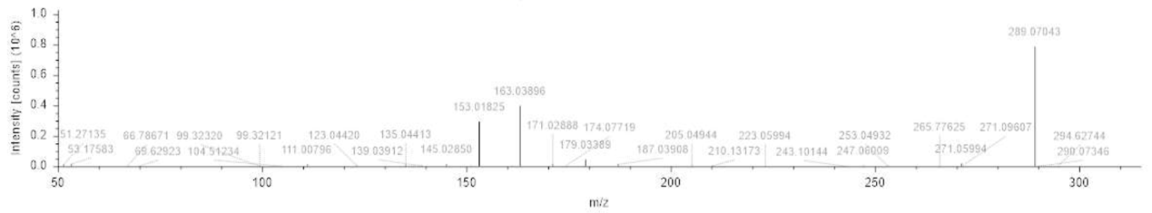

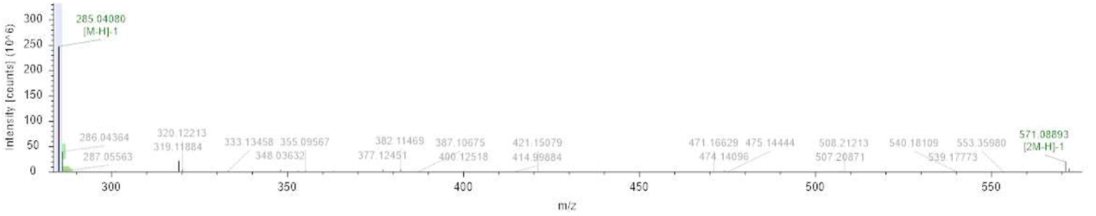
23. Luteolin

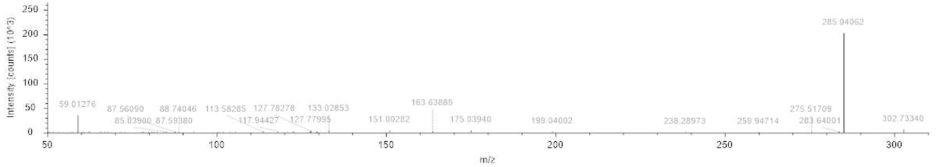

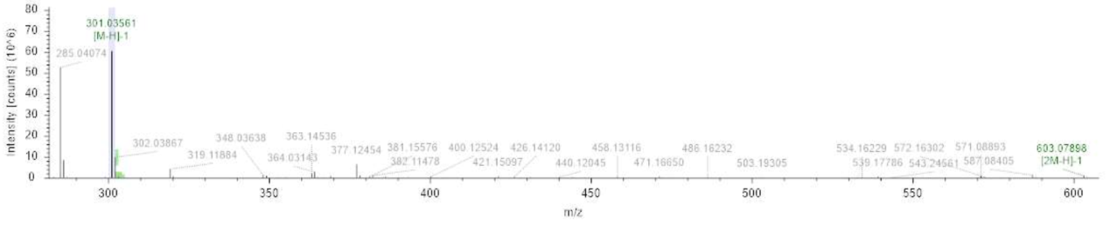
24. Quercetin

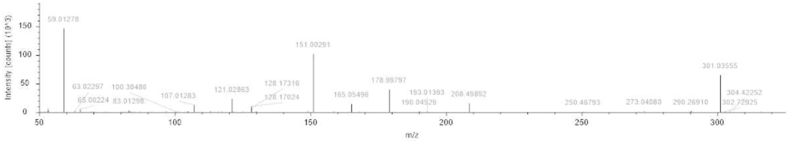

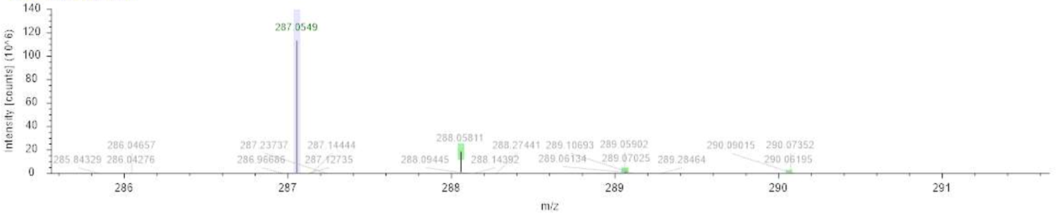
25. Kaempferol

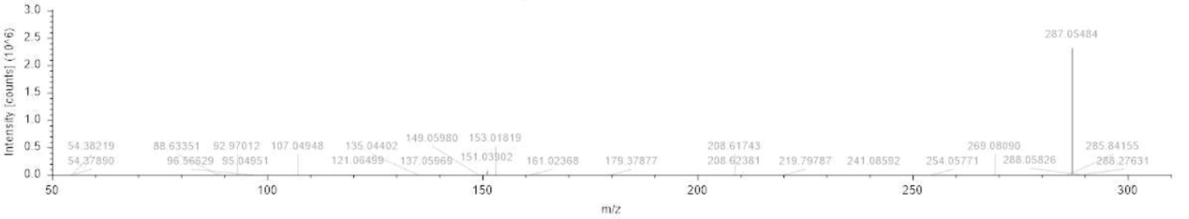

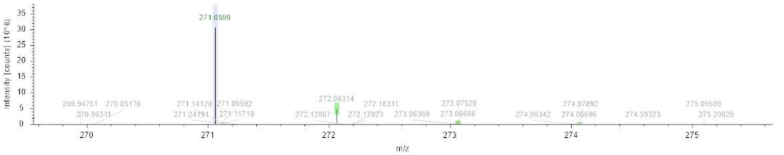
26. Apigenin

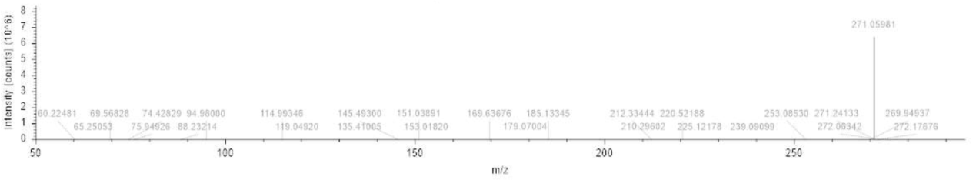
27. Hispidulin

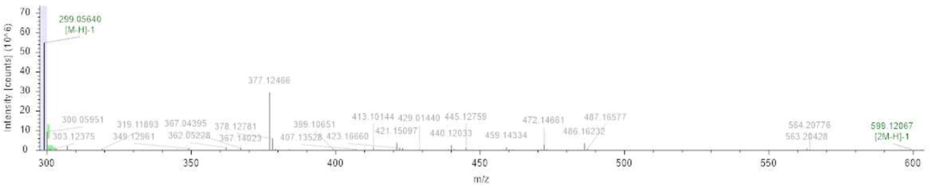
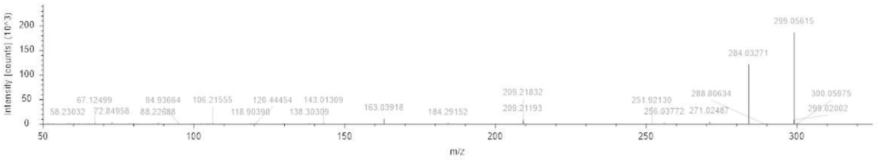

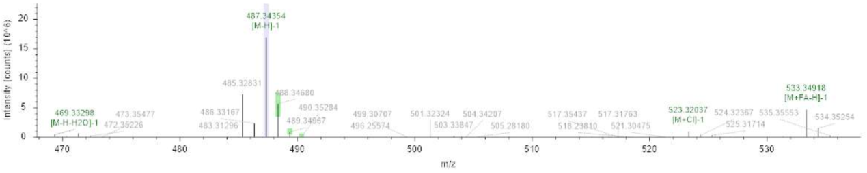
28. Asiatic acid

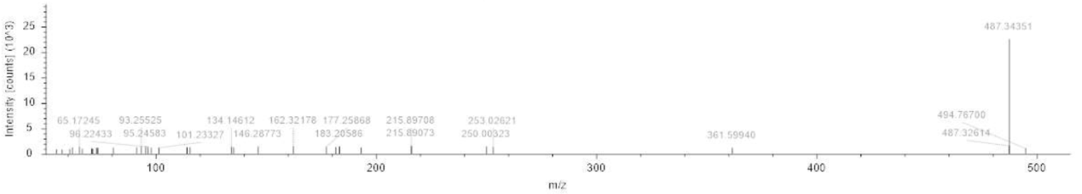

29. Oleanonic acid

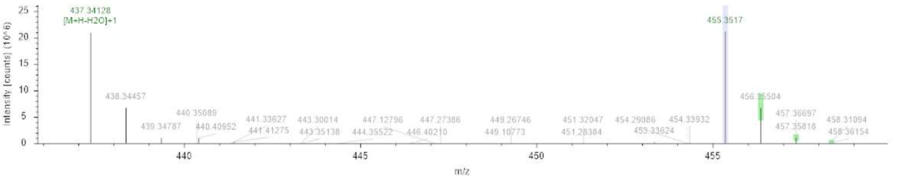
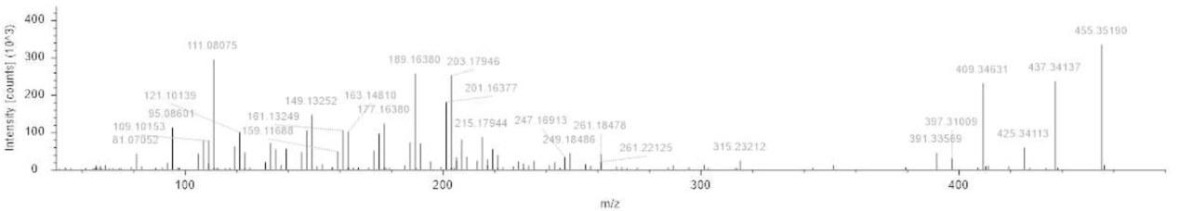

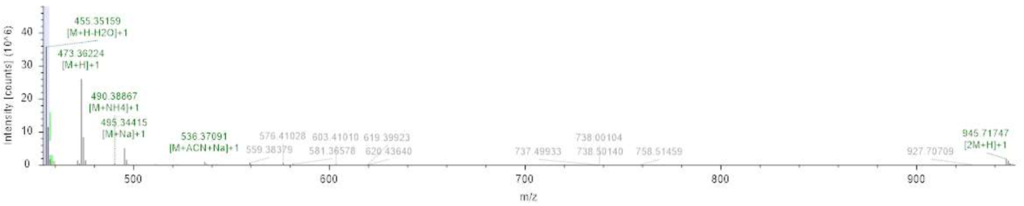
30. Maslinic acid

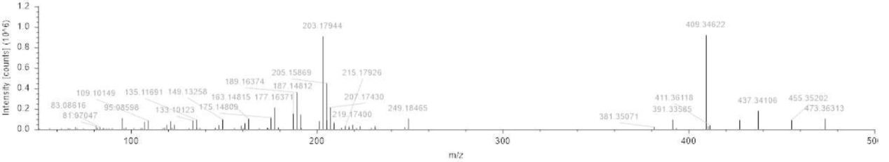

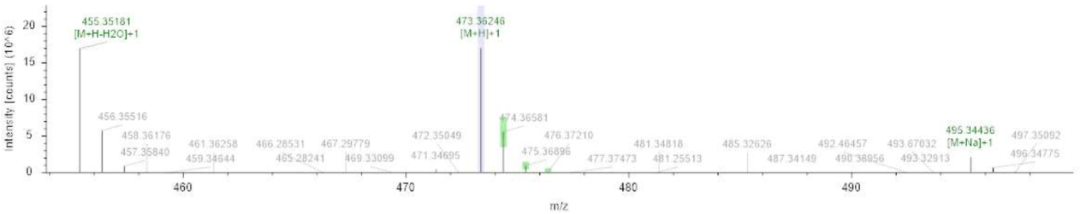
31. Corosolic acid

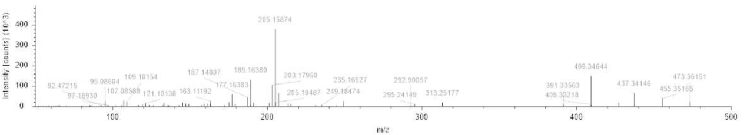

32. Ursolic acid

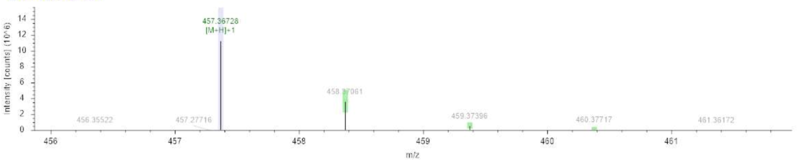
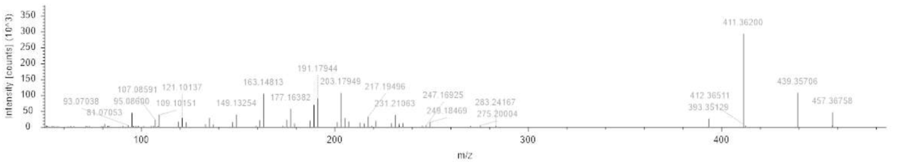

33. Oleanolic acid

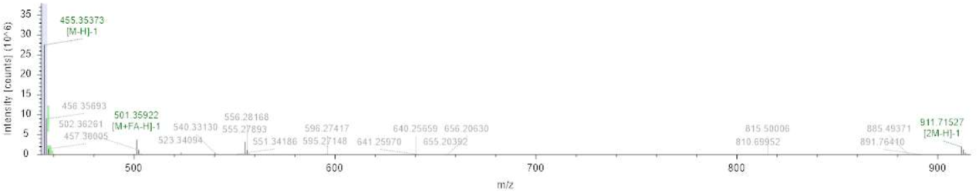
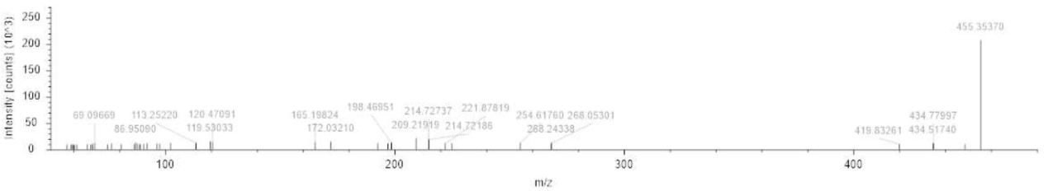
Figure S1. MS and MS/MS data of the 33 phytochemicals identified in the olive leaves by UPLC-Q-Exactive Orbitrap-MS.

