Supplementary Material
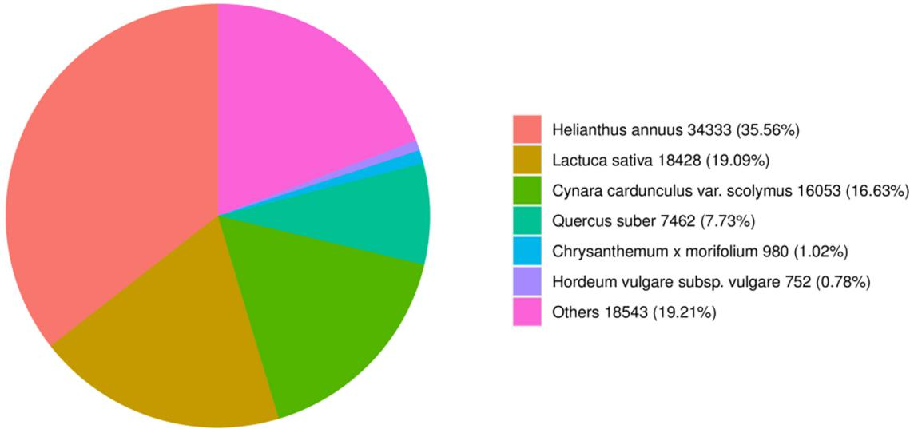
Supplementary Figure 1. Species distribution of unigenes in the NR database.
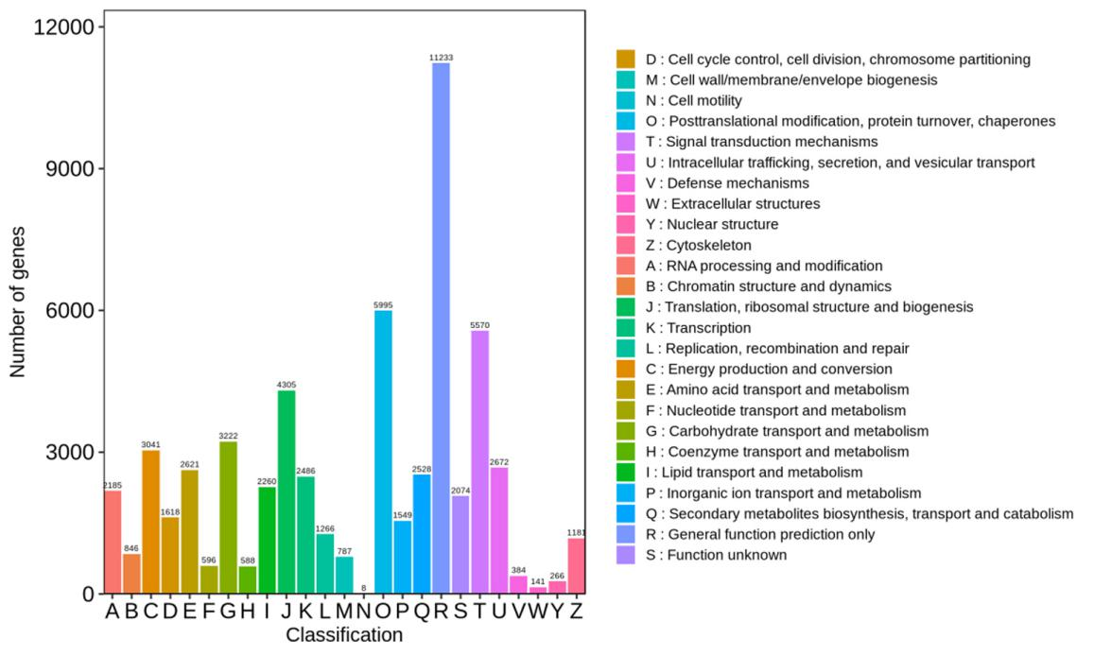
Supplementary Figure 2. KOG functional classification of unigene sequences.
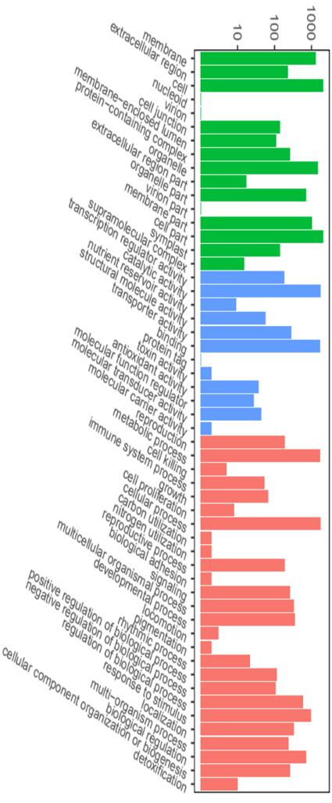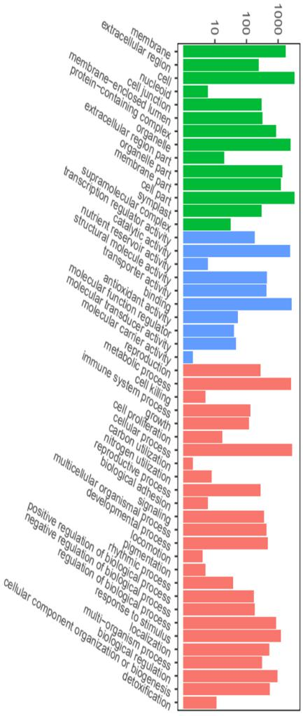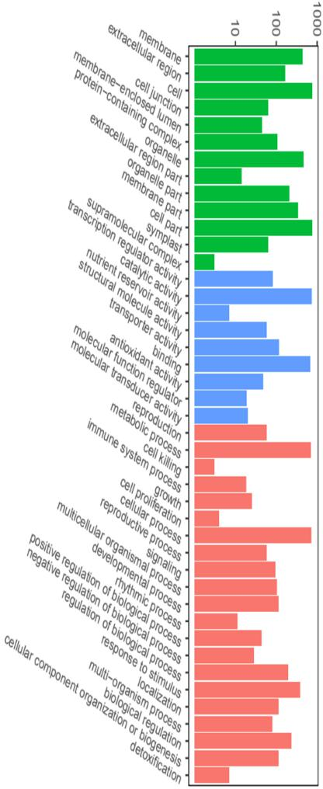
cellular components
molecular functions
biological processes
Supplementary Figure 3. GO analysis of upregulated DEGs in (A) W0 vs. WJ , (B) R0 vs. RJ , and (C) WJ vs. RJ.
W0 vs. WJ
R0 vs. RJ
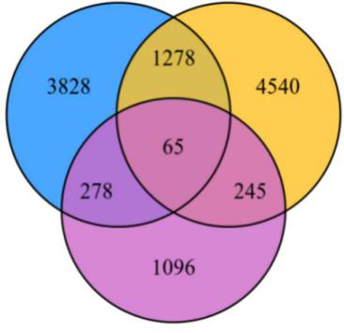
WJ vs. RJ
Supplementary Figure 4. Venn diagram of DEGs. The overlapping region of the circles indicates common DEGs among the three combinations.
A
Statistics of KEGG Enrichment

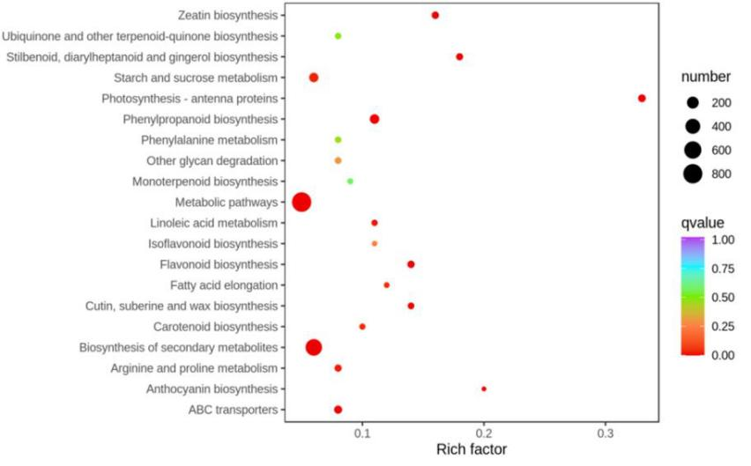
B
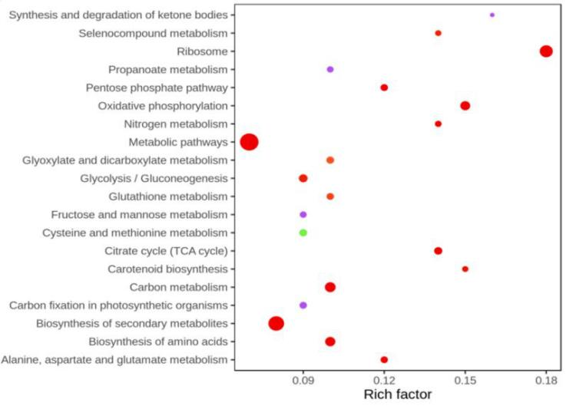
C
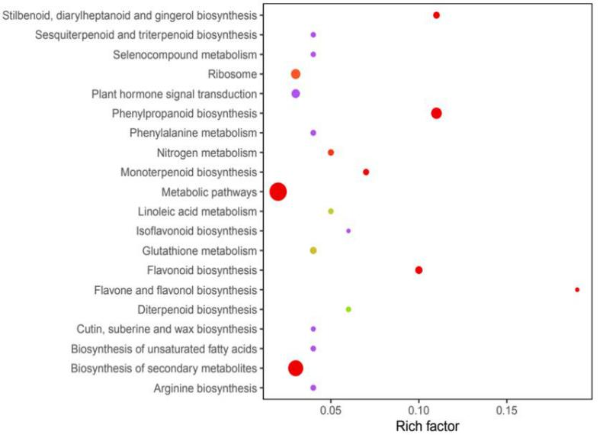
Supplementary Figure 5. KEGG pathway enrichment analysis of continuous DEGs in (A) W0 vs WJ、(B) R0 vs RJ and (C) WJ vs RJ. The enrichment factor indicates the ratio of DEGs enriched in this pathway to the total number of annotated unigenes. The size and color of each point represents the number of genes enriched in a particular pathway and the q-values, respectively. A larger enrichment factor value and lower q-values shows a greater degree of enrichment. We selected the 20 most significantly enriched pathway for display in this figure.
Supplementary Table 1 Output quality in data
Sample | Raw Reads | Clean reads | Clean bases | Error (%) | Q20 (%) | Q30 (%) | GC (%)
W0-1 | 54439456 | 56583406 | 7.21 | 0.04 | 95.36 | 89.61 | 42.35
W0-2 | 61428398 | 62933114 | 8.13 | 0.04 | 95.55 | 89.87 | 42.53
W0-3 | 61770522 | 53182862 | 8.43 | 0.04 | 95.28 | 89.45 | 42.32
R0-1 | 53881368 | 47321334 | 7.1 | 0.03 | 95.75 | 90.44 | 42.79
R0-2 | 79116126 | 71166892 | 10.68 | 0.04 | 95.53 | 89.76 | 42.48
R0-3 | 79123908 | 69912478 | 10.49 | 0.04 | 95.49 | 89.86 | 42.69
WJ-1 | 70581018 | 61505336 | 9.23 | 0.03 | 95.74 | 90.4 | 42.91
WJ-2 | 62773642 | 53886718 | 8.08 | 0.03 | 95.89 | 90.6 | 42.39
WJ-3 | 63611882 | 57595304 | 8.64 | 0.04 | 95.46 | 89.64 | 42.50
RJ-1 | 52069694 | 56184430 | 8.43 | 0.03 | 95.74 | 90.27 | 42.32
RJ-2 | 57502978 | 46555074 | 6.98 | 0.04 | 95.89 | 89.29 | 41.76

Supplementary Table 2 The data statistics of gene annotation to each protein databases
Database | Number of genes | Percentage（%）
KEGG | 67279 | 24.67
NR | 96551 | 35.41
SwissProt | 64421 | 23.63
Trembl | 94966 | 34.83
KOG | 53463 | 19.61
GO | 81136 | 29.76
Pfam | 60558 | 22.21
Annotated in at least one Database | 98031 | 35.95
Total Unigenes | 272669 | 100.00

Supplementary Table 3 The expression levels of 7 DEGs
Gene-id | W | WJ | Trend | R | RJ | Trend | WJ | RJ | Trend
Cluster-45258.46315（NPR1） | 0 | 3.488 | up | 0 | 1.463 | up | 3.488 | 1.463 | down
Cluster-45258.147113（PAL1） | 0 | 7.675 | up | 0 | 3.123 | up | 7.675 | 3.123 | down
Cluster-45258.100151（PAL2） | 0 | 6.081 | up | 0 | 1.797 | up | 6.081 | 1.797 | down
Cluster-45258.111810（TGA1） | 0 | 6.159 | up | 0 | 4.845 | up | 6.159 | 4.845 | down
Cluster-45258.107755（TGA3） | 0 | 2.228 | up | 0 | 2.140 | up | 2.228 | 2.140 | down
Cluster-45258.62530（PR1） | 0 | 13.588 | up | 0 | 7.043 | up | 13.588 | 7.043 | down
Cluster-45258.61119（PR5） | 0 | 6.865 | up | 0 | 1.828 | up | 6.865 | 1.828 | down

Supplementary Table S4 Primers used in this study
Primer function | Primer name | Primer sequence (5′-3′)
Cloned primers | CmNPR1-F  CmNPR1-R | ATGGTGGCTGCATCACAT
 |  | TCACGAGTACTTCCGAGATCTGTTCTT
qRT-PCR primers | qRT-Actin-F  qRT-Actin-F | TCCGTTGCCCTGAGGTTCT
 |  | GATTTCCTTGCTCATCCTGTCA
 | qRT-NPR-F  qRT-NPR-R | TGTCGAGAAGGATGGAAAGCC
 |  | GGAGGCACCCATCATCAACA
 | qRT-PAL1-F  qRT-PAL1-R | GCTCGGAACAGGTTACTTGACAGG
 |  | CCATTCCAGCCTTGAAGACACTCC
 | qRT-PAL2-F  qRT-PAL2-R | ACAGTCAAGAACACCGTAAGCCAAG
 |  | ATACTCACGATCAACCACACGAAGC
 | qRT-TGA1-F  qRT-TGA1-R | TCCCTCCATCTTTGCTCTTTCGTTTC
 |  | TGATTGACTCCACCTTTGAAGACTGC
 | qRT-TGA3-F  qRT-TGA3-R | CTCCAGCACCAACCCATCTTTCG
 |  | CTTCGGGCTAACATGAGTCTCGTATG
 | qRT-PR1-F  qRT-PR1-R | CCTTAAACCCAATCTCACAATG
 |  | TGAGTGCGTTGGTGGAGTT
 | qRT-PR5-F  qRT-PR5-R | CCAATGGAGTTTAGCCCCGT
 |  | GTCCACAACTACCACGCTCA
 | qRT-PR-10-F  qRT-PR-10-R | TCGACTGACATAAGGCACATAACGC
 |  | GCTTCCATAACCTCCATCTCCTTCG
pTRV2-NPR1 vector construction primers | pTRV2-NPR1-F  pTRV2-NPR1-R | GAATTCAGGCTCTTGTTGAAGATGTGATCC
 |  | GGTACCCCTCCTCGGATTTTTCTAAGAGTT
hiTAIL-PCR primers | NPR1SP1-F/R  NPR1SP2-F/R  NPR1SP3-F/R | CTCGGATC AGAATCCAAGTCAGTTTC
 |  | CGATGGACTGCTGAGTGGCACCTGTACCACAACAACCGCGTCACTA
 |  | CAGTACCTAACAAGAACCAAACACCC
pCAMBIA1301-NPR1-GUS vector primers | pNPR1.1-F | TACGAATTCGAGCTCGGTACCGAGTGATTCAAATTCCTGGGTAAAG
 | pNPR1.1-R | TTACCCTCAGATCTACCATGGCTGCCACGAGAAGGTGATGATGATG
 | pNPR1.2-F | TACGAATTCGAGCTCGGTACCCACGCTATCGTATACAAACGCTCCG
 | pNPR1.2-R | TTACCCTCAGATCTACCATGGCTGCCACGAGAAGGTGATGATGATG
 | pNPR1.3-F | TACGAATTCGAGCTCGGTACCTTACTTGTTGTTTGACAAACGAACAT
 | pNPR1.3-R | TTACCCTCAGATCTACCATGGCTGCCACGAGAAGGTGATGATGATG
pAbAi-NPR1 vector primers | pNPR1-AbAi-F | CTTGAATTCGAGCTCGGTACCGAGTGATTCAAATTCCTGGGTAAAG
 | pNPR1-AbAi-R | TACAGACACATGCCTCGAGACTAATAGATGATGATGGTTCAGCCA
 | PA1-AbAi-F | CTTGAATTCGAGCTCGGTACCGAAGGTAGATTTGGTGTTGTGTTGA
 | PA1-AbAi-R | TACAGACACATGCCTCGAGACTAATAGATGATGATGGTTCAGCCA
 | PA2-AbAi-F | CTTGAATTCGAGCTCGGTACCGAGTGATTCAAATTCCTGGGTAAAG
 | PA2-AbAi-R | ATACAGAGCACATGCCTCGAGCATTATCATTCAACACAACACCAAAT
pGAD-CmWRKY15-1 vector primers | pGAD-CmWRKY15-1-F | GCCATGGAGGCCAGTGAATTCATGGTGGCTGCATCACATGC
 | pGAD-CmWRKY15-1-R | CAGCTCGAGCTCGATGGATTCTTAACATACTTTGAATAAAAAATTACTAC
BiFc vector primers | P2YC-CmWRKY15-1-F | CATTTACGAACGATAGTTAATTAAATGGTGGCTGCATCACATGC
 | P2YC-CmWRKY15-1-R | CACTGCCACCTCCTCCACTAGTACATACTTTGAATAAAAAATTACTAG
 | P2YN-CmNPR1-F | CATTTACGAACGATAGTTAATTAAATGGCTGAACCATCATCATCTATTA
 | P2YN-CmNPR1-R | CACTGCCACCTCCTCCACTAGTCGAGTACTTCCGAGATCTGTTCTTCA

