Supplementary Material

Supplementary Table 1. Sample sizes (n) of larvae per species and treatment used in the behavioural assay and subsequent morphological analysis.
Species (habitat type) | Treatment | n
C. lunulatum (fishless habitat) | Fish | 15
 | Control | 16
C. mercuriale (fish habitat) | Fish | 19
 | Control | 16
C. ornatum (fish habitat) | Fish | 14
 | Control | 13
C. pulchellum (fishless habitat) | Fish | 15
 | Control | 15

Supplementary Table 2. Model results of Linear mixed-effect models (LMM) examining differences in (A) PC1: lamella size, (B) PC2: foraging activity, and (C) PC3: movement activity between species, habitat types, and treatments. For fixed effects, Wald-χ²-values, degrees of freedom (DF), and P-values are presented. All significant effects (P < 0.05) are given in bold letters.
(A) PC1: Lamella Size
Fixed Effects | Wald-χ² | DF | P
Habitat | 126.789 | 1 | < 0.001
Treatment | 9.289 | 1 | 0.002
Head width | 66.689 | 1 | < 0.001
Habitat:Species | 6.916 | 2 | 0.031
Habitat×Treatment | < 0.001 | 1 | 0.991
Habitat:Species×Treatment | 2.549 | 2 | 0.280
(B) PC2: Foraging Activity
Fixed Effects | Wald-χ² | DF | P
Habitat | 5.293 | 1 | 0.021
Treatment | 0.402 | 1 | 0.526
Head width | 0.020 | 1 | 0.888
Habitat:Species | 3.474 | 2 | 0.176
Habitat×Treatment | 0.219 | 1 | 0.640
Habitat:Species×Treatment | 0.685 | 2 | 0.710
(C) PC3: Movement Activity
Fixed Effects | Wald-χ² | DF | P
Habitat | 2.360 | 1 | 0.124
Treatment | 6.164 | 1 | 0.013
Head width | 0.074 | 1 | 0.786
Habitat:Species | 1.483 | 2 | 0.476
Habitat×Treatment | 4.994 | 1 | 0.025
Habitat:Species×Treatment | 0.989 | 2 | 0.610

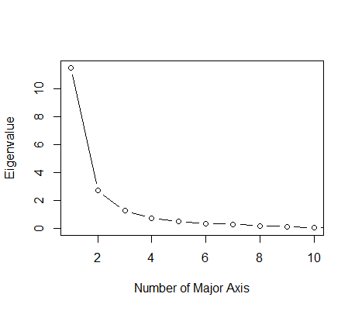
Supplementary Figure 1. Results of a principal component analysis (PCA) conducted on the behavioural variables and lamellae morphometrics of larval Coenagrion damselflies. Depicted are eigenvalues of the first 10 major axes.

