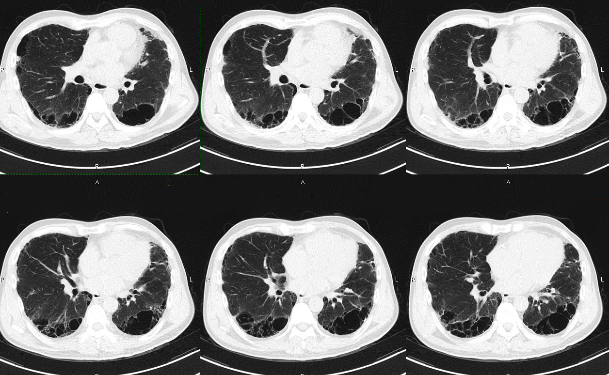
. Figure S5a. Original HRCT image

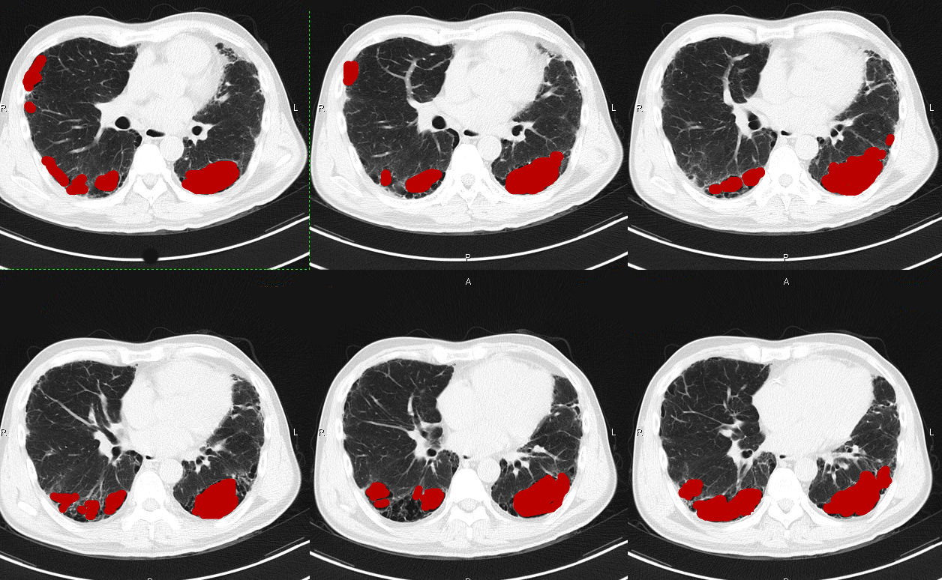
Figure S5b. HRCT image marked manually

