Supplementary Material
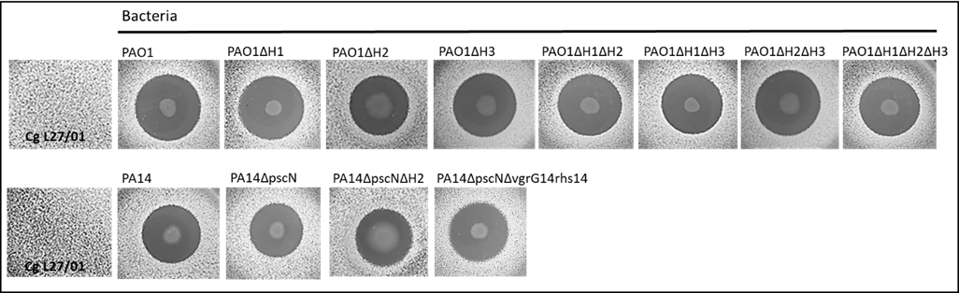
Supplementary figure S1: Antagonistic activity of metabolites secreted by different P. aeruginosa strains (PAO1 and PA14) and mutants (PAO1ΔH1, PAO1ΔH2, PAO1ΔH3, PAO1ΔH1ΔH2, PAO1ΔH1ΔH3, PAO1ΔH2ΔH3, PAO1ΔH1ΔH2ΔH3, PA14ΔpscN, PA14ΔpscNΔH2, PA14ΔpscNΔvgrG14rhs14) inhibiting C. gattii (L27/01 strain) growth.

Supplementary Figure S2: BMDMs Viability assessed through the MTT assay. DMSO: BMDM treated with dimethylsulfoxide. NI: Non-infected BMDM. Pa: BMDM infected with Pseudomonas aeruginosa during the whole protocol. Cg: BMDM infected with Cryptococcus gattii.

Supplementary Figure S3: Survival Curves with heat killed (HK) Pa. A) Survival curve of mice infected intratracheally with 10⁴ viables Cg cells or coinfected intranasally with 10⁵ non viables Pa cells (Pa Heat killed (HK)). PaHK: group infected with P. aeruginosa HK. Cg: group infected with C. gattii; PaHK+Cg: group infected with P. aeruginosa HK 3 days before infection with C. gattii; Cg+PaHK: group infected with P. aeruginosa HK 3 days after infection with C. gattii. B) Survival curve of mice infected intratracheally with 10⁴ viable Cg cells or coinfected intranasally with 10⁵ non viables Pa cells (Pa Heat killed (HK)). PaHK: group infected with P. aeruginosa HK. Cg: group infected with C. gattii; PaHK+Cg: group infected with P. aeruginosa HK 5 hours before infection with C. gattii.

