Supplementary Material

The chloride salt for the demonstration solar loop at Oak Ridge National Laboratory was provided by AICL Magnesium. The supplier assessed the salt as having the composition MgCl₂ (48.8 weight %) – KCl (40.8 weight %) – NaCl (3.8 weight %). Details are given in Table 1. The salt composition was used to guide the mixtures tested in this purification process.
Supplementary Table 1. Analysis of Dehydrated Carnallite by AICL Magnesium
Component | Specifications  Min-Max weight% | Sample 1 (weight %) | Sample 2 (weight %)
MgCl₂ | 44 – 50 | 49.0 | 48.7
KCl | 38 – 43 | 40.5 | 41.0
K₂O calculated from KCl |  | 25.6 | 25.9
NaCl | 2.5 – 10 | 3.8 | 3.8
MgO | 1.5 – 2.5 | 1.69 | 1.58
H₂O | 3.5 – 4.5 | 4.5 | 4.3
SO₄²⁻ | 0.05 (max) | 0.019 | 0.020
Br | 0.6 (max) | 0.55 | 0.58
B | 0.0001 – 0.0002 | 0.0001 | 0.0001
Insoluble residue | 0.01 (max) | < 0.01 | < 0.01
Mg/K mole ratio |  | 0.94 | 0.94

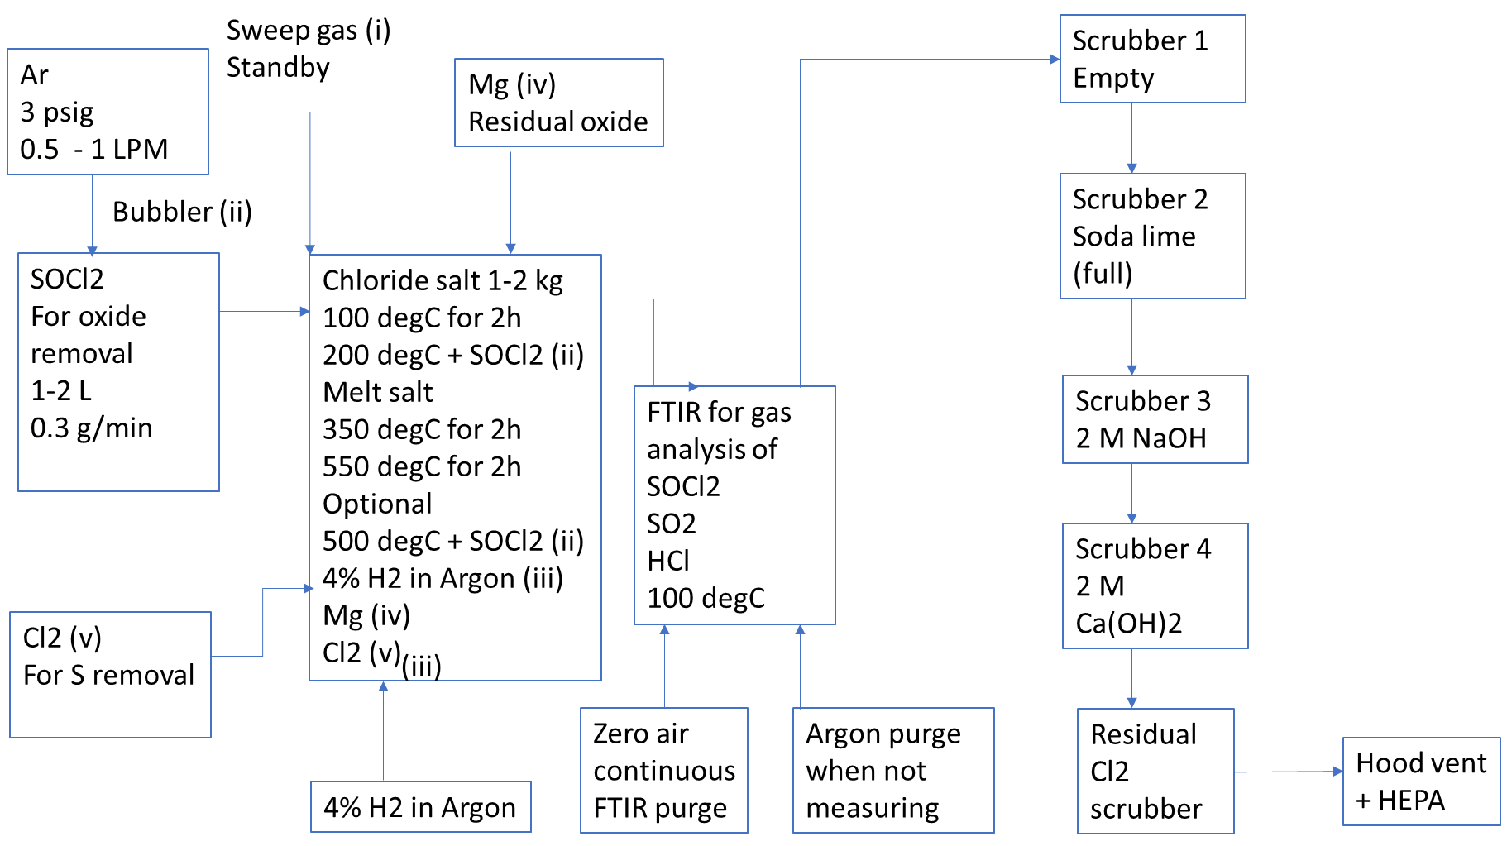
Supplementary Figure 1. Flow chart for thionyl chloride purification process.

