Hdh-Tektin-4 Regulates Motility of Fresh and Cryopreserved Sperm of Pacific Abalone, Haliotis discus hannai

Supplementary Figures

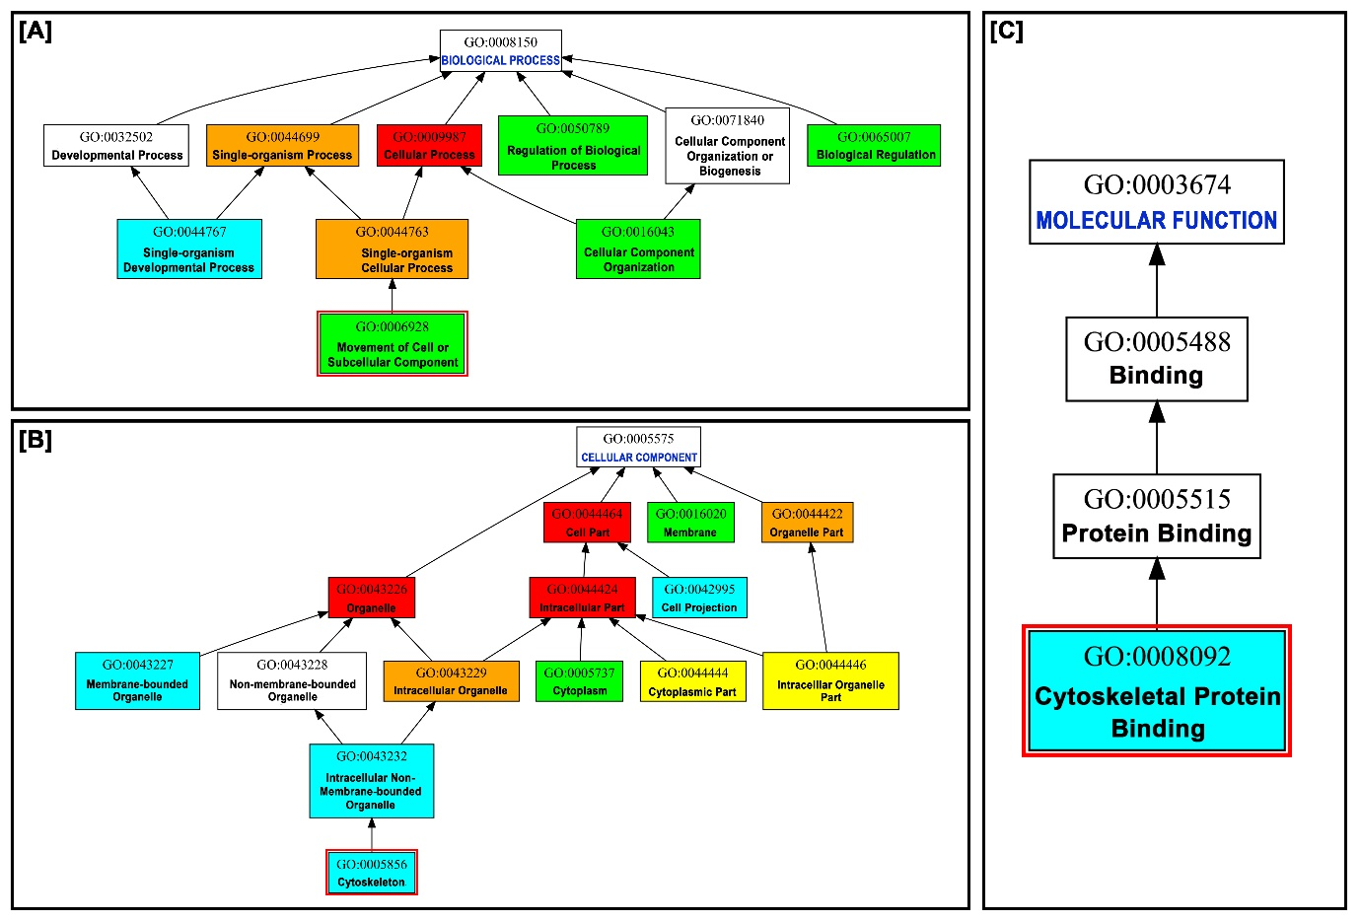
S Figure 1. Gene ontology (GO) of Hdh-TEKT4 gene of H. discus hannai. Figure illustrated three component of gene ontology, [A] biological process, [B] cellular component and [C] molecular function. Biological process revealed Hdh-TEKT4 as movement of cell or subcellular component protein.

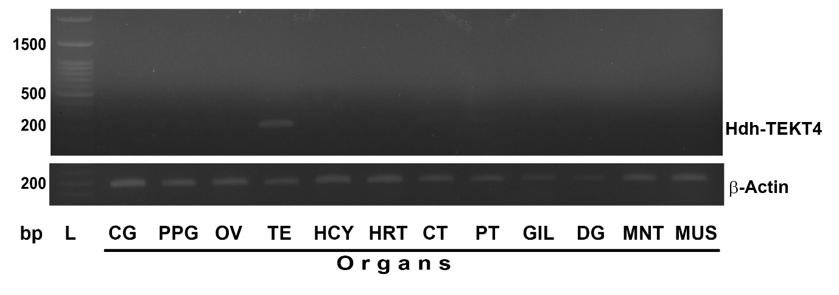
S Figure 2. Gene expression analyses of Hdh-TEKT4 in various tissues of Haliotis discus hannai and β-Actin gene as reference gene. Lane L, 10000 bp DNA marker; CG, cerebral ganglion; PPG, pleuropedal ganglion; OV, ovary; TE, testis; HCY, hemocyte; HRT, heart; CT, cephalic tentacle; PT, pleuropedal tentacle; GIL, gill; DG, digestive gland; MNT, mantle; MUS, muscle

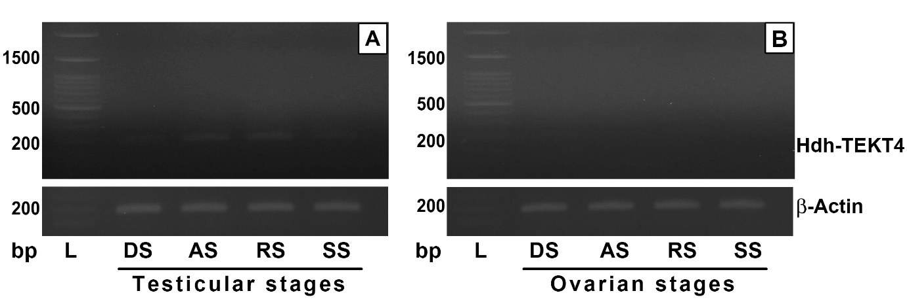
S Figure 3. Gene expression analyses of Hdh-TEKT4 in different gonadal developmental stages of Haliotis discus hannai and β-Actin gene as reference gene: [A] Testicular developmental and [B] Ovarian developmental stages. Lane L, 10000 bp DNA marker; DS, degenerative stage; AS, active stage; RS, ripening stage; SS, spent stage.

