Supporting Information

Spectroscopy, Structure, Biomacromolecular Interactions and Anti-proliferation Activity of a Fe(II) Complex with DPA-Bpy as Pentadentate Ligand

Hehe Bai ª, Jia Shi ª, Qingyu Guo ª, Wenming Wang ª, Zhigang Zhang ª, Yafeng Li ^{b},
Manohar Vennampalli ^{c}, Xuan Zhao ^{c}, Hongfei Wang ª

ª Key Laboratory of Chemical Biology and Molecular Engineering of the Education Ministry,
Institute of Molecular Science, Shanxi University, Taiyuan 030006, China
^{b} The Fifth Hospital (Shanxi Provincial People's Hospital) of Shanxi Medical University, Taiyuan,
030012, China
^{c} Department of Chemistry, University of Memphis, Memphis, TN 38152, USA

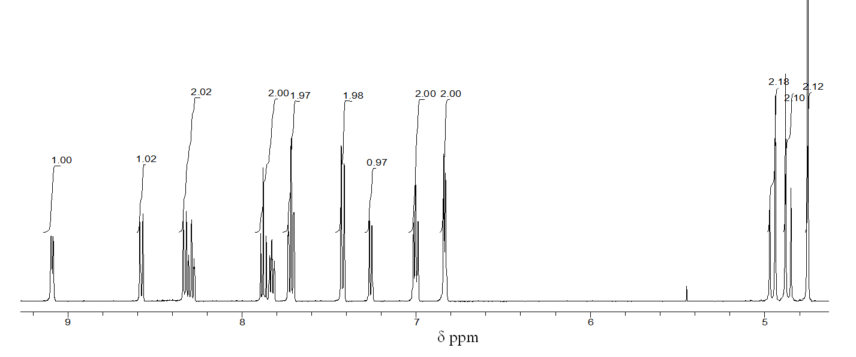

FIGURE S1. ¹H NMR spectra (CD₃CN) for [Fe(DPA-Bpy)(NCCH₃)](OTf)₂.

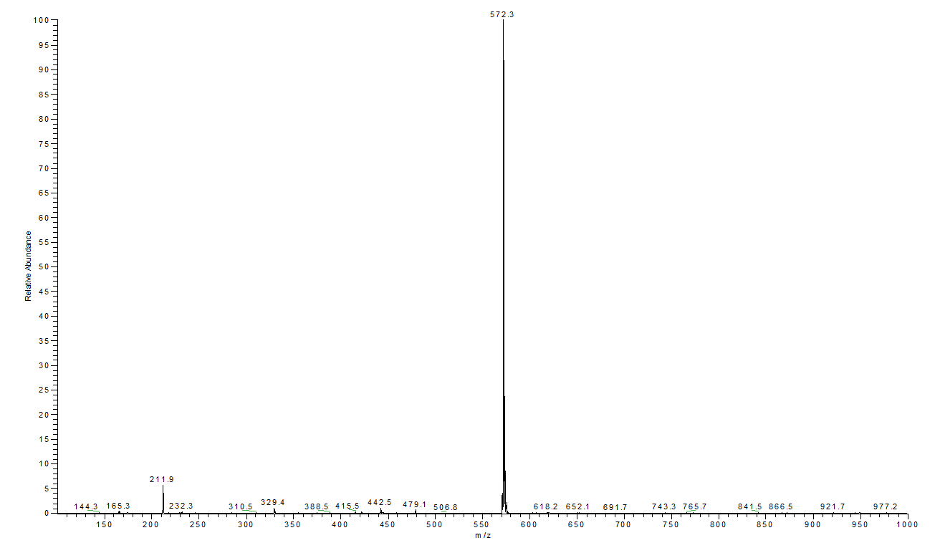
FIGURE S2. Mass spectrum of [Fe(DPA-Bpy)(NCCH₃)](OTf)₂ (1).

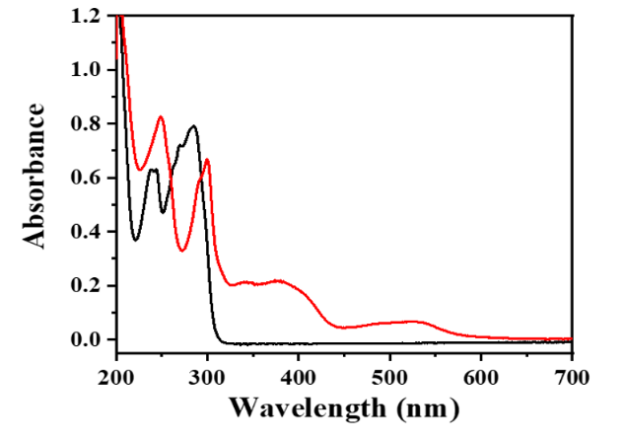

FIGURE S3. UV-Vis spectra of [Fe(DPA-Bpy)(NCCH₃)](OTf)₂ complex (red line) and DPA-Bpy ligand in CH₃CN.

