Supplementary Materials

Supplementary Materials and Methods
Quantitative RT-PCR analysis
Quantitative RT-PCR (qRT-PCR) analysis was performed as described previously. Total RNA was isolated using the Trizol reagent (TaKaRa Biotechnology, China) according to the manufacturer’s protocol, cDNA synthesis and qRT-PCR were performed using the Mir-X miRNA First-Strand Synthesis Kit (TaKaRa), SYBR Prime Script RT-PCR Kit (TaKaRa) and QuantStudio 3 realtime PCR system (Life Technologies, MA). Primers are listed in Supplementary Table S1.
Western blotting
Western blotting analysis was performed as described previously. Antibodies included β-actin (1:2000, Beyotime), Cleaved Caspase-3(1:1000, Abcam), Cleave PARP (1:1000, Abcam), PPTC7 (1:1000, Abcam), HRP-conjugated goat anti-rabbit IgG (Genshare, China) and HRP-conjugated goat anti-mouse IgG (Genshare, China).
Luciferase Assay
Luciferase assay was performed as described previously. The 3’-UTR fragments of human PPTC7 (NM_139283) were amplified by RT-PCR, and inserted into GV272 downstream to the luciferase gene to construct GV272-WT-PPTC7. The putative binding sites for miR-582-5p were mutated by PCR to obtain GV272-mut-PPTC7. For luciferase reporter assay, HEK293T cells were co-transfected with 50 nM of pre-miR-582 mimics or pre-miR-Ctrl, 100 ng GV272-wt-PPTC7 or GV272-mut-PPTC7, and Lipofectamine 2000TM (Invitrogen). After 72 h, cells were harvested and valuated with a Dual-Luciferase Reporter Assay System (Promega).
Cell viability detect
Cell viability of NALM-6, KOPN-8 and SUP-B15 cells was determined by using MTT [3-(4, 5-dimethylthiazol-2-yl)-2, 5-diphenyl- 2H-tetrazolium bromide] kit (Beyotime, China) according to the manufacturer’s protocol.
Supplementary Table S1. PCR Primers Used in the Study.
Name/Target gene | Primer sequence
Human miR-582-5p | F: 5’- CAGTTGTTCAACCAGTTAC -3’  R: 5’- GAACATGTCTGCGTATCTC -3’
Human miR-582-3p | F: 5’-GCACACATTGAAGAGGACAGAC-3’  R: 5’-TATTGAAGGGGGTTCTGGTG-3’
Human PPTC7 | F: 5’-GACTGCCAGAAGCATTGCTGAG-3’  R: 5’-CGGTGATGTCATCTGGCTTTCC-3’
Human CD276 | F: 5’-CTGGCTTTCGTGTGCTGGAGAA-3’  R: 5’-GCTGTCAGAGTGTTTCAGAGGC-3’
Human β-actin | F: 5’-CACCATTGGCAATGAGCGGTTC-3’  R: 5’-AGGTCTTTGCGGATGTCCACGT-3’
Human-PPTC7 3’UTR | F: 5’-GATCGCCGTGTAATTCTAGAGACTATCATTATTTGTCTTATTAC -3’  R:5’CCGGCCGCCCCGACTCTAGATTAGTATAAATACTATATTTATTAAATATCTTTAC -3’

Supplementary Table S2. List of human BM samples information
Human sample number | Gender | Disease type
1 | male | unexplained anemia
2 | male | unexplained anemia
3 | male | unexplained anemia
4 | female | unexplained anemia
5 | male | BCP-ALL
6 | male | BCP-ALL
7 | female | BCP-ALL
8 | female | BCP-ALL
9 | female | BCP-ALL

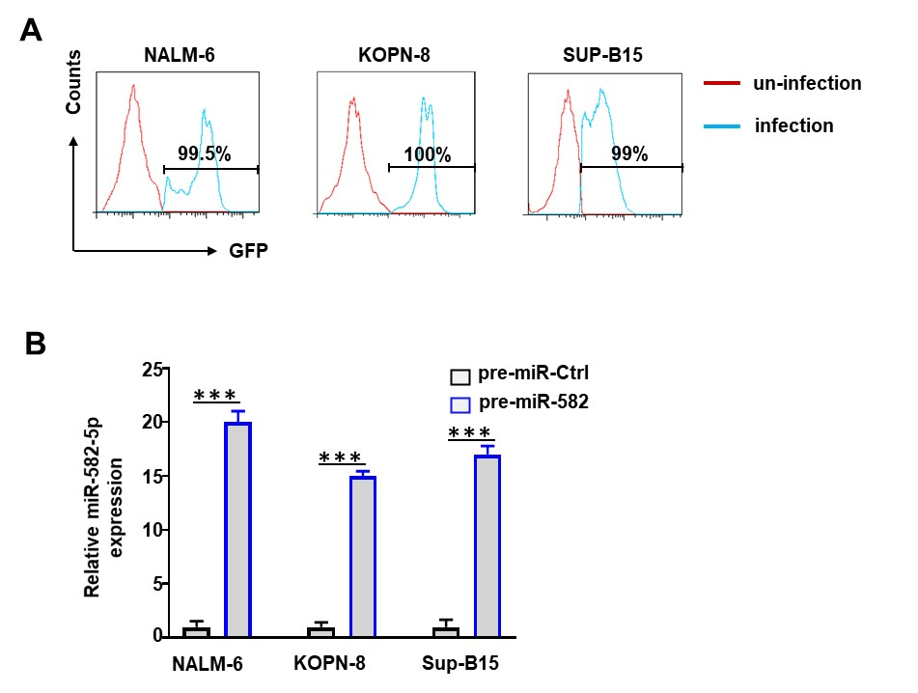
Fig.S1 Overexpression of miR-582. (A) Detect the infection efficiency of EGFP-labeled lentivirus on BCP-ALL cell lines at 24 h by flow cytometry. (B) BCP-ALL cell lines were infected with pre-miR-582 or pre-miR-Ctrl lentivirus for 72 h. The expression of miR-582-5p was determined by qRT-PCR. Bars represent means ± SD, ***P < 0.001.

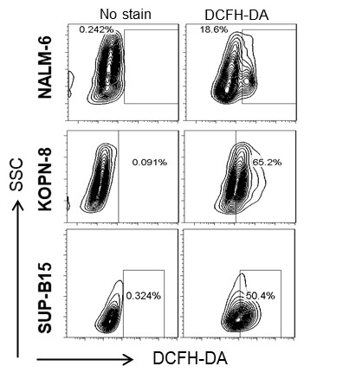
Fig.S2 Gating strategies. The positive gating of DCFH-DA for single-stained cells with DCFH-DA of figure 3C.

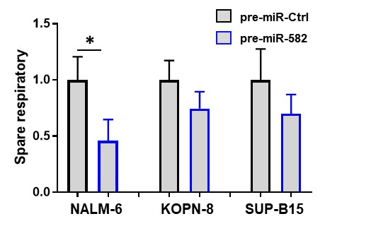
Fig.S3 The quantification of spare respiratory capacity of the three BCP-ALL cell lines. Bars represent means ± SD, *P < 0.05.
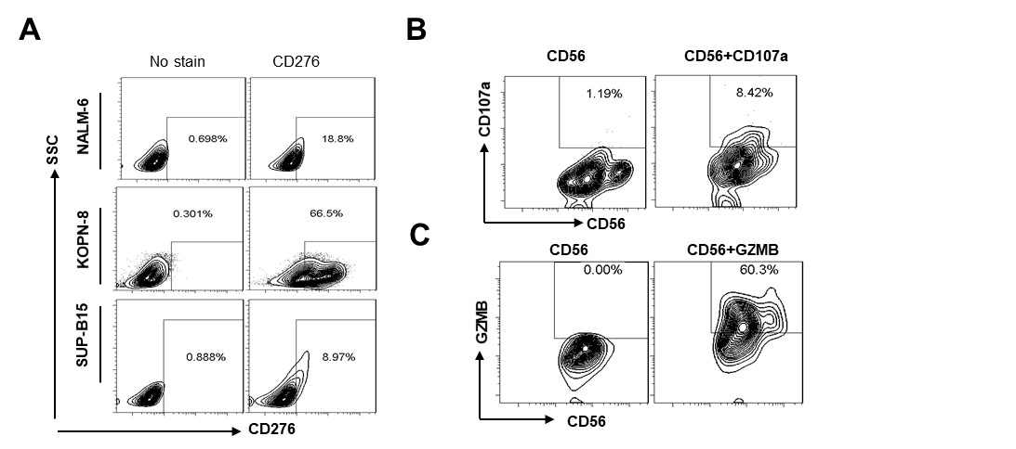
Fig.S4 Gating strategies. (A)The positive gating of CD276 for single-stained cells in BCP-ALL cell lines; (B)The positive gating of CD107a for double-stained cells with CD56 and CD107a in NK cells; (C) The positive gating of GZMB for double-stained cells with CD56 and GZMB in NK cells.

